THE MISHAMIKOWEESH & ARCTIC WATER PARTNERSHIP
ANNUAL REPORT 2025

"We pray for that water because water is a living thing. It's not a commodity. We look at it as a spiritual element."
— Shirley Williams, the late Anishinaabe elder from Wikwemikong Unceded Territory on Manitoulin Island (1938 – 2025)

Pimatiziwin Nipi (Living Waters Group)
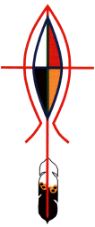
For fourteen years, a network of concerned Anglicans (and friends) have been partnering with First Nation Communities in securing clean, running water in Indigenous homes across Canada. Lack of clean, running water impacts physical and mental health, hygiene and access to education.
Alongside Hope (previously PWRDF) works in developing partnerships, receiving donations, and implementing these projects following the best partnership-led practices which allow these developing relationships and our donations to be as impactful as possible.

Our partnership work has:
-secured clean running water in approximately 60-75 homes in Pikangikum First Nation
-been part of developing a model between PWRDF and First Nations’ communities across Canada that allows our fundraising to be directed to responsive Indigenous-led grants.
-raised $150,000 toward a Water Truck in Kingfisher Lake First Nation, a need identified by First Nations’ leaders of the Indigenous Spiritual Ministry of Mishamikoweesh.

This year, our partnership expanded to include the Diocese of the Arctic.

Water Matters: Projects and Partnerships for 2025 and Beyond…

This year’s fundraising, and our work for the foreseeable future, includes:
Mishamikoweesh: providing running water for Big Beaver House Bible Camp, a multi-use facility playing a central role for the people of Kingfisher Lake and particularly a treasured place of formation and refreshment for the community’s young people.
Diocese of the Arctic: providing washroom facilities in their churches, thereby amplifying the ability for these buildings to be places where community can safely and comfortably gather, and where healthy and life-giving relationships are built and strengthened.
Costs & Timeline: costs for both projects are in the final stages of being calculated. Our hope is that work with the Bible Camp can begin as soon as March 2026, with running water available for most of the coming summer’s camp season and beyond. The Arctic partnership will be a multi-year project of equipping the 58 disparate churches across the diocese with washroom facilities and the ability to be a community hub for their people.
The Ripple Effect
These new projects are identified as priorities by Indigenous leadership in Mishamikoweesh and the Arctic and build on the recognition that access to clean, running water has a powerful ripple effect. It is not just a claiming of physical health and hygiene. Better physical health and hygiene also strengthen mental health, assists in access to education, and builds capacity, dignity, and hope across communities.
A Deeper Dive…
Here are the five locations where Pimatisiwin Nipi will partner with Indigenous and Inuit churches to provide safer, cleaner, and more welcoming facilities to serve their communities.

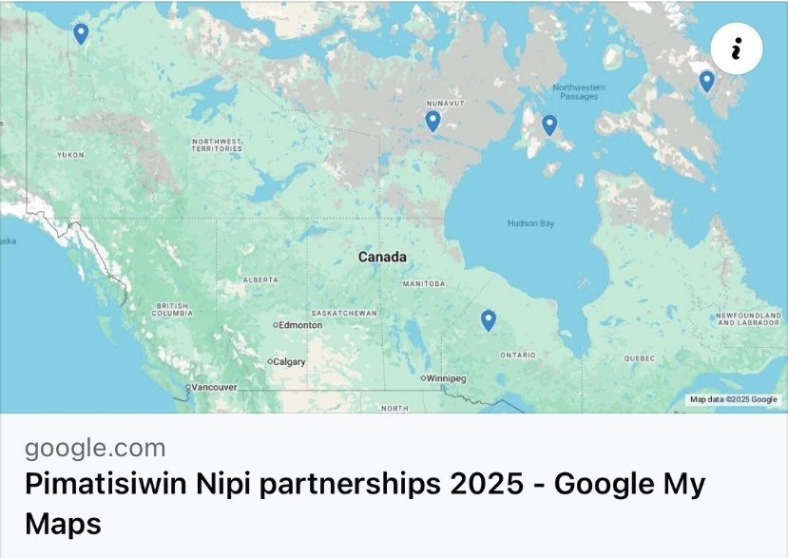
From west to east: All Saints, Aklavik; St. Aidan's, Baker Lake; Big Beaver House Bible Camp;
St. Mark's, Coral Harbour; Pangnirtung

Indigenous Spiritual Ministry of Mikamishoweesh: Big Beaver House Bible Camp
This is a Diocese of the Anglican Church of Canada consisting of communities in Northeastern Manitoba and Northwestern Ontario. At the Big Beaver House Bible Camp, accessible by a drive and a boat ride from the fly-in community of Kingfisher Lake, this will mean a well, to provide potable water that no longer has to be hauled up from the lake. “It was originally envisioned by local elders as a site for training indigenous clergy, and it . . . continues to provide an ideal setting for family camps and the teaching of traditional life skills. . . . Through our camp, St. Matthew’s Church has partnered with many local organizations to serve the people of Kingfisher Lake and surrounding communities. Activities are land-based and locally coordinated. The natural setting provides opportunities for fishing, boating, traditional food preparation as well as novel experiences like tubing."
Big Beaver House Bible Camp brochure, St. Matthews Church, Kingfisher Lake
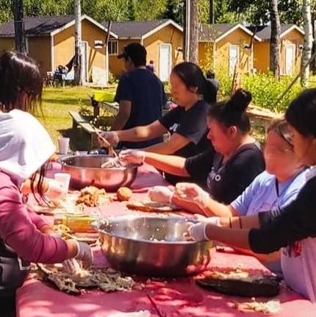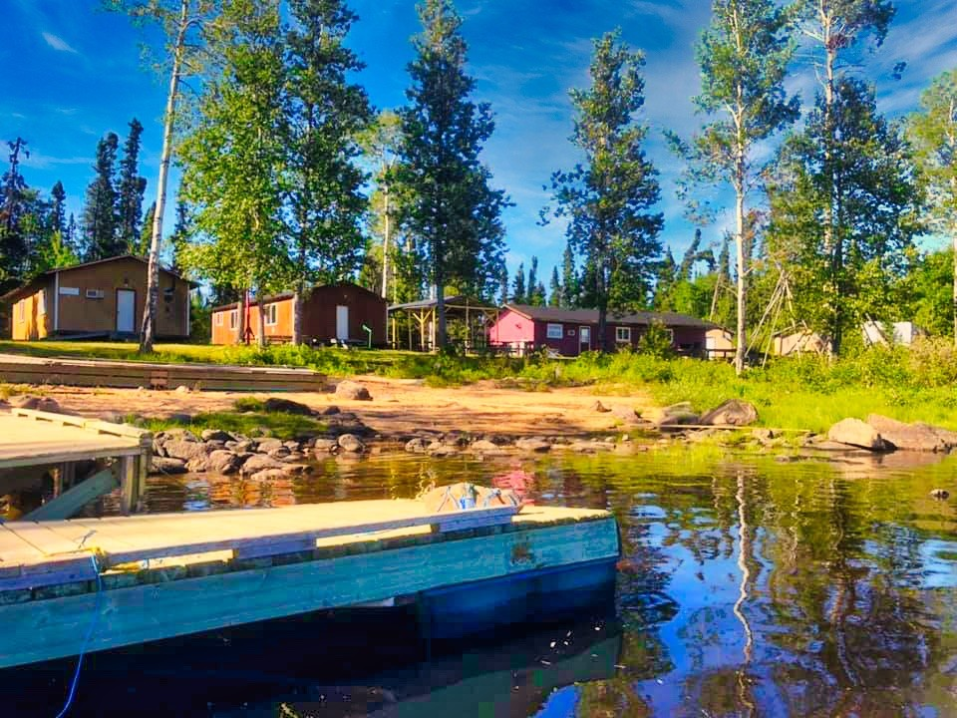

All Saints, Aklavik, N.T.
The church is in the process of converting a room formerly used as the church office, to washrooms. Rev. Victor Johnson describes this project as "indeed our pressing need, which at the moment discourages Elders, Women and Children . . . to attend," as well as those who have health concerns. Access to water and sanitary facilities is one way for churches to open their doors to more people, to include more people, and to provide hospitality to their communities.

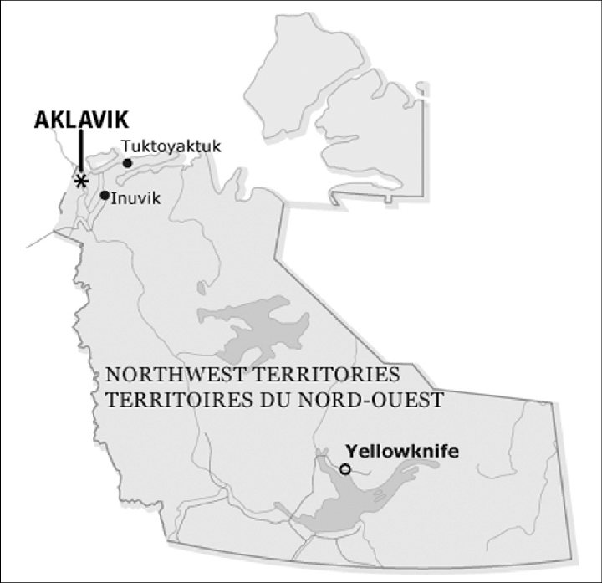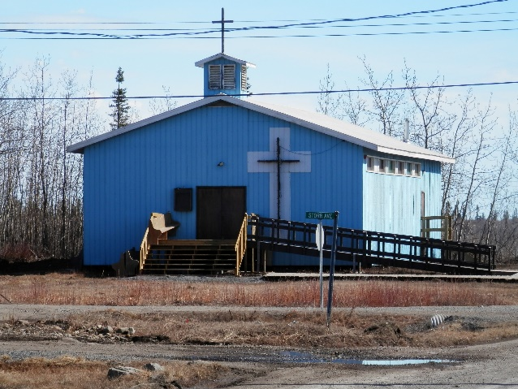
St. Aidan’s, Baker Lake, Nunavut
The Lay Leader in Charge writes: "The church was built mostly by parishioners in the early to mid 1970's. A building was added in the 1980's/90's to serve as a multipurpose addition: . . . a Sunday School, office and a meeting place. Attempts to add toilets were planned but were never completed . . . around 2010/15. Funding to add this function would be of much benefit to the parishioners especially elders and those with babies."
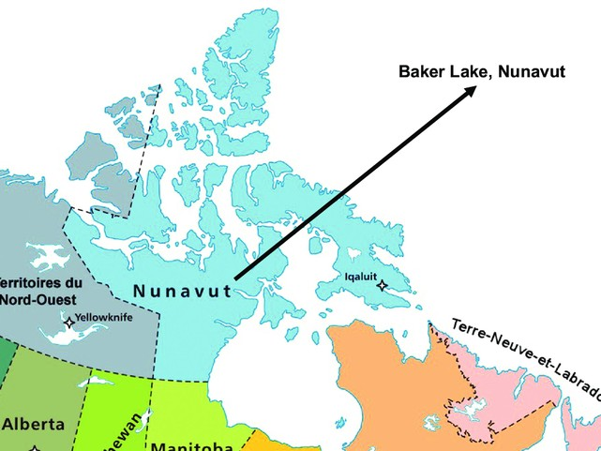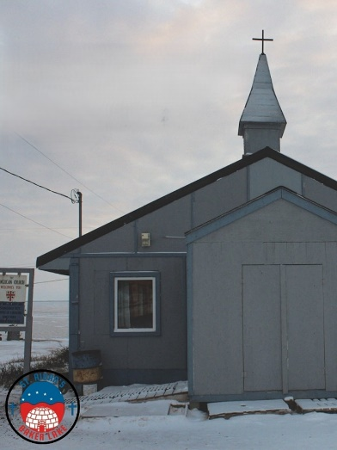
Baker Lake, ᖃᒪᓂᑦᑐᐊᖅ, Qamani'tuaq (Inuktitut: where the river widens) is home to eleven distinct Inuit groups. It is Nunavut's only inland community, about 320 km. west of Hudson Bay on the Thelon River, near the geographic centre of Canada. It's the fourth largest community in Nunavut, with a population of 2,061 (2021). The Meadowbank gold mine and related infrastructure and logistics operations are an important part of the local economy, but Baker Lake is also a centre for artists and craft studios. There is an elementary school, a high school, and a branch of Nunavut Arctic College.
St. Mark’s, Coral Harbour, Nunavut
"Known as Salliq (“large, flat island in front of the mainland”) by the Inuit, it was named for the fossilized coral found at nearby Fossil Creek. From the earliest Inuit hunters of the Sallirmuit, to the Scottish whalers, to the Hudson’s Bay fur traders, to the military air base, it has long served as a strategic point on the northern rim of Hudson Bay," on Southampton Island.
Coral Harbour Community Website: https://coralharbour.ca/
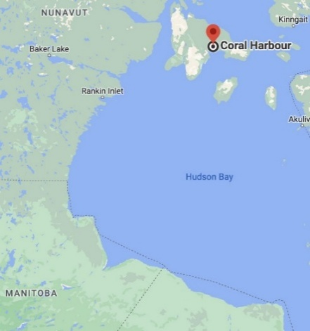
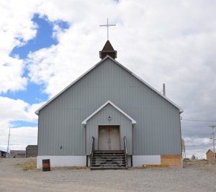

Pangnirtung, Baffin Island
A former training centre for clergy, derelict since severely damaged by weather in 2007, is being torn down to make way for a new development in a partnership between the municipal authority and the Anglican Diocese of the Arctic. Pending consultations with local elders and community groups, a new build, partly funded through a federal/territorial housing initiative, is hoped to include:
- a multi-purpose space that can function as church, parish hall, community centre,
- additional storeys containing 18 affordable housing units, including one for a resident minister.

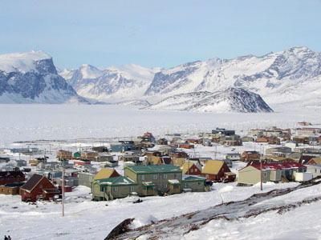
Photo: ‘Uptown Pangnirtung,’ 2006. technicalglitch via Wikimedia Commons
This is one of several projects in the works by the newly-formed Arctic Anglican Development Corporation, which aims to use existing land assets to improve Northern housing availability and affordability, and foster investment in Arctic mission and ministry. Although Pimatiziwin Nipi is not currently involved in this initiative, it is worth noting as a significant development in the community. Our partnership with Pangnirtung will focus on indoor plumbing and running water.

