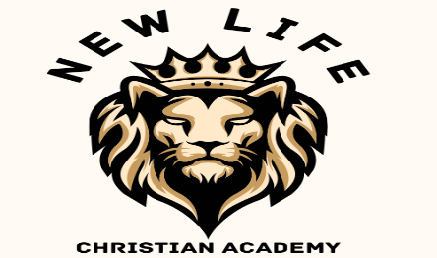
www.nlchristianacademy.com
K4 March Newsletter


Special Theme Day
This will be on Tuesday, March 31st. The theme is “Career Day”. Students who wish to participate may choose an occupation to dress up as. Students who do not participate must wear the normal school uniform.


March Events
March 2nd – Dr. Seuss’ Birthday
March 17th – Picture Day
March 31st – Special Theme Day

March Scripture of the Month
The scripture verse for this month is:
2 Corinthians 5:17
“Therefore, if anyone is in Christ, he is a new creation; old things have passed away; behold, all things have become new.”

Any student that memorizes this verse and recites it to Mrs. Henry will receive a non-uniform certificate.


Dr. Seuss’ Birthday
Monday, March 2nd, will be Dr. Seuss’ birthday. Some of our Student Council members will be reading to our younger classes on this day.


Smile, It’s Picture Day!
Our spring pictures will be taken on Tuesday, March 17th. We will also take class pictures of all grades, and cap/gown pictures for our K4, K5, and 12th grade students.
This will be a non-uniform day for students.

Please like, share and follow our Facebook page, New Life Christian Academy Concord.

