This Week at PPBC
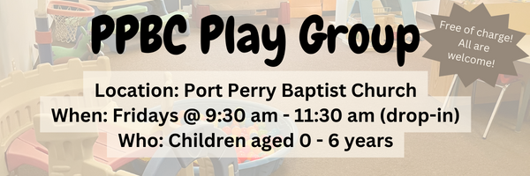




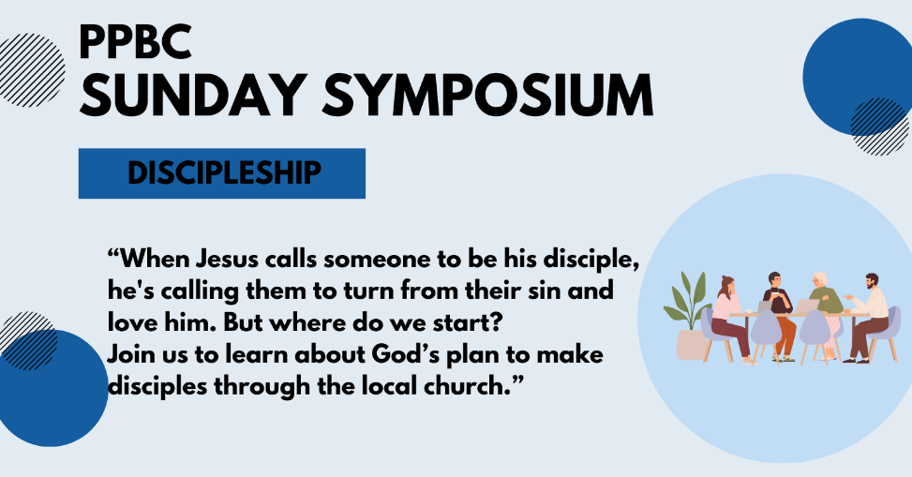


A Prayer Request from the Jones'. Paul and Helen will be traveling to the UK for the EIUK AGM. It is also an opportunity to visit a number of people in the UK who have been friends and supporters over the years they were in Malawi. Pray for their witness with some of those there who do not share our faith, for opportunities to share Jesus’ love.

Notes

Sunday Ministry Schedules
Below are ministry schedules for Nursery, Jr. Church, Greeters, Ushers, and Sound & Video:
Nursery
Feb 22: Jen Werner, TBA
March 1: Kathryn denOuden, Alyssa Summers
Infant Nursery
Feb 22: TBA, TBA
March 1: Karen Clemens, Rosalie McLaren
Jr. Church; ages 3 to grade 1
Feb 22: Justine McKenzie, Kelsey Schoenrock
March 1: Ellianne McLaren, Grace Brown
Jr. Church; Grades 2 to 6
Feb 22: Tracy Ballanger, Jen Owens
March 1: Gregg & Karen Anderson, Kim St-Onge
Greeters
Feb 22: Leno & Donna Araujo
March 1: Fern & Kim St-Onge
Ushers
Feb 22: Roy Wilson, Mark McLaren
March 1: Leno Araujo, Nick Woytowich
Sound & Video
Feb 22: Sound: Wyatt Werner | Video: Josh Bolsonello
March 1: Sound: | Video: Josh Myers

Morning Service
Song – 10,000 Reasons (Bless The Lord)
Welcome
Song – Victory in Jesus
Scripture
Song – Wonderful Merciful Savior
Prayer
Message – Pastor Jim Clemens
Song – Holy Spirit


PPBC Members Meeting
Sunday, March 1, 2026
We will be meeting in the sanctuary.
4:00pm – Meeting

Praise & Prayer Highlights
PRAY for Joan Mabley who has been moved to Glen Hill Strathaven in Bowmanville. Please PRAY for Joan’s comfort and peace.
PRAY for John & Joan Mank and their ongoing health concerns. PRAY for John who has some medical tests this week.
PRAY for Martin & Tina McCurley and their ongoing health concerns.
PRAY for Bert Faber and the family as the mourn Ada's passing. PRAY that God will give them great comfort in Christ and that the truth of the Gospel will shine through this loss.
PRAY for New Song Church & Port Perry Baptist as they plan to co-host a Christianity Explored outreach at That Place on Queen in the new year. Please PRAY for God to prepare the hearts of those who will attend from the community to receive the gospel.
PRAY for the community of Tumbler Ridge BC. PRAY for Pastor George Rowe and Tumbler Ridge Baptist Church as they care for their community.
PRAY for Brian and Janine Kovack. PRAY for Brian's ongoing healing and recovery.
PRAY for Dave and Susie’s nephew Martin and his heart condition. PRAY for the family and the doctors who are caring for them.

Giving
Just as a reminder, there are several ways you can give:
In Person using the offering box located on the back wall of the sanctuary. Donation envelopes are available at the Welcome Centre. Please contact the church office if you would like a box of donation envelopes (office@portperrybaptist.ca)
Through your online banking, you may send electronic transfers to ppbcdonations@gmail.com.
You can also give through Canada Helps. Donation receipts will be provided by Canada Helps, and transaction fees apply.
***********************************************************************
Weekly Newsletter
The PPBC Newsletter is emailed to the church family every Friday. If you would like to be added to the weekly email list, please contact the office by phone: 905-985-8681 or by email: office@portperrybaptist.ca.
*****************************************************************
Church Information:
Location:
2210 Hwy 7A
Port Perry, ON
L9L 1B4
Office Hours:
Monday: 8:30am – 4:00pm
Tuesday: 8:30am – 4:00pm
Wednesday: Closed
Thursday: 8:30am – 4:00pm
Friday: 8:30 am - 3:00 pm
Contact:
Phone: 905.985.8681
Email: office@portperrybaptist.ca
Website: www.portperrybaptist.ca
Staff:
Sr. Pastor – Rev. Jim Clemens
Administrative Assistant – Madeline Werner
Family Ministries Director – Josh Anderson
Pastoral Intern – Scott McKenzie

PPBC Newsletter
Sunday, February 22, 2026


Sunday Starting Point
Sunday, February 22, 2026 - 9:30 am
“Beginning the day with the Word and prayer”
Adults:
Adults will meet in the sanctuary for a time of study and prayer.
Youth:
Jr High (Grades 7-8) will meet in room 18 with Kate Anderson to study Ecclesiastes.
Children:
Children ages 3 - grade 6 will meet in room 26.
(Please note nursery is unavailable during Starting Point)
Sunday Morning Worship
Sunday, February 22, 2026 - 10:30 am
We are meeting in the sanctuary and will continue to live-stream for those who are unable to attend.
Message: The Word and Spirit of God
Scripture: 1 Corinthians 2:1-16
Pastor Jim Clemens

