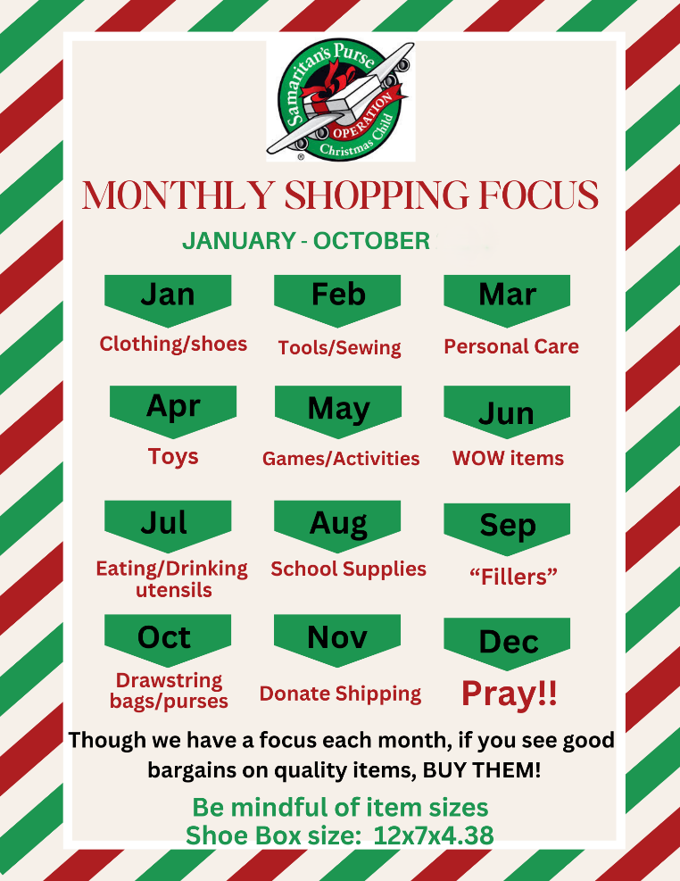
Clothing/shoes | T shirts, underwear, caps/hats, scarves, gloves, socks, flip flops, sandals, shoes, watch, jewelry, sweat bands, bandanas/handkerchiefs, sunglasses
Tools/sewing | hammer, nails, screw drivers, nuts and bolts, wire, string/twine, sewing kits, spools of thread, buttons, needles, fabric, cross stitch kits, duct tape, batteries for items needing them
Personal care | toothbrushes, wash cloths, comb, brush, nail clippers, emery boards, Band-Aids (NON- medicated), small/collapsible cup, feminine products, gauze, first aid tape, small folding umbrellas
Toys | balls, building blocks or LEGO® sets, Slinky® or yo-yo, plastic animals, magnets, puppets, interactive toys, figures, Barbie-style dolls, cars, trucks, farm or work vehicles, Mr. or Mrs. Potato Head, small stuffed toy 5-8 inches
Games/Activities | Card games, chess, checkers, small board/cloth games, puzzles, coloring books or pads, dry watercolor set with paint brush, plastic binoculars, a compass, musical instruments, chalkboard and chalk, jump rope, sticker books, dice, pick-up sticks, arts & crafts kits with NO liquids, like glue or paint, play dough
WOW! Items  Need 300 total | Soccer ball(deflated) WITH pump, 10-12inch soft stuffed toy, baby dolls, with clothes/accessories, Barbie-like dolls with clothes & accessories, jewelry making or leather working kits, larger car or truck
Eating/drinking utensils | spoons, forks, butter knives, drinking cups(plastic), plastic bowls, water bottle plastic or metal, reusable lunch bags, silly or regular reusable straws
School supplies | pencils, sharpener, and erasers, pencil container, pens, crayons, colored pencils, markers, notebooks, index cards, calculator, safety scissors, ruler, glue stick, adhesive tape, colorful binder clips or paper clips, rubber bands, books to read, highlighters, dry erase markers and small dry erase board, plain white printer paper, lined paper, pocket folders
Small “Fillers”  (to fill every tiny empty spot with a gift) | small “bouncy” ball, mini pencils or markers, fun erasers, small squishes (animals), “fidget” toys, slap bracelets, small figures, self-inking stamps
Drawstring bags/purses | Made of cloth or poly, with straps for back wear or just to cinch closed, coin purses or purses with handles or straps

OUR OCC GOAL FOR 2026 IS 300 GOSPEL OPPORTUNITIES!!

Please, DO NOT INCLUDE: food, candy, or gum, toothpaste, used or damaged items, scary or war-related items, wearable traditional camouflage, seeds or organic matter, liquids, gels, medication, money, breakable items, matches, fire starters, aerosols, knives (except butter knives), saws, or razor blades, glass.

