Saturday, February 14 & Sunday, February 15, 2026 - Transfiguration of Our Lord

Prayer of the Day
Let us pray. O God, in the transfiguration of your Son you confirmed the mysteries of the faith by the witness of Moses and Elijah, and in the voice from the bright cloud declaring Jesus your beloved Son, you foreshadowed our adoption as your children. Make us heirs with Christ of your glory, and bring us to enjoy its fullness, through Jesus Christ, our Savior and Lord, who lives and reigns with you and the Holy Spirit, one God, now and forever. Amen.

First Reading: Exodus 24:12-18
The Lord said to Moses, “Come up to me on the mountain and wait there; I will give you the tablets of stone, with the law and the commandment, which I have written for their instruction.” So Moses set out with his assistant Joshua, and Moses went up onto the mountain of God. To the elders he had said, “Wait here for us, until we come back to you. Look, Aaron and Hur are with you; whoever has a dispute may go to them.” Then Moses went up on the mountain, and the cloud covered the mountain. The glory of the Lord settled on Mount Sinai, and the cloud covered it for six days; on the seventh day he called to Moses out of the cloud. Now the appearance of the glory of the Lord was like a devouring fire on the top of the mountain in the sight of the Israelites. Moses entered the cloud and went up on the mountain. Moses was on the mountain for forty days and forty nights.
Word of God, word of life.
Thanks be to God.

Psalm 2 (read responsively)
¹Why are the nations in an uproar? Why do the peoples mutter empty threats?
²Why do the kings of the earth rise up in revolt, and the princes plot together, against the Lord and against the Lord’s anointed?
³“Let us break their yoke,” they say; “let us cast off their bonds from us.”
⁴God whose throne is in heaven is laughing; the Lord holds them in derision.
⁵Then in wrath God speaks to them, and in rage fills them with terror.
⁶“As for me, I have anointed my king upon Zion, my holy mountain.”
⁷Let me announce the decree of the Lord, who said to me, “You are my son; this day have I begotten you.
⁸Ask of me, and I will give you the nations for your inheritance and the ends of the earth for your possession.
⁹You shall crush them with an iron rod and shatter them like a piece of pottery.”
¹⁰And now, you kings, be wise; be warned, you rulers of the earth.
¹¹Submit to the Lord with fear, and with trembling bow in worship;
¹²lest the Lord be angry, and you perish in a sudden blaze of wrath. Happy are all who take refuge in God!

Second Reading: 2 Peter 1:16-21
For we did not follow cleverly devised myths when we made known to you the power and coming of our Lord Jesus Christ, but we had been eyewitnesses of his majesty. For he received honor and glory from God the Father when that voice was conveyed to him by the Majestic Glory, saying, “This is my Son, my Beloved, with whom I am well pleased.” We ourselves heard this voice come from heaven, while we were with him on the holy mountain. So we have the prophetic message more fully confirmed. You will do well to be attentive to this as to a lamp shining in a dark place, until the day dawns and the morning star rises in your hearts. First of all you must understand this, that no prophecy of scripture is a matter of one’s own interpretation, because no prophecy ever came by human will, but men and women moved by the Holy Spirit spoke from God.
Word of God, word of life
Thanks be to God.

Gospel: Matthew 17:1-9
Six days later, Jesus took with him Peter and James and his brother John and led them up a high mountain, by themselves. And he was transfigured before them, and his face shone like the sun, and his clothes became bright as light. Suddenly there appeared to them Moses and Elijah, talking with him. Then Peter said to Jesus, “Lord, it is good for us to be here; if you wish, I will set up three tents here, one for you, one for Moses, and one for Elijah.” While he was still speaking, suddenly a bright cloud overshadowed them, and a voice from the cloud said, “This is my Son, the Beloved; with him I am well pleased; listen to him!” When the disciples heard this, they fell to the ground and were overcome by fear. But Jesus came and touched them, saying, “Get up and do not be afraid.” And when they raised their eyes, they saw no one except Jesus himself alone.
As they were coming down the mountain, Jesus ordered them, “Tell no one about the vision until after the Son of Man has been raised from the dead.”
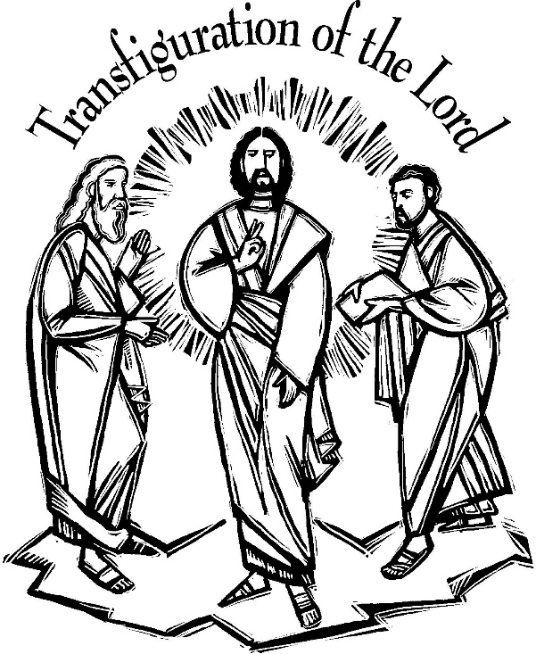

Transfiguration Sunday – 2/14 & 2/15/2026 Prayers of Intercession
As God’s beloved children united in Christ, let us pray for the church, the whole human community, and the well-being of the earth, our home.
A brief silence.
Revealing God, your Spirit sustains the church. Strengthen the faithful with the revelation of Christ transfigured, that we may joyfully follow him in the way of the cross. Merciful God,
receive our prayer.
Life-giving God, creation is full of your majesty. Nurture in us a deep respect for the interdependence of all life, and make us wise and vigilant stewards of your good earth. Merciful God,
receive our prayer.
Peacemaking God, the nations are in turmoil. We pray for an end to violent conflict (regions at war may be named). Give wisdom to negotiators and sanctuary to refugees. Defend any who are in danger. Merciful God,
receive our prayer.
Healing God, you desire wholeness for all people. Bring healing to any who are experiencing illness, chronic pain, or mental anguish. Comfort the dying and those who grieve (especially [names].…and all other people or concerns we now name aloud on our lips or in the silence of our hearts.). Merciful God,
receive our prayer.
Holy God, in our worship we glimpse your glory, hear your voice, and receive assurance of your love. Inspire all who prepare, lead, and participate in worship to serve you with reverence and joy. Merciful God,
receive our prayer.
Transforming God, you bring life from death. We give thanks for the witness of those who have died in faith, and we praise you for the hope we have in Christ, our Morning Star. Merciful God,
receive our prayer.
Confident that the Holy Spirit receives our prayers and answers us, we commend all for whom we pray to God’s loving-kindness made known to us in Christ Jesus our Savior.
Amen.

