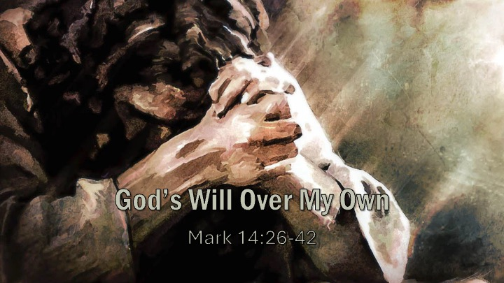
Discussion Questions & Spiritual Practice
- The Sincere but Self-Confident Will (14:26–31)
- Where does self-confidence quietly shape your discipleship — especially in areas where you assume, “I would never…”?
- When pressure rises in your life, what do you instinctively rely on first: prayerful dependence or personal strength?

- The Crushing Weight of Obedience (14:32–35)
- When you feel overwhelmed or distressed, do you tend to bring your anguish honestly to God — or manage it internally?
- What does your response to pressure reveal about what you have been giving your attention to?

- The Surrendered Son (14:36)
- Is there a “cup” in your life right now that you are asking God to remove? What would it mean to add, sincerely, “Yet not my will, but Yours”?
- Do you believe obedience guarantees easier outcomes? How does Gethsemane challenge that belief?

- The Sleeping Disciples & the Cost of Control (14:37–42)
- In what areas of your life does control masquerade as responsibility?
- What repetitive practices are shaping you right now — toward surrender or toward self-reliance?
Spiritual Practice
Step 1 – Enter the Garden (Awareness)
Read slowly: Mark 14:32–36.
Then sit in silence for two minutes.
Ask yourself:
- Where in my life do I feel pressure right now?
- What situation feels uncertain, threatening, or out of control?
Write it down plainly.
Not the spiritual version.
The honest version.
This is your “garden.”

Step 2 – Expose the Control (Discernment)
Now ask:
- What outcome am I trying to secure?
- What am I afraid will happen if I don’t manage this?
- Where am I saying internally, “I will handle this”?
Be specific.
Control often hides under words like:
- responsibility
- wisdom
- leadership
- protecting others
- planning ahead
Control is not always loud.
Sometimes it is quiet anxiety dressed as maturity.
Circle any sentence in your journal that begins with “I need to…”

Then ask:
What would happen if I didn’t?
Notice what emotion surfaces:
Fear? Shame? Anger? Insecurity?
That emotion is usually the root.

Step 3 – Name the Cup (Honesty Before God)
Now pray like Jesus did.
Write this sentence and complete it:
“Father, if possible, take this from me…”
Do not rush.
Let yourself want what you actually want.
Gethsemane gives you permission to desire relief.

Step 4 – Release the Outcome (Surrender)
Now slowly write:
“Yet not what I will, but what You will.”
Ask:
- What specifically am I being asked to release?
- What outcome do I need to stop trying to control?
- What would trust look like here?
Trust is not passivity.
It is active relinquishment.
If helpful, physically open your hands as you pray.
You may even say aloud:
“Father, I release the outcome of ______ to You.”
Be concrete.

Step 5 – Identify the Next Faithful Step (Obedience)
Surrender does not remove responsibility.
It clarifies it.
Ask:
- If I am no longer controlling the narrative, what is my next faithful act of obedience?
- What is within my responsibility — and what is not?
Write two columns:
Mine to Obey / God’s to Carry
This is often where freedom begins.

Step 6 – Rest Under the Shepherd (Security)
Read Romans 8:32 or Hebrews 7:25.
Sit quietly.
Remember: The One who perfectly surrendered in the garden now intercedes for you.
Your security does not rest on the strength of your surrender —
but on His.

