Johnsville United Methodist Church
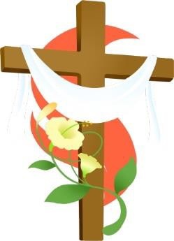

Spring Bazaar & Bake Shop

Saturday, March 28,2026

9am – 2pm

Food available: breakfast sandwiches

Lunch: soup and sandwiches

Baked goodies, Easter treats for Easter baskets,

and crafts for sale


JUMC

11106 Green Valley Road (Rt.75) Union Bridge, MD 21791
More info: 410-775-7217



