Holy Trinity Lutheran Church
150 River Road Red Bank, NJ 07701
Church Office: (732) 741-9241 Fax: (732) 741-9577
email: holytrinitychurch4@verizon.net
Website: htlcredbank.org
Pastor: Rev. John Mack, Jr.
Cell: (336)-392-5839
Minister of Music: Peter Isherwood
Parish Administrator: Deanna Vergari
Council President: Cynthia Kazmac



February 08, 2026

Fifth Sunday after Epiphany

Introduction

Light shines in the darkness for the upright, the psalmist sings. Isaiah declares that when we loose the bonds of injustice and share our bread with the hungry, the light breaks forth like the dawn. In another passage from the Sermon on the Mount, Jesus, the light of the world, calls his followers to let the light of their good works shine before others. Through baptism we are sent into the world to shine with the light of Christ.

Welcome & Announcements (Please remember to silence your cell phone!)

Prelude (We prayerfully prepare our hearts and minds to worship!)

+ GATHERING +

Confession and Forgiveness
All may make the sign of the cross, the sign that is marked at baptism, as the presiding minister begins.
P:Blessed be the holy Trinity, ☩ one God,
the Creator of heaven and earth,
the Word who spoke life into being,
the Wind stirring the waters.
C:Amen.
P:Let us turn in confession to the one who knows us completely.
Silence is kept for reflection.
Mighty God, lover of justice,
C:you call us to life in community,
but we have served our own interests
at the expense of our neighbors.
We have sown deceit where honesty was needed.
We say the right words,
but our hearts are far from you.
Turn us to seek your face.
Knit us together and give us the mind of Christ,
that we may do justice, love mercy,
and walk humbly with you, our God.
Amen.
P:The former things have passed away,
and new things God now declares:
Like a spring of water that never fails,
God covers you in the righteousness of Christ,
and forgives your sin in ☩ Jesus’ name.
May the Spirit give you strength to live for others,
and bless you with the gift of peace.
C:Amen.

*Gathering Hymn ELW 413 Holy, Holy, Holy, Lord God Almighty!
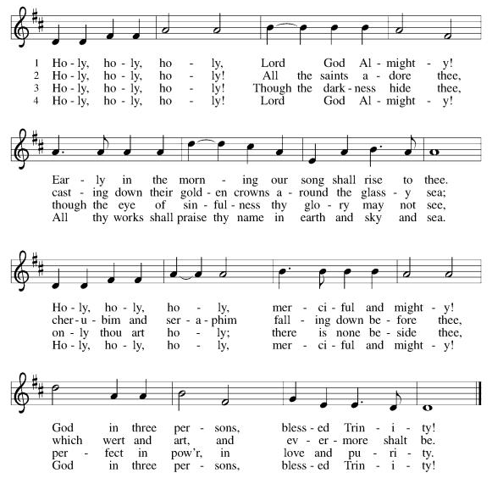

*Pastoral Greeting

P: The Grace of our Lord Jesus Christ, the love of God, and the communion of the Holy Spirit be with you all.

C: And also with you!

Hymn of Praise

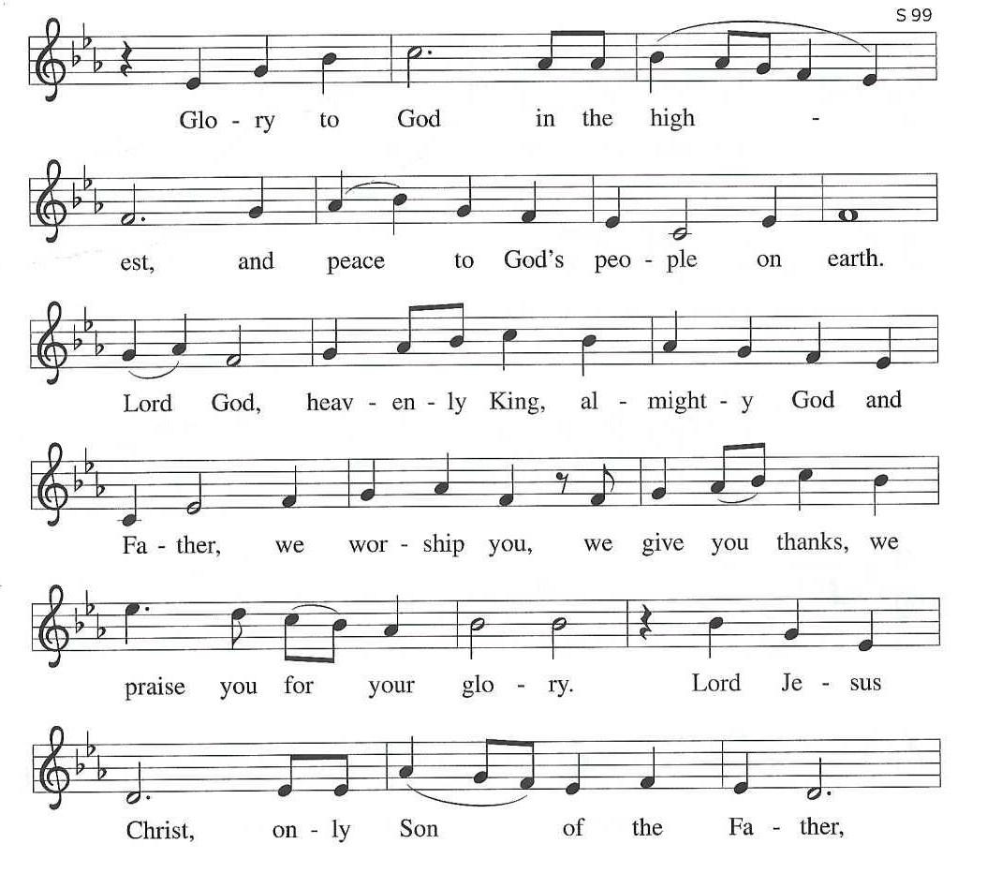

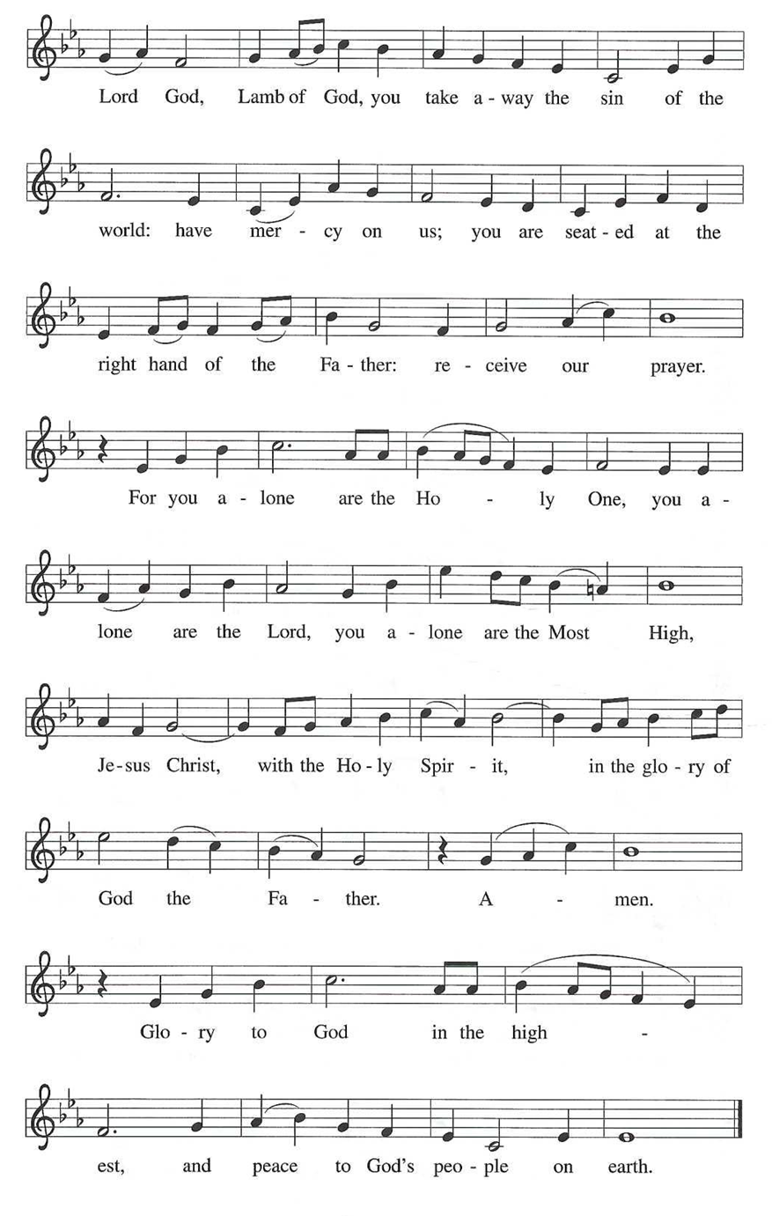

*Prayer of the Day
P: Lord God, with endless mercy you receive the prayers of all who call upon you. By your Spirit show us the things we ought to do, and give us the grace and power to do them, through Jesus Christ, our Savior and Lord.
C: Amen!

Children’s Message

+WORD+

First Reading: Isaiah 58:1-9
Shortly after the return of Israel from exile in Babylon, the people were troubled by the ineffectiveness of their fasts. God reminds them that outward observance is no substitute for genuine fasting that results in acts of justice, such as feeding the hungry, sheltering the homeless, and clothing the naked.
1 Shout out; do not hold back!
Lift up your voice like a trumpet!
Announce to my people their rebellion,
to the house of Jacob their sins.
2 Yet day after day they seek me
and delight to know my ways,
as if they were a nation that practiced righteousness
and did not forsake the ordinance of their God;
they ask of me righteous judgments;
they want God on their side.
3 “Why do we fast, but you do not see?
Why humble ourselves, but you do not notice?”
Look, you serve your own interest on your fast day
and oppress all your workers.
4 You fast only to quarrel and to fight
and to strike with a wicked fist.
Such fasting as you do today
will not make your voice heard on high.
5 Is such the fast that I choose,
a day to humble oneself?
Is it to bow down the head like a bulrush
and to lie in sackcloth and ashes?
Will you call this a fast,
a day acceptable to the Lord?
6 Is not this the fast that I choose:
to loose the bonds of injustice,
to undo the straps of the yoke,
to let the oppressed go free,
and to break every yoke?
7 Is it not to share your bread with the hungry
and bring the homeless poor into your house;
when you see the naked, to cover them
and not to hide yourself from your own kin?
8 Then your light shall break forth like the dawn,
and your healing shall spring up quickly;
your vindicator shall go before you;
the glory of the Lord shall be your rear guard.
9a Then you shall call, and the Lord will answer;
you shall cry for help, and he will say, “Here I am.”
[ 9b If you remove the yoke from among you,
the pointing of the finger, the speaking of evil,
10 if you offer your food to the hungry
and satisfy the needs of the afflicted,
then your light shall rise in the darkness
and your gloom be like the noonday.
11 The Lord will guide you continually
and satisfy your needs in parched places
and make your bones strong,
and you shall be like a watered garden,
like a spring of water
whose waters never fail.
12 Your ancient ruins shall be rebuilt;
you shall raise up the foundations of many generations;
you shall be called the repairer of the breach,
the restorer of streets to live in.]

Psalm: 112:1-9 [10]
Light shines in the darkness for the upright. (Ps. 112:4)
1 Hallelujah! Happy are they who | fear the Lord
and have great delight in | God’s commandments!
2 Their descendants will be mighty | in the land;
the generation of the upright | will be blessed.
3 Wealth and riches will be | in their house,
and their righteousness will | last forever.
4 Light shines in the darkness | for the upright;
the righteous are merciful and full | of compassion.
5 It is good for them to be gener- | ous in lending
and to manage their af- | fairs with justice.
6 For they will nev- | er be shaken;
the righteous will be kept in everlast- | ing remembrance.
7 They will not be afraid of any | evil rumors;
their heart is steadfast, trusting | in the Lord.
8 Their heart is established and | will not shrink,
until they see their desire up- | on their enemies.
9 They have given freely to the poor, and their righteousness stands | fast forever;
they will hold up their | head with honor.
[ 10 The wicked will see it and be angry; they will gnash their teeth and | pine away;
the desires of the wick- | ed will perish. ]

Second Reading: 1 Corinthians 2:1-12 [13-16]
Though people such as the Corinthians are enamored with human philosophy and wisdom, Paul continuously presents God’s hidden wisdom which is Jesus Christ crucified. True spiritual maturity involves judging ourselves and others in light of God’s revelation in the cross.
1 When I came to you, brothers and sisters, I did not come proclaiming the testimony of God to you with superior speech or wisdom. 2 For I decided to know nothing among you except Jesus Christ and him crucified. 3 And I came to you in weakness and in fear and in much trembling. 4 My speech and my proclamation were made not with persuasive words of wisdom but with a demonstration of the Spirit and of power, 5 so that your faith might rest not on human wisdom but on the power of God.
6 Yet among the mature we do speak wisdom, though it is not a wisdom of this age or of the rulers of this age, who are being destroyed. 7 But we speak God’s wisdom, a hidden mystery, which God decreed before the ages for our glory 8 and which none of the rulers of this age understood, for if they had, they would not have crucified the Lord of glory. 9 But, as it is written,
“What no eye has seen, nor ear heard,
nor the human heart conceived,
what God has prepared for those who love him”—
10 God has revealed to us through the Spirit, for the Spirit searches everything, even the depths of God. 11 For what human knows what is truly human except the human spirit that is within? So also no one comprehends what is truly God’s except the Spirit of God. 12 Now we have received not the spirit of the world but the Spirit that is from God, so that we may understand the gifts bestowed on us by God. [13 And we speak of these things in words not taught by human wisdom but taught by the Spirit, interpreting spiritual things to those who are spiritual.
14 Those who are unspiritual do not receive the gifts of God’s Spirit, for they are foolishness to them, and they are unable to understand them because they are spiritually discerned. 15 Those who are spiritual discern all things, and they are themselves subject to no one else’s scrutiny.
16 “For who has known the mind of the Lord
so as to instruct him?”
But we have the mind of Christ.]

Gospel Acclamation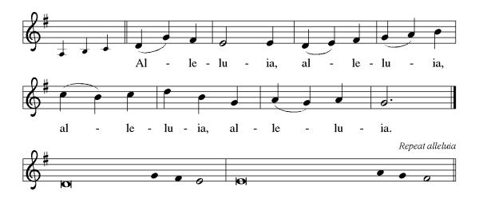

P: The Holy Gospel According to St. Matthew 5th Chapter
C: Glory to You O Lord!

Gospel: Matthew 5:13-20
In the Sermon on the Mount, Jesus encourages his followers to be the salt of the earth and the light of the world, doing good works and keeping God’s commandments.
[Jesus said:] 13 “You are the salt of the earth, but if salt has lost its taste, how can its saltiness be restored? It is no longer good for anything but is thrown out and trampled under foot.
14 “You are the light of the world. A city built on a hill cannot be hid. 15 People do not light a lamp and put it under the bushel basket; rather, they put it on the lampstand, and it gives light to all in the house. 16 In the same way, let your light shine before others, so that they may see your good works and give glory to your Father in heaven.
17 “Do not think that I have come to abolish the Law or the Prophets; I have come not to abolish but to fulfill. 18 For truly I tell you, until heaven and earth pass away, not one letter, not one stroke of a letter, will pass from the law until all is accomplished. 19 Therefore, whoever breaks one of the least of these commandments and teaches others to do the same will be called least in the kingdom of heaven, but whoever does them and teaches them will be called great in the kingdom of heaven. 20 For I tell you, unless your righteousness exceeds that of the scribes and Pharisees, you will never enter the kingdom of heaven.”

P: The Gospel of the Lord
C: Praise to you, O Christ!

Sermon

*Hymn of the Day ELW 580 How Clear is Our Vocation, Lord
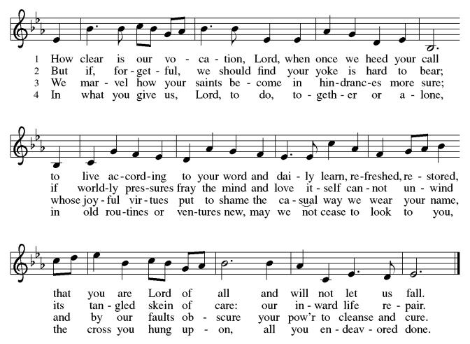

*Prayers of Intercession
As God’s beloved children united in Christ, let us pray for the church, the whole human community, and the well-being of the earth, our home.
A brief silence.
Your church does ministry in many and various ways. Keep the baptized true to the mind of Christ, that our works and witness bring hope to a troubled world. Merciful God,
C:receive our prayer.
Your marvelous creation cries out to you. Restore polluted air, soil, and water sources to wholeness. Guard honeybees, elephants, great whales and songbirds from harm, and renew the face of the earth. Merciful God,
C:receive our prayer.
Your people in every nation suffer injustice, poverty, and the threat of violence. Guide those in authority to govern with compassion, and bring peace to war zones (areas of conflict may be named). We pray for our enemies. Merciful God,
C:receive our prayer.
Your blessings are poured out for all in need. Help and heal any who experience trauma, discrimination, disease, hunger, abuse, or persecution. Comfort those who are sick or grieving (especially). Merciful God,
C:receive our prayer.
Your wisdom guides this congregation and its ministries. Sustain our ordained leaders, staff, lay leaders, and volunteers. Form us to be salt and light for the neighbors we serve, following the example of Christ. Merciful God,
C:receive our prayer.
Here other intercessions may be offered.
Your saints rejoice at your heavenly banquet. We give thanks for their lives of faith, trusting that we also will be embraced by your eternal love. Merciful God,
C:receive our prayer.
Confident that the Holy Spirit receives our prayers and answers us, we commend all for whom we pray to God’s loving-kindness made known to us in Christ Jesus our Savior.
C: Amen.

Greeting of Peace
P: The peace of Christ be with you always!
C: And also with you!

Offering (Thank you for your support for our ministry!)
*Doxology ELW 306 Come, Beloved of the Maker (v.5)(Please stand and join in singing as we share our gifts!)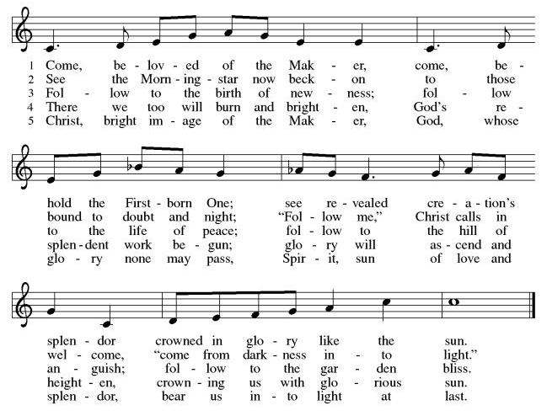

*Offering Prayer
A: God of majesty,
C: no eye has seen, no ear has heard
what you have prepared for those who love you,
yet in this meal you reveal the wideness of your mercy.
Use what we have gathered
to feed us with the reign of God come near,
Jesus Christ, our Savior and Lord.
Amen!

+MEAL+
*Great Thanksgiving
P: The Lord be with you.
C: And also with you.

P: Lift up your hearts.
C: We lift them to the Lord.

P: Let us give thanks to the Lord our God.
C: It is right to give our thanks and praise.

P: It is indeed right, our duty and our joy,
that we should at all times and in all places
give thanks and praise to you, almighty and merciful God,
through our Savior Jesus Christ.
By the leading of a star he was shown forth to all nations;
in the waters of the Jordan you proclaimed him your beloved Son;
and in the miracle of water turned to wine he revealed your glory.
And so, with all the choirs of angels,
with the church on earth and the hosts of heaven,
we praise your name and join their unending hymn:

*Sanctus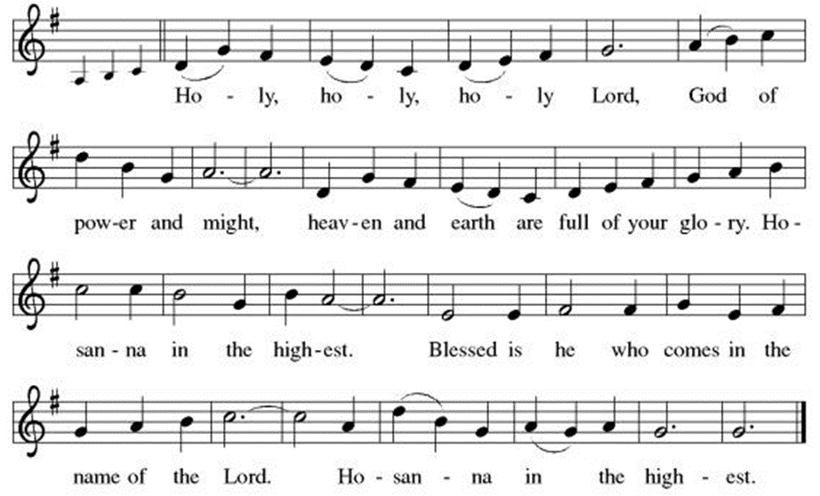
*Eucharistic Prayer
P:Holy God, mighty Lord, gracious Father:
Endless is your mercy and eternal your reign.
You have filled all creation with light and life;
heaven and earth are full of your glory.

We praise you for the grace shown to your people in every age:
the promise to Israel,
the rescue from Egypt,
the gift of the promised land,
the words of the prophets;
and, at this end of all the ages, the gift of your Son,
who proclaimed the good news in word and deed
and was obedient to your will, even to giving his life.

In the night in which he was betrayed,
our Lord Jesus took bread, and gave thanks;
broke it, and gave it to his disciples, saying:
Take and eat; this is my body, given for you.
Do this for the remembrance of me.

Again, after supper, he took the cup, gave thanks,
and gave it for all to drink, saying:
This cup is the new covenant in my blood,
shed for you and for all people for the forgiveness of sin.
Do this for the remembrance of me.

For as often as we eat of this bread and drink from this cup,
we proclaim the Lord’s death until he comes.
C: Christ has died. Christ is risen. Christ will come again.

P:Therefore, O God, with this bread and cup
we remember the life our Lord offered for us.
And, believing the witness of his resurrection,
we await his coming in power
to share with us the great and promised feast.
C:Amen. Come, Lord Jesus.

P:Send now, we pray, your Holy Spirit,
that we who share in Christ’s body and blood
may live to the praise of your glory
and receive our inheritance with all your saints in light.
C:Amen. Come, Holy Spirit.

P:Join our prayers with those of your servants
of every time and every place,
and unite them with the ceaseless petitions of our great high priest
until he comes as victorious Lord of all.
Through him, with him, in him,
in the unity of the Holy Spirit,
all glory and honor is yours, almighty Father,
now and forever.
C:Amen.

*THE LORD’S PRAYER
Our Father, who art in heaven,
hallowed be thy name,
thy kingdom come,
thy will be done,
on earth as it is in heaven.
Give us this day our daily bread;
and forgive us our trespasses,
as we forgive those
who trespass against us;
and lead us not into temptation,
but deliver us from evil.
For thine is the kingdom,
and the power, and the glory,
forever and ever. Amen.
*Lamb of God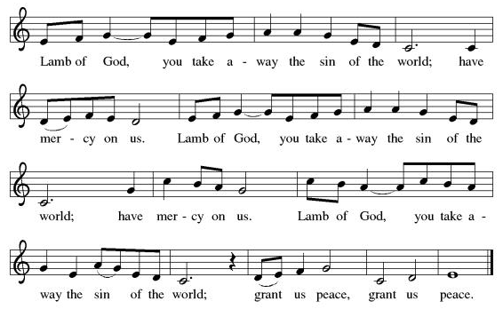

Spiritual Communion Prayer
P: Let us pray for the communion of all present here, those viewing our service virtually, those in our hearts and in our world.
C: Lord Jesus, I believe you are truly present in the Sacrament of Holy Communion. When I cannot receive Communion, I pray that you come into my heart. I know that nothing in Heaven or on earth can separate me from your love. Amen.

Invitation to Communion
P: Here is the Lamb of God who takes away the sin of the world!
Come to the table; taste and see.
C: Thanks be to God!

(All are invited to the communion rail following the guidance of the ushers. Communion will be shared through the host and individual cups. If you would like communion but are unable to join us at the rail, please alert the usher!)

Communion Hymns (Please join in singing!)
ELW 696 Jesus Calls Us; o’er the Tumult 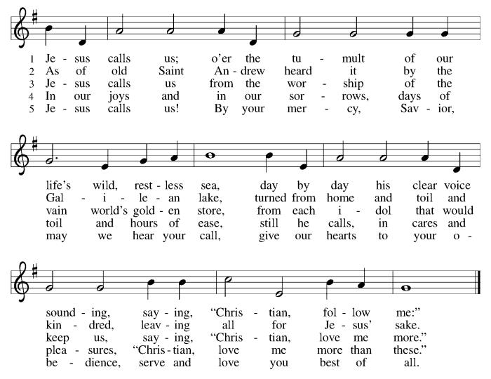

ELW 574 Here I Am, Lord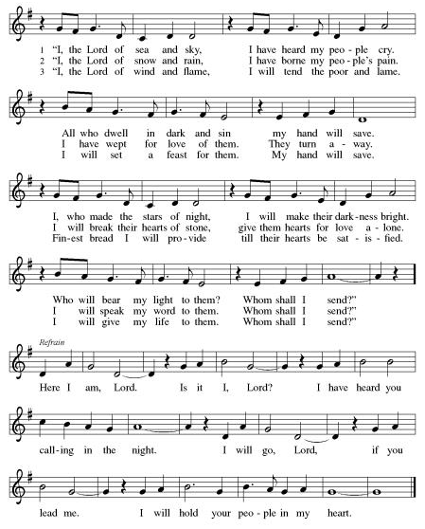

*Prayer after Communion
A: Radiant God,
we have seen your glory in the face of Jesus Christ.
In the sacrament of his body and blood
you have drawn us to your heart.
Send us from this table with delight,
that our lives may reflect the beauty of your love,
and bear witness to all we have seen and heard,
through Jesus Christ, our Savior and Lord. C: Amen.

+Sending+

*Blessing
P: May the triune God,
who has put a new song in your mouth
and tuned your heart for praise
☩ bless you now and forever. C: Amen!

*Sending Hymn ELW 414 Holy God, We Praise Your Name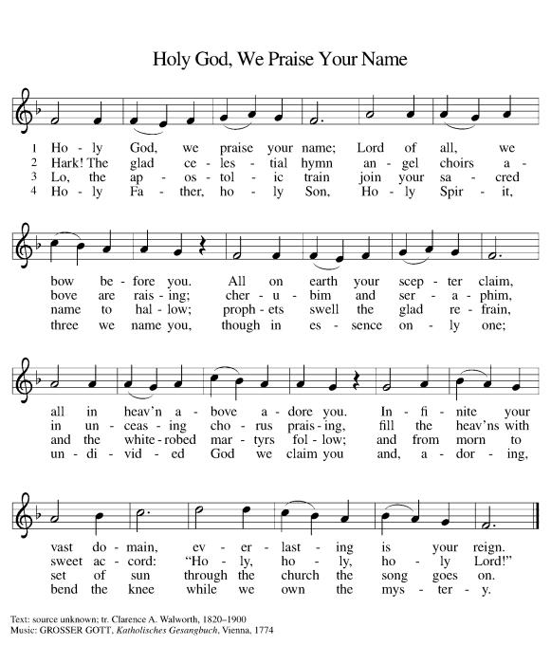

*Dismissal
A: Go in peace. Do justice. Love mercy.
C: Thanks be to God!

Postlude

Copyright © 2020 Augsburg Fortress. All rights reserved. Reprinted by permission under Augsburg Fortress Liturgies Annual License #SB106907. New Revised Standard Version Bible, Copyright © 1989, Division of Christian Education of the National Council of the Churches of Christ in the United States of America. Used by permission. All rights reserved. Revised Common Lectionary, Copyright © 1992 Consultation on Common Texts, admin Augsburg Fortress. Used by permission.

Treasurer’s Report
HTLC Financial Snapshot - December 2025
Category | Actual | Budget | +/- vs Budget | Status
December Income | $20,559 | $19,208 | $1,351 | On Track
December Expenses | $20,507 | $20,672 | -$165 | On Track
December Result | $53 | -$1,464 | $1,516 | On Track
YTD Income | $215,914 | $230,500 | -$14,586 | Attention
YTD Expense | $243,005 | $245,564 | -$2,559 | On Track
YTD Result | -$27,091 | -$15,064 | -$12,027 | Attention

While expense control was strong throughout the year,. income did not meet expectations, creating a larger deficit than planned. However, we are certain that the generosity andthe commitment of the people of Holy Trinity will make great things happen in 2026!
Thank you for supporting our ministry! Chris Foard, Treasurer

Worship Volunteer Schedule
Date | Asst. Min | Usher | Sacristan | Lector | Counter
February 1 | Linda Coleman | Kathy Caputo | Sherry Lee | Cynthia Kazmac | Carleo/Csernica
February 8 | Keith Bennett | Jill Socha | Carol Rosen | Molly Foard | McKenna/Kazmac
February 15 | Chris Foard | Dan Gillon | Helga Britton | Rosemary Lane | Foss/Coleman
February 22 | Elaine Bradford | The Gripps | Nancy Poole | Bill Spreen | Socha/Giordano

Coffee Hour- Casey Hochheiser

ANNOUNCEMENTS Thank you! To all who consistently support our church and ministries through your time, talent, and treasure. Please help us grow by inviting your friends and family to worship and events. You are what makes Holy Trinity a wonderful church family!

Stay in touch! Please visit our church website, www.htlcredbank.org for updates and information. You can also find us on Facebook and view services online. The office is open from 9am to 2pm, Monday to Thursday.

100 Anniversary Committee- If you are interested in being a part of the committee to help plan the 100th anniversary celebration of HTLC in 2028, please sign up in the red book. All are welcome! Also, the committee will be looking for photos and documents of HTLC throughout the years. If you have anything to share, please bring them to the church and marked envelopes or email electronic copies to the church office.

Name Tag Sundays: On the first Sunday of each month, names tags and markers will be at each entrance of the sanctuary. Please fill out a tag and wear one for worship and for coffee hour to welcome visitors and help newcomers put names to faces.

Sunday School in the New Year, we will continue to study stories and lessons from the Old Testament beginning with Jacob. Kids will love the crafts, songs and games that accompany each lesson.
The following dates there will be Sunday School:
Jan- 11 and 25, Feb- 8 and 22, March- 1, 15 and 29*Easter Egg Hunt!
April- 12 and 26, May- 3, 17 and 31, June- 7 and 14
As was done in the fall, there will be opportunities to volunteer as SS lead teacher. A signup will be emailed out shortly and will also be posted in the red binder. Consider signing up! All lesson materials will be supplied and laid out and a leader guide will be emailed to volunteers approximately 1 week in advance. Blessings for a wonderful 2026!~Lauren

Usher refresher session Feb. 15 Dan Grillon will lead an usher refresher session after worship service on Feb. 15. Please join the session if you are currently an usher, if you are interested in filling in, or if you are just curious. Anyone is welcome! Dan will go over usher duties and answer questions. Feel free to bring suggestions as well. Thanks to all who offer their time and talent to serve our church.

Pancake Sunday February 15th immediately following worship service. Donations benefit Camp Crossroads Daycamp.

Trivia Night!! Mark your calendars! Plan for a fun night at Holy Trinity on Feb. 28 at 5pm for great food and trivia. We have an International theme, so we ask you to bring a pot luck dinner item showing your ethnic heritage. There is a sign up sheet for your convenience.
You don't have to be another Ken Jennings---this is just for fun. See you then!

Our Easter Food Drive is Coming!
Again this year, WELCA is collecting requested foods for Lutheran Social Ministries of NJ to distribute in April. Food will be collected during February and March, and we hope to fill at least 35 grocery bags!. Watch for the labeled bins at the side door to the church and thanks for your help. We need the following food items:
  - Boxed potatoes- Rice - Pasta - Mac & Cheese
  - Canned Vegetables and Beans canned fruit or Pineapple or Apple Sauce
  - Small Olive or Canola Oil
  - Corn Bread/Muffin Mix - Carnation Milk Can
  - Cake Mix and Frosting or Brown Sugar

Choir The Holy Trinity Choir welcomes our singers back for a preparation rehearsal on Sunday, September 7th at 9am in the church hall. All are welcome to join us in song as often as you are able. Choir meets each Sunday at 9am to practice and prepare our music. Join us and help us grow by spreading the word about the HTLC Choir!

Quilting- The Quilters need gently used any bed sheets of any size! Please leave any donations in the quilters closet in Fellowship Hall. Thank you!

Quilters Need Help
If anyone is traveling through Mechanicsville, PA, and can add a few extra minutes to your trip, the warehouse for shipping quilts, school kits, etc is located directly off one of the exits.
We accumulate many quilts throughout the year and we would appreciate sending some quilts with you to deliver. Any questions, please call Sherry Lee or Elaine Theophall.

Weekly Quilting on Wednesdays at 9:30. Bring your lunch and enjoy some fellowship at noon. All are welcome. There will be no quilting on Wednesday September 24 due to the garage sale set up.

Evening Quilting Evening Quilting –
Please share this information . This is an important ministry that helps so many. It’s very easy and you don’t need to know how to sew. We have a great time socializing too! We will meet: Jan. 21, Feb. 18, March 18 at 6:00 PM. Note: If we have to cancel I will send an email. Please let me know only if you can come. Contacts: Pat Pienkos 732-513-9615 Debbie Yetka 908-461-4084 Looking forward to seeing you all!

Social Ministry
*Year-round collections will continue for food items for Lunch Break. There is a sign-up sheet in the red book for those who can help drop these items to Lunch Break.
*We will also collect adult men's socks to periodically drop at the Red Bank Warminq Center.
*For those interested in the Heartwarminq Center — the new women's shelter is adjacent to the First Baptist Church of Red Bank at 90 Maple Ave. You can follow up on this mission through their website - https://www.thefeastnj.org- On this site, they also include wish list items that can be purchased through amazon. We will be exploring purchasing some of these through a Thrivent card. If you want to purchase on your own, you can leave items at church, and the Social Ministry will deliver them.
Pastoral Care and Prayer... We are here to care for and pray! Please contact the office to add or adjust prayer requests. If you or someone you know needs pastoral care, please contact the office and Pastor Mack!

THANK YOU for supporting and sustaining our church and ministries! All are welcome here! Please invite your family and friends to worship with us! Find us online at www.htlcredbank.org

