This Week at PPBC
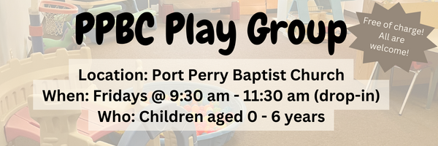




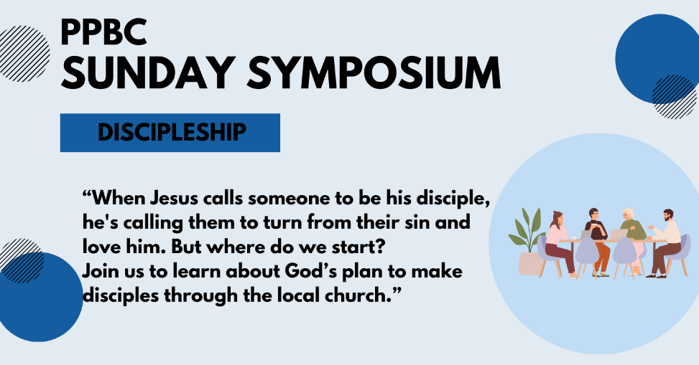

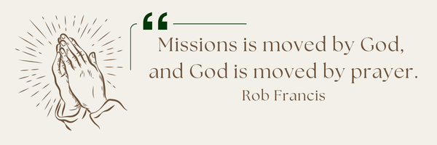
A Prayer Request from the Lambs. They are asking us to pray for wisdom and unity within the Ethnos organization. They have some significant leadership meetings together with our board in February that could really impact direction for our ministry and goals this year so appreciate your prayers for that!

Notes

Sunday Ministry Schedules
Below are ministry schedules for Nursery, Jr. Church, Greeters, Ushers, and Sound & Video:
Nursery
Feb 15: Brenda Clemens, Audrianna Angrove
Feb 22: Jen Werner,
Infant Nursery
Feb 15: Kathryn denOuden, Karis Henkelman
Feb 22: Laura Saunders,
Jr. Church; ages 3 to grade 1
Feb 15: Ellianne McLaren, Hailey Ferguson
Feb 22: Justine McKenzie, Kelsey Schoenrock
Jr. Church; Grades 2 to 6
Feb 15: Miriam Bolsonello, Graeme Anderson
Feb 22: Tracy Ballanger, Jen Owens
Greeters
Feb 15: Paul & Helen Jones
Feb 22: Leno & Donna Araujo
Ushers
Feb 15: Nick Woytowich, Matt Saunders
Feb 22: Roy Wilson, Mark McLaren
Sound & Video
Feb 15: Sound: Charlie Deane | Video: William Conley
Feb 22: Sound: Wyatt Werner | Video: Josh Bolsonello

Morning Service
Welcome
Song – God of Wonders
Song – Only a Holy God
Scripture
Prayer
Song – How Deep the Father’s Love for Us
Message – Pastor Jim Clemens
Song – When I Survey the Wondrous Cross
Song – It was Finished Upon that Cross


PPBC Members Meeting
Sunday, March 1, 2026
We will be meeting in the sanctuary. All are Welcome.
4:00pm – Meeting

Praise & Prayer Highlights
PRAY for Joan Mabley who has been moved to Glen Hill Strathaven in Bowmanville. Please PRAY for Joan’s comfort and peace.
PRAY for John & Joan Mank and their ongoing health concerns. PRAY for John who has some medical tests this week.
PRAY for Martin & Tina McCurley and their ongoing health concerns.
PRAY for Bert Faber and the family as the mourn Ada's passing. PRAY that God will give them great comfort in Christ and that the truth of the Gospel will shine through this loss.
PRAY for New Song Church & Port Perry Baptist as they plan to co-host a Christianity Explored outreach at That Place on Queen in the new year. Please PRAY for God to prepare the hearts of those who will attend from the community to receive the gospel.
PRAY for the community of Tumbler Ridge BC. PRAY for Pastor George Rowe and Tumbler Ridge Baptist Church as they care for their community.
PRAY for Brian and Janine Kovack. PRAY for Brian's ongoing healing and recovery.
PRAY for Dave and Susie’s nephew Martin and his heart condition. PRAY for the family and the doctors who are caring for them.

Giving
Just as a reminder, there are several ways you can give:
In Person using the offering box located on the back wall of the sanctuary. Donation envelopes are available at the Welcome Centre. Please contact the church office if you would like a box of donation envelopes (office@portperrybaptist.ca)
Through your online banking, you may send electronic transfers to ppbcdonations@gmail.com.
You can also give through Canada Helps. Donation receipts will be provided by Canada Helps, and transaction fees apply.
***********************************************************************
Weekly Newsletter
The PPBC Newsletter is emailed to the church family every Friday. If you would like to be added to the weekly email list, please contact the office by phone: 905-985-8681 or by email: office@portperrybaptist.ca.
*****************************************************************
Church Information:
Location:
2210 Hwy 7A
Port Perry, ON
L9L 1B4
Office Hours:
Monday: 8:30am – 4:00pm
Tuesday: 8:30am – 4:00pm
Wednesday: Closed
Thursday: 8:30am – 4:00pm
Friday: 8:30 am - 3:00 pm
Contact:
Phone: 905.985.8681
Email: office@portperrybaptist.ca
Website: www.portperrybaptist.ca
Staff:
Sr. Pastor – Rev. Jim Clemens
Administrative Assistant – Madeline Werner
Family Ministries Director – Josh Anderson
Pastoral Intern – Scott McKenzie

PPBC Newsletter
Sunday, February 15, 2026


Sunday Starting Point
Sunday, February 15, 2026 - 9:30 am
“Beginning the day with the Word and prayer”
Adults:
Adults will meet in the sanctuary for a time of study and prayer.
Youth:
Jr High (Grades 7-8) will meet in room 18 with Kate Anderson to study Ecclesiastes.
Children:
Children ages 3 - grade 6 will meet in room 26.
(Please note nursery is unavailable during Starting Point)
Sunday Morning Worship
Sunday, February 15, 2026 - 10:30 am
We are meeting in the sanctuary and will continue to live-stream for those who are unable to attend.
Message: Divisions Defused in The Cross
Scripture: 1 Corinthians 1:10-31
Pastor Jim Clemens

