The Exchange, Bolton 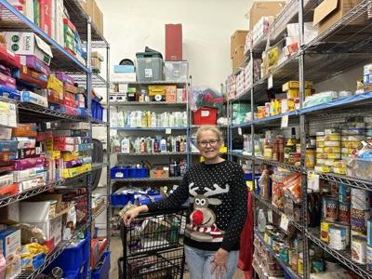
Caledon Community Service’s (CCS) Food Bank, the Exchange, is facing record demand, with visits up 18% from last year and 73% since before the pandemic. Between 2023/2024 and 2024/2025, visits rose by nearly 1,000, and volunteers recently distributed 2,900 pounds of food in a single day.
Board Member Catherine Jackson says the food bank has become a long-term support system rather than a temporary fix. She volunteers weekly and stresses that anyone can suddenly find themselves needing help.
Carol Good has contributed to CCS for over three decades. “Affordability is hitting everyone. She was shocked to learn that prices have increased by 20-25% in recent years—far outpacing wage growth and causing financial strain for many. Community support is essential.
To volunteer at the Exchange community members can visit them in person at 55 Healey Road in Bolton or visit their website with CCS: ccs4u.org/life/the-exchange.

