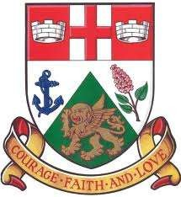
ST. MARK’S ANGLICAN CHURCH
BARRIEFIELD, KINGSTON
Founded 1843
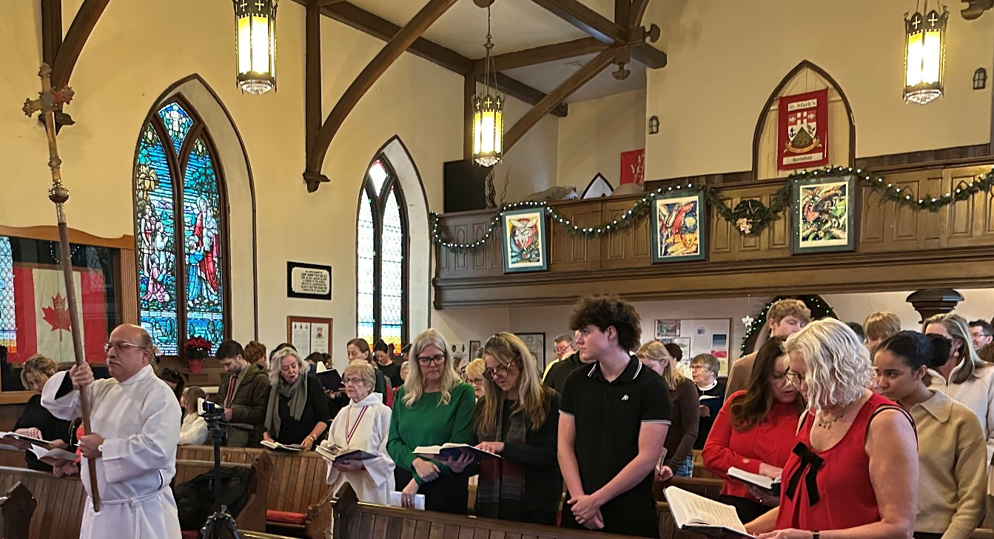
ANNUAL VESTRY MEETING
SUNDAY FEBRUARY 22, 2026

St. Mark’s Mission Statement
As followers of Jesus Christ, we at St. Mark’s are called to worship, grow in our faith, and serve the community with understanding and respect
while sharing the good news about Jesus.

RECTOR
The Reverend Sandra Hounsell-Drover

TABLE OF CONTENTS

Agenda Page: 4

Minutes of Annual Vestry Meeting held 25 February 2025 5

Rector’s Report 11

Worship Statistics 13
Wardens’ Report 14
Annual Financial Report & Auditor’s Statement :
The Annual Financial Report for 2025 and the proposed Budget for 2026 are provided as
separate reports. The Auditor’s statement will be provided separately.
Envelope Secretary’s Report 18
Lay Delegates to Synod 2025 Report 19
Property Report 20

Gas and sewage connections 23

Tower Restoration Report 25

Garden Club 29

Anglican Church Women (ACW) Report 30
Choir Report 33
Volunteers’ Report 34
Mission & Outreach Report 35
Alongside Hope 38
Fundraising Reports 39
Special Projects Group Report 42
Seniors Having Fun Report 43
Men’s Fellowship Report 45
Bible Study Report 46
Veterans’ Fellowship Report 47
Book Club Report 49
Martial Arts 51
Fun Fitness 52
Advertising 53
Nominations for Parish Council 2025 - Separate

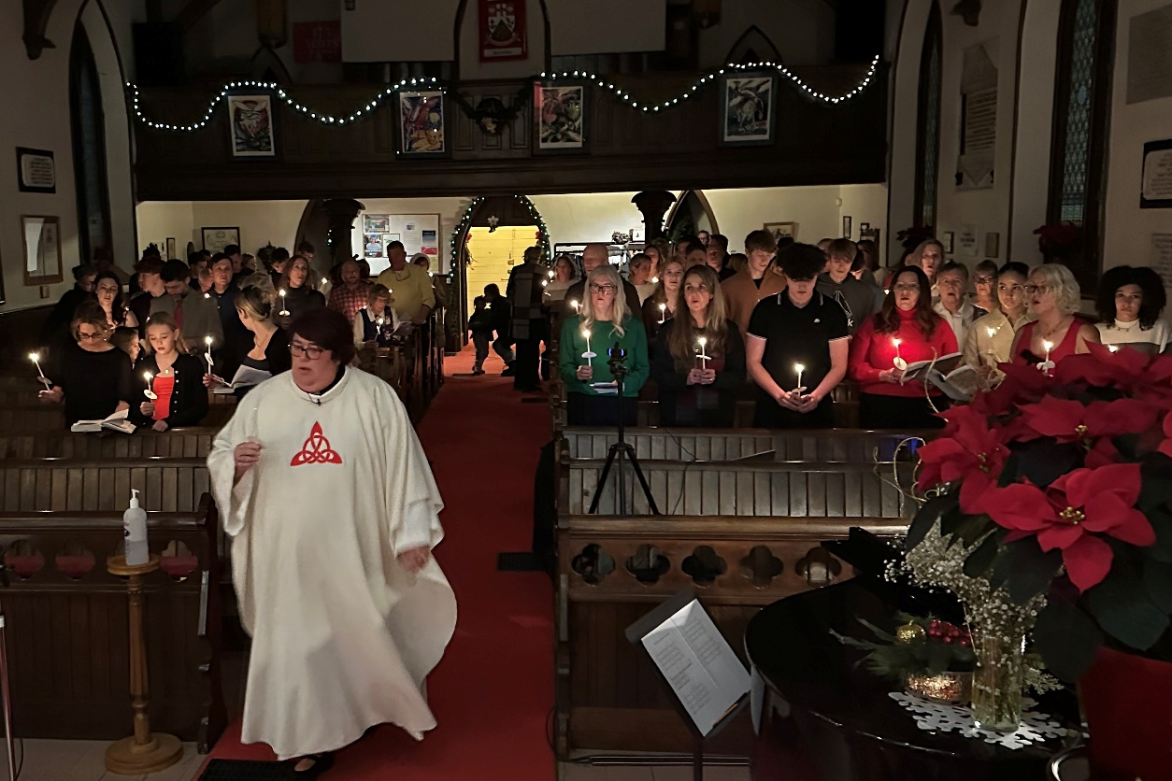

AGENDA

Annual Vestry Meeting
February 22, 2026
LOOKING BACK AT 2025

- Call to Order
- Opening Prayer
- Appointment of Vestry Clerk
- Warden Ted Davie to record those present.
- Approval of the Minutes of the Annual Meeting
held February 23, 2025
- Matters arising from the Minutes
- Motion to receive the reports on the year 2025.
- A picturesque look at 2025.
- Motion to accept the 2025 Reports.
- Annual Financial Report for 2025 - separate
- Motion to accept the Annual Financial Report for 2025.

LOOKING FORWARD TO 2026 AND BEYOND

- Proposed Budget for 2026 – separate
- A Motion to accept the 2026 Budget
- Election and Appointment of Parish Officers for 2026-separate

NEW BUSINESS
- Motion for the appointment of an Auditor for 2026
- Motions for donations to Anglican Foundation of Canada/ - Acknowledgements

MOTION TO ADJOURN THE ANNUAL VESTRY MEETING

Minutes of the Annual Vestry Meeting at
St. Mark’s Anglican Church-Barriefield
Sunday, 23 February 2025

Following the worship service, the community of St. Mark’s-Barriefield gathered before God at 11:45 a.m. in its church hall on February 23, 2024 (7th Sunday after Epiphany) for the 2025 Annual Vestry Meeting.

The meeting commenced at 11:55AM and was opened by Rev. Sandra Hounsell-Drover “in the Spirit of Prayer”.

Attendance:

Thirty-two (32) parishioners gathered in the church hall; eligible voters total was 32.

Appointment of Vestry Clerk

Rev. Sandra advised that Ann Yaxley was appointed Vestry Clerk for the 2025 meeting and an attendance sheet was circulated.

Approval of Agenda

BE IT RESOLVED THAT the Agenda be approved (as circulated).
Moved by Ted Davie and seconded by Anne Patterson. Carried

Approval of Minutes of Annual Vestry Meeting of February 25, 2024

Rev. Sandra asked for a motion to accept the Minutes of February 25, 2024.
BE IT RESOLVED THAT the Minutes of February 25th 2024 be accepted as presented. Moved by Dave Muralt and seconded by Anne Patterson. Carried

Matters arising from the Minutes - Nil

Motion to receive the Reports of 2024

Rev. Sandra asked if anyone had questions arising regarding receipt of the Annual Reports of 2024 previously circulated (excluding the Financial Report). A motion to receive the reports of 2024 was made.

BE IT RESOLVED THAT the Reports for the year 2024 be received as presented.
Moved by Ted Davie and seconded by Katherine Huffman. Carried
Alan Rumsey then provided a short “picturesque view of 2024” at St. Mark’s. Rev. Sandra extended congratulations for all that took place during 2024 and followed with thanks to Alan for the slide show.
After the slide show, the following motion was made:

BE IT RESOLVED THAT the Reports for the year 2024 be accepted as presented.
Moved by Anne Patterson and seconded by Heather Grimshaw. Carried

2024 Annual Financial Report:

Following through with the financial statements provided for all parishioners 10 days prior to the meeting, Rev. Sandra asked if there were any errors or omissions. Nil.

Alan Rumsey stated that:
- St. Mark’s received less than expected in 2024. Financially we have good control of our expenses, but our income is unpredictable.
- Investments have dropped over the past decade but in 2024 we ended up with a slight uptick.
- On page 10 of the Financial Report, the green line shows income since 2022 (roughly $250,000.00) while the red dotted line shows what we need to raise.
- For the maintenance phase, it’s time to check out funding from municipal, provincial and federal sources.
- Other than the tower concerns, we are doing very well financially.

Rev. Sandra asked if there were any questions about the Financial Report. Nil.

Motion to Accept Annual Financial Report of 2024

BE IT RESOLVED THAT the Financial Report for 2024 be accepted as presented.
Moved by Susan Stevenson and seconded by Andrea Muralt. Carried

Rev. Sandra made special thanks to Alan Rumsey for his tireless work as Financial Advisor and his patience and positivity throughout 2024.

LOOKING FORWARD TO 2025 AND BEYOND

Proposed Budget for 2025:

- Alan Rumsey presented the proposed budget for 2025, analyzing categories under Operating Income and Expenses, and the Building Account, its comparisons and analysis, mentioning that the 2025 budget is similar to 2024.
- Alan Rumsey stated that there will be a new income source in 2025: the St. Mark’s Martial Arts Program. We are looking to receive roughly $10K in 2025.
- Alan stated that profits from all fundraising events in the past have gone into the Tower Restoration Fund. It will be the same for 2025, except for the Newfoundland Cold Plate Supper which will go into the General Account.
- In response to a question about the annual CMM payments, Alan said that in 2025, St. Mark’s Church will pay only what the Diocese invoices us for. Rev. Sandra explained that all churches in our Diocese of Ontario are having the same problem with the “green sheets”.
- Alison Smith volunteered to review St. Mark’s investment accounts. Permission granted.

Motion to accept the 2025 Budget:

BE IT RESOLVED THAT Vestry Council agrees and accepts the 2025 Operating Budget, together with its recommendations, as presented by Alan Rumsey.
Moved by Dave Muralt and seconded by Alison Smith. Carried

Election and Appointment of Parish Officers for 2025

Rev. Sandra announced the following positions for 2025:

Rector’s Warden: Edward (Ted) Davie
People’s Warden: Heather Grimshaw
Deputy Warden: Susan Stevenson
Financial Officer: Alan Rumsey
Envelope Secretary: Susan Evans
Vestry Council Clerk: Ann Yaxley
Parish Council Clerk: Ann Yaxley
Lay Delegates to Synod: Heather Grimshaw and Lou Grimshaw
Alternate Lay Delegates: Edward (Ted) Davie, Sheila Kiruluta
Auditor: ___________ (see New Business)

Parish Council for 2025:

Rev. Sandra stated that the following members have all agreed to serve:
Choir Representative: Jeannette Calmettes
Property/Maintenance: Dave Muralt
ACW Chair: Katherine Huffman
Altar Guild: Andrea Muralt
Mission & Outreach Chair: Ann Yaxley
Members at large: Sheila Kiruluta, Anne Patterson, Ross Evans,
Mercedes Cobham, Paul Yaxley and Brad Smith.
Ex-officio members: Rev. Sandra and Melody Massey.

BE IT RESOLVED THAT Parish Council adopts the Appointments and Nominations as presented.
Moved by Pierre duPrey and seconded by Elaine Bryan. Carried

NEW BUSINESS

- Gifts and Talents Survey (as a result of the Parish Visioning Report)

Alan Rumsey presented an overhead of the results of the survey with
Rev. John Hounsell-Drover providing details.

b) Parish Council Highlights

Rev. Sandra suggested that we might have highlights of PC meetings printed in bullet points in the Friday newsletter produced by Alan Rumsey. (No decision made.) c)

Auditor for 2025

Rev. Sandra advised that the Canons of the Diocese of Ontario require the financial statements of the parish to be audited at the end of each year. Our bookkeeper prepares the financial statements and in the past Alan Rumsey, our Financial Officer, did the audit review.

A motion was presented to appoint Alison Smith as an independent auditor of St. Mark’s books for 2025.
The motion was moved by Ted Davie and seconded by Pierre duPrey. Carried

d) Donations to the Anglican Foundation of Canada and the Diocesan Foundation:

- Anne Patterson read a letter from the Diocese of Ontario Foundation (DOF) stating that it would be folding their Foundation into the Anglican Foundation of Canada (AFC). The consensus of the DOF’s Board of Directors was to give $25,000.00 to the Diocese of Ontario Refugee Support (DOORS) with the remainder being sent to the AFC.

BE IT RESOLVED THAT Vestry Council approved the amount of One hundred Dollars ($100.00) to be donated to the Anglican Foundation of Canada.
Moved by Anne Patterson and seconded by Alan Rumsey. Carried

e) Thank You:

Rev. Sandra thanked the following for their involvement at St. Mark’s in 2024:

- Melody Massey as Office Administrator and also Music Director.
- Andrea (Andi) Muralt as she retires as Warden after 6 years.

Rev. Sandra also thanked all those who have accepted to serve St. Mark’s for 2025.

Adjournment

There being no further business, Rev. Sandra requested a motion to adjourn the Annual Vestry Meeting.
BE IT RESOLVED THAT the Annual Vestry Meeting held on February 23, 2025 (for the year 2024) be adjourned.
Moved by Lou Grimshaw. Unanimous agreement. Carried

Faithfully submitted by
Ann Yaxley
Vestry Clerk

PARISH COUNCIL RETREAT 2025

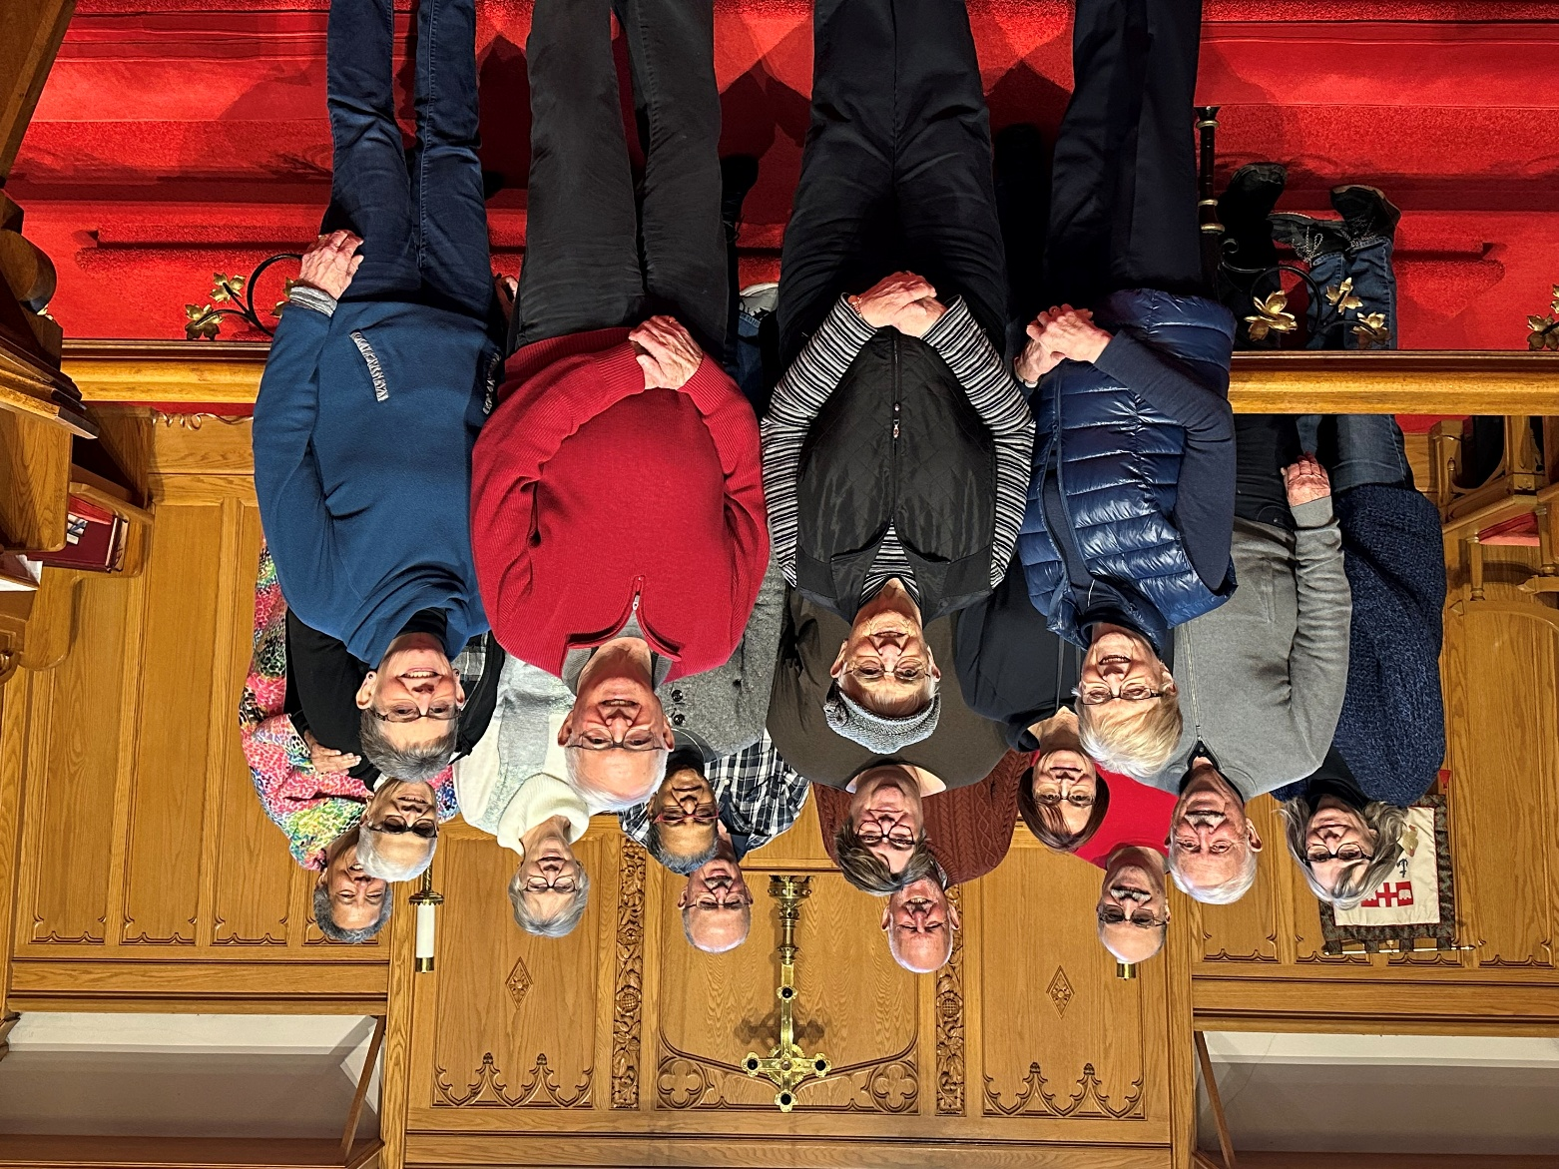

Missing from picture: Jeannette Calmettes; Brad Smith

Rector’s Report for 2025

“Discernment is the ability to know where your heart is being led,
and whether that direction is of God.”
Henri Nouwen, Discernment: Reading the Signs of Daily Life
Each year, as I prepare this report, I begin with a prayerful search for words that reflect both the spirit of our parish and the movement of God among us. This year, Henri Nouwen’s reflection on discernment captured my heart. From where I stand as your Incumbent, 2025 has truly been a year shaped by listening, learning, and faithful discernment.
Throughout this Annual Vestry Meeting booklet, you will find rich and detailed ministry reports that speak beautifully for themselves. Rather than repeating what others have already shared, I would like to highlight a few areas of ministry that fall primarily under my responsibility.

One such area is the leadership and coordination of Council and the Annual Vestry Meeting. In March 2025, I gathered Council for a day of retreat and conversation. Together we explored a new model of Council structure and ministry reporting, including a clearer organizational framework for how ministries communicate with one another and with Council. As with any meaningful change, this process involved learning curves and growing pains. Through prayerful observation and listening, I have come to understand that further clarification and direct communication will continue to strengthen this work. It is very much a living process — one that will keep evolving as we grow.

Another responsibility entrusted to me is the Rector’s Discretionary Fund. This fund exists to provide immediate and compassionate assistance to those in financial need. While we budget $500 annually for this purpose, in 2025 nearly $2,000 was distributed to individuals facing hardship. At times, I quietly covered additional costs myself. I share this not for recognition, but to bear witness to the real and increasing needs within our wider community. Many people are struggling with food insecurity, housing instability, limited access to medical care, and underemployment. For some, reaching out to the church is their last hope. I am deeply grateful for your generosity and invite anyone who is able to consider contributing to this fund throughout the year so that we may continue to respond with compassion and dignity.
One of the great joys of 2025 was the formation of a Discernment Committee to accompany Dave Muralt in exploring his call to the diaconate. Along with Sheila Kiruluta, Ann Yaxley, and Ted Davie, I had the privilege of walking with Dave through a season of reflection, learning, and prayer. This journey was deeply meaningful for all involved. In November, the committee concluded its formal work by recommending Dave for ordination to the diaconate in the service of our church and diocese. We continue to hold him in our prayers with gratitude and hope.

Liturgy and preaching remain among the most life-giving aspects of my ministry, and 2025 was a wonderfully rich liturgical year. We were blessed with bi-weekly services at Normandy Retirement Home and monthly Evening Prayer in the tradition of the Book of Common Prayer. During Lent, we gathered weekly using prayer resources from across the Anglican Communion. Holy Week was a particular highlight, marked by an Agape meal and Maundy Thursday liturgy, a moving Good Friday service, and a joyful celebration of the Resurrection on Easter Day. From our summer picnic Sunday to Harvest Thanksgiving, and from Advent’s quiet longing to the radiant joy of Christmas, our worship life was vibrant and full. None of this would be possible without the many people who read, prayed, preached, presided, decorated, sang, played music, welcomed others, and supported our worship with love and care.

As we enter 2026, I do so with deep trust in the Holy Spirit’s guidance. I remain in a season of discernment — both personally and with you — about how God is calling us to live and serve as a faith family in this time and place.

I close with heartfelt gratitude: to our Wardens — Ted, Heather, and Susan — for their leadership and steadfast support; to Council for their faithful commitment to the mission and ministry of St. Mark’s; to Alan for his tireless work in all things electronic and financial; to Josie for the gentle wisdom she brings to pastoral care; to the ACW for their constant readiness to serve; to the Choir and Melody’s music ministry; to our lay ministers Heather, Jeanette, Ted, Dave, Mary Lou, and Ann; to Dave Muralt, the Rev’d Bill Morrow, John Barron, Alan Rumsey, and the Rev’d Canon (Cdr.) John Hounsell-Drover for their support and collegiality; to Melody for the grace, competence, and compassion she brings to the parish office; and finally to John, William, and Peter — whose love and resilience make my ministry possible.

Blessings on a faith-filled year ahead.

Your faithful servant,

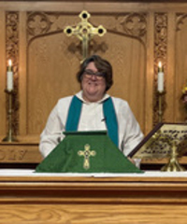
Rev. Sandra Hounsell-Drover
Incumbent
St. Mark’s, Barriefield

WORSHIP STATISTICS REPORT

2025

Average Attendance

8:30 a.m. in person - 7

10:30 a.m. in person only – 40

Hybrid - when in person worship was offered, we averaged 3 people online.

Christmas

4:00 p.m. – 90+ people; 6 people online
9:00 p.m. – 60 people in person
Christmas Day, 10:00 a.m. - 9

Easter Day

8:30 – 5 people in person

10:30 – 80 people in person; 3 people online

Funerals & Internments – 3 (please note this number does not include the funerals of others connected to St. Mark’s who either did not have a funeral/Memorial or their funeral/memorial was held in a different place.)

Weddings – 0

Baptisms- 1

WARDENS’ REPORT

2025, we are happy to report, was once more a very busy and successful year for our Parish. We made improvements in several areas particularly through the support of various committees and parishioners, as we will mention herein.

We also mention those parishioners who are no longer with us but are not forgotten: John Beveridge, Ronald Tracey, Maurice Smith, Shirley Gowdy Anne Peake and Sylvia Davies.

The Wardens recognize the strong leadership and dedication of our Rector, The Rev Sandra Hounsell-Drover, and we thank her for her guidance, enthusiasm, energy and warm personality that never wanes. We also appreciate the assistance of Sandra’s husband John, Cdr The Rev Canon John Hounsell-Drover, who attends St. Mark’s when he is able and provides clerical leadership and religion instruction when needed. For occasional musical celebrations or emphasis with hymns we thank William and Peter Hounsell-Drover who have willingly supported the choir and parish with their musical talent and instruments.

Our thanks and appreciation are particularly recognized towards Melody Massey, our Parish Administration Assistant, for her unwavering dedication to the position, her knowledge and experience in the job, and the “extra mile” she puts in daily to cover those last-minute requests or requirements. So much is accomplished without us even knowing! In addition, we extend grateful thanks to Melody for the additional “hat she wears” as Organist and Choir Director for St. Mark’s. Melody is an accomplished musician, and our choir members benefit from the variety of music they try to learn at choir practices. We thank you Melody for all the time and talent you provide!

We are fortunate to have Carlos Silva who attends to the cleaning of our church and hall. Enormous thanks are extended to Carlos as he quietly goes about his routine, generally on a Sunday afternoon, and has both buildings ready for the coming week. We are all grateful for this ministry from Carlos. This year, we learned that Carlos was taking our weekly garbage and recycling home to dispose, often requiring him to buy garbage tags because of the volume. Not part of his contract. Effective immediately, we began looking after our own garbage using the free curbside City service. All we need to do is take the garbage, and recycle material, down the driveway to Main Street, every Monday evening. We have asked for volunteers to “do” garbage weekly for a month, several times. We have three families who have volunteered but would like at least three more. For details of what a volunteer is required to do, please contact Ted Davie or to volunteer speak to Melody.

Throughout the past year we have again been indebted to the advice and expertise of our Financial Officer, Alan Rumsey. St. Mark’s is very fortunate to have Alan’s financial knowledge and background together with his time (and graphs!). Alan provides monthly details of St. Mark’s financial status in advance of the upcoming PC meetings, and he is always available and willing to answer any questions we may have. We acknowledge Alison Lines and Anne Patterson for their assistance with bank deposits, and Brenda Hoekstra with thanks for her accounting and timely cheque preparations. Tax Receipts for regular offerings, special gifts, donations etc are prepared annually by Susan Evans, our Envelope Secretary, completely confidential for each donor, and we appreciate this ministry of record keeping by Susan. Thank you, Susan!

For fear of not recognizing a parishioner or committee member as we mentally go through the many committees/organizers/volunteers at St. Mark’s, please know that your Wardens are very aware of your commitment and contribution towards all fundraising events, including the ongoing advertising (Thanks Ann Y!) In addition, we thank all those who contribute to our weekly services whether it be Altar Guild, Servers, Readers, Intercessors, Choir or more. Not forgetting the Fellowship Group, Bible Studies, Book Club, Outreach and Pastoral Care teams.

Routine upkeep and small improvements for our Church and Hall need to be addressed regularly. These jobs occur frequently and usually go unnoticed by most Parishioners. We give special thanks to Dave Muralt who dealt with all the problems assigned, big and small, looking for the least expensive solutions. Still working, Dave Dave was asked to resolve this year in his Property report.

The Parish Council has 14 members and held 8 meetings in 2025, plus a Parish Retreat to reorganize responsibilities among seven members for new monthly ministry reports. The annual retreat after the AVM helps new Council members connect, pray, share a meal, and plan the way ahead. In December, a special meeting finalized the 2026 event calendar.

Last year we formed a small Garden Club. There is a Garden report telling what this small group has accomplished with little Parish financial support. Two members of our Seniors Having Fun group, non-parishioners, were active members. We want to recognize Sheila Kiruluta for her dedication and hard work, and especially for her hours of watering during the hot, dry summer months keeping our plants alive. Thanks to those who donated bulbs for our expanded bulb garden and for the trees and plants donated.

There is also a separate report on our Martial Arts ministry, but we wanted to add a special thank you to Pete Rogers who suggested the ministry and donates all his time and talents along with all his instructors. All the revenue from the program comes to St. Mark’s. Everyone is disappointed with the small number presently enrolled but, be assured, the quality of the program and its low cost compared to other MA programs will eventually attract more. A local Facebook ad with video is being prepared which may help. It has good potential and we are planning a special MA program for the Spring school break.

At our June PC meeting, a presentation recommended we build a Parish shed as part of our strategy to resolve our general storage problems in the Hall. Several people researched pre-built sheds that were affordable, sturdy, and maintenance-free, but found none that met our requirements. PC approved that a team of parishioners build an 8’ x 10’ shed over the summer, managed by Ted Davie, with $2,500 approved for the project. After sourcing plans and materials, construction began on July 7. A timely $500 donation and a great sale of metal siding helped to fund high-grade, maintenance-free sheeting for the sides and roof. The shed was finished by late August at a cost of $3,125. Special thanks Ted Davie, John Ferguson, Dave Muralt and Mel Douglas who contributed their time, tools, and talent. See the Shed report for more details. Currently, only the BBQ is in the shed. Stage 2, clearing the storage room by the main entrance, was delayed due to a busy Fall. Primarily, this space will be reserved for office needs, and after it’s organized, we’ll determine what additional items can be kept there. The main source of clutter in that room is several large tables stacked on top of an old metal desk. These tables will be used to help organize the shed, but they need to be moved before anything else can be added. In the Spring, we plan to clear out this storage room, assess what should be kept or discarded, and decide what items can be stored in the shed. With the other small storage room under the clock, we anticipate meeting all stakeholders’ needs while keeping clutter out of sight in the Hall. Please be assured that all stakeholders will be consulted when decisions are required.

This Fall we tried to form a partnership with Lionhearts hoping to address some of the social problems in our surrounding community. However, with all the necessary privacy and confidentiality laws, we were unable to identify specific people to help. Other ideas may develop. Lionhearts have Fresh Food Pop-up Markets around the City on a regular basis providing quality fresh fruit/vegetables, home made soup and other deals at reduced prices. We hope to host a couple market days at St. Mark’s in 2026. Lionhearts is also working on a plan to provide pre-packaged meals for Seniors and shut-ins at a very low price. To receive the service in our area will require volunteers to coordinate the orders, place the orders with Lionhearts, collect and distribute the meals to the customers. If this service is offered, we would need the volunteers. We’ll have to see whether we have the necessary resources to participate if/when the program starts.

Our present financial situation is concerning to us, particularly given the potential for unforeseen expenses related to our Tower. Maintaining a yearly deficit of $50,000 will eventually exhaust our investments unless we implement corrective measures. What alternatives are available to us? We need to increase income and reduce expenses, but none of our attempts to date has lowered our deficit. Our investments have dropped to half a million dollars, below the target for covering the deficit with interest earned. Please review Alan’s Financial report for a breakdown of expenses and income by category and pay attention to the category percentages for context.

Weekly givings make up 78% of our income. Using Pre-authorized Giving (PAG) and considering Planned Giving are encouraged. While fundraising events show growth, last year’s cancelled Fall Spaghetti Supper highlighted volunteer fatigue and reminded us that we need to balance event frequency with congregational well-being. To improve profits, perhaps we should consider expanding ‘take out’ options at some fundraisers. Hall rentals remain restricted by kitchen limitations.

There may be options to reduce expenses; however, this would require assuming certain tasks currently outsourced. Payroll accounts for 51% of our expenditures and includes compensation for our Priest, Administrative Assistant, Organist, and Bookkeeper—with most salaries controlled by the Diocese. Accordingly, there is limited opportunity for cost reduction in this area unless staff positions are eliminated. Community service comprises 23% of our expenditures, primarily through our Common Ministry and Mission (CMM), which constitutes 80% of this category and is determined by the Diocese based on our annual income. A decrease here is not desirable. Weekly service-related expenses are minimal at 5% and are already closely monitored. General maintenance of buildings and property represents 21% of total expenses. Within this category, heating oil accounts for 43%, insurance for 18%, and grounds maintenance such as grass cutting and snow removal for approximately 20%. To address heating costs, gas services are being installed, but this will necessitate replacing church furnaces and the Hall boiler—requiring an initial investment of at least $50,000 before realizing any savings. Insurance premiums are arranged collectively by the Diocese for all churches, and any other options are more expensive. However, premiums are calculated based on replacement costs and for St. Mark’s that means identical size, design, and construction of what we have now, which is not a likely scenario, but we are required to pay for it. Given these constraints, we must consider our next steps carefully. So, we ask, are there steps we should take that might improve our longevity? Any suggestions would be gratefully received.

We sincerely appreciate the congregation's generous financial support in response to our many requests throughout 2025, always giving beyond our expectations. The Wardens are aware and grateful for all your donations and gifts. Our prayerful thanks to everyone.

Prepared by Ted Davie and Heather Grimshaw
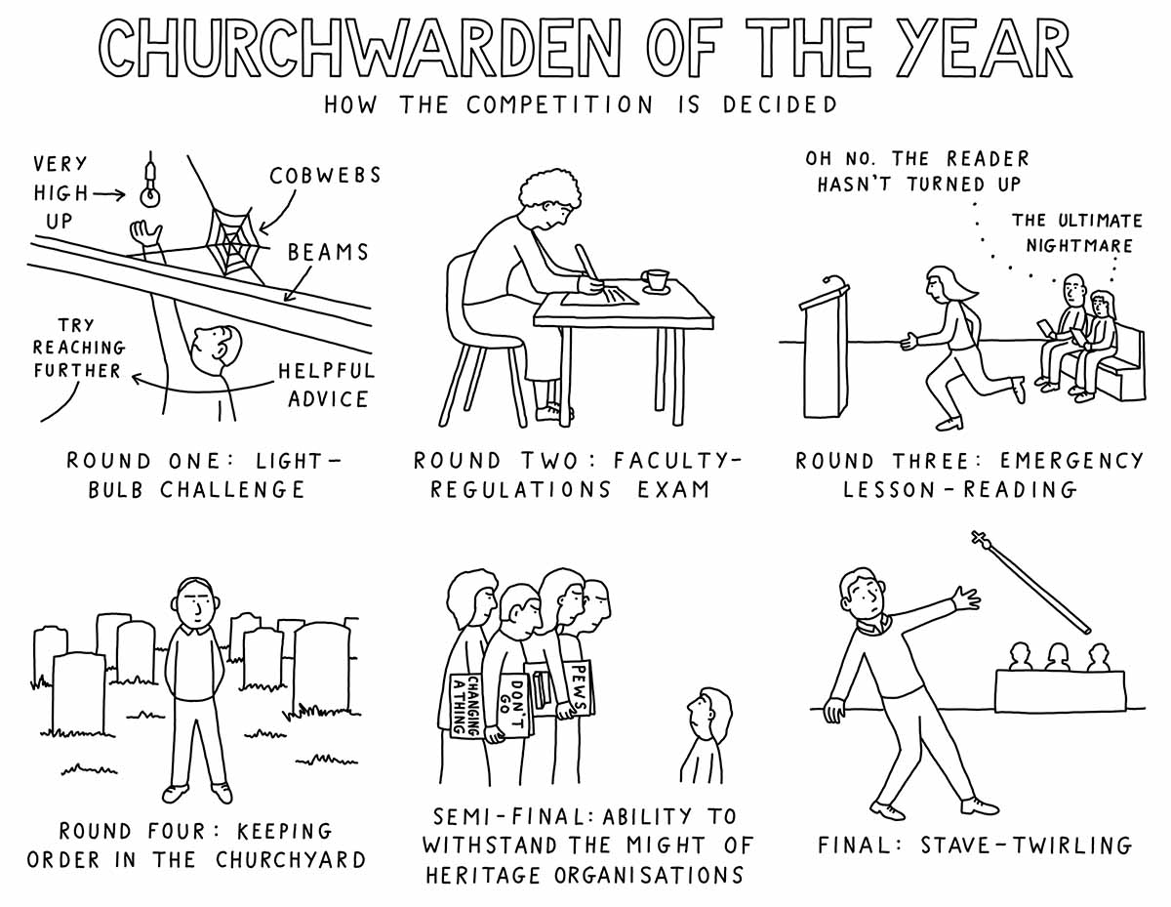

REPORT OF ENVELOPE SECRETARY FOR 2025

Total number of parish families using offering envelopes in 2024: 33
Total number of parish families using PAG in 2024: 35
Total number of donors through Tithe.ly: 27

Financial support to St. Mark’s in 2025 was provided mainly by current members, past members and visitors through offerings and donations, memorials, flower memorials, mission and outreach, building donations and other contributions and for which receipts were issued. In 2025, many parishioners and community members donated to our Tower Restoration Fund, which was greatly appreciated. Support to St. Mark’s is offered by the use of the Pre Authorized Giving (PAG), parish offering envelopes or online via the St. Mark’s website (Tithe.ly). A few parishioners also use Canada Helps.

The use of PRE Authorized Giving (PAG) through your bank/Visa/Master Card is encouraged and can begin any month of the calendar year which can also be changed, modified or cancelled at any time by informing the Envelope Secretary by the 15th of any month. This method is helpful to our financial team to better manage our finances and expectations. PAG contributors can also donate to special appeals or make extra donations at any time by enclosing their donation in an envelope with their name and/or PAG number on it. Annual tax receipts are provided for the use of envelopes and/or PAG as well as for online donations through the website. Open cash offerings placed on the offering plate are welcome, but will only be receipted if a contact name and address or email are provided on the envelope.

In 2025 we continued using the Tithe.ly program to record all donations. The donations from all sources were entered weekly, and in January the website generated tax receipts. This year, the tax receipts were emailed to anyone for whom we have an email address . The rest were printed and sent through Canada Post. There were some parishioners who requested a printed copy and those copies were provided. Although we continue to have some growing pains with the new system, it worked very well. I would like to express my thanks to Alan Rumsey for his ongoing support over the past two years as we implemented and used the new program. For further assistance on making online donations through St. Mark’s website, please feel free to speak to our Financial Advisor, Alan Rumsey. It is worthwhile to note that donations received for the benefit of St. Mark’s through Canada Helps are receipted directly through Canada Helps and not from St. Mark’s.

Please contact the Envelope Secretary if you require any information regarding your support to St. Mark’s (which is completely confidential). An application form can be provided to begin using PAG at any month. Envelope boxes for 2026 are available from the office.

Respectfully submitted,
Susan Evans,
Envelope Secretary
LAY DELEGATES’ SYNOD REPORT

Louis Grimshaw and Heather Grimshaw, duly elected Lay Delegates to Diocesan Synod (2025 to 2027) attended the 148th Synod of the Anglican Diocese of Ontario on May 8th to 10th, 2025. The Synod Theme was “Communities of hope, disruptive grace”. The key to Synod is the Bishop’s Charge, issued during the Synod opening service held at St. George’s Cathedral. Bishop Cliff charged Synod to address the following three matters:

- The mission of being communities of hope
- The formation of hopeful leaders who inspire joy
- A transformation in the business of being church

The delegates were tasked to respond to the Bishop’s Charge through 3 questions:

- What needs to be disrupted in my own spiritual life?
- What needs to be disrupted in our parish?
- What needs to be disrupted in our surrounding community?

To aid in our work the following were key speakers: The Rt Rev Rosemary Mallet, Bishop of Croydon, England; The Rev. Scott Gunn, Executive Director of the Forward Movement; and Ms. Kaleena Hanoski from the Parish of Tyendinaga, Ont. All delegates were assigned to various workshops. As well the business of Synod was conducted during the two days.

From this Synod Bishop Cliff has enabled a task force to determine actions moving forward with his Charge. In our Diocese each parish has been asked to take on the study of the book To Love and Serve: Anglican Beliefs and Practices, by Scott Gunn. St. Mark’s has accepted to begin the study during Lent 2026.

Respectfully submitted,
Louis and Heather Grimshaw

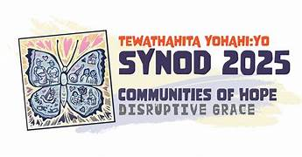
PROPERTY REPORT

Introduction

2025 was a busy year on the property front, with a number of small projects completed. We have continued the “self help” approach: conducting repairs using our own labour as much as is possible and safe to do. The table below lists the work that has been carried out since the last Annual Vestry Meeting.

Besides the condition of the tower, there are three on-going areas of concern that will likely require attention going forward. These include:

- The condition of the Church roof;
- The condition of the Church’s electrical wiring, heating system and appliances; and
- Pest control.

Church Roof

The Church roof is large and the location of the Church means that it receives the most wind of any Church in the city. There were repairs necessary following wind damage this year and we will eventually need to have the roof replaced. My intention, if I am still the Property Member at the time, would be to have the shingles replaced with steel roofing.

Church Wiring and Electrical

The wiring within the Church is a veritable museum of the electrician’s art over the decades. There are several different generations of wiring, with very few electrical sockets available in the building. Replacing a switch in the Vestry eventually required the assistance of an industrial electrician to make a new switch work with wiring technology that predates it by several generations.

The ceiling fans will soon both need to be replaced. The fan in the rear of nave, closest the entrance, is squeaking to the point that it cannot be used and the shroud on the fan in the front of the nave has come unfastened and slid down the rod that connects the fan to the ceiling, but still works. This fan will be run to the point of failure. When it eventually fails, we will then have to have a contractor come in with a lift and replace both fans.

Once the natural gas installation is complete, we can then start the process of replacing the heating-oil fired furnaces with much more economical and environmentally sound natural gas furnaces.

Pest Control

The health and safety of the congregation require ongoing efforts at pest control. We have problems with ants in the Hall, particularly in the spring, and with mice in both the Church and the Hall year-round. The ants are been dealt with using ant traps as we have in the past, changed every Spring and Fall, as well as the deployment of diatomaceous earth barriers by the back door and kitchen door of the Hall. Regarding the mice, we have had success with the newer-generation disposable bait stations. The baits deployed in the Spring had much more uptake than the baits deployed this past Fall, so we are ahead of the game for the moment, but the baiting program will need to be continued indefinitely or at least until such time as field mice go extinct.

PROPERTY REPAIRS AND ACTIVTIES

- The grass-cutting schedule with Sharpe was changed to bi-weekly vice weekly, resulting in savings with no complaints about the conditions of the lawns.

- A steel garbage can was purchased a and a cart was donated to get it down to the curb for garbage day.

- The shingles on the roof of the church were repaired.

- The furnaces in the Church and the boiler in the Hall were both inspected by McDougall Energy and all are serviceable.

- Our alarms continued to be accidentally or inexplicably triggered, which is not unusual in a setting such as a Church and Hall

- All of the controllers for the fans in both the Church and the Hall have been replaced.

- My electrical talents having been exhausted in attempting to repair the lighting in the Vestry, Jonathan Smith, a professional industrial electrician, assisted the congregation by effecting the necessary repairs.

- Thanks to Ted, John Ferguson and Mel Douglas for all of their stellar work on the storage shed.

- A wireless doorbell and peep hole were installed in the front door of the Church.

- Between last Summer and this January, three repairs have been made to the Church door, resulting in a wholesale securing hardware replacement. An additional repair will be required when the weather warms up, as the door will need to be kept open while a piece of damaged wood is cut out and replaced.
- The faucets in the Hall washrooms have been replaced. One was leaking badly and it was decided to replace both of them as they appeared to be original to the building.

- The clearing of the snow from the Church and Hall steps and entrances was taken on by a new contractor who was willing to do the job for nearly 2/3 less than our previous contractor ($500 for the year), as long as he was provided with a new snow shovel.

- The supply of Enviro-Safe ice melter has been replenished in both the Church and the Hall for the Winter.

Respectfully submitted
Dave Muralt

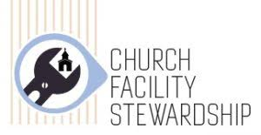

GAS AND SEWAGE INSTALLATION PROJECT

In 2024, the Barriefield Highlands housing development next to the Parish Hall was underway and we were able to seize the opportunity to have both gas and sewage services extended to our property. A special Parish meeting was held where the idea of connecting these services was presented and approved. Fifty thousand dollars was approved to make it happen. The awareness of our aging Hall septic system, the increasing costs of heating with fuel oil plus the sudden proximity of City services from the new development helped make this decision. The necessary arrangements were made with the City to extend gas/sewer services to our property from the development next door.

A contract was signed with City Flats to have them extend a sewer line from their nearest sewer connection to our property line. Fortunately, in the layout of the development a small access area was left between the two adjoining lots near the Bell building for easy access for people from the development to the church property. This also allows gas/sewer lines to pass from the development to our property without an easement. The septic line to our property line was completed in 2024 at a cost of $26,349. Unfortunately, the sewer line was covered over without advising us but I have been assured it is a few centimeters from our property line.

Once the gas line has been installed, we will need to hire a contractor to dig the sewer pipe trench from our property line to the sewer hookup at the Hall. The City has specific requirements for “decommissioning a septic system”: we are required to pump the septic tank empty and remove or destroy the septic tank in place. As Rev Sandra and Melody work in the Hall, we need to make a quick changeover from old system to new as we need to provide toilet service. The sewer hookup will take place after the gas line installation has been completed. The gas installation was supposed to be much easier.

Enbridge is responsible for gas services in this area of Kingston. They were contacted shortly after we dealt with the City and they have been planning the installation since. The Enbridge installation centre for installations from Cornwall to Belleville is in Cornwall. We have had several on-site meetings since June, 2025. They have been aware of the Bell infrastructure on our property since the first meeting as well as the location of our septic bed.

In November they finalized their installation plan. They started at the west end of the Hall near the entrance where they installed the gas meter station. From there they installed the line between the edge of the septic bed and the driveway to the end of the bed near the big tree then turned and headed for the narrow gap in front of the Bell building. To get to the property line meant intersecting the Bell underground pipes twice and Enbridge still did not have the details of the underground infrastructure from Bell which they required to proceed. They still don’t, but when they do will complete the gas line installation.

Once the supply line is complete and the meter installed, we will hire a local gas company to run a line from the meter into the Hall basement and another under the driveway and into the church basement. Both gas lines, once inside the buildings will be capped and the end valve closed until we decide to replace our heating furnaces/boiler. More decisions at another time to be made.

Prepared by Ted Davie

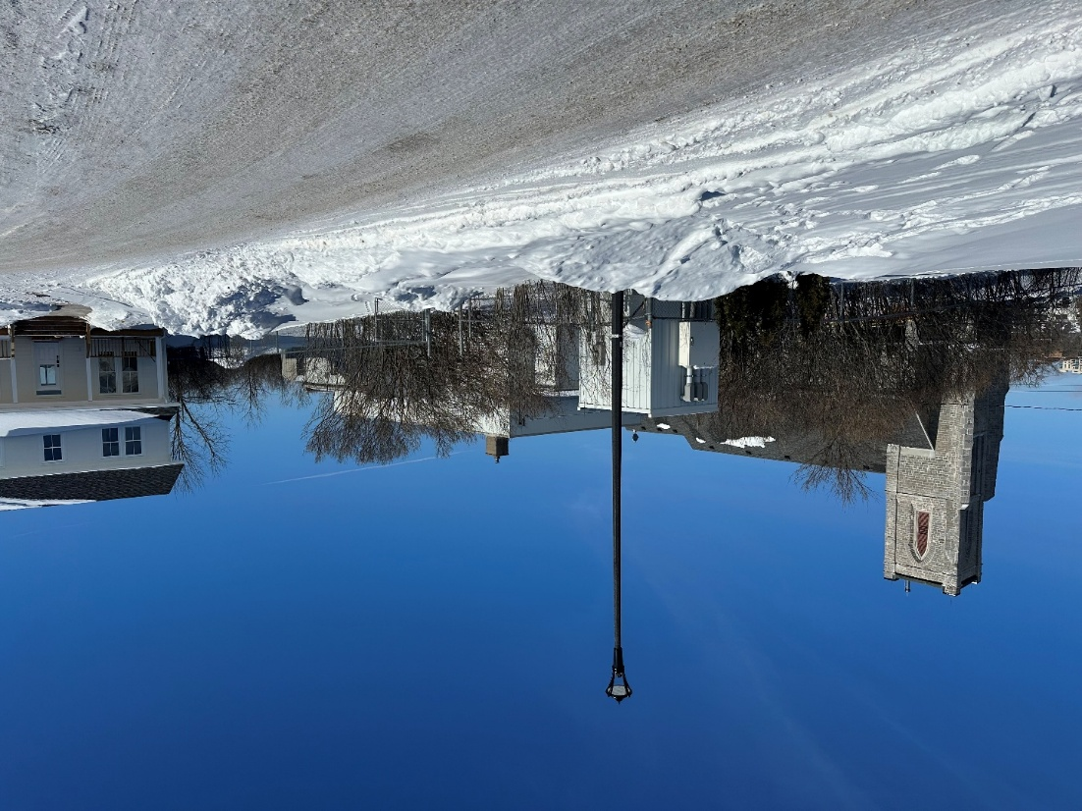

St. Marks Tower Restoration Project

Presentation to Parish Council
by Brad Smith, Chairman Tower Restoration Committee
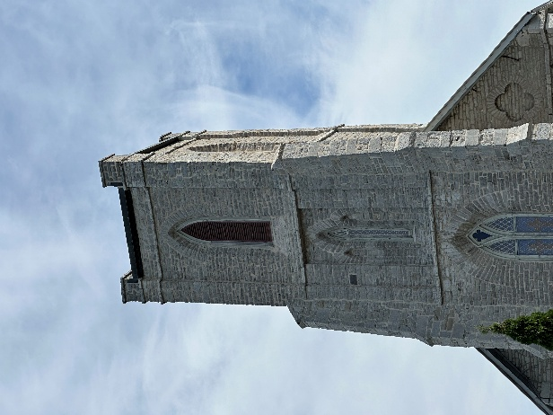
To provide some background regarding my efforts on the church tower project, I would like to mention my involvement many years ago with the Friends of the Lyndhurst Bridge. I believe this experience is relevant because, together, we faced what appeared at the time to be an insurmountable problem—and ultimately found a successful and creative solution.
The Lyndhurst Bridge had been severely damaged by age and, more significantly, by the heavy gravel trucks of the modern era—a dynamic load it was never designed to withstand. Local political leaders held the widespread belief that the only viable option was to demolish the bridge entirely and replace it with a modern two-lane concrete structure.
As many of you know, this stone bridge, completed in 1857, is the oldest bridge in Ontario. It is a breathtakingly beautiful landmark and the focal point of the village—made all the more vital after a recent fire had destroyed the main building on the main street. In many ways, the bridge was all the community had left.
Although I no longer recall the exact projected cost of the proposed replacement, it was considerable. However, with a determined and imaginative group of people, we developed a unique solution that ultimately preserved the bridge and cut the estimated cost in half. The approach involved re-pointing only the exterior walls, excavating the interior down to bedrock, and then filling the interior with concrete and rebar. The new concrete structure now carries 100% of the load, while the original stone walls remain in place for appearance.
Fast-forward to today:
When I first became involved in the church tower project, I will admit I felt overwhelmed by the scale of the work and the seemingly insurmountable costs. Recalling the Lyndhurst Bridge experience, I reached out to building engineers with significant expertise to explore whether similar innovative approaches might ensure the tower’s long-term structural integrity while reducing costs.
Although I am a Mechanical Engineering graduate—not a Civil or Structural Engineer—I remain well connected within the engineering community. My eldest brother, currently the Director of the Heavy Construction Association of Ontario, has been particularly helpful. Through him, I have been in contact with several builders experienced in this field, and a potential solution has been proposed.
Ted and I will be having a Zoom upon his return to receive an update. Following that discussion, I intend to prepare a written report to be emailed to everyone involved, rather than waiting until our next meeting.
The following outlines a proposed structural solution for the necessary stabilization of the existing tower wall structure. This approach is designed to be efficient, structurally sound, and cost-effective, offering a viable path forward for the restoration project given current constraints.

I. Proposed Stabilization Methodology
The proposed solution involves creating a reinforced, integral inner wall using high-strength, flexible concrete. The process is summarized as follows:
- Anchor and Reinforcement Installation: A matrix of anchors will be installed into the existing stone wall in a general array pattern. These anchors will be securely tied together using rebar.
- Formwork: The existing outer stone wall will serve as the exterior formwork, while a temporary wooden interior form will be installed to define the void.
- Concrete Pour: High-strength "flexible" concrete will be poured into the void between the forms to create a new, reinforced integral inner wall.
- Completion: The inner wood forms will subsequently be removed.

II. Evaluation of the Proposal

Category | Details
Advantages | * Expediency: Construction is relatively fast, significantly reducing the lengthy time commitment associated with traditional, hand-labored re-pointing methods. * Durability: The finished structure will be permanent and possess superior structural integrity. * Financial Feasibility: The methodology allows for the project to be performed in distinct, manageable stages, which significantly aids in funding and procurement.
Primary Disadvantage | * The solution requires the formation of a new inner wall, resulting in the unavoidable loss of the stone inner wall's historic aesthetic appearance.
It is recognized that the preservation of the inner stone aesthetic is a priority. However, the intersection of project cost, time, and the imperative for structural longevity makes this approach a necessary and prudent compromise to ensure the tower’s survival and facilitate timely funding.

III. Next Steps and Funding Discussion
Given that the availability of funding cannot be decoupled from the chosen methodology, I formally request that the Tower Committee meet at the earliest suitable date to specifically discuss the financial aspects and phased funding strategy related to this proposal.

IV. Separate Initiative: Replacement of Tower Spires
Finally, I wish to present a separate, related initiative: the replacement of the four stone spires that previously topped the tower.
I propose constructing these elements from lightweight sheet metal, utilizing the same material as modern roofing trim. I commit to providing a preliminary design drawing, and if approved, I would personally fabricate and install the first of the four spires entirely at my cost. Subject to the Committee’s approval of the first unit, I would then complete and install the remaining three, also at my personal expense.

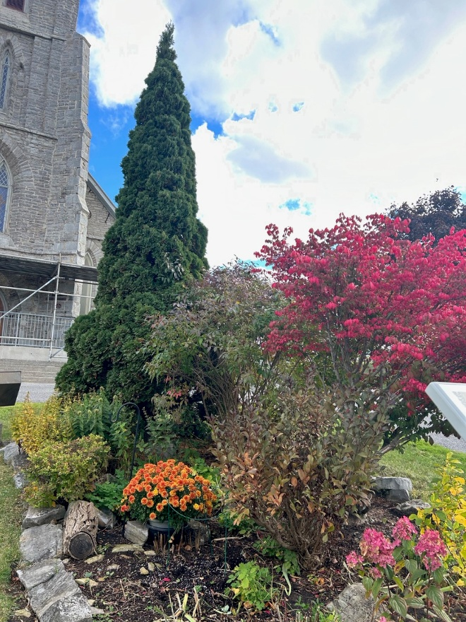

GARDEN CLUB REPORT

Our meetings were conducted monthly from May to October 2025. Ted sourced soil and compost for the lower gardens in June, with expenses covered by Ted and Sheila. The large crop of golden rod was decreased to allow for other plants. He also transported the water barrel to the gardens at the main entrance. Water for the gardens was supplied either by a kind neighbour’s hose to the barrel or transported by car courtesy of Sheila. Due to the summer drought, watering was essential to keep our plants alive.

A new “Hosta” garden was established behind the church in areas improved by recent drainage work, and these hostas have flourished. The plants were generously donated by the Stickles, members of SHF who joined our Garden Club. Later in the summer, Ted supplemented these beds with ‘rabbit tracks’ plants between the hostas, which brought vibrant red flowers in the autumn. Our previous bulb planting last fall did not yield satisfactory results; as a result, an additional 200 bulbs were planted in September and October in a much enlarged bulb bed, with mulch sourced and applied by Ted.

We extend our gratitude to Alan Rumsey for providing flowers and plants for the church’s front steps and for tending to those gardens, and to Mercedes Cobham for gifting plants to the main centre garden. We hope everyone enjoyed the beautiful display of mums at the main gates during late summer, which were replanted by Ted following the Church’s Easter arrangements.

As our active membership has declined, we warmly welcome anyone interested in joining our Garden Club. The sole requirement is a love of gardening.
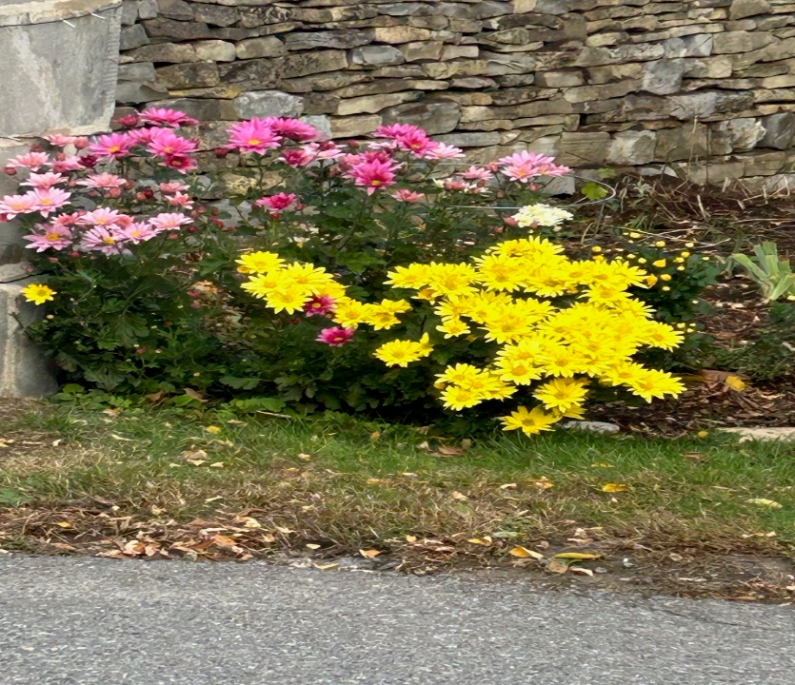
Prepared by Sheila Kiruluta

ANGLICAN CHURCH WOMEN (ACW) REPORT

ACW members gather in the hall once a month with the exception of January, July and August, 2025 having an average attendance of 12 at each meeting. We gather to pray, receive reports of our various committees, make arrangements for sale events for fundraising purposes, disperse funds for charitable causes, and generally to enjoy each other’s company. All women of the parish are invited and are considered members of the ACW – you are most welcome at any of our meetings held on the second Tuesday at 1 pm. Let us tell you what we got up to this past year.

We support MEA (formerly Kingston Pregnancy Care Centre) by attending their Fundraising Gala in February with 1 or 2 tables from our parish. We also support them by having a bassinette at the back of the church to receive items of baby clothes, diapers, formula, maternity clothes, blankets, toys, etc right after Easter until Mother’s Day. Proceeds from the Change for Life campaign in June are support for this organization as well.

We offer a huge ‘thank you’ to Ann and Paul Yaxley for advertising our events as well as Parish events; it is a commitment that they fulfill month after month, year after year. They create posters and sandwich board announcements then post them at the entrance to Main Street in Barriefield, on Facebook pages, in Kingston East Neighbour’s, pamphlets/fliers are printed for apartment buildings, bulletin boards and in places around the area. We have great success with our fundraising events and our deep appreciation goes out to the Yaxley’s.

The Baking, Books, Bargains and Bling (4B’s Sale) is a good fundraiser for us and held in April after Easter. Along with this sale, regular sale of books on the table in the hall, merchandise sold on Marketplace, and our Bazaar in November we are able to give generously to various charities as well as to St. Mark’s Church. The Money Jar just outside the secretary’s office collects funds for the Tower Restoration Fund. We also have fun at the end of our meetings with games, puzzles, or just passing a basket to add to our fundraising/outreach endeavours.

Beginning our meetings in June and December it has become a custom to have lunch catered either from Minos or Swiss Chalet. A nice treat as well as a great time to be together and chat. In April we hosted a reception for the Tracey family after the Memorial Service for Ron, and during July and August a reception for John Beveridge and Anne Peake. Cards are sent out regularly to our parishioners: sympathy, get well, thinking of you, birthdays and special occasions. Please reach out to any ACW member if you know of someone we should be sending a card to.
The ACW Retreat in September was attended by 8 ladies at the Italo-Canadian Club with The Reverend Margaret Johnston-Jones presiding. St. Mark’s ACW hosted the ACW Frontenac Regional Annual meeting in October where Bishop William Cliff preached and celebrated at our Eucharistic service with the theme: ‘Come and Journey with a Saviour.’ Following a catered lunch by Lionhearts in the hall, our annual meeting took place, Maureen Butler, president, presided. Our guest speaker was Travis Blackmore, CEO of Lionhearts, Inc.

At our November meeting we supported the Hamper Campaign and aid to the Diocese of the Cayman Islands and Jamaica after the hurricane. Preparations for the Bazaar on the 22nd took up much of our meeting, but in the end, a very successful and rewarding day.

Our appreciation goes out to each person who joyfully supports our endeavours in ministry, to Melody who supports us with administrative requests, and for the guidance and wisdom of our priest, Rev. Sandra. It takes a community . . .

Respectfully submitted,
Katherine Huffman, President Anne Patterson, Secretary

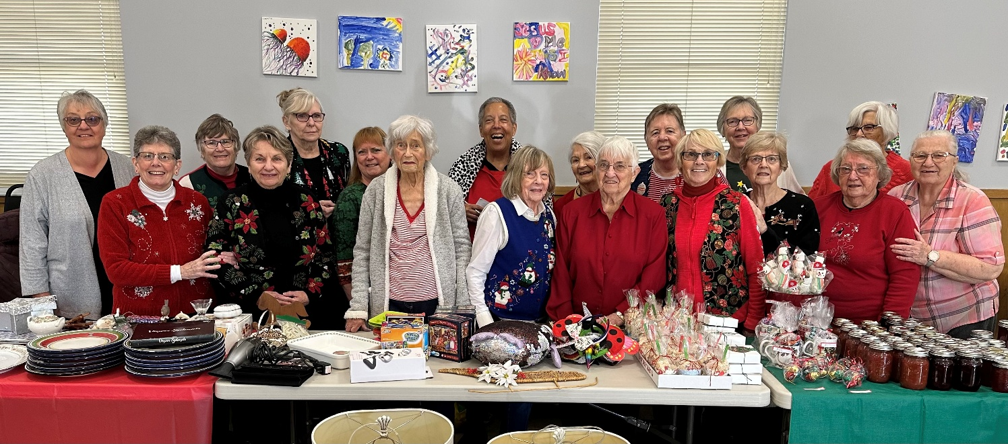

ACW FINANCIAL REPORT 2025

 | $ | $
BALANCE FORWARD FROM 2024 |  | 3,090.98
INCOME
Catering & donations funerals & personal) |  | 950.00
Rebate from ACW Annual and Regional meetings |  | 975.00
4B’s sales |  | 2,372.75
Bazaar |  | 4,544.00
Interest |  | 1.05
TOTAL INCOME |  | 8,842.80
DISBURSEMENTS
Diocesan ACW (Thankoffering, Registrations for Annual and Regional meetings & food) | 1,415.00
Articles to dump after clean-up | 54.11
Expenses (funeral receptions, gifts, cards & stamps) | 540.00
Christmas Hampers | 500.00
Donations to St. Mark’s General Fund | 7,000.00
 | 9,509.11
BALANCE END OF 2025 |  | $2,424.67



CHOIR REPORT
Though small in number our versatile Choir led the people of God in all worship services and presented appropriate songs and choral items in various formats with our most recent being on Christmas Eve - a Caribbean carol supported by the rhythms of the Hounsell-Drover men on guitars and drum. Thank you gentlemen for your accompaniment.

During the course of the year the voices of Heather, Jeannette, Dawn, Ruth, and Nancy, were further enriched with the addition of two new members - MaryLou and Judy. Thank you all for your dedication to this Ministry and willingness to move in new directions.

Up in the sanctuary we hear some lovely voices from the congregation and invite you to join us - our Choir rehearsals are on Thursdays at 2:00 p.m. during the winter and 3:00 p.m. in the spring/summer and we go on vacation during the summer months .

Personal thanks to Rev. Sandra, Choristers and the wider congregation for your support and reception.
Respectfully submitted,

Melody Massey






VOLUNTEER MINISTRIES
We thank our Parishioners who continue volunteering for the following Sunday Ministries however there have been occasions on which we have fallen short of persons to fill in and have had no volunteers to fill in.
READERS; INTERCESSORS (Prayers of the People); ALTAR SERVERS;
ALTAR GUILD; ALTAR FLOWERS; GREETERS; COFFEE HOUR HOSTS.
All Parishioners are invited to consider volunteering for any of the above so as to increase the pool of available persons and ease the strain. These Ministries will not take too much of your time as there is a four monthly Roster, based on the volunteer’s availability.
Altar Guild
The Altar Guild is a small but very dedicated team, consisting of six ladies from our congregation. They make sure that the Altar area is readied before each Service by ensuring that the Altar itself is set-up, candles are lit and that the flowers are refreshed. They are also heavily involved with the decoration of the church for each liturgical season.
This past year we had sufficient coverage but could use more willing hands to assist, especially when team members are away for extended periods such as holidays. We’ve installed a water dispenser that has helped us with the cleaning of the liturgical vessels, without having to transfer water from the Hall to the church.
I would like to thank our Team members for their dedicated service, including Melody, who always makes sure that supplies are reordered on time.
Thank you
Respectfully submitted by

Andrea Muralt

Mission and Outreach Committee Report for 2025

In 2025, our Mission and Outreach Committee consisted of Rev. Sandra Hounsell-Drover, Elaine Bryan, Ross and Susan Evans, Jerry Mayer and Deb Patterson, Andrea Muralt, Alan Rumsey, as well as Paul and Ann Yaxley. Mary Running remains an ex-officio member. We had several planning meetings via Zoom in 2025, during which we also decided on financial support for missions and projects, designated as Local, National or International.

In 2025, we supported the following missions/projects for a total of $3,200.00, which came from our allocation in St. Mark’s 2025 budget:

Name of Ministry/Group/Project | L, N or I | 2025
MEA (previously called Kingston Pregnancy Centre) | Local | 600.00
Almost Home - Kingston | Local | 600.00
Lionhearts Inc. | Local | $1,000.00
Alongside Hope-Canada (previously called PWRDF) | National | $1,000.00
TOTAL: |  | $3,200.00

On 28 February 2025, six of St. Mark’s parishioners attended MEA’s Fundraising Gala to further support their efforts to help parents and families in the Kingston area.

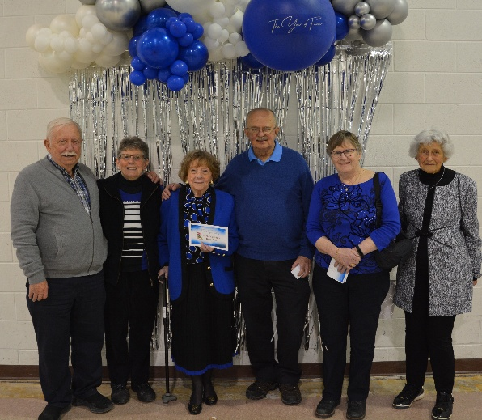
In the spring, we collected donations for the MEA Centre’s “Change for Life”/Baby Bottle Campaign. In December 2025, we gratefully received $5,358.00 in donations for the Christmas Hamper campaign!! Therefore, we were able to purchase gift cards totalling $5,400.00 for 12 families who each received $400.00 to buy their own food and Christmas gifts. Below is a table representing St. Mark’s support of MEA from 2019 to 2025:

 | 2019 | 2020 | 2021 | 2022 | 2023 | 2024 | 2025
Baby Bottles | $1,256 | $905 | $1,235 | $1,525 | $710 | $720 | $1,010
Christmas Hampers | $5,013 | $4,260 | $4,386 | $4,000 | $4,000 | $5,222 | $5,358

In addition, we collected non-perishable items and monetary donations (every third Sunday of each month) from the back of the church and delivered them to the Partners in Mission Food Bank at their NEW location on Harvey Street, not far from their previous building. Several parishioners attended the Open House in September at the new location of the Partners in Mission Food Bank.

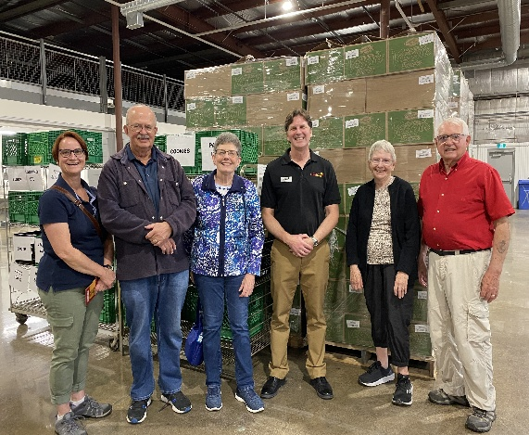

We also held two community food drives: 26 April and 4 October 2025. Your regular donations were very much needed and very much appreciated. The results are:

Quarterly in 2025 | Bags of Food | Boxes of Food | Cheques & Cash | (Compared to 2024)
1 Jan. to 31 March | 23 | 2 | $4,175.00 | $1,800.00
1 April to 30 June | 30 | 7 | $3,485.00 | $2,280.00
1 July to 30 Sept. | 13 | 3 | $2,675.00 | $3,700.00
1 Oct. to 31 Dec. | 26 | 6 | $3,455.00 | $2,680.00
Totals | 92 | 18 | $13,790.00 | $10,460.00

Our team members thank you all again for your regular prayers and your very generous support of our missions and projects. We are very blessed at St. Mark’s, and we attempt to share our blessings and love with those who are less fortunate.

I am pleased to say that all current members of the M&O Team have agreed to remain for 2026. (Mary Running and Elaine Bryan will be ex-officio members.) We will meet in April to discuss our support for various missions and programs in the coming year.

Respectfully submitted,
Ann Yaxley
(Chair of the M&O Team)

NOTE: Although not administered by the M&O Team, St. Mark’s outreach to others included:
$100.00 to the Anglican Foundation of Canada
$2,382,00 to the Jamaican Disaster Relief via Alongside Hope



ALONGSIDE HOPE REPORT

In 2025 the Canadian Anglican Church changed the name of its relief and development organization from Primate’s World Relief and Development Fund to ALONGSIDE HOPE

Alongside Hope is the Anglican Church of Canada’s agency for sustainable development and relief. Since 1958, they have worked hand-in-hand with trusted partners in Canada and around the world on a journey of positive change. Together, we are improving health, food security and livelihoods where needs are greatest. Alongside Hope receives donations from people across Canada – Anglicans as well as non-Anglicans – and also receives funds from other sources, including Global Affairs Canada and institutional donors. Our volunteers promote Alongside Hope programs in churches and communities, to raise money and awareness about the needs of vulnerable people around the world.

This year, St. Mark’s did not have a dedicated Sunday for Alongside Hope. However, our donations in response to the hurricane damage in Jamaica were sent to Jamaica through Alongside Hope.

I encourage all to visit the ALONGSIDE HOPE website: https://alongsidehope.org/

Prepared by Ted Davie
Parish Alongside Hope Representative




Annual Shrove Tuesday Pancake Supper
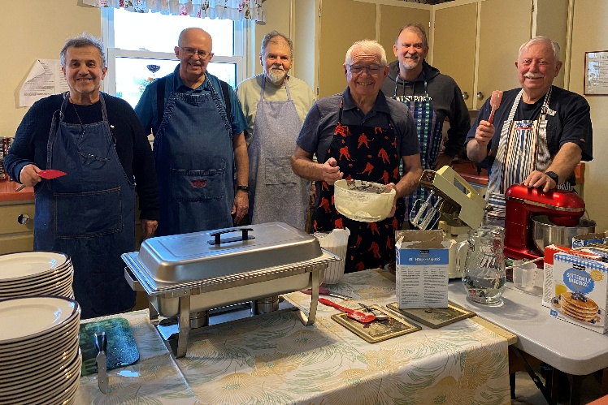
Our annual Shrove Tuesday Pancake Supper was held on March 4, 2025, with many of the men serving as cooks and servers in the kitchen, and several women assisting in the hall with tea, coffee, and desserts. As usual, six young Embers helped by clearing dirty dishes and refilling water glasses and syrup pitchers. A total of 161 people attended, raising $2,185.00 for the Tower Restoration Fund. Expenses totaled $337.71 for sausages, maple syrup, milk, juice, and other supplies. All remaining cooked pancakes, maple syrup, and desserts were donated to the Kingston Street Mission the following day.

Coffee House Report
Coffee House performances over the years have been extremely enjoyable and have provided a fun and welcoming activity for both the St. Mark’s and wider Kingston community. Since 2014, countless performers have generously donated their time and talents to help raise funds for the church’s Tower Restoration Fund. We are deeply thankful to everyone who has performed, as well as to those who have worked tirelessly behind the scenes. The 2025 statistics below show the attendance and funds raised.

DATES | ATTENDANCE | FUNDS RAISED
March 15, 2025 | 80 | $ 656.00
May 31, 2025 | 38 | $ 355.00
September 27, 2025 | 45 | $ 515.00
November 27, 2025 | 50 | $ 505.00
 | TOTAL | $2,031.00
Car Rally Report
St. Mark's Car Rally/Scavenger Hunt was held on October 24, 2025 and included 22 participants in 6 vehicles. A chili lunch was served before the event, with dessert offered afterward. A fun time was had by all! After expenses, the rally raised $538.58.

Newfoundland Cold Plate Supper
A delicious Newfoundland Cold Plate take out Supper was held in March featuring cold cuts, three types of potato salads, vegetables and delicious dessert. The brainchild of Rev. Sandra supported by Karen Freake, Verly Douglas, supported by their respective families and fellow Newfoundlaner Dion Kendall, the event raised $1,560.00.

STRAWBERRY SOCIAL/BBQ 2025


Our annual SS/BBQ was held in the Parish Hall on June 27. Approximately 80 persons attended and enjoyed the BBQ’d hamburgers/hotdogs, various salads and the cake/ice cream/fresh strawberries dessert. Judging by the high level of noise in the Hall and the many compliments we assumed the customers were more than content. Where else could you get such quality and quantity for $25? And that included coffee/tea/lemonade!

This year we tried to accommodate most diet requests with vegan/gluten free/dairy free but recommend we do not repeat next year as it is a lot of extra work and extra expense for the satisfaction of a very few that is not cost effective. There were many lessons learned about staffing which will be simplified next year, reducing the numbers required. Perhaps we should consider a ‘take out’ option as well, if we substitute cream for the ice cream.

Thanks to the many volunteers that executed the plan. The poster needs to make sure the price is not camouflaged.

Our appreciation to the Thousand Islands Playhouse in Gananoque for donating (for the second year) two theatre tickets.
Revenue $2,010.00
Expenses 509.46
PROFIT $1500.54
Prepared by Ted Davie
Event Co-Ordinator

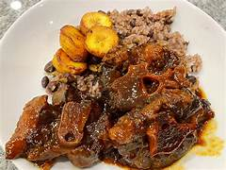
TASTE OF THE CARIBBEAN

The Taste of the Caribbean ‘Take-Out Dinner’ on Friday
July 25th was well received by a number of persons outside the St. Mark’s family. One late registrant who had to be turned down when told we hope the next time he would be lucky he asked if that meant the next month! Accommodation for persons with dietary restrictions were made and also appreciated.
Eighty-five (85) meals were served that generated $2,125.00 which was deposited to the Church’s general fund. Donations toward the cost of various items were made by members of the Group hence no requests for reimbursement being made to date

Respectfully submitted
Sheila Kiruluta, Mercedes Cobham, Melody Massey



SPECIAL PROJECTS GROUP REPORT

During 2025 Special Projects Group were pleased once more to hold a very successful “Tea on the Hill” on Saturday June 7th serving dainty sandwiches and desserts accompanied with scones and tea. As in previous years we had a sold out attendance! The preparation and organization of the annual Tea is a large undertaking but could not be accomplished without the willing help and hands of all members of the SP Group along with a number of men in the congregation who kindly assist with the set up and take down of the tables, chairs, and even decorations and cleanup. Thank you to everyone!

Special Projects two cupboards in the church hall have contained a large amount of fabric which the members have used often to prepare items for the annual ACW bazaar. Further we have created blankets for those in need who might live on the street or in shelters around the city. We have more fabric that can be used if anyone is interested in completing more blankets, at any time of the year.

Looking ahead, we are putting plans in place for a spring tea in 2026, and a further event close to Harvest Thanksgiving as a fund raiser.

Special Projects Group is open to all members of St. Mark’s who would like to join in raising funds for the benefit of the church, and to enjoy friendship and laughter along the way.

Respectfully submitted,
Heather Grimshaw, Jeannette Calmettes
on behalf of all the SPG

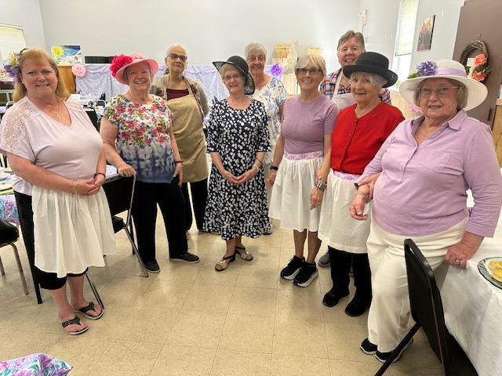

SENIORS HAVING FUN

2025 was a good year for this ministry. Attendance continued to be 20-25 every week with a core of about 15 regulars as others come and go depending on health, weather and other interests. Usually, 8-10 attendees are from St. Mark’s, and the remainder are from all parts of Kingston. Many friendships have been formed and many of the group continued to meet when our program stopped for the summer.

Other than opening the Hall and starting the coffee and tea, the group is pretty well self-supporting: helping to arrange the tables required, bringing snacks for the group and getting out the games and nametags. Some who do not bring food, contribute money which is passed to the ACW for coffee/tea we use or/and is used to provide milk and cream.

We continued to have a presentation every semester: one in the Fall and one in the Spring. In April, we had a seminar sponsored by Canada Purple Shield titled “Ducks in a Row” which covered Estate Administration, Wills and Power of Attorneys, Planned Giving options, Funeral preplanning, considerations if a death occurs away from home and Executor tips. This was also a fundraiser as the Sponsor paid us $20 for every attendee. $700 was donated to the Church. In December, we had a presentation on “Human Trafficking” given by Cpl Murano, RCMP, and supported by the Diocesan representative of the subject, Captain the Rev John Van Stone. Learning from our “MAID” presentation last year, we hosted this presentation so agitators from near and far did not get the impression we were in favour of the subject, we were simply providing awareness.

Several members of our SHF group are also involved with our Parish Veterans group, the Men’s group, ACW sales and the Garden Group. Some have even come to church, more than once.

Thanks for the able assistance from Nancy Varley, Ann Yaxley and Mary Lou Hamilton who have helped make this happen. This ministry is meeting our expectations, but we invite other church members to volunteer their time and talents to help coordinate the weekly event.

Prepared by
Ted Davie, SHF Co-ordinator



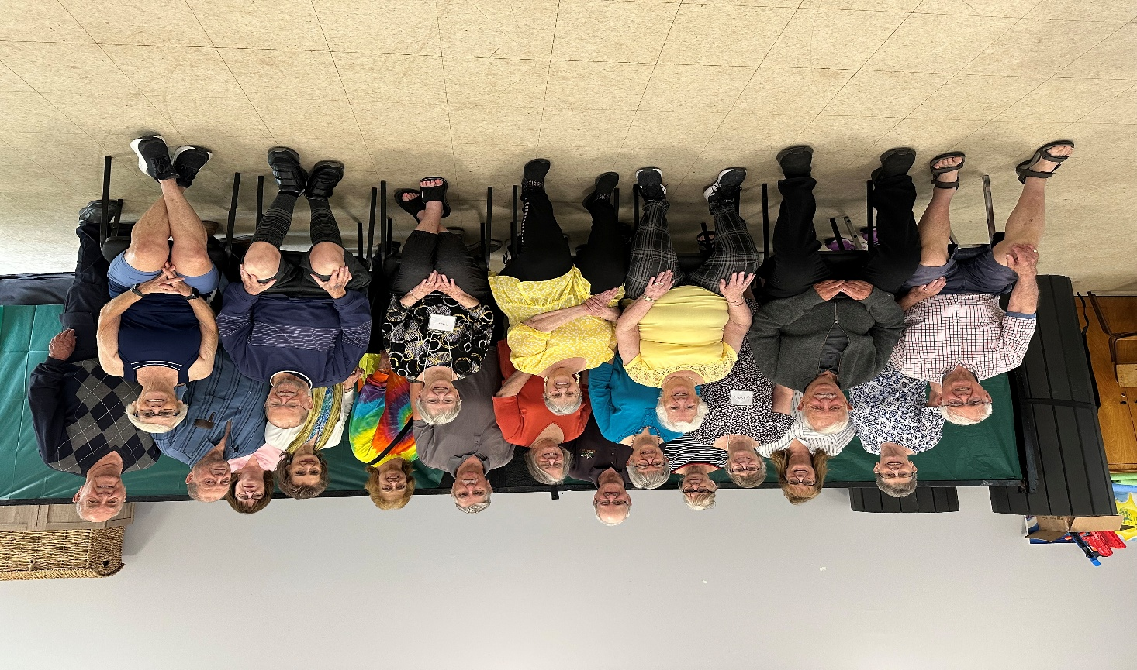

REPORT ON MEN’S FELLOWSHIP

During 2025, St. Mark’s Men’s Group continued to gather in the parish hall, each Monday morning from 9:00 am to 10:30 am, for a time of lively conversation, discussion, learning, and Christian fellowship.
Weekly attendance was typically between 6 to 10 attendees, from both within and outside the parish.
The group warmly welcomes all who feel called to serve God and the community. Sometimes we discuss challenging and emotive issues, but we acknowledge and respect each other’s individual calling and faith journey and seek always to treat each other with love and courtesy.



Fall 2025/Spring 2026 Bible Study –
Parables

Our study of Parables began in the early Fall of 2025. We stopped the study during the late Fall, due to unforeseen circumstances, and started again in January 2026. Eight people have been in attendance since the Fall of 2025. All contribute to the discussions and prayers and readings
.
As usual each of the readings lead to many offshoot topics, but all center on the particular chapters of study that we are covering. Although a ‘weighty’ book at times to digest, Christ helps us to battle through the study of Parables with a deeper understanding of His Word.

This is the seventh study we are tackling from Core Christianity. It consists of ten lessons which usually take two weeks to complete. The format is clear as well as thought provoking and the Reflection Questions open our minds (or maybe I should say, stretch our minds) to a closer relationship to one another and to God.

There is room for others to attend. All will be welcome. (No cover charge – unless more Tariffs kick in). We tackle our study with Joy, Love and Laughter.

The Bible studies we pursue are extremely worthwhile and everyone who participates enjoys them very much.
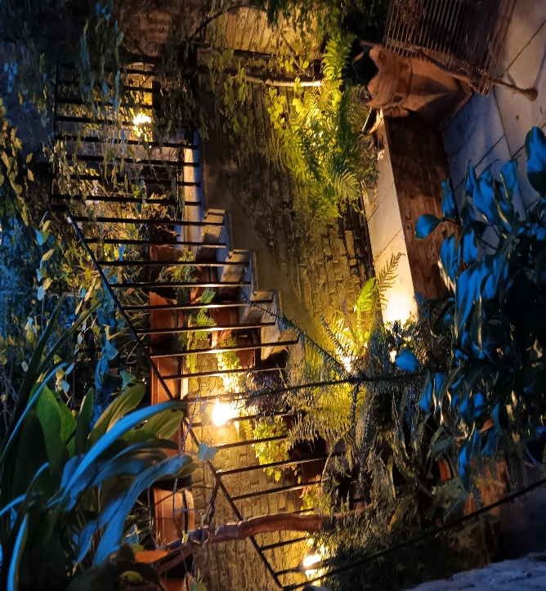

In Christ alone,
John/Pam Barron


VETERANS’ REPORT – ST. MARKS

The St Mark’s veterans’ group was deeply saddened by the loss of our oldest member when Colonel John Beveridge, CD, (Retired) passed away this past year, going to join his beloved Sharon. We were privileged to be able to say good-bye to him in our own Church.

This small group, normally about half-a-dozen members at any given meeting, continues to provide a place for dodgy coffee and good conversation on Wednesday afternoons at
2 P.M. for veterans from several generations of military service. It is a professionally distinguished group, with several holding membership in various grades of the Order of Military Merit. Members of our veterans’ group have served across Canada and around the world in places as varied as in the Sinai with the UN, in Cyprus during the 1974 Turkish invasion, the Cold War in Europe, the high Arctic, the Balkans and Afghanistan as well as showing the flag for Canada on, and under, the High Seas.

Our veterans’ group is a place where veterans are able to relax and talk with, in many cases, the only people who can understand them and their experiences, and is providing a valuable service to both members of our congregation and the public within our Parish. As an example, a “field trip” was taken to visit the new Echelon Wellness establishment which opened in Kingston, providing medical treatment to CAF and RCMP veterans. This has resulted in one member of the group finally being able to apply for a medical pension for injuries suffered in the 1960s. Prior to this point he could not find a medical practitioner to sign the required paperwork.

Respectfully submitted,
Dave Muralt

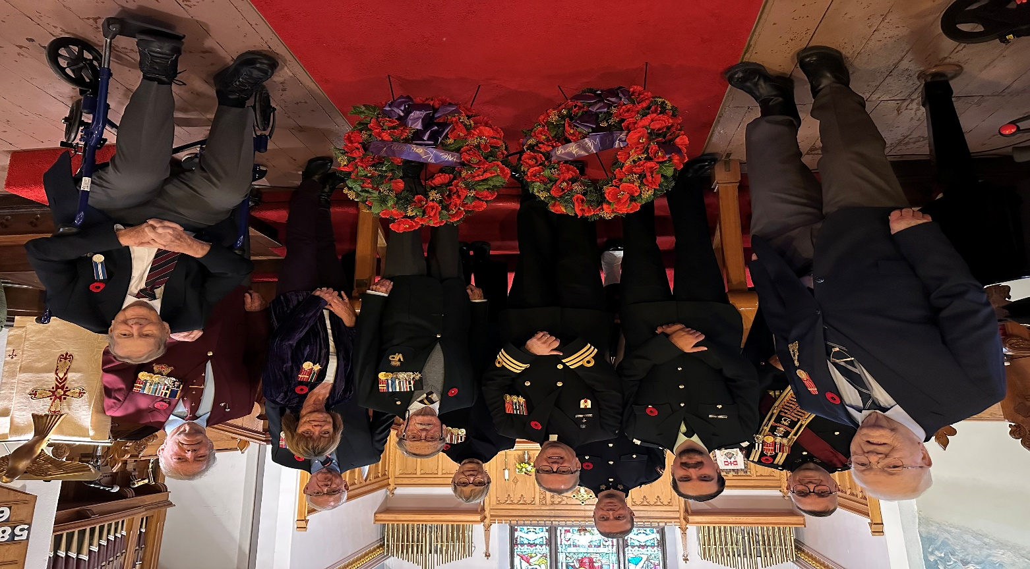

REMEMBRANCE DAY 2025

St. Mark’s Book Club 2025

We have had a good Book Club year reading a diverse group of books.
And we increased our attendees slowly but surely each one adding new books and rich discussion to the group.

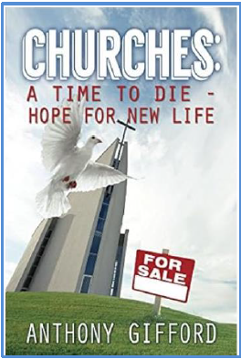
January 28th was our first book by a local author Anthony Gifford with the controversial Churches: A Time Die – Hope for New Life with the author attending and sharing in the discussion.
The discussion was spirited especially in light of our book read at the end of 2024 which also challenged churches. The Rebel Christ by Michael Coren.

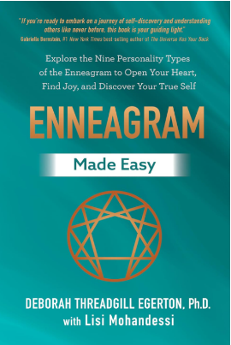
April 30th was our next book Enneagram Made Easy by Deborah Threadgill Egerton, PhD. USA where some of us had taken the Enneagram Rheti test for a better understanding of the Enneagram.
While an interesting discussion occurred it was agreed that the direction of the books for the club should be based on books that inspired our spiritual direction without a focus on self study on our personality in addition to some other guidelines. This was a lovely informative way of setting the direction for the future meetings and
discussions.

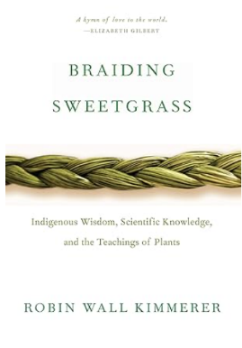
July 8th found us discussing Braiding Sweetgrass by Robin Wall Kimmerer a profound exploration of indigenous wisdom, ecology, and the interconnectedness of all living beings. Kimmerer, a botanist and member of the Citizen Potawatomi Nation, weaves together personal narratives, scientific insights, and indigenous teachings to offer a vision of reciprocity and reverence for the natural world.
This met the guidelines set at our previous meeting.

November 17th our discussion centered all about Love of all kinds.
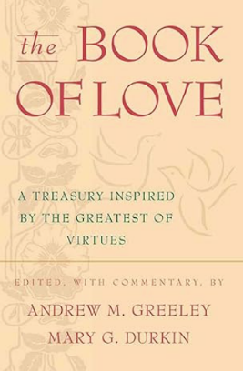
Through a grand treasury of essays, poems, and stories, Andrew M. Greeley and Doctor Mary G. Durkin portray the limitlessness of the human spirit's capacity to care for one another as a result of the greatest virtue ever bestowed upon members of all nations and faiths: love.

Lessons Learned: That everyone should feel free to be as articulate and as involved in the discussion as they want to be. And that loving kindness and interest in everyone’s opinion should be allowed and welcomed as should their silence and presence.

Everyone is welcome.

Respectfully submitted,

Mercedes Cobham



Martial Arts Report

The St. Mark’s martial arts program has continued to operate through the year under the guidance of Peter Rogers. The schedule has been adapted so that classes are conducted Monday, Tuesday and Wednesday evenings. Thursday night classes were discontinued as it was difficult to work around the Embers’ schedule, and, frankly, the Embers were here first so there was no willingness to ask them to change their schedule.

The martial arts program continues to operate with about half a dozen students, a majority of whom are new Canadians from Central and South America. But we are now in the situation where an adult member with no prior martial arts experience has progressed in their training to the level that they are now starting to coach others. This is a crucial step for the perpetuation of any martial arts program.

Going forward, Pete would like to expand his program to include awareness classes for seniors and adults during the day.

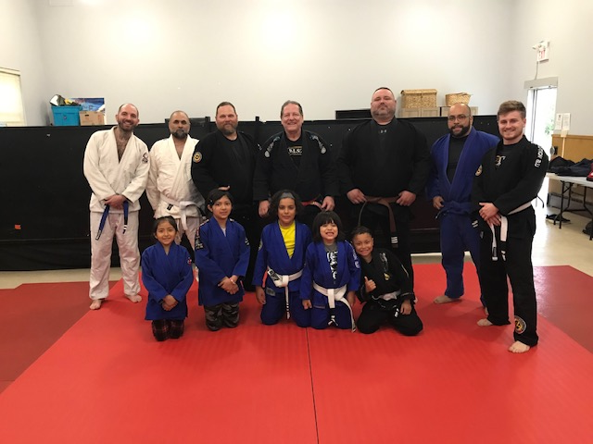

Spring, Summer and Winter Fitness Programs 2025

The Spring, Summer and Winter Fitness Programs continued in 2025. The program is a free Community drop-in session held on Thursday mornings for an hour and a half. It is loosely based on a combination of programs that I facilitate for the free Phone At Home series offered by the City of Kingston and partners through the Senior’s Association and the fitness training provided by the Senior’s Association for their volunteer teachers.

The focus is to provide a fun, yet educational experience encompassing Stretching, Yang (slow) Yoga, Movement and light Weightlifting while exposing the participants to Self-Care through massage, reflexology and other energy techniques such as Qigong, Brain Gym to name a few. Finishing with a mindful meditation session encouraging relaxation, potential relief of anxiety, depression or stress with a goal of restoring calm and inner peace. This encourages cardiovascular health in a low impact fashion, posture, flexibility, frailty avoidance with a focus on bone and basic strengthening for life’s daily tasks. We also incorporate some cognitive variations within the exercises to limber up the brain pathways. All of this with a target to stay functional at home as long as possible and providing some potential for recovery resilience post a traumatic incident or other health issue.

During the time that I have been offering this program I continue to provide the why as to what we are doing in the program so that the students themselves are capable enough of being teachers as well, this means that we are all free to bring whatever issues we are having to try and tailor the exercises and techniques to benefit any or all of us. This has been very encouraging. At the same time, I continue to benefit from the ongoing research and training myself which I consider one of the best outcomes, which in turn means that I share that knowledge and we all benefit. This also means that the program changes and evolves as we go along.

If you ever walk in on a Thursday depending on when you come you will either see us egging each other on with lots of hilarity or you will see everyone silent as if sleeping while meditating and relaxing. Or we might be on a virtual trip to my favourite beach in Barbados or sandbanks on Amherst Island, and our latest experience has been to reset our nervous system and imagination through conscious boredom. Always an adventure these Thursday sessions.

Respectfully submitted,
Mercedes Cobham

Advertising/Publicity in 2025

During 2025, there were many events at St. Mark’s which required information to be transmitted to the parishioners, as well as to the Kingston East community and beyond. Mercedes Cobham, Allan Rumsey and Ann Yaxley collaborated with
Melody Massey to ensure that our events were broadcast via:

- St. Mark’s Facebook page
- Friday newsletter; Emails to Parishioners; our Church Website under Events
- 3 Community Facebook pages in Kingston East; The Anglican Diocese of Ontario Events webpage; Kingston East Neighbours Magazine; The Kingstonist (on-line daily newspaper); Emails to Barriefield Village Association and to various contacts around Kingston.
- Posters in Barrett Court buildings and at the Kingston East Community Centre; Barriefield Pharmasave; Public Library on Gore Road.
- Three sandwich boards on Highway #15.

At the beginning of 2025, and at various times throughout the year, notices were published for:
- Men’s Fellowship (Mondays)
- Martial Arts Program (evenings on Mondays through Thursdays)
- Veterans’ Group (Wednesdays)
- E-Z Fitness Fun/Exercise Class (Thursdays)
- Seniors Having Fun Group [S.H.F.] (Thursdays)

In addition to our regular programmes our many social events and church services were advertised using the above media which have proven to be very successful.

It appears that 2026 will be another busy year for St. Mark’s !!

Respectfully submitted,
Ann Yaxley

