Parkside Lutheran Church
Rediscovering the Radical Love of Jesus
Gathering All
Serving All
Caring For All

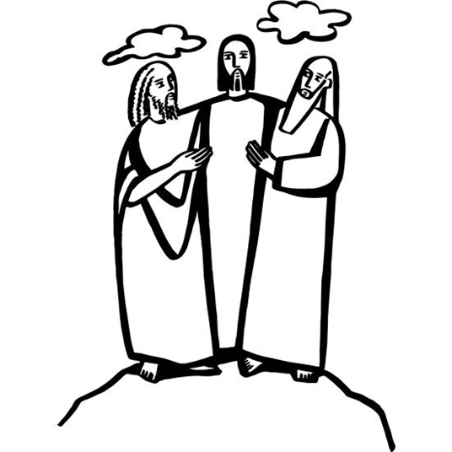

February 15th, 2026
Transfiguration of Our Lord
Holy Communion 10:00am
Rev. Jeremiah Smith
Parkside Lutheran Values

Proclaiming Grace - Jesus shared and lived out a message of grace, love, and new life. We believe these promises come from God freely, as a gift for all. We are loved and the Spirit inspires us to share this good news in accessible, relevant, and new ways. Luke 4:17-19, John 1:16-17, John 3:16-17, Ephesians 2:8-9

Practicing Hospitality – Jesus welcomed the little children, broke bread with outcasts, and proclaimed the Good News to all. Whether you are strong in faith, wrestling with doubt, or somewhere in between, we affirm that you are welcome here. Jesus is for everyone. Leviticus 19:34, Matthew 9:10, Matthew 19:14, Hebrews 13:2

Loving Boldly - Jesus challenged traditions to demonstrate God’s justice and love of neighbor. His compassionate and sacrificial love inspires us to take risks. Striving to follow his command to love neighbor, our ministries serve, transform, and advocate for folks near and far. Micah 6:8, Mark 11:15-17, Luke 10:25-28, John 15:12-13

Cultivating Community - Jesus built communities that transformed lives. We are the body of Christ and we are called to continue this ministry of transformation. Guided by the Holy Spirit, we build connections within and outside of these walls, and with all of God’s creation. Ecclesiastes 4:9-12, Matthew 28:16-20, 1 Corinthians 12:12-14, Galatians 3:26-29

Welcome Visitors!
Please use QR code
to let us know you were here today or to sign up for our weekly enewsletter
or, sign up for weekly enewsletter via website parksidelutheran.org.
Find us on Facebook & Instagram WIFI: Balcony password: FreeGrace

For your safety in the event of an emergency: In addition to the three exits in the back of the sanctuary, there are exits on either side of the altar (on left side: floor level near piano and up steps past altar. On right side: up steps to the altar, past band area)

Contact us: (716) 836-1361
2 Wallace Ave. Buffalo, NY 14214
parksidelutheran.org | parksidelutheran@gmail.com

GATHER
The Holy Spirit calls us together as the people of God.

Prelude: “Come, Now is the Time to Worship” by Brian Doerksen
Faith Journey

Call to Worship
WA: God, we come to the mountaintop to be covered in your presence. We are comforted by your holiness and your glow;
C: we are comforted by the hope of the mountain top, where you are so close, so accessible, where there is no doubt of your glory.
WA: The mountain top reminds us why we worship you.
C: We witness your bright power, and your plan for the nations of the earth.
WA: As we prepare for worship, God bring us to the mountain top;
C: bring us to the mountain top so that we may be inspired to do your work in the valley below.

+Gathering Hymn: Shine, Jesus, Shine ELW #671

Lord, the light of your love is shining,
In the midst of the darkness shining;
Jesus, light of the world, shine upon us,
Set us free by the truth you now bring us.
Shine on me, shine on me.

Refrain: Shine, Jesus, Shine, fill this land with the Father’s glory;
Blaze, Spirit, Blaze, set our hearts on fire.
Flow, river flow, flood the nations with grace and mercy;
Sent forth your Word, Lord, and let there be light!

As we gaze at your kingly brightness,
So our faces display your likeness,
Ever changing from glory to glory,
Mirrored here, may our lives tell your story.
Shine on me, shine on me. Refrain

Welcome and Announcements

+Confession and Forgiveness
P: Blessed be the holy Trinity, ☩ one God, the Creator of heaven and earth,
the Word who spoke life into being, the Wind stirring the waters.
C: Amen.
P: Let us turn in confession to the one who knows us completely.
(a brief silence)
P: Mighty God, lover of justice,
C: you call us to life in community, but we have served our own interests
at the expense of our neighbors. We have sown deceit where honesty was needed. We say the right words, but our hearts are far from you. Turn us to seek your face. Knit us together and give us the mind of Christ,
that we may do justice, love mercy, and walk humbly with you, our God. Amen.
P: The former things have passed away, and new things God now declares:
Like a spring of water that never fails, God covers you in the righteousness of Christ, and forgives your sin in ☩ Jesus’ name. May the Spirit give you strength to live for others, and bless you with the gift of peace. C: Amen.

Greeting

WA: The grace of our Lord, Jesus Christ, the love of God, and the communion of the Holy Spirit be with you all. C: And also with you.

Kyrie
(printed next page)

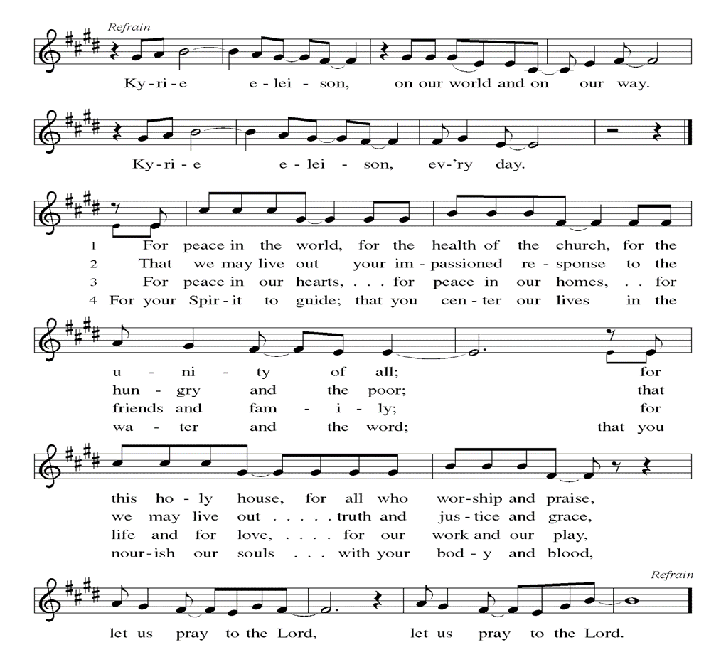

Prayer of the Day
WA: Let us pray together.
C: O God, in the transfiguration of your Son you confirmed the mysteries of the faith and you foreshadowed our adoption as your children. Make us heirs with Christ of your glory, and bring us to enjoy its fullness, through Jesus Christ, our Savior and Lord, who lives and reigns with you and the Holy Spirit, one God, now and forever. Amen.

Children’s Sermon: Jesus said, “Let the little children come to me!”
We welcome children in worship.
WORD
God speaks to us in scripture readings, preaching and song.

First Reading: Exodus 24:12-18
At Mount Sinai, Moses experienced the presence of God for forty days and forty nights. The “glory of the Lord” settled on the mountain, and on the seventh day God called out to Moses. On the mountain God gave Moses the stone tablets inscribed with the Ten Commandments. L: 12 The Lord said to Moses, “Come up to me on the mountain and wait there; I will give you the tablets of stone, with the law and the commandment, which I have written for their instruction.” 13 So Moses set out with his assistant Joshua, and Moses went up onto the mountain of God. 14 To the elders he had said, “Wait here for us, until we come back to you. Look, Aaron and Hur are with you; whoever has a dispute may go to them.”
15 Then Moses went up on the mountain, and the cloud covered the mountain. 16 The glory of the Lord settled on Mount Sinai, and the cloud covered it for six days; on the seventh day he called to Moses out of the cloud. 17 Now the appearance of the glory of the Lord was like a devouring fire on the top of the mountain in the sight of the Israelites. 18 Moses entered the cloud and went up on the mountain. Moses was on the mountain for forty days and forty nights. L: Word of God, word of life. C: Thanks be to God.

Psalm: Psalm 99 Proclaim the greatness of the Lord; worship upon God’s holy hill.
(Ps. 99:9) L: ¹The Lord is king; let the people tremble.
The Lord is enthroned upon the cherubim; let the earth shake.
C: ²The Lord, great in Zion, is high above all peoples.
L: ³Let them confess God’s name, which is great and awesome;
God is the Holy One.
C: ⁴O mighty king, lover of justice, you have established equity;
you have executed justice and righteousness in Jacob.
L: ⁵Proclaim the greatness of the Lord and fall down before God’s footstool;
God is the Holy One.
C: ⁶Moses and Aaron among your priests,
and Samuel among those who call upon your name,
O Lord, they called upon you, and you answered them,
L: ⁷you spoke to them out of the pillar of cloud;
they kept your testimonies and the decree that you gave them.

C: ⁸O Lord our God, you answered them indeed;
you were a God who forgave them, yet punished them for their evil
deeds.
L: ⁹Proclaim the greatness of the Lord and worship upon God’s holy hill;
for the Lord our God is the Holy One.
L: Word of God, word of life. C: Thanks be to God

Second Reading: 2 Peter 1:16-21
At the transfiguration, God’s voice was heard declaring Jesus to be the beloved Son. By the activity of the Holy Spirit, God’s voice continues to be heard through the word of scripture. L: ¹⁶For we did not follow cleverly devised myths when we made known to you the power and coming of our Lord Jesus Christ, but we had been eyewitnesses of his majesty. ¹⁷For he received honor and glory from God the Father when that voice was conveyed to him by the Majestic Glory, saying, “This is my Son, my Beloved, with whom I am well pleased.” ¹⁸We ourselves heard this voice come from heaven, while we were with him on the holy mountain. ¹⁹So we have the prophetic message more fully confirmed. You will do well to be attentive to this as to a lamp shining in a dark place, until the day dawns and the morning star rises in your hearts. ²⁰First of all you must understand this, that no prophecy of scripture is a matter of one’s own interpretation, ²¹because no prophecy ever came by human will, but men and women moved by the Holy Spirit spoke from God.
L: Word of God, word of life. C: Thanks be to God

Please stand as you are able
Gospel Acclamation ELW Setting 4 (p. 151)

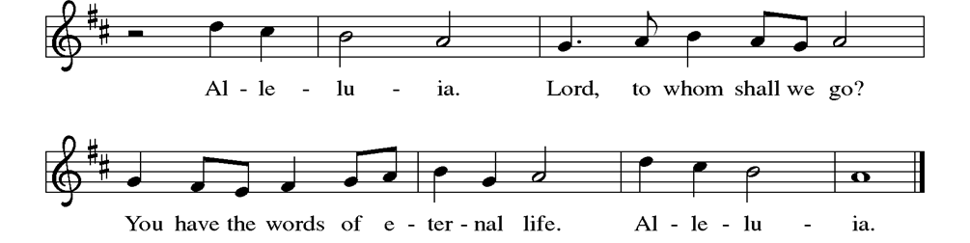

Gospel Reading: Matthew 17:1-9

Shortly before he enters Jerusalem, where he will be crucified, Jesus is revealed to Peter, James, and John in a mountaintop experience of divine glory called the transfiguration.
P: The Holy Gospel According to Matthew. C: Glory to you, O Lord.
P: Jesus took with him Peter and James and his brother John and led them up a high mountain, by themselves. ²And he was transfigured before them, and his face shone like the sun, and his clothes became dazzling white. ³Suddenly there appeared to them Moses and Elijah, talking with him. ⁴Then Peter said to Jesus, “Lord, it is good for us to be here; if you wish, I will make three dwellings here, one for you, one for Moses, and one for Elijah.” ⁵While he was still speaking, suddenly a bright cloud overshadowed them, and from the cloud a voice said, “This is my Son, the Beloved; with him I am well pleased; listen to him!” ⁶When the disciples heard this, they fell to the ground and were overcome by fear. ⁷But Jesus came and touched them, saying, “Get up and do not be afraid.” ⁸And when they looked up, they saw no one except Jesus himself alone. ⁹As they were coming down the mountain, Jesus ordered them, “Tell no one about the vision until after the Son of Man has been raised from the dead.” P: The Gospel of the Lord. C: Praise to you, O Christ.

Sermon Rev. Jeremiah Smith

Please stand as you are able

+Hymn of the Day: Beautiful Savior ELW #838
(printed next page)

Apostles Creed
WA: Let us confess the faith using the words of the Apostles’ Creed.
C: I believe in God, the Father almighty, creator of heaven and earth.
I believe in Jesus Christ, God’s only Son, our Lord, who was conceived by the Holy Spirit, born of the virgin Mary, suffered under Pontius Pilate, was crucified, died, and was buried; he descended to the dead. On the third day he rose again; he ascended into heaven, he is seated at the right hand of the Father, and he will come to judge the living and the dead.
I believe in the Holy Spirit, the holy catholic church, the communion of saints, the forgiveness of sins, the resurrection of the body, and the life everlasting. Amen.

Prayers of the People WA: As God’s beloved children united in Christ, let us pray for the church, the whole human community, and the well-being of the earth, our home. (a brief silence)
WA: Revealing God, your Spirit sustains the church. Strengthen the faithful with the revelation of Christ transfigured, that we may joyfully follow him in the way of the cross. Merciful God, C: receive our prayer.
WA: Peacemaking God, the nations are in turmoil. We pray for an end to violent conflict. Give wisdom to negotiators and sanctuary to refugees. Defend any who are in danger. Merciful God, C: receive our prayer.
WA: Healing God, you desire wholeness for all people. Bring healing to any who are experiencing illness, chronic pain, or mental anguish. Comfort the dying and those who grieve. We pray especially for those whom we name aloud or in the silence of our hearts…. Merciful God, C: receive our prayer.

WA: Holy God, in our worship we glimpse your glory, hear your voice, and receive assurance of your love. Inspire all who prepare, lead, and participate in worship to serve you with reverence and joy. Merciful God,
C: receive our prayer.

WA: Transforming God, you bring life from death. We give thanks for the witness of those who have died in faith, and we praise you for the hope we have in Christ, our Morning Star. Merciful God, C: receive our prayer.

WA: Confident that the Holy Spirit receives our prayers and answers us, we commend all for whom we pray to God’s loving-kindness made known to us in Christ Jesus our Savior. C: Amen.

Peace
P: The peace of Christ be with you always. C: And also with you.

Meal - God feeds us with the presence of Jesus Christ

Offering
We are grateful to those who help sustain our mission. To donate online, please use QR code:


Offering Song: PLC Choir

Offering Prayer
WA: Let us pray together:
C: God of majesty, no eye has seen, no ear has heard what you have prepared for those who love you, yet in this meal you reveal the wideness of your mercy. Use what we have gathered to feed us with the reign of God come near, Jesus Christ, our Savior and Lord. Amen.

+ Offertory Song: “Praise God from Whom….” (doxology) ELW 885 /883

Praise God, from whom all blessings flow; praise God, all creatures here below;
praise God above, ye heav’nly host; praise Father, Son, and Holy Ghost. Amen.

Great Thanksgiving
P: The Lord be with you. C: And also with you.
P: Lift up your hearts. C: We lift them to the Lord.
P: Let us give thanks to the Lord our God.
C: It is right to give our thanks and praise.

Preface
P: It is indeed right, our duty and our joy, that we should at all times and in all places give thanks and praise to you, almighty and merciful God, through our Savior Jesus Christ; who, sharing our life, lived among us to reveal your glory and love, that our darkness should give way to your own brilliant light. And so, with all the choirs of angels, with the church on earth and the hosts of heaven, we praise your name and join their unending hymn:

Holy Holy Holy ELw setting 4 (p. 153)
(printed next page)
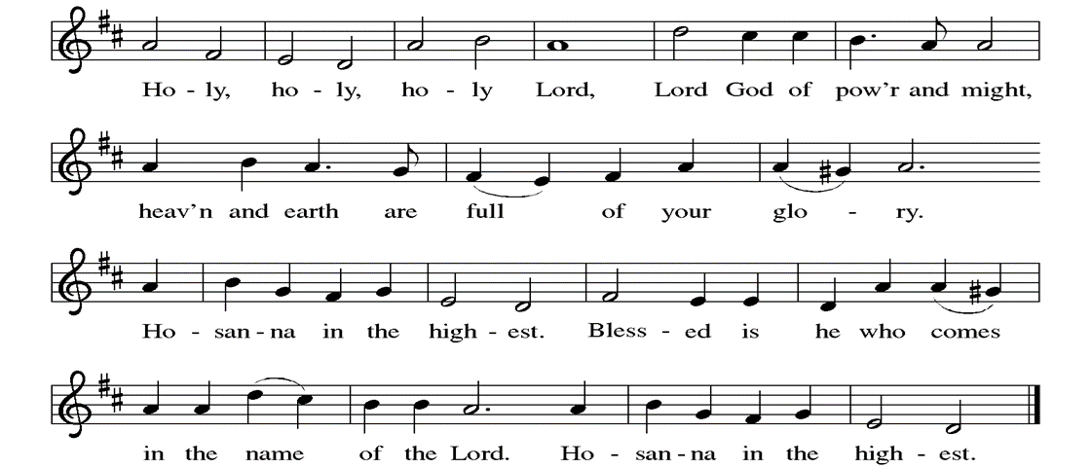

Thanksgiving at the Table

P: Holy God, mighty and merciful, your people praise you, saying: Your mercy endures forever. C: Your mercy endures forever.
P: By your promise you bound yourself to earth and all its creatures, granting them life and calling them to flourish, setting the sign of your bow in the clouds, the colors of your love and faithfulness. Your mercy endures forever.
C: Your mercy endures forever.
P: By your promise you bound yourself to your people of old, blessing them with family outnumbering the stars and calling them to be a blessing to others, showing them steadfast love in every generation and calling them to be a light to the nations. Your mercy endures forever. C: Your mercy endures forever.
P: By your promise you joined us to Jesus, your Beloved, grafting us into your living Vine, and calling us to bear the fruit of your self-giving love. In the night in which he was betrayed, our Lord Jesus took bread, and gave thanks; broke it, and gave it to his disciples, saying: Take and eat; this is my body, given for you. Do this for the remembrance of me. Again, after supper, he took the cup, gave thanks, and gave it for all to drink, saying: This cup is the new covenant in my blood, shed for you and for all people for the forgiveness of sin. Do this for the remembrance of me. With this bread and cup we remember his life laid down and lifted up as we proclaim the mystery of faith.
C: Christ has died. Christ is risen. Christ will come again.
P: Send your Holy Spirit upon us and these gifts of bread and wine. Bless us to be a blessing. Make us a sign of your faithfulness. Send us to tend and cherish the earth and to serve the world with mercy and love. With all the saints in light, with the earth and all its creatures, with sun and moon and stars, we praise you, O God, through Christ Jesus, in your Spirit, now and forever. C: Amen.

Lord’s Prayer
P: Lord, remember us in your kingdom and teach us to pray.
C: Our Father, who art in heaven, hallowed be thy name, thy kingdom come, thy will be done, on earth as it is in heaven. Give us this day our daily bread; and forgive us our trespasses, as we forgive those who trespass against us; and lead us not into temptation, but deliver us from evil. For thine is the kingdom, and the power, and the glory, forever and ever. Amen.

Invitation to the Table
At Parkside Lutheran Church we have an open table. We believe the invitation to receive comes from Jesus himself and all are welcome at Christ’s table. More than just Bread and Wine these are tangible signs of God’s love for you! If you do not wish to receive communion but would like a blessing, come forward and cross your arms over your chest. The Pastor will give you a blessing before you return to your seat via the side aisle. You’ll receive a communion wafer* in your hands. You may dip it in the cup of wine or juice. When giving the bread and cup, the communion ministers say: “The body of Christ, given for you. The blood of Christ, shed for you.”
and each person may respond : Amen
*Please let Pastor know if you need a gluten-free wafer
P: Here is the Lamb of God who takes away the sin of the world! Come to the table; taste and see.

The Communion Distribution

Communion Song ELW setting 4 (p. 154)
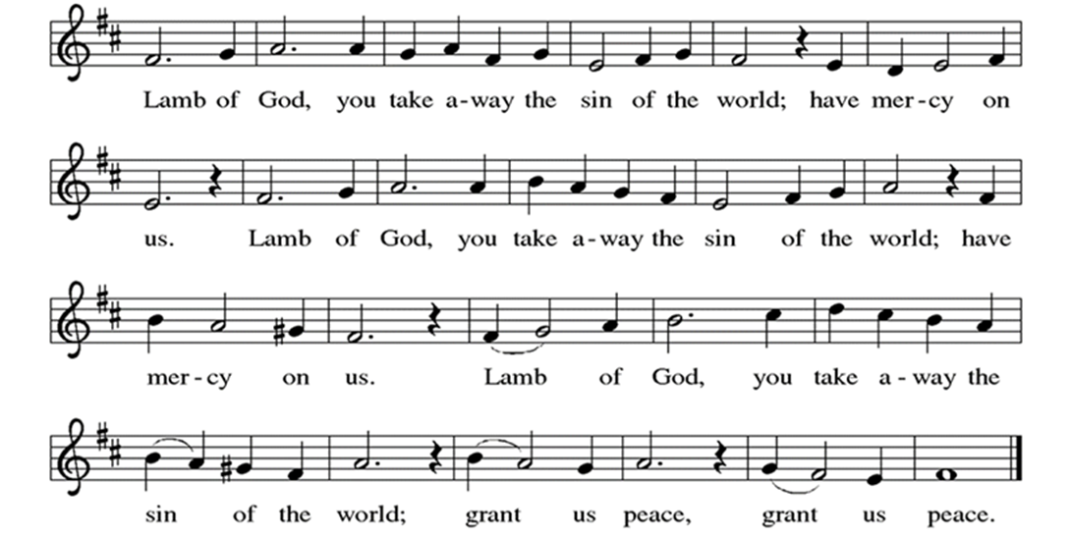

Communion Song: “I Come Expecting Jesus” by John Chisum and Nancy Gordon

Communion Song: Sanctuary
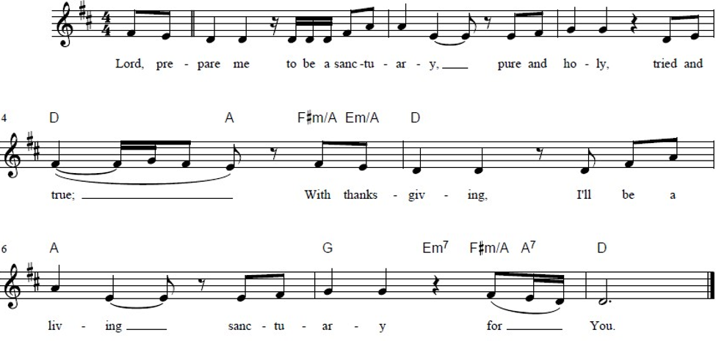

Post Communion Blessing
P: The Body and Blood of our Lord and Savior, Jesus Christ, strengthen you and keep you in God's grace. C: Amen.

Prayer After Communion
WA: Let us pray together.
C: Radiant God, we have seen your glory in the face of Jesus Christ. In the sacrament of his body and blood you have drawn us to your heart. Send us from this table with delight, that our lives may reflect the beauty of your love, and bear witness to all we have seen and heard, through Jesus Christ, our Savior and Lord. Amen.

Sending - God blesses us and sends us in mission to the world.

Blessing
P: The Lord bless you and keep you. The Lord’s face shine on you with grace and mercy. The Lord look upon you with favor and + give you peace. C: Amen

Sending Hymn: Alleluiah, Song of Gladness ELW #318
(printed next page)

Dismissal
P: Parkside Lutheran Church is rediscovering the radical love of Jesus.
C: Gathering All, Serving All, Caring For All
P: Go in peace. Do justice. Love mercy.
C: Thanks be to God.

Postlude: “Rock of Ages” by Rita Baloche

ELW Music licensed from Sundays & Seasons, Augsburg Fortress CCLI MUSIC License # 11440069 , CCLI Streaming License#21835523 Do not duplicate any music or Liturgy herein without license and permission
scripture readings adapted and written by susan lukey

- Sponsor Altar flowers or a Soloist in honor of a loved one
or to mark a special occasion. Contact the office for more info.
PARKSIDE STAFF:
• The Rev. Jeremiah Smith: prjeremiahpsmith@gmail.com
• Kris Pope & Suzanne Gracie, Admin. Assistants (Church Office): parksidelutheran@gmail.com
• Mike Hooker, Music Director: mrhooker@me.com

CHURCH OFFICE HOURS: M/T/R 10:00am-3:00pm (716)836-1361
SCHEDULES and Events:
Acolytes: |  |  | Worship Assistants
2/15 – David & Grace |  |  | 2/15 – Susan
2/22 – Annalie & Lorenzo |  |  | 2/22 – Vince
Readers: |  |  | Ushers:
2/15 – Kathie |  |  | 2/15 - Dave C, Tom S, Charlie R
2/22 – Anne |  |  | 2/22 - Kathy S, Gary S, Joanne N

Coming up:
- TODAY - New Member Informational Lunch with Pastor Jeremiah, after Worship.
- February 18th – 5:30pm Ash Wednesday Dinner & Service with Fellowship and Faschnauts Theology - Bring your own Beverages.
- February 25th - 5:30pm Lenten Dinner & Worship – SIGN UP SHEET IN THE NARTHEX, OR CONTACT THE OFFICE.
- February 27th – Middle School Game Night – 7pm in Stowell Lounge

Visit our website for more information about these and other Events at Parkside – www.parksidelutheran.org/events

