40-Day Lenten Journey through Matthew

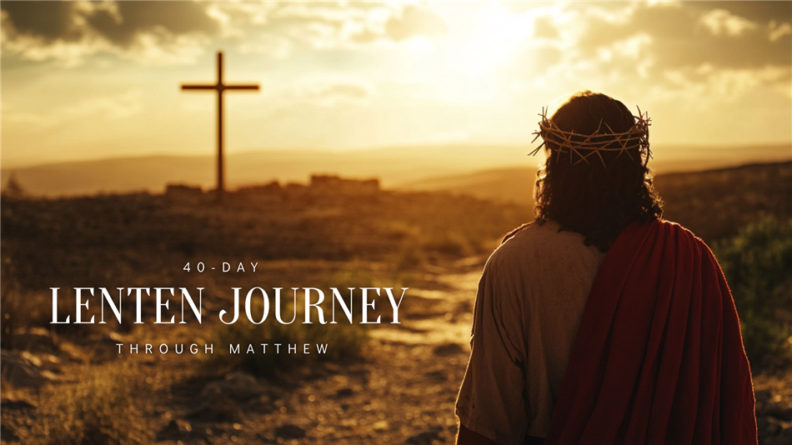

February 18, 2026

As we enter the sacred season of Lent, we invite you to join us on a 40-day journey through the Gospel of Matthew. Beginning on Ash Wednesday, this reading plan will guide us through Jesus' life, ministry, teachings, and ultimately, His sacrifice for us.

Each day, we will reflect on a passage from Matthew, walking together through His genealogy, the Sermon on the Mount, His miracles, parables, and the events leading to the cross. This is a time to grow in faith, deepen our understanding of Christ’s love, and prepare our hearts for Easter.

Find the full reading plan below and follow along with us in prayer and reflection. Let’s walk this Lenten journey together!

Ash Wednesday, February 18
Matthew 1-4: The Genealogy and Birth of Jesus, John the Baptist, Temptation of Jesus
Prayer: Gracious God, as we begin this Lenten journey, we thank You for the gift of Jesus, who came through generations of faithfulness to bring light into our world. Strengthen us, as You strengthened Him in the wilderness, to resist temptation and walk in obedience to Your will.

Thursday, February 19
Matthew 5-7: The Beatitudes, Salt and Light, Teachings on Righteousness, The Lord's Prayer, Warnings and Wisdom
Prayer: Lord, teach us to hunger for Your righteousness and to live as salt and light in a world that longs for Your grace. May Your wisdom guide our hearts, and may we trust in You fully, praying as Jesus taught us, "Your kingdom come, Your will be done."

Friday, February 20
Matthew 8-9: Healing the Leper, Centurion's Servant, Healing Peter’s Mother-in-Law, Calling of Matthew, Paralyzed Man, New Wine in Old Wineskins, Healings and Miracles
Prayer: Jesus, our Healer and Redeemer, we come before You with faith, trusting in Your power to restore and renew our hearts, minds, and bodies. Just as You called Matthew and healed the broken, call us to follow You more deeply and make us vessels of Your mercy and grace.

Saturday, February 21
Matthew 10: The Twelve Apostles and Their Commission, Instructions on Persecution
Prayer: Lord, as You sent Your disciples into the world, send us with courage to proclaim Your love, even in the face of trials. Strengthen our hearts to trust in Your provision and to stand firm in faith, knowing You are always with us.

Monday, February 23
Matthew 11: Jesus’ Message to John the Baptist, Woes to Unrepentant Cities, Jesus’ Invitation to Rest
Prayer: Jesus, in the midst of our doubts and burdens, help us to trust in Your gentle invitation to find rest in You. Soften our hearts to receive Your grace, that we may turn to You with faith and walk in the peace only You can give.

Tuesday, February 24
Matthew 12: Lord of the Sabbath, Healing on the Sabbath, Jesus and Beelzebul, Family of Jesus
Prayer: Lord of the Sabbath, teach us to rest in Your presence and trust in the healing grace You freely give. May we seek to do Your will, knowing that true belonging is found in being part of Your family, shaped by faith and obedience to You.

Wednesday, February 25
Matthew 13:1-23: Parable of the Sower
Prayer: Lord, prepare our hearts to be good soil, ready to receive Your Word and bear fruit that glorifies You. Remove the distractions and doubts that hinder our faith, so that we may grow deeper in Your truth and love.

Thursday, February 26
Matthew 13:24-43: Parables of the Weeds, Mustard Seed, Yeast
Prayer: Lord, even when we see weeds among the wheat, help us trust in Your perfect timing and justice. Grow our faith like the mustard seed, that we may be a sign of Your kingdom’s presence, spreading Your love and grace to the world.

Friday, February 27
Matthew 13:44-58: Parables of the Hidden Treasure, Pearl, the Net
Prayer: Lord, help us to seek Your kingdom above all else, recognizing its priceless worth like a hidden treasure or a precious pearl. Teach us to live with a heart that values what is eternal, embracing Your call to follow You with everything we have.

Saturday, February 28
Matthew 14:1-21: The Death of John the Baptist, Feeding the 5,000
Prayer: Lord, as we remember the sacrifice of John the Baptist, strengthen us to stand firm in our faith, even in the face of hardship. May we also trust in Your abundant provision, knowing that You will feed our souls with all we need to follow You faithfully.

Monday, March 2
Matthew 14:22-36: Jesus Walks on Water, Heals the Sick
Prayer: Lord, when the storms of life surround us, help us to fix our eyes on You, trusting that You will make a way even when it seems impossible. Heal our hearts and souls, that we may find strength in Your presence and bring Your hope to a hurting world.

Tuesday, March 3
Matthew 15:1-20: Traditions of the Elders and What Defiles a Person
Prayer: Lord, cleanse our hearts and minds, that we may not be bound by empty traditions but live in the purity of Your love. Help us to focus on what truly matters—compassion, humility, and faith—that we may honor You with our lives.

Wednesday, March 4
Matthew 15:21-39: Healing the Canaanite Woman’s Daughter, Feeding the 4,000
Prayer: Lord, just as You responded to the faith of the Canaanite woman, grant us the courage to approach You with persistent faith, trusting in Your mercy. May we also be mindful of the needs around us and share generously, knowing You are the source of all our blessings.

Thursday, March 5
Matthew 16:1-12: The Yeast of the Pharisees and Sadducees
Prayer: Lord, guard our hearts from the subtle influences of pride and hypocrisy, and help us to discern the truth You offer. May we be faithful in following You, free from the yeast of division and self-righteousness, and filled with Your pure love.

Friday, March 6
Matthew 16:13-28: Peter’s Confession, Jesus Predicts His Death
Prayer: Lord, like Peter, we confess that You are the Christ, the Son of the Living God; help us to follow You faithfully, even when the path is difficult. Strengthen us to take up our cross and live with the hope of resurrection, trusting in Your promise of eternal life.

Saturday, March 7
Matthew 17:1-13: The Transfiguration
Prayer: Lord, reveal Your glory to us, just as You did to the disciples on the mountaintop, that we may be transformed by Your presence. Help us to listen to Your voice, trusting that in the midst of life’s challenges, You are with us, guiding us to a deeper understanding of Your love.

Monday, March 9
Matthew 17:14-27: Healing the Demon-possessed Boy, Peter and the Temple Tax
Prayer: Lord, as You healed the demon-possessed boy, heal us from the struggles and burdens that bind us, restoring us to wholeness in You. Teach us to trust in Your provision, and may we humbly follow Your example of obedience and faith, even in the smallest of things.

Tuesday, March 10
Matthew 18:1-14: The Greatest in the Kingdom of Heaven, Parable of the Lost Sheep
Prayer: Lord, teach us to humble ourselves like little children, trusting in Your care and love above all else. May we also rejoice with You when the lost are found, reflecting Your grace and compassion to all who are in need of Your saving love.

Wednesday, March 11
Matthew 18:15-35: Instructions on Conflict and Forgiveness
Prayer: Lord, grant us the courage to reconcile with others and the humility to forgive as You have forgiven us. May our hearts be free from bitterness, and may we live in peace, offering grace and healing to those around us.

Thursday, March 12
Matthew 19:1-15: Teachings on Divorce, Blessing of Children
Prayer: Lord, help us to honor the sacredness of relationships, offering grace and healing where there is brokenness. May we also cherish the innocence of children, welcoming them into Your love and blessing, as we seek to build a community of care and compassion.

Friday, March 13
Matthew 19:16-30: The Rich Young Ruler, Rewards for Following Jesus
Prayer: Lord, help us to release the things that hinder us from fully following You, trusting that Your rewards are far greater than anything we can possess. Give us the courage to place our hope in You alone, knowing that in giving up all, we gain everything in Your kingdom.

Saturday, March 14
Matthew 20:1-16: Parable of the Workers in the Vineyard
Prayer: Lord, remind us that Your grace is not earned but freely given, and help us to rejoice in the blessings You provide to all, no matter when they come. May we cultivate hearts of gratitude and humility, trusting that in Your kingdom, all are welcomed with abundant love.

Monday, March 16
Matthew 20:17-34: Jesus Predicts His Death a Third Time, Healing of Two Blind Men
Prayer: Lord, as You predicted Your suffering and death, help us to embrace the cross and follow You with unwavering faith, trusting in Your redemptive power. Open our spiritual eyes, like the blind men, that we may see You clearly and seek Your healing presence in every part of our lives.

Tuesday, March 17
Matthew 21:1-22: The Triumphal Entry, Cleansing of the Temple, Cursing of the Fig Tree
Prayer: Lord, as we welcome You into our hearts, cleanse us of all that does not honor You, making our lives a temple of righteousness. Teach us to bear fruit in Your kingdom, removing the barrenness of sin and living faithfully to Your call.

Wednesday, March 18
Matthew 21:23-32: The Authority of Jesus Questioned, Parable of the Two Sons
Prayer: Lord, help us to recognize Your authority in our lives and respond to Your call with obedience, not just in words but in action. May we turn from our disobedience and follow You faithfully, trusting that Your grace invites us back to Your loving embrace.

Thursday, March 19
Matthew 21:33-46: Parable of the Tenants
Prayer: Lord, help us to be faithful stewards of the gifts You have entrusted to us, living in a way that honors Your kingdom. Keep our hearts humble and open to Your call, so that we may produce the fruit of righteousness and bring glory to Your name.

Friday, March 20
Matthew 22:1-14: Parable of the Wedding Feast
Prayer: Lord, invite us to Your heavenly feast, where we may be clothed in Your righteousness and welcomed into Your eternal presence. Help us to honor Your invitation with humility and gratitude, living each day in readiness for the joy You promise to all who follow You.

Saturday, March 21
Matthew 22:15-22: Paying Taxes to Caesar
Prayer: Lord, help us to honor our earthly responsibilities while keeping our ultimate allegiance to You and Your kingdom. Give us wisdom to navigate the world with integrity, always seeking to align our hearts and actions with Your will.

Monday, March 23
Matthew 22:23-40: The Greatest Commandment
Prayer: Lord, teach us to love You with all our heart, soul, and mind, and to love our neighbors as ourselves. May this commandment guide our every thought and action, drawing us closer to You and to one another in true unity.

Tuesday, March 24
Matthew 22:41-46: Jesus’ Question About David’s Son
Prayer: Lord, reveal to us the depth of who You are, that we may understand You as both Son of David and Lord of all. Help us to recognize Your authority in every aspect of our lives, and to follow You with hearts fully surrendered to Your will.

Wednesday, March 25
Matthew 23: Woes to the Pharisees
Prayer: Lord, guard our hearts from the pride and hypocrisy that lead us astray, and help us to seek humility and sincerity in our relationship with You. May we live with integrity, serving You and others with love, rather than seeking recognition or honor for ourselves.

Thursday, March 26
Matthew 24: The Olivet Discourse
Prayer: Lord, in the midst of uncertainty and trials, help us to stay watchful and ready for Your return, trusting in Your promises. Strengthen our faith to endure and remain steadfast, knowing that Your kingdom is near and Your love never fails.

Friday, March 27
Matthew 25: Parable of the Ten Virgins, Parable of the Talents, The Sheep and the Goats
Prayer: Lord, help us to keep our lamps burning brightly, ready for Your return with hearts faithful to Your call. May we use the gifts You’ve entrusted to us wisely, serving others in love and compassion, that we may hear, "Well done, good and faithful servant."

Saturday, March 28
Matthew 26:1-16: The Plot Against Jesus, Anointing at Bethany
Prayer: Lord, as the plot against You unfolded, help us to remain steadfast in our faith, trusting in Your ultimate plan of redemption. May we, like the woman who anointed You, offer our lives in extravagant love and devotion, giving all we have to honor You.

Palm Sunday, March 29
Matthew 26:17-30: The Last Supper
Prayer: Lord, as we remember the Last Supper, help us to approach Your table with humility and gratitude, recognizing the deep love You have shown for us. May we take and eat in remembrance of You, drawing closer to Your sacrifice and sharing in the unity You offer through Your body and blood.

Holy Monday, March 30
Matthew 26:31-46: Jesus Predicts Peter’s Denial, Gethsemane
Prayer: Lord, in our moments of weakness, when we deny You or fall short, remind us of Your grace and restore us with Your forgiving love. Strengthen us to pray and stay awake in the face of temptation, trusting in Your will, just as You did in Gethsemane.

Holy Tuesday, March 31
Matthew 26:47-56: The Arrest of Jesus
Prayer: Lord, as You were arrested and betrayed, help us to remain faithful in times of trial and not to shrink back in fear. Strengthen us to stand firm in Your love, trusting that even in the darkest moments, Your plan of redemption is unfolding.

Holy Wednesday, April 1
Matthew 26:57-75: Jesus Before the Sanhedrin, Peter Denies Jesus
Prayer: Lord, when we falter in our faith or deny You in our actions, lift us up with Your mercy and restore our courage. Help us to stand firm in Your truth, and like Peter, may we repent and return to You, knowing You are always ready to forgive.

Maundy Thursday, April 2
Matthew 27:1-26: Judas Hangs Himself, Jesus Before Pilate, The Crowd Chooses Barabbas
Prayer: Lord, in moments of regret and despair, help us to seek Your forgiveness rather than turning away, trusting in Your grace to heal our brokenness. Strengthen us to stand with You, even when the world turns its back, choosing the path of righteousness over the easy way of the crowd.

Good Friday, April 3
Matthew 27:27-66: The Soldiers Mock Jesus, The Crucifixion, The Death of Jesus, The Burial of Jesus
Prayer: Lord, as we reflect on Your suffering and death, help us to grasp the depth of Your love for us, shown in the sacrifice of Your life. May we live in gratitude for Your gift, finding new life in Your resurrection and living out the hope You offer through Your victory over death.

Adapted from the Florida Annual Conference of the UMC

