This Week at PPBC
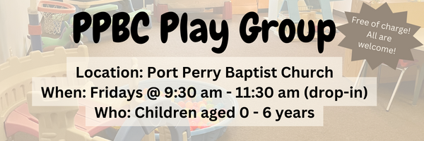





February 14th, 2026

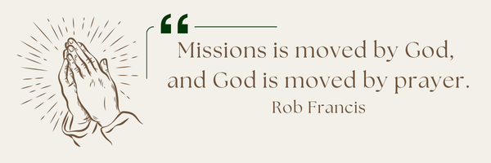
A Prayer Request from Maria: Please pray for the salvation of Miguel from Argentina, who is very catholic and represents Maria and the tenants for the tenant association of her building. He does not have family in Canada. Maria had a long bout of illness through December. She is much better now but would appreciate prayer for continued healing and strength.

Notes

Sunday Ministry Schedules
Below are ministry schedules for Nursery, Jr. Church, Greeters, Ushers, and Sound & Video:
Nursery
Feb 8: Jan Gerrow, Hannah Colwell
Feb 15: Brenda Clemens, Audrianna Angrove
Infant Nursery
Feb 8: Lisa Dallas, Elise Anderson
Feb 15: Kathryn denOuden, Karis Henkelman
Jr. Church; ages 3 to grade 1
Feb 8: Deb Brown, Mikayla Ferguson
Feb 15: Ellianne McLaren, Hailey Ferguson
Jr. Church; Grades 2 to 6
Feb 8: Kate Anderson, Tiffany Green
Feb 15: TBA, Graeme Anderson
Greeters
Feb 8: Tracy & Karen Ballanger
Feb 15: Paul & Helen Jones
Ushers
Feb 8: Graeme Foster, Leno Araujo
Feb 15: Nick Woytowich, Matt Saunders
Sound & Video
Feb 8: Sound: Wyatt Werner | Video: Josh Myers
Feb 15: Sound: Charlie Deane | Video: William Conley
Thank You
The Faber family would like to thank Port Perry Baptist Church for their love, prayers, outreach, cards and care during Ada's (our mother's) time of need.

Morning Service
Song – To God Be the Glory
Welcome
Song – Come People of the Risen King
Scripture
Song – All My Ways
Song – Blessed Assurance
Prayer
Message – Pastor Jim Clemens
Song – You Made Us Your Own

PPBC Members Meeting
Sunday, March 1, 2026
We will be meeting in the sanctuary. All are Welcome.
4:00pm – Meeting

Praise & Prayer Highlights
PRAY for Joan Mabley who has been moved home. Please PRAY for her and her family as they organize a care plan for her. PRAY for Joan’s comfort and peace.
PRAY for John & Joan Mank and their ongoing health concerns. PRAY for John who has some medical tests this week.
PRAY for Martin & Tina McCurley and their ongoing health concerns.
PRAY for Bert Faber and the family as the mourn Ada's passing. PRAY that God will give them great comfort in Christ and that the truth of the Gospel will shine through this loss.
PRAY for Betty & Ray Collins and their ongoing health concerns.
PRAY for New Song Church & Port Perry Baptist as they plan to co-host a Christianity Explored outreach at That Place on Queen in the new year. Please PRAY for God to prepare the hearts of those who will attend from the community to receive the gospel.
PRAY for Shelley VanUden and her nieces family and their ongoing health concerns with their children. PRAY for their daughter Bryte who has been moved to Hospice care. PRAY for the family and for Brytes pain and quality of life.
PRAY for Brian and Janine Kovack. Brian is dealing with a serious infection. PRAY for Brian's healing and that the doctors and nurses would have wisdom and discernment in their care for him.

Giving
Just as a reminder, there are several ways you can give:
In Person using the offering box located on the back wall of the sanctuary. Donation envelopes are available at the Welcome Centre. Please contact the church office if you would like a box of donation envelopes (office@portperrybaptist.ca)
Through your online banking, you may send electronic transfers to ppbcdonations@gmail.com.
You can also give through Canada Helps. Donation receipts will be provided by Canada Helps, and transaction fees apply.
***********************************************************************
Weekly Newsletter
The PPBC Newsletter is emailed to the church family every Friday. If you would like to be added to the weekly email list, please contact the office by phone: 905-985-8681 or by email: office@portperrybaptist.ca.
*****************************************************************
Church Information:
Location:
2210 Hwy 7A
Port Perry, ON
L9L 1B4
Office Hours:
Monday: 8:30am – 4:00pm
Tuesday: 8:30am – 4:00pm
Wednesday: Closed
Thursday: 8:30am – 4:00pm
Friday: 8:30 am - 3:00 pm
Contact:
Phone: 905.985.8681
Email: office@portperrybaptist.ca
Website: www.portperrybaptist.ca
Staff:
Sr. Pastor – Rev. Jim Clemens
Administrative Assistant – Madeline Werner
Family Ministries Director – Josh Anderson
Pastoral Intern – Scott McKenzie

PPBC Newsletter
Sunday, February 8, 2026


Sunday Starting Point
Sunday, February 8, 2026 - 9:30 am
“Beginning the day with the Word and prayer”
Adults:
Adults will meet in the sanctuary for a time of study and prayer.
Youth:
Jr High (Grades 7-8) will meet in room 18 with Kate Anderson to study Ecclesiastes.
Children:
Children ages 3 - grade 6 will meet in room 26.
(Please note nursery is unavailable during Starting Point)
Sunday Morning Worship
Sunday, February 8, 2026 - 10:30 am
We are meeting in the sanctuary and will continue to live-stream for those who are unable to attend.
Message: To the Church of God
Scripture: 1 Corinthians 1:1-9
Pastor Jim Clemens

