



Sunday 8 February 2026, Epiphany 5
Morning Prayer
Service outline, Parish News & Events

8.00 am MORNING PRAYER _____________________
Officiant: Mark Laidlaw
Preacher: Jennifer Sharlow

9.30 am MORNING PRAYER ___________________
Officiant: Mark Laidlaw
Preacher: Jennifer Sharlow
The Gathering of the Community
Worship Songs
Welcome
Territorial Acknowledgement
Greeting
Invitatory – Venite (Come, let us sing to the Lord)
Song of Praise Seek Ye First
The Story of Faith is Proclaimed
First Reading: 1 Corinthians 2:1-12 (13-16)
Psalm 112:1-9
Gradual Hymn
Gospel: Matthew 5:13-20
Sermon
A short period of silent reflection follows,
signalled by the sound of a bell
Affirmation of Faith – the Apostles’ Creed
Prayers of the People
Prayer of Thanksgiving
Collect
The Peace BAS 192
Offertory Hymn
Prayer over the Tithes and Offerings BAS 354
Doxology (Praise God from whom all blessings flow)
Prayer for Sundays
The Lord’s Prayer
Announcements and Birthday Box
Blessing
Closing Song
Sending


Welcome to St Philip!
Please join us for coffee and fellowship after the service.
The abbreviation BAS in the service order refers to page numbers in the Book of Alternative Services, the green volume in the pews. CP is Common Praise, the blue hymn book.

Offering
It is Anglican custom to receive a financial offering in our worship, as an expression of gratitude to God. Please do not feel compelled to participate in this offering. Your presence is gift enough.

Services this week
8 February 2026 – Epiphany 5
8 am Morning Prayer.
Officiant: Mark Laidlaw. Preacher: Jennifer Sharlow.
9am Community Prayers downstairs in the youth room
9.30am Morning Prayer, in-person & streamed via Facebook Live
Officiant: Mark Laidlaw.
Preacher: Jennifer Sharlow.
Altar Guild: Felicity, Beth
Usher: Susan Smith
Musicians: Dana, Jenni, Merle, Christina
Children's ministry: Melinda Weicker
Readers: Joe Weicker, Bruce Richmond
Prayers of the People: Chris Harvey
Chalice bearer: Catherine Morris Scambler
Powerpoint slides: Clayton Savage, Neil Ryan
Facebook Live: Karishma Iyer
Coffee: Lillian Konkin, Jennifer Clarke
Offerings Counters: Norma and Leslee
10 Feb Tuesday 10:30 am Contemplative Prayer
12 Feb Thursday no service or study
Fr. Allen will be away 8-13 Feb.
The Lord’s Prayer: Reflections on the Petitions - an invitation for lent
We've been invited to join with Holy Trinity, North Saanich (The Rev. Denise Doerksen) for a series of Lenten devotionals. The announcement is self-explanatory and should be very meaningful for all who join up. - Fr. Allen
Join us this Lent as we embark on a gentle 7-week study of the petitions in the Lord’s Prayer. This is a course designed for everyone who ever wanted to dig a bit more deeply into the words we pray together every Sunday.
It is an email-based course and material will be sent every Monday, Wednesday and Friday; beginning on Ash Wednesday. In each email you will find some art, a reflection on part of the prayer – beginning with “Our Father”, and a link to some music to help guide your meditation on the topic.
The course is based on the book Prayer by Karl Barth but can be enjoyed with or without reading the book. It is a self-paced and self-directed course with the opportunity to do as much or as little as you wish. We will offer a Zoom meeting every two weeks if you are interested to talk about what we have been studying.
To register please email the Rev. Denise at incumbent@holytrinity.org . Feel free to share the emails with anyone you think would like to read them!

Treasurer’s update – January 2026
Dear Members of the St. Philip’s Family,
Please find a summary of parish income and expenses for January 2026 below. Financial summaries/updates for the past year are available on the parish website under About Us > Parish Documents, and in print form in the purple file marked 'Parish Council minutes' on the notice board downstairs. All financial summaries are available in electronic or print format at any time on request to the office: admin@stphilipvictoria.ca
I ask that you keep our parish mission in your prayers for the New Year, and that with the Vestry meeting coming up you consider whether you feel called to serve the parish on Council, as a Synod delegate, or in another capacity.
In faith,
Mark Laidlaw
Treasurer, St. Philip’s Oak Bay

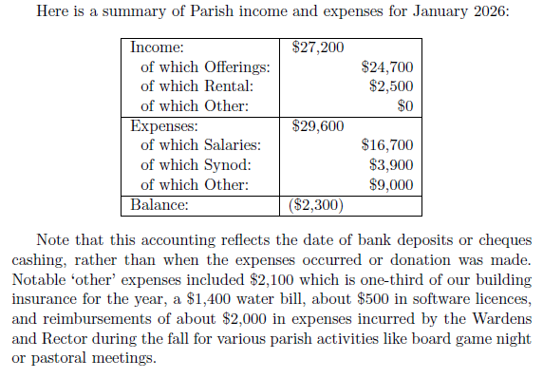
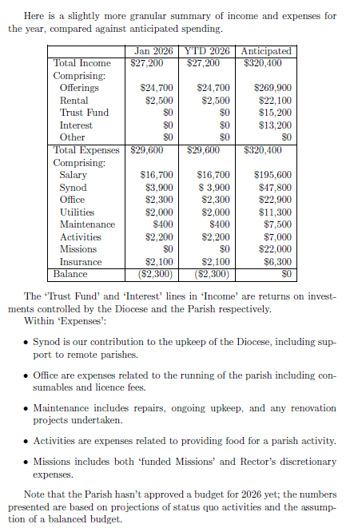
Update from the Gleams of Hope Refugee Sponsorship: Medical News and an Appeal for Further Support
The Gleams of Hope Refugee group are thrilled to report that we have now deposited with the Inter Cultural Association all the necessary funds to bring the Syrian Palestinian widow and her two daughters to Canada. This is a major accomplishment and could not have happened without the generosity of people at St Philip and the wider community. The Gleamers thank you all for your open hearts and gifts.
Unfortunately, the mother’s health continues to be a struggle. She has Stage 4 metastatic breast cancer. She has completed chemotherapy, all costs covered to date, and is waiting for surgery on February 23rd. Please keep her and her daughters in your prayers.
The surgery will be approximately an additional $9,000. To date, we have almost enough in our VanCity bank account to cover that. However, we humbly ask for you to consider donating again to insure we have sufficient funds to cover the surgery and any post-surgical costs. Please remember that none of the donations for her health care are tax deductible.
Donations can be made directly by cheque or e-transfer to the Gleams of Hope Refugee Support account.
Here are the details for setting up the e-transfer:
Name GLEAMS OF HOPE REFUGEE SUPPORT
Email gleamsofhope25@gmail.com
By Email
Cheques written to Gleams of Hope Refugee Support can be left with Dave Conway or the office. For more information please speak to Dave at church or email him at zdconway@shaw.ca
Palm crosses
It's that time of year again - please bring any old palm crosses to church and leave them in the basket in the narthex, for making into this year's ashes for Ash Wednesday (17 Feb).
St Luke Cedar Hill: Reflections - Seabreeze Trio, 8 Feb 4.30pm
This month's Reflections will feature the Seabreeze Trio, along with poems and prayers. Please join us for a unique and uplifting service of beautiful music and inspirational words, conducive to meditative reflection and spirituality. Drawing on the tradition of evensong, the service recognizes our need for stillness and connection to the soul at the end of the day.
The Seabreeze Trio has been gaining a local reputation as a remarkably versatile group. They cover well-known songs from many decades in a wide range of styles from folk and country to jazz and pop. They comprise guitarist and vocalist Fraser Kerley, drummer and vocalist Freddy Brown, and bass player and vocalist Dave Conway.
Sunday 8 February, 4.30pm, 3805 Cedar Hill X Rd. By donation.
Mark Heim articles - from midweek study
Following last week's Zoom session with Mark Heim, author of this winter's midweek study book Saved from Sacrifice, Mark has shared two of his articles on similar themes, published in The Christian Century:
- Visible victim: Christ's death to end sacrifice
- Christ crucified: Why does Jesus’s death matter?
Printed copies are available in the narthex/on request.
Tax receipts
2025 tax receipts are ready to pick up in the narthex, arranged alphabetically by surname. Given the price of stamps these days, please remember to pick up your receipt if you are able! Receipts not picked up will be mailed mid Feb.
Contemplative Prayer
Please join us on Tuesday mornings, 10:30 - 11:30, meeting in the choir area of the nave (at the front of the church), for a 20 minute contemplative sit with a time of prayer following.

Our Place Lunch
The Missions fund at St Philips sponsored a meal at "Our Place" on January 28th. A team of parishioners - Florie, Liz, Ceal, Barb, Clayton and Evelyn - served up and cleaned up after the lunch meal. The meal was Taco chips with a meat/bean mix with cheese sauce, salsa/sour cream sauce and coleslaw. This lunch was well received by the Friends at Our Place, so much so that many came back for seconds or thirds! Many thanks to all that serve at Our Place to serve those in need, and to all St Philip's parishioners who donate their time and funds to make this possible.
- Evelyn Savage
Drop-in Knitting Evening - Thursday, February 12, 2026
Bring your knitting project (or your mending basket) Thursday, February 12, 7:00 - 8:30 pm at the Richmonds'. Enjoy a cup of tea and if it’s a blustery night, a fire in the fireplace. If you don’t know how to knit, someone will be there to get you started, or help you out if you get tangled! Contact Sharon for the address.
UVic lectures: The City Talks - An interview with the Rev. Maggie Helwig - Thursday, February 12, 2026
As part of the University of Victoria's The City Talks lecture series, Anglican priest and author Maggie Helwig (Encampment: Resistance, Grace, and an Unhoused Community) will be in conversation with Gregor Craigie, host of CBC's On the Island and author of Our Crumbling Foundation: How We Solve Canada's Housing Crisis.
This event is being held at United Commons (932 Balmoral Road) on Thursday, February 12, 2026 at 7 PM. The event is free and open to the public.
The housing crisis has sent countless people into the streets. In spring 2022, some of them pitched tents, formed an encampment, and settled into the yard beside the Toronto Anglican church where Maggie Helwig is the priest. She has spent the last three years getting to know the residents and fighting to allow them to stay. Her book confronts our society's callousness in allowing so many to go unhoused and demands, by bringing their stories to the fore, that we begin to respond with compassion and grace.
Community Karaoke Night - Friday, February 13, 2026
We have the microphones, the songs, the snacks and the (non-alcoholic) drinks, and all we need is you! Feel free to bring your friends, families, snacks and (non-alcoholic) drinks with you as well, because this is an all age karaoke event!
Date: 2nd Fridays of the month: 13 Feb, 13 March, 10 April 2026
Location: downstairs hall at St Philip’s Anglican Church @ 2928 Eastdowne Road, Victoria, BC, V8R 5R8 - step-free ramp entrance from the parking lot. Follow the sign!
Feel free to drop in or leave at any time. You can access the church within walking distance through buses 4, 9, 7, 11, and 15.
See you then! If you have any questions, please reach out to Anderson at bvsdawnofnewyear@gmail.com!
Shrove Tuesday Pancake Supper - Tuesday, February 17, 2026
We hope that many of you will come together for this year’s Shrove Tuesday Pancake dinner on February 17th. This is a great opportunity to share a casual meal with our church community and family, friends or neighbours.
To make this evening possible, a Coordinator or Coordinators are needed to organize the dinner. Others will be needed to help prepare the food, serve, set up and take down.
We are planning 2 sittings, 5:00 p.m. and 6:30 p.m. Please consider if you might make this year’s dinner a success by accepting a coordination role. We are looking forward to hearing from you! Detailed notes from previous dinners are available to guide you in organizing this dinner.
Please let us know as soon as possible (jarmstrong@stphilipvictoria.ca and lanthony@stphilipvictoria.ca)
With gratitude.
Judith and Larry.
Ash Wednesday, 18 February - the season of Lent begins
Ash Wednesday services at St Philip:
- 10am Holy Eucharist with imposition of ashes
- 5pm family & youth friendly service with imposition of ashes (no Eucharist).
St Philip Parish Vestry: Annual General Meeting & Annual Reports - Tues February 24, 2026
Thank you to all who have sent in their annual reports - the rest are due, please! If you organized or led a group, team, or event at St Philip in 2025, we want to hear about it. Even a line or two helps to create a picture of this year in our life together. There is no word limit, but reports don't need to be long or formal. If you haven't written one before or need help, please ask Anna in the office. Please send as plain text to admin@stphilipvictoria.ca so I can collate, print and circulate them ahead of the meeting.
Prayers & readings for Sun 8 February & the following week:
We pray for Anna, our bishop, and Allen, our rector. In our parish cycle of prayer, we pray for the Parish Council.
This week our diocese prays for the Diocesan Council and for Parish Councils .
In our ecclesiastical province's cycle of prayer, we pray for the Diocese of Yukon .
This week the Anglican Church of Canada prays for The Rt. Rev. John Watton, Bishop, and the people and clergy of the Diocese of Central Newfoundland; for a growing openness to dialogue and encounter with people of other faith traditions during World Interfaith Harmony Week.
In the Anglican Communion cycle of prayer, we pray for the Hong Kong Sheng Kung Hui.
Collect: Merciful Lord, grant to your faithful people pardon and peace, that we may be cleansed from all our sins and serve you with a quiet mind; through Jesus Christ our Lord, who is alive and reigns with you and the Holy Spirit, one God, now and for ever . (BAS)
Anglican Communion Cycle of Prayer for the week:
- Mon 9 Feb The Diocese of South West Tanganyika – Tanzania
- Tues 10 Feb The Diocese of Western Tanganyika - Tanzania
- Wed 11 Feb The Diocese of Tarime – Tanzania
- Thurs 12 Feb The Diocese of Tasmania – Australia
- Fri 13 Feb The Diocese of Taungoo – Myanmar (Burma)
- Sat 14 Feb The Diocese of Temotu – Melanesia
Lectionary for Sunday 8 February: Isaiah 58:1-9a (9b-12); Psalm 112:1-9 (10); 1 Corinthians 2:1-12 (13-16); Matthew 5:13-20
- Mon 9 Feb Ps 119:105-112; 2 Kings 22:3-20; Romans 11:2-10
- Tues 10 Feb Ps 119:105-112; 2 Kings 23:1-8, 21-25; 2 Cor 4:1-12
- Wed 11 Feb Psalm 119:105-112; Prov 6:6-23; John 8:12-30
- Thurs 12 Feb Psalm 2; Exodus 6:2-9; Hebrews 8:1-7
- Fri 13 Feb Psalm 2; Exodus 19:9b-25; Hebrews 11:23-28
- Sat 14 Feb Psalm 2; 1 Kings 21:20-29; Mark 9:9-13
Cover image: Jupiterimages on Canva (alt). Canva Non-Profit license.

Rector: Rev. Allen Doerksen (incumbent@stphilipvictoria.ca,
work cell 236-508-2928; day off: Friday)
Warden: Judith Armstrong (jarmstrong@stphilipvictoria.ca)
Warden: Larry Anthony (lanthony@stphilipvictoria.ca)
Parish Office Hours: Mon 1-4.30, Wed & Thurs 9-4.30
250-592-6823 | admin@stphilipvictoria.ca
Facebook including live streams: https://www.facebook.com/stphilipoakbay
Instagram: https://www.instagram.com/stphilipoakbay/
Thank you for avoiding scented products at church.

