Holy Trinity Lutheran Church
150 River Road Red Bank, NJ 07701
Church Office: (732) 741-9241 Fax: (732) 741-9577
email: holytrinitychurch4@verizon.net
Website: htlcredbank.org
Pastor: Rev. John Mack, Jr.
Cell: (336)-392-5839
Minister of Music: Peter Isherwood
Parish Administrator: Deanna Vergari
Council President: Cynthia Kazmac

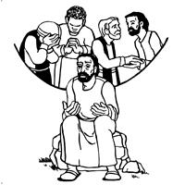

February 01, 2026

Fourth Sunday after Epiphany

Introduction

Who are the blessed ones of God? For Micah, they are those who do justice, love kindness, and walk humbly with God. For Paul, they are the ones who find wisdom in the weakness of the cross. For Jesus, they are the poor, the meek, the merciful, the pure in heart, the peacemakers, those who mourn, and those who hunger for righteousness. In baptism we find our blessed identity and calling in this countercultural way of living and serving.

Welcome & Announcements (Please remember to silence your cell phone!)

Prelude (We prayerfully prepare our hearts and minds to worship!)

+ GATHERING +

Confession and Forgiveness
All may make the sign of the cross, the sign that is marked at baptism, as the presiding minister begins.
P:Blessed be the holy Trinity, ☩ one God,
the Creator of heaven and earth,
the Word who spoke life into being,
the Wind stirring the waters.
C:Amen.
P:Let us turn in confession to the one who knows us completely.
Silence is kept for reflection.
Mighty God, lover of justice,
C:you call us to life in community,
but we have served our own interests
at the expense of our neighbors.
We have sown deceit where honesty was needed.
We say the right words,
but our hearts are far from you.
Turn us to seek your face.
Knit us together and give us the mind of Christ,
that we may do justice, love mercy,
and walk humbly with you, our God.
Amen.
P:The former things have passed away,
and new things God now declares:
Like a spring of water that never fails,
God covers you in the righteousness of Christ,
and forgives your sin in ☩ Jesus’ name.
May the Spirit give you strength to live for others,
and bless you with the gift of peace.
C:Amen.

*Gathering Hymn ELW 507 O God of Light
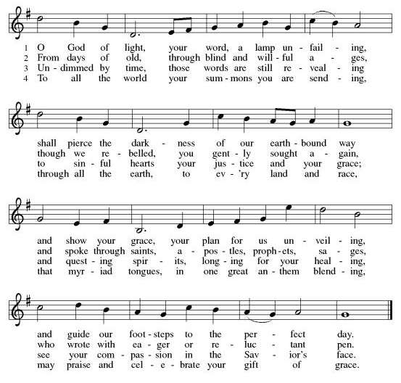

*Pastoral Greeting

P: The Grace of our Lord Jesus Christ, the love of God, and the communion of the Holy Spirit be with you all.

C: And also with you!

Hymn of Praise

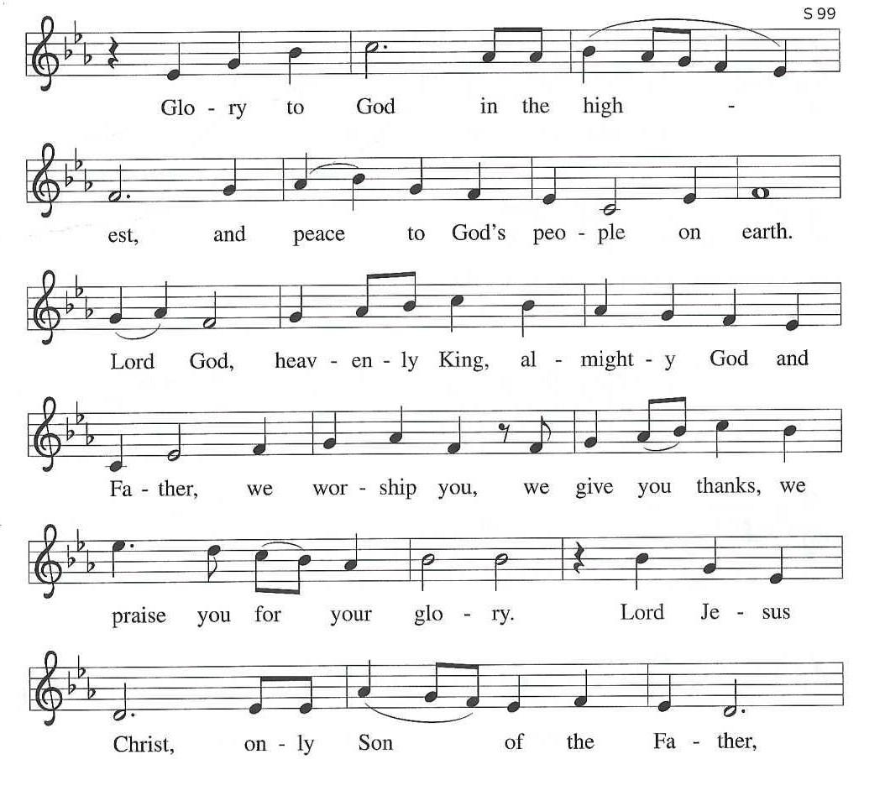

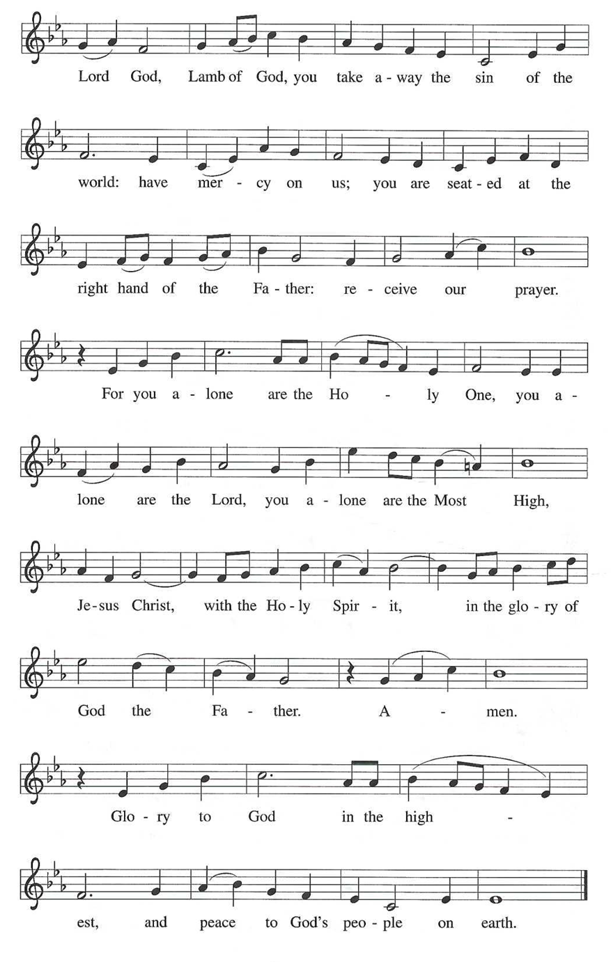

*Prayer of the Day
P: Holy God, you confound the world’s wisdom in giving your kingdom to the lowly and the pure in heart. Give us such a hunger and thirst for justice, and perseverance in striving for peace, that in our words and deeds the world may see the life of your Son, Jesus Christ, our Savior and Lord.
C: Amen!

+WORD+

First Reading Micah 6:1-8
With the mountains and the foundations of the earth as the jury, God brings a lawsuit against Israel. God has “wearied” Israel with a long history of saving acts. God does not want or expect lavish sacrifices to attempt to earn divine favor. Rather God empowers the people to do justice, to love loyalty to God, and to walk shrewdly in God’s service.
¹ Hear what the Lord says:
Rise, plead your case before the mountains,
and let the hills hear your voice.
² Hear, you mountains, the case of the Lord,
and you enduring foundations of the earth,
for the Lord has a case against his people,
and he will contend with Israel.
³ “O my people, what have I done to you?
In what have I wearied you? Answer me!
⁴ For I brought you up from the land of Egypt
and redeemed you from the house of slavery,
and I sent before you Moses,
Aaron, and Miriam.
⁵ O my people, remember now what King Balak of Moab devised,
what Balaam son of Beor answered him,
and what happened from Shittim to Gilgal,
that you may know the saving acts of the Lord.”
⁶ “With what shall I come before the Lord
and bow myself before God on high?
Shall I come before him with burnt offerings,
with calves a year old?
⁷ Will the Lord be pleased with thousands of rams,
with ten thousands of rivers of oil?
Shall I give my firstborn for my transgression,
the fruit of my body for the sin of my soul?”
⁸ He has told you, O mortal, what is good,
and what does the Lord require of you
but to do justice and to love kindness
and to walk humbly with your God?

Psalm: Psalm 15
Lord, who may abide upon your holy hill? (Ps. 15:1)

¹ Lord, who may dwell in your | tabernacle?
Who may abide upon your | holy hill?
² Those who lead a blameless life and do | what is right,
who speak the truth | from their heart;
³ they do not slander with the tongue, they do no evil | to their friends;
they do not cast discredit up- | on a neighbor.
⁴ In their sight the wicked are rejected, but they honor those who | fear the Lord.
They have sworn upon their health and do not take | back their word.
⁵ They do not give their money in hope of gain, nor do they take bribes a- | gainst the innocent.
Those who do these things shall never be | overthrown.

Second Reading: 1 Corinthians 1:18-31
According to the world’s standards of power and might, the message of the cross seems stupid and offensive. Yet this word reveals the paradoxical way God has chosen to work power and salvation through weakness, rejection, and suffering. Hence the message of the cross becomes true wisdom and power for believers.

¹⁸ The message about the cross is foolishness to those who are perishing, but to us who are being saved it is the power of God. ¹⁹ For it is written,
“I will destroy the wisdom of the wise,
and the discernment of the discerning I will thwart.”
²⁰ Where is the one who is wise? Where is the scholar? Where is the debater of this age? Has not God made foolish the wisdom of the world? ²¹ For since, in the wisdom of God, the world did not know God through wisdom, God decided, through the foolishness of the proclamation, to save those who believe. ²² For Jews ask for signs and Greeks desire wisdom, ²³ but we proclaim Christ crucified, a stumbling block to Jews and foolishness to gentiles, ²⁴ but to those who are the called, both Jews and Greeks, Christ the power of God and the wisdom of God. ²⁵ For God’s foolishness is wiser than human wisdom, and God’s weakness is stronger than human strength.
²⁶ Consider your own call, brothers and sisters: not many of you were wise by human standards, not many were powerful, not many were of noble birth. ²⁷ But God chose what is foolish in the world to shame the wise; God chose what is weak in the world to shame the strong; ²⁸ God chose what is low and despised in the world, things that are not, to abolish things that are, ²⁹ so that no one might boast in the presence of God. ³⁰ In contrast, God is why you are in Christ Jesus, who became for us wisdom from God, and righteousness and sanctification and redemption, ³¹ in order that, as it is written, “Let the one who boasts, boast in the Lord.”

Gospel Acclamation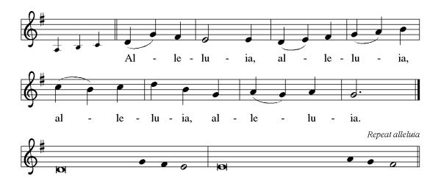

P: The Holy Gospel According to St. Matthew 5th Chapter
C: Glory to You O Lord!

Gospel: Matthew 5:1-12
Jesus opens the Sermon on the Mount by naming those who are blessed in the reign of God.

¹ When Jesus saw the crowds, he went up the mountain, and after he sat down, his disciples came to him. ² And he began to speak and taught them, saying:
³ “Blessed are the poor in spirit, for theirs is the kingdom of heaven.
⁴ “Blessed are those who mourn, for they will be comforted.
⁵ “Blessed are the meek, for they will inherit the earth.
⁶ “Blessed are those who hunger and thirst for righteousness, for they will be filled.
⁷ “Blessed are the merciful, for they will receive mercy.
⁸ “Blessed are the pure in heart, for they will see God.
⁹ “Blessed are the peacemakers, for they will be called children of God.
¹⁰ “Blessed are those who are persecuted for the sake of righteousness, for theirs is the kingdom of heaven.
¹¹ “Blessed are you when people revile you and persecute you and utter all kinds of evil against you falsely on my account. ¹² Rejoice and be glad, for your reward is great in heaven, for in the same way they persecuted the prophets who were before you.”

P: The Gospel of the Lord
C: Praise to you, O Christ!

Sermon

*Hymn of the Day ELW 514 O Word of God Incarnate
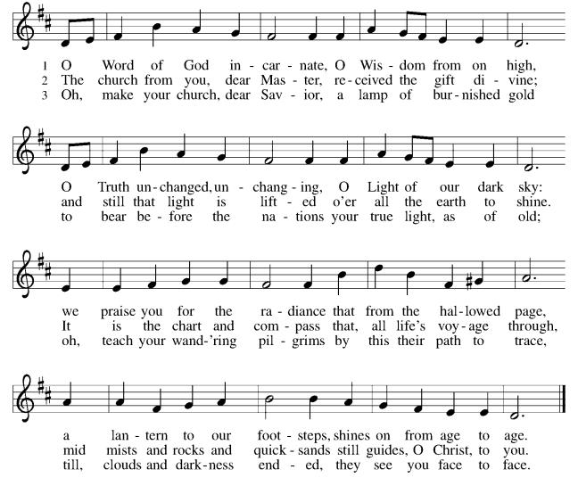

Reception of New Members
(Prefaced with a brief introduction of new members)

P:These persons have come to us from other worshipping
communities and walks of life, and they desire to become
fellow disciples and members within and among this
community of faith.

Dear friends, we rejoice that you now desire to make public
profession of your participation in the mission and ministry of
Holy Trinity Evangelical Lutheran Church, and assume greater
Responsibility in the life of God’s Christian community, a merciful gift given to you —a gift for the world.

As baptized Christians, God’s promises of forgiveness,
faithfulness and salvation shape our lives inviting us:
to live among God’s faithful people,
to hear God’s Word and share in the Lord’s Supper,
to proclaim the good news of God in Christ through
word and deed,
and to serve all people, following the example of
our Lord Jesus striving for justice and peace
in all the earth.

Do you intend to continue in this covenant God made with you
in Holy Baptism? If so, answer “I do, and I ask God to help
and guide me.”
R: I do, and I ask God to help and guide me.

C:We welcome you as ministers and members of Holy
Trinity Evangelical Lutheran Church to join with us:
in worship celebrating God’s good news in Word
and sacrament, loving our neighbors,
and in growth believing that God’s baptism
continues to shape us throughout our whole lives.

P:Let us pray… We thank you, Lord, for these new members of
this assembly, fellow laborers in your good vineyard. By your
life-giving power, bind us to each other in you, strengthen us
for service, support us all our days, and bring us at length to that
day when all your children will be one and you will be All-in-All.
C: Amen.

P:Please welcome these brothers and sisters in Christ with applause!

The Peace of the Lord be with you always
(and also with you).
Let us share this peace with one another.

*Prayers of Intercession
As God’s beloved children united in Christ, let us pray for the church, the whole human community, and the well-being of the earth, our home.
A brief silence.
God our wisdom, renew the church in the power of the Spirit, that it may do justice, love kindness, live humbly, and boldly proclaim Christ crucified. We pray for social justice and humanitarian aid ministries (faith-based organizations may be named). Merciful God,
C:receive our prayer.
God our source, we honor you by caring wisely for your creation. We pray for the health of old growth forests, ice caps, and ocean currents. Preserve the diversity of life on earth. Merciful God,
C:receive our prayer.
God our righteousness, raise up visionary leaders who serve with integrity and respect human rights. Increase freedom in every nation. Protect educators, journalists, artists, and religious activists who are reviled for speaking truth. Merciful God,
C:receive our prayer.
God our advocate, you give hope to all who suffer because of persecution, poverty, or war. Reunite separated families and bring orphaned children to safety. Comfort any who grieve or suffer in any way (especially). Merciful God,
C:receive our prayer.
God our blessing, we pray for the children and youth of this congregation, and for parents, grandparents, mentors, teachers, and youth ministers who model love for their neighbor and care for others. Merciful God,
C:receive our prayer.
Here other intercessions may be offered.
God our joy, we give thanks for the lives of those before us who journeyed humbly with you. Merciful God,
C:receive our prayer.
Confident that the Holy Spirit receives our prayers and answers us, we commend all for whom we pray to God’s loving-kindness made known to us in Christ Jesus our Savior.
C: Amen.

Offering (Thank you for your support for our ministry!)
*Doxology ELW 306 Come, Beloved of the Maker (v.5)(Please stand and join in singing as we share our gifts!)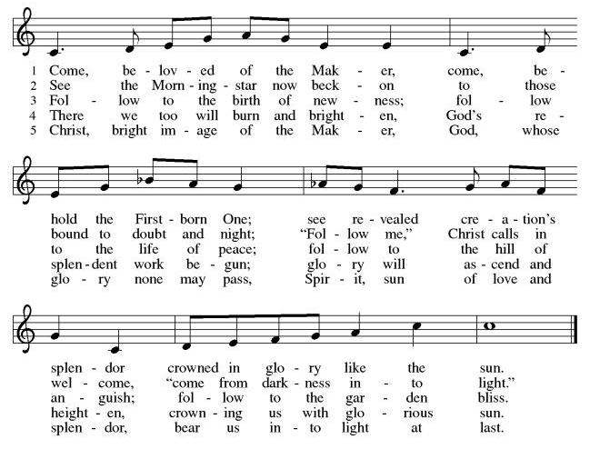

*Offering Prayer
A: God of majesty,
C: no eye has seen, no ear has heard
what you have prepared for those who love you,
yet in this meal you reveal the wideness of your mercy.
Use what we have gathered
to feed us with the reign of God come near,
Jesus Christ, our Savior and Lord.
Amen!
+MEAL+
*Great Thanksgiving
P: The Lord be with you.
C: And also with you.

P: Lift up your hearts.
C: We lift them to the Lord.

P: Let us give thanks to the Lord our God.
C: It is right to give our thanks and praise.

P: It is indeed right, our duty and our joy,
that we should at all times and in all places
give thanks and praise to you, almighty and merciful God,
through our Savior Jesus Christ.
By the leading of a star he was shown forth to all nations;
in the waters of the Jordan you proclaimed him your beloved Son;
and in the miracle of water turned to wine he revealed your glory.
And so, with all the choirs of angels,
with the church on earth and the hosts of heaven,
we praise your name and join their unending hymn:

*Sanctus
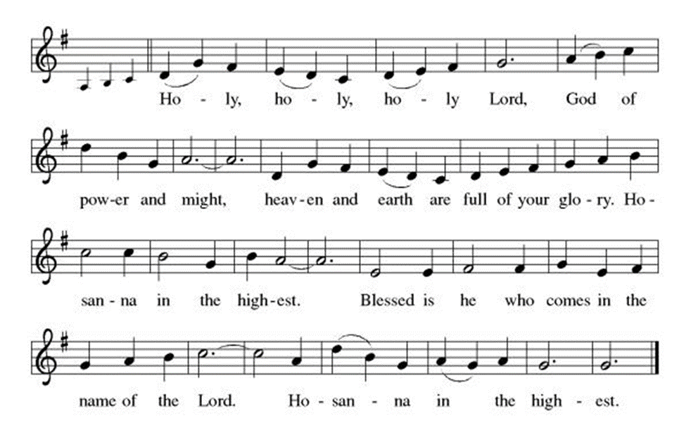
*Eucharistic Prayer
P:Holy God, mighty Lord, gracious Father:
Endless is your mercy and eternal your reign.
You have filled all creation with light and life;
heaven and earth are full of your glory.

We praise you for the grace shown to your people in every age:
the promise to Israel,
the rescue from Egypt,
the gift of the promised land,
the words of the prophets;
and, at this end of all the ages, the gift of your Son,
who proclaimed the good news in word and deed
and was obedient to your will, even to giving his life.

In the night in which he was betrayed,
our Lord Jesus took bread, and gave thanks;
broke it, and gave it to his disciples, saying:
Take and eat; this is my body, given for you.
Do this for the remembrance of me.

Again, after supper, he took the cup, gave thanks,
and gave it for all to drink, saying:
This cup is the new covenant in my blood,
shed for you and for all people for the forgiveness of sin.
Do this for the remembrance of me.

For as often as we eat of this bread and drink from this cup,
we proclaim the Lord’s death until he comes.
C: Christ has died. Christ is risen. Christ will come again.

P:Therefore, O God, with this bread and cup
we remember the life our Lord offered for us.
And, believing the witness of his resurrection,
we await his coming in power
to share with us the great and promised feast.
C:Amen. Come, Lord Jesus.

P:Send now, we pray, your Holy Spirit,
that we who share in Christ’s body and blood
may live to the praise of your glory
and receive our inheritance with all your saints in light.
C:Amen. Come, Holy Spirit.

P:Join our prayers with those of your servants
of every time and every place,
and unite them with the ceaseless petitions of our great high priest
until he comes as victorious Lord of all.
Through him, with him, in him,
in the unity of the Holy Spirit,
all glory and honor is yours, almighty Father,
now and forever.
C:Amen.

*THE LORD’S PRAYER
Our Father, who art in heaven,
hallowed be thy name,
thy kingdom come,
thy will be done,
on earth as it is in heaven.
Give us this day our daily bread;
and forgive us our trespasses,
as we forgive those
who trespass against us;
and lead us not into temptation,
but deliver us from evil.
For thine is the kingdom,
and the power, and the glory,
forever and ever. Amen.
*Lamb of God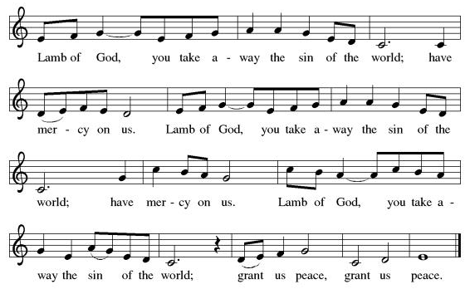

Spiritual Communion Prayer
P: Let us pray for the communion of all present here, those viewing our service virtually, those in our hearts and in our world.
C: Lord Jesus, I believe you are truly present in the Sacrament of Holy Communion. When I cannot receive Communion, I pray that you come into my heart. I know that nothing in Heaven or on earth can separate me from your love. Amen.

Invitation to Communion
P: Here is the Lamb of God who takes away the sin of the world!
Come to the table; taste and see.
C: Thanks be to God!

(All are invited to the communion rail following the guidance of the ushers. Communion will be shared through the host and individual cups. If you would like communion but are unable to join us at the rail, please alert the usher!)

Communion Hymns (Please join in singing!)

ELW 469 By Your Hand You Feed Your People
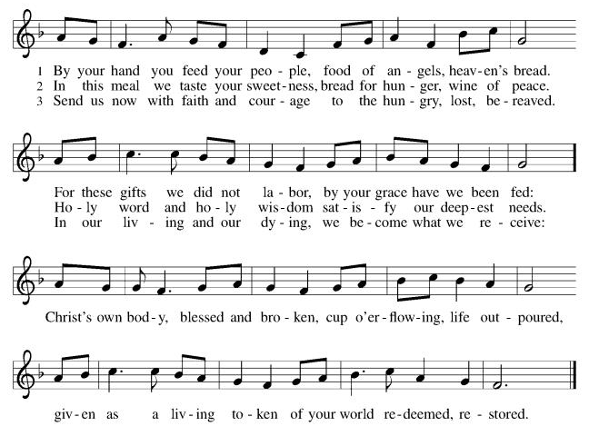

ELW 737 He Comes to Us as One Unknown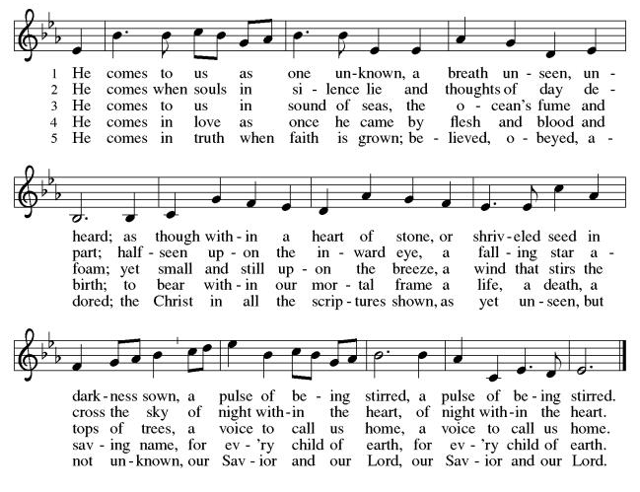

*Prayer after Communion
A: Radiant God,
we have seen your glory in the face of Jesus Christ.
In the sacrament of his body and blood
you have drawn us to your heart.
Send us from this table with delight,
that our lives may reflect the beauty of your love,
and bear witness to all we have seen and heard,
through Jesus Christ, our Savior and Lord. C: Amen.

+Sending+

*Blessing
P: May the triune God,
who has put a new song in your mouth
and tuned your heart for praise
☩ bless you now and forever. C: Amen!

*Sending Hymn ELW 705 God of Grace and God of Glory
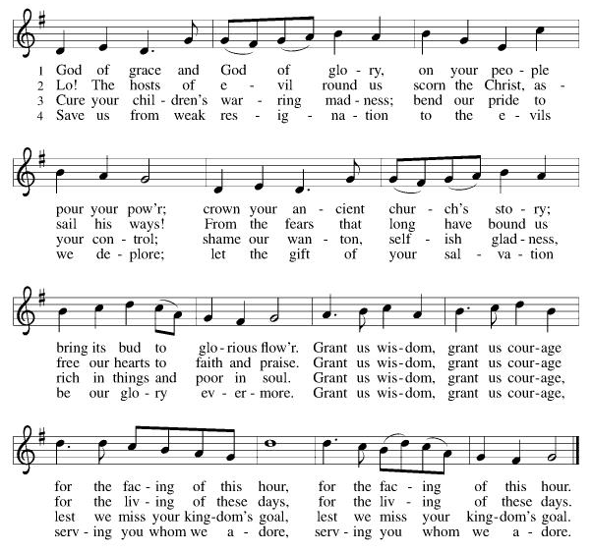

*Dismissal
A: Go in peace. Do justice. Love mercy.
C: Thanks be to God!

Postlude

Copyright © 2020 Augsburg Fortress. All rights reserved. Reprinted by permission under Augsburg Fortress Liturgies Annual License #SB106907. New Revised Standard Version Bible, Copyright © 1989, Division of Christian Education of the National Council of the Churches of Christ in the United States of America. Used by permission. All rights reserved. Revised Common Lectionary, Copyright © 1992 Consultation on Common Texts, admin Augsburg Fortress. Used by permission.

Treasurer’s Report
HTLC Financial Snapshot - December 2025
Category | Actual | Budget | +/- vs Budget | Status
December Income | $20,559 | $19,208 | $1,351 | On Track
December Expenses | $20,507 | $20,672 | -$165 | On Track
December Result | $53 | -$1,464 | $1,516 | On Track
YTD Income | $215,914 | $230,500 | -$14,586 | Attention
YTD Expense | $243,005 | $245,564 | -$2,559 | On Track
YTD Result | -$27,091 | -$15,064 | -$12,027 | Attention

While expense control was strong throughout the year,. income did not meet expectations, creating a larger deficit than planned. However, we are certain that the generosity andthe commitment of the people of Holy Trinity will make great things happen in 2026!
Thank you for supporting our ministry! Chris Foard, Treasurer

Worship Volunteer Schedule
Date | Asst. Min | Usher | Sacristan | Lector | Counter
February 1 | Linda Coleman | Kathy Caputo | Sherry Lee | Cynthia Kazmac | Carleo/Csernica
February 8 | Keith Bennett | Jill Socha | Joanne Giordano | Molly Foard | McKenna/Kazmac
February 15 | Chris Foard | Dan Gillon | Helga Britton | Rosemary Lane | Foss/Coleman
February 22 | Elaine Bradford | The Gripps | Nancy Poole | Bill Spreen | Socha/Giordano
March 1 | Charlie Rugg | Gary Joblon | Carol Rosen | Cynthia Kazmac | Bohner/Volk

Coffee Hour- Council Members
Altar Flowers- Happy Birthday Clara! The Doyles

ANNOUNCEMENTS Thank you! To all who consistently support our church and ministries through your time, talent, and treasure. Please help us grow by inviting your friends and family to worship and events. You are what makes Holy Trinity a wonderful church family!

Stay in touch! Please visit our church website, www.htlcredbank.org for updates and information. You can also find us on Facebook and view services online. The office is open from 9am to 2pm, Monday to Thursday.

100 Anniversary Committee- If you are interested in being a part of the committee to help plan the 100th anniversary celebration of HTLC in 2028, please sign up in the red book. All are welcome! Also, the committee will be looking for photos and documents of HTLC throughout the years. If you have anything to share, please bring them to the church and marked envelopes or email electronic copies to the church office.

Name Tag Sundays: On the first Sunday of each month, names tags and markers will be at each entrance of the sanctuary. Please fill out a tag and wear one for worship and for coffee hour to welcome visitors and help newcomers put names to faces.

Congregational Meeting February 1, 2026

Sunday School in the New Year, we will continue to study stories and lessons from the Old Testament beginning with Jacob. Kids will love the crafts, songs and games that accompany each lesson.
The following dates there will be Sunday School:
Jan- 11 and 25, Feb- 8 and 22, March- 1, 15 and 29*Easter Egg Hunt!
April- 12 and 26, May- 3, 17 and 31, June- 7 and 14
As was done in the fall, there will be opportunities to volunteer as SS lead teacher. A signup will be emailed out shortly and will also be posted in the red binder. Consider signing up! All lesson materials will be supplied and laid out and a leader guide will be emailed to volunteers approximately 1 week in advance. Blessings for a wonderful 2026!~Lauren

Trivia Night!! Mark your calendars! Plan for a fun night at Holy Trinity on Feb. 28 at 5pm for great food and trivia. We have an International theme, so we ask you to bring a pot luck dinner item showing your ethnic heritage. There is a sign up sheet for your convenience.
You don't have to be another Ken Jennings---this is just for fun. See you then!

Choir The Holy Trinity Choir welcomes our singers back for a preparation rehearsal on Sunday, September 7th at 9am in the church hall. All are welcome to join us in song as often as you are able. Choir meets each Sunday at 9am to practice and prepare our music. Join us and help us grow by spreading the word about the HTLC Choir!

Quilting- The Quilters need gently used any bed sheets of any size! Please leave any donations in the quilters closet in Fellowship Hall. Thank you!

Quilters Need Help
If anyone is traveling through Mechanicsville, PA, and can add a few extra minutes to your trip, the warehouse for shipping quilts, school kits, etc is located directly off one of the exits.
We accumulate many quilts throughout the year and we would appreciate sending some quilts with you to deliver. Any questions, please call Sherry Lee or Elaine Theophall.

Weekly Quilting on Wednesdays at 9:30. Bring your lunch and enjoy some fellowship at noon. All are welcome. There will be no quilting on Wednesday September 24 due to the garage sale set up.

Evening Quilting Evening Quilting –
Please share this information . This is an important ministry that helps so many. It’s very easy and you don’t need to know how to sew. We have a great time socializing too! We will meet: Jan. 21, Feb. 18, March 18 at 6:00 PM. Note: If we have to cancel I will send an email. Please let me know only if you can come. Contacts: Pat Pienkos 732-513-9615 Debbie Yetka 908-461-4084 Looking forward to seeing you all!

Social Ministry
*Year-round collections will continue for food items for Lunch Break. There is a sign-up sheet in the red book for those who can help drop these items to Lunch Break.
*We will also collect adult men's socks to periodically drop at the Red Bank Warminq Center.
*For those interested in the Heartwarminq Center — the new women's shelter is adjacent to the First Baptist Church of Red Bank at 90 Maple Ave. You can follow up on this mission through their website - https://www.thefeastnj.org- On this site, they also include wish list items that can be purchased through amazon. We will be exploring purchasing some of these through a Thrivent card. If you want to purchase on your own, you can leave items at church, and the Social Ministry will deliver them.
Pastoral Care and Prayer... We are here to care for and pray! Please contact the office to add or adjust prayer requests. If you or someone you know needs pastoral care, please contact the office and Pastor Mack!

THANK YOU for supporting and sustaining our church and ministries! All are welcome here! Please invite your family and friends to worship with us! Find us online at www.htlcredbank.org

