Sermon Notes, The Parable of the Sower
Mark 4:1-20
Feb 1st, 2026

Scripture:

The Parable of the Sower
4 Again Jesus began to teach by the lake. The crowd that gathered around him was so large that he got into a boat and sat in it out on the lake, while all the people were along the shore at the water’s edge. 2 He taught them many things by parables, and in his teaching said: 3 “Listen! A farmer went out to sow his seed. 4 As he was scattering the seed, some fell along the path, and the birds came and ate it up. 5 Some fell on rocky places, where it did not have much soil. It sprang up quickly, because the soil was shallow. 6 But when the sun came up, the plants were scorched, and they withered because they had no root. 7 Other seed fell among thorns, which grew up and choked the plants, so that they did not bear grain. 8 Still other seed fell on good soil. It came up, grew and produced a crop, some multiplying thirty, some sixty, some a hundred times.”
9 Then Jesus said, “Whoever has ears to hear, let them hear.”
10 When he was alone, the Twelve and the others around him asked him about the parables. 11 He told them, “The secret of the kingdom of God has been given to you. But to those on the outside everything is said in parables 12 so that,
“‘they may be ever seeing but never perceiving,
and ever hearing but never understanding;
otherwise they might turn and be forgiven!’ ”
13 Then Jesus said to them, “Don’t you understand this parable? How then will you understand any parable? 14 The farmer sows the word. 15 Some people are like seed along the path, where the word is sown. As soon as they hear it, Satan comes and takes away the word that was sown in them. 16 Others, like seed sown on rocky places, hear the word and at once receive it with joy. 17 But since they have no root, they last only a short time. When trouble or persecution comes because of the word, they quickly fall away. 18 Still others, like seed sown among thorns, hear the word; 19 but the worries of this life, the deceitfulness of wealth and the desires for other things come in and choke the word, making it unfruitful. 20 Others, like seed sown on good soil, hear the word, accept it, and produce a crop—some thirty, some sixty, some a hundred times what was sown.”

Theme and Goal: Jesus moves like a G sower so that we may grow in the
K that moves the world.

- Jesus moves like a G sower
Mark 4:3
3 “Listen! A farmer went out to sow his seed.

The sows plants G and indiscriminately, like Jesus proclaiming the Kingdom of God, and the infertile soils remind us of the people R Jesus’ message.

Mark 3:20-22
20 Then Jesus entered a house, and again a crowd gathered, so that he and his disciples were not even able to eat. 21 When his family heard about this, they went to take charge of him, for they said, “He is out of his mind.”
22 And the teachers of the law who came down from Jerusalem said, “He is possessed by Beelzebul! By the prince of demons he is driving out demons.”

This parable is not telling us what we ought to do, but rather is D how things are. It is an invitation to see if we are D ourselves.

Mark 4:4, 15
4 As he was scattering the seed, some fell along the path, and the birds came and ate it up.
15 Some people are like seed along the path, where the word is sown. As soon as they hear it, Satan comes and takes away the word that was sown in them.

Mark 4:5-6, 16-17
5 Some fell on rocky places, where it did not have much soil. It sprang up quickly, because the soil was shallow. 6 But when the sun came up, the plants were scorched, and they withered because they had no root.
16 Others, like seed sown on rocky places, hear the word and at once receive it with joy. 17 But since they have no root, they last only a short time. When trouble or persecution comes because of the word, they quickly fall away.

Mark 4:7, 18-19
7 Other seed fell among thorns, which grew up and choked the plants, so that they did not bear grain.
18 Still others, like seed sown among thorns, hear the word; 19 but the worries of this life, the deceitfulness of wealth and the desires for other things come in and choke the word, making it unfruitful.

The good soil “has been given” as the kingdom of God “has been given”, a

D A of God.

Mark 4:11
11 He told them, “The secret of the kingdom of God has been given to you. But to those on the outside everything is said in parables.

- Jesus moves so that we may grow in the K that moves the world.

Jesus is a S , not a military force or a salesperson. He is the L , the truth and wisdom of God.

Mark 4:14
14 The farmer sows the word.

When people encounter truth, everything is L or everything is G .

Mark 4:12
12 so that, “‘they may be ever seeing but never perceiving,
and ever hearing but never understanding;
otherwise they might turn and be forgiven!’ ”

The number of seeds not able to bear fruit does not compare to the A of the
H to here / now and to come.

Mark 4:8, 20
8 Still other seed fell on good soil. It came up, grew and produced a crop, some multiplying thirty, some sixty, some a hundred times.”
20 Others, like seed sown on good soil, hear the word, accept it, and produce a crop—some thirty, some sixty, some a hundred times what was sown.”

Application
Reflect on how you have R the Word of God.
Where do you see the Kingdom of God G in your own life?

Colossians1:3-6; 9-12
3 We always thank God, the Father of our Lord Jesus Christ, when we pray for you, 4 because we have heard of your faith in Christ Jesus and of the love you have for all God’s people— 5 the faith and love that spring from the hope stored up for you in heaven and about which you have already heard in the true message of the gospel 6 that has come to you. In the same way, the gospel is bearing fruit and growing throughout the whole world—just as it has been doing among you since the day you heard it and truly understood God’s grace.
9 For this reason, since the day we heard about you, we have not stopped praying for you. We continually ask God to fill you with the knowledge of his will through all the wisdom and understanding that the Spirit gives, 10 so that you may live a life worthy of the Lord and please him in every way: bearing fruit in every good work, growing in the knowledge of God, 11 being strengthened with all power according to his glorious might so that you may have great endurance and patience, 12 and giving joyful thanks to the Father, who has qualified you to share in the inheritance of his holy people in the kingdom of light.

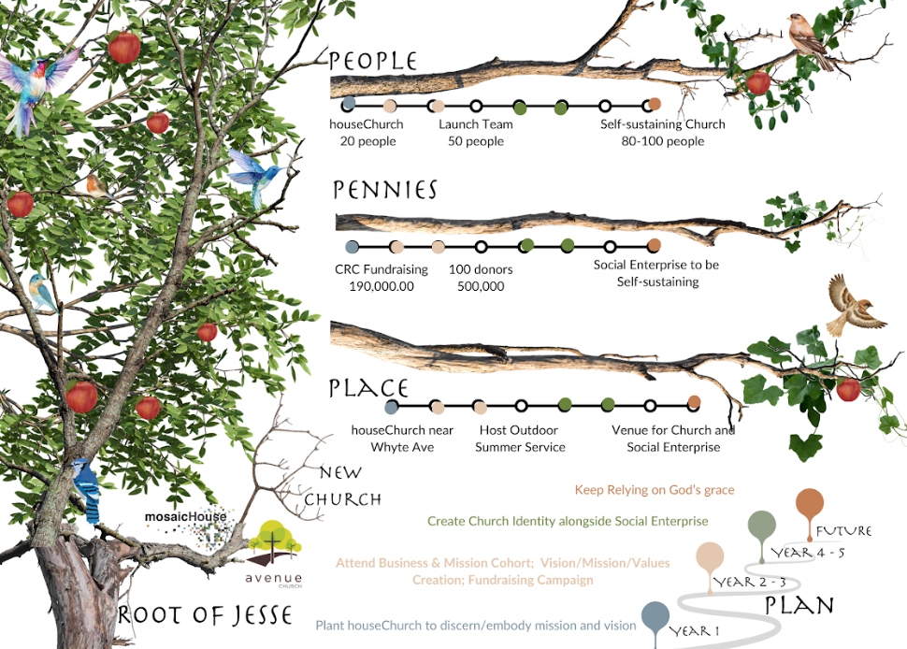
2 Corinthians 9:10
10 Now he who supplies seed to the sower and bread for food will also supply and increase your store of seed and will enlarge the harvest of your righteousness.

