Mission Trip
Puerto Peñasco, México
March 20-22, 2026
General Trip Overview & Itinerary
We invite you to join us for a life-changing weekend of meaningful work, community, and service while staying near the shores of the Sea of Cortez! Please see the general schedule below - for this trip we will rent a home or set of hotel rooms to serve as our home base. Please register by March 12th so that we can confirm details with our partners in Mexico. $190 per adult includes housing, most meals while in Mexico, and materials for the projects that we will work on. We have work opportunities for all ages - something for everyone! Once lodging is full, we will close registration.
Contact Reid or Talitha Martin with any questions! Reid Martin - 520.840.5707 Talitha Martin - 785.550.8777 email 785tmartin@gmail.com

Friday (times are subject to change as we roll with it)
8:00 a.m. Meet @ Community of Hope Church, Maricopa - we will stop for gas in Ajo before we cross - please plan to bring lunch, or lunch $ for the trip, as we will be stopping along the way. Bring snacks and bottled water also.
noon-1:00 pm - Meet with Conrado at Oc3an View Ministries to head to his recent building project. Some of the group may connect with Radigans for a different project.
5:00ish - head to lodging - Mi Amor Vacation Rental- to get settled in
7 pm- ish pm - Dinner together with Conrado’s work crew
After Dinner - discuss Sat opportunities & then free time. Our house is near the beach and we tend to spend as much free time around there as possible.
Saturday
7:30ish AM - Breakfast w/ Conrado’s Group
8:30 AM - Group Photo & Prayer
9 AM – Will head out for projects - housing projects with Conrado are certain and additional projects will be firmed up as we near the date.
12:30 PM - Break for lunch and then return to finish projects
4:30-5 - Wrap up work and head toward the house
6:30ish - Dinner together
8:30 PM – Reflections and group sharing, hanging out together
Sunday
7:30 AM - Breakfast/ Clean Up & Head Out

Sign-up: www.cohmaricopa.com - look under Events

Packing List
Clothing |  |  | Miscellaneous
 | Work t-shirts |  |  | Snacks
 | Work shorts |  |  | Sunglasses
 | Work long-sleeve shirts |  |  | Beach towel
 | Work long pants |  |  | Bible/reading material
 | Sweatshirt/Jacket |  |  | Reusable water bottle, labeled
 | Pajamas |  |  | Camera
 | Socks |  |  | Ear plugs (optional)
 | Underwear |  |  | Journal, pen
 | Closed-toe work shoes
 | Flip-flop sandals
 | Casual clothes for evenings
 | Work gloves
 | Swimwear - might be chilly!
 | Hat/visor |  | Money
 |  |  |  | Offering/donation, optional
 |  |  |  | Spending money, optional - there are vendors on the beach and all along the roadways.
Toiletries
 | Shampoo & Conditioner
 | Sunscreen |  | Documentation
 | Prescriptions |  |  | Passport/Birth Certificate
 | Allergy/pain medication |  |  | Passport/Birth Certificate (Youth)
 | Insect repellant |  |  | Mexican Auto insurance (drivers will secure this)
 | Lotion/lip balm
 | Soap
 | Hand sanitizer

Consider leaving valuable, personal items at home, including anything of “personal” value such as one-of-a-kind personal items.

Meals
These meals are included in your registration. We will shop there for groceries. Please plan to bring any specific food you need or communicate dietary restrictions so we can plan accordingly. We may choose to have some shared outdoor meals, cooked by Conrado’s crew, at the El Mirador hotel where a partner group is staying.
Friday
Lunch - on your own - will stop at a grocery store in Ajo that has a good deli for breakfast/lunch stuff. There is also a Subway in Gila Bend. Bring snacks and water as dinner will be later!
Dinner TBD - at the house together. We try to utilize local and locally available ingredients as much as possible.
Saturday
Breakfast 7:30 a.m - at the house together - typically breakfast burritos, fruit, coffee
Lunch 12:30 - on the go (typically sandwiches, fruit, chips etc)
Dinner 6:30 p.m. -at the house together
Sunday
Breakfast - 7:30 AM
Lunch - On your own - we should be home before noon unless traffic is very backed up at the border. We typically avoid that concern by leaving early enough on Sunday.

Accommodations -
Lodging for this trip will be at Mi Amor vacation rental in the Los Conchas area of Rocky Point. It has been a great stay for us before - well-appointed, comfortable, with a sea view from the rooftop terrace.

FAQs
Who?
You! Couples, singles, families are all welcome (ages 7 and up). Our mission host, Oc3an View Ministry (OVM), is a Mexican non-profit organization that welcomes people of all walks of life to enjoy serving God and serving others.
What clothing should I bring?
Please dress appropriately for the weekend. Check http://www.weather.com to help you determine temperatures and bring layers.
Friday: Dress comfortably. The drive down Friday will be in a vehicle for an extended amount of time. You will need to change into work clothes if you don’t wear them during the drive. Friday dinner is casual. Note: The evenings often feel cooler than expected due to the sea breeze.
Saturday: Dress in work gear, and be prepared to get dirty on Saturday! You may be part of a messy project. Note: We will be taking our group photo Saturday morning.
Saturday, if available for free time: Relax! You may have time to shop, walk on the beach, swim, or explore local tourism areas. Bring a swimsuit and towel if you’d like to enjoy the sea or the pool.
Saturday evening: It’s time to celebrate! Bring layers if you’d like to spend time on the beach.

Do I need additional money?
You will need to provide your own lunch on the way down, and may want some $ to purchase from beach or street vendors. Additional money will be needed for Sunday lunch if you choose to stop to eat. You may also want to buy snacks, souvenirs, make a donation to our mission partners, or give an offering. If you are not a driver, chipping in for gas is always appreciated!
How can I help? I don’t have specific skills.
There is definitely a great way for you to help! Please don’t think of what you CAN’T do! The trip is very diverse, from building and painting, to playing with the local kids and doing art projects. We need help cooking for the attendees, cleaning up, etc. You name it! If you come with a heart to serve others, then you will be needed and appreciated. If you are open to it, you will likely LEARN a NEW skill!

Should I bring tools?
Bringing basic tools is not required, however if you have construction tools that our group can use, you can label them and bring them! Reid will know more of what we need as the trip gets closer.
Should I bring bedding?
Bedding is provided and there is a washer and dryer in the home. If you have special pillows or blankets that you need for comfort, please bring those.

Will my phone or computer work in Mexico?
If you need cell service, talk to your provider before heading down. Most major cell phone companies have a free cell service to this part of Mexico. The trick is to ask for the FREE Mexico service BEFORE you head out Friday. Wi-Fi is available at the El Mirador hotel.
Note: The U.S. phone number for Oc3an View Ministry is 480-264-1172. Jenny Radigan’s number is (631) 680-4565 and Tom Radigan’s number is (631) 680-4566 and they will have cell service. Give these numbers to your family back home so they can reach you in case of an emergency.
Can I drink the water?
The water served in restaurants and resorts is generally OK to drink, but otherwise bring water.
I am driving my own vehicle, what do I need to know?
You will need to get insurance for your vehicle, it is the law. Typical car insurance doesn’t cover you in Puerto Peñasco, Mexico, but it’s best to call your own insurance company and ask. Please be sure to have access to your insurance policy, either printed or easily accessible on your phone, and a full tank of gas when arriving to meet the caravan.
Insurance suggestions: You can call your own insurance company, or you could contact Chris Cahall with American Family Insurance. His number is (520) 350-2500.
What do I do in case of a medical emergency?
Rocky Point has several medical clinics with English speaking doctors and reliable and inexpensive service. The Red Cross (Cruz Roja) provides free emergency service 24 hours a day, 7 days a week. Emergency Numbers (dial from Mexican phone): Red Cross/Ambulance–065, All Other Emergencies–066.

Mission Trip Tips

Be flexible.
Flexibility is the key. The needs of the ministry we are working with may change, and groups may need to be prepared to change directions in order to serve effectively. If we could be sensitive to what our mission partner needs, we can make the most of our time here.
Go as servants.
The primary motivation for our mission team is to go and serve God. Serving may mean that our group will have to make some adjustments. We may not have all the kinds of food we want, the best places to sleep, or all the comforts—we’re hoping for a hot shower!, but it's a wonderful opportunity to experience the kind of life that may be foreign to us, but is part of everyday life in this part of the world.
Leave your agenda behind.
Let your ministry partner set the goals for your group, especially in construction projects! Understanding and supporting the work local churches and ministries are already doing is a blessing, and they are the ones who go on to finish many projects! We don’t know yet exactly what our work will be, because it is determined by those who are already doing the work there - we jump in where they need us at the time we arrive.
Be a team.
Let’s stay in open communication with all team members so we keep the same goals in mind. If we keep our focus on fellowship, learning, and encouragement, both with our mission team members as well as those we serve, we will have the opportunity to model Christ in our interactions with each other.
Open yourself to the world.
Going on a mission trip can change your life, but this trip is not about us. We have the opportunity to learn more about this part of the world as we serve, but please, be open to learning what other people and cultures can teach you, and recognize the gifts and strengths God has given each of them, not just their needs and deficits. We can form relationships by using our gifts to serve each other.

Mission Partners/Organizations

Oc3an View Ministry (Our Mission Host) – Conrado Flores founded this ministry to provide outreach and serving opportunities in the community of Puerto Peñasco for mission groups of various sizes. OVM has a passion to serve alongside others to help those in need, while sharing God’s word. They are committed to building lifelong relationships with local churches, community centers, rehab centers, schools, and others. They also provide food and clothing through their donation facility. We partner with them in these endeavors. Find out more at www.facebook.com/Oc3anViewMinistry or visit their website at www.oc3anviewministry.com
Steps of Love/AIM of Puerto Peñasco – Steps of Love is a U.S. 501(c)(3). AIM is a Mexican Civil Association founded by Kathleen Duncan. These organizations work together to provide educational opportunities for children in Puerto Peñasco and Sonoyta who are not thriving due to poverty, disabilities, or other challenges. We partner with them in these endeavors. Visit their website at www.stepsoflove.org
God’s Grace Foundation - This Saturday morning feeding, clothing is located alongside the train tracks and serves some of the most impoverished people that live in Peñasco. They serve the community by feeding the homeless every Saturday, bringing food to the local jail, providing clothing, and giving basic first aid. We have supported them through donations, work projects, and serving meals. Visit their Facebook page at https://www.facebook.com/pages/category/Religious-Organization/Gods-Grace-Foundation-139675769742152/

About Rocky Point
Puerto Peñasco, also known as Rocky Point, is a quaint fishing village located 60 miles southwest of the U.S.-Mexico border on the Sea of Cortez. It is approximately a 3.5 hour drive from the City of Maricopa. Passports are required for ages 17 and up, while birth certificates are fine for children under age 17. Mexican car insurance is necessary if you are driving your personal vehicle. See suggestions for where to purchase car insurance under FAQ’s.
The language is Spanish. Most of the people we will be working with do not speak English; however, most locals who work in tourism speak English quite well. The local currency is the Mexican peso. You do not need to exchange dollars for pesos, because almost all establishments will take US currency. Most places will also take credit cards. Be sure to advise your credit card company that you will be using your card in Mexico. The current exchange rate is between 17-18 pesos to $1, but if you pay in local shops with dollars, you may not receive the current exchange rate as they often have fees to pay when exchanging.
The Malecón in the Old Port part of town is alive with shops that sell everything from tourist souvenirs to fine art. The fish market at the Malecón is a popular stop for the fresh catch of the day, especially during the shrimp season, September to March. There are also many good restaurants to be found along the Malecón, some of which provide stunning sunset views of the Sea of Cortez.

The Sea of Cortez, or Gulf of California, is known for its deep blue waters and white sand beaches. Among the most notable is Sandy Beach, home to most of the newer resorts. Swimming, snorkeling, parasailing, jet skis and banana boats can be enjoyed virtually all year long, not to mention the wonderful fishing and oyster beds! Swimming in the area is very safe and generally emulates lake conditions with no rip tides and very calm water. Temperatures are similar to those in Arizona, and the average sea temperature is very close to the outside air. This region of the Gulf of California experiences one of the greatest tidal shifts in the world. Twice a day the ocean will rise and fall as much as 24 vertical feet. This extreme tidal shift makes for excellent tide pooling.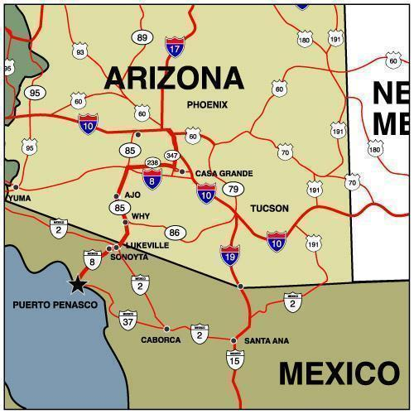
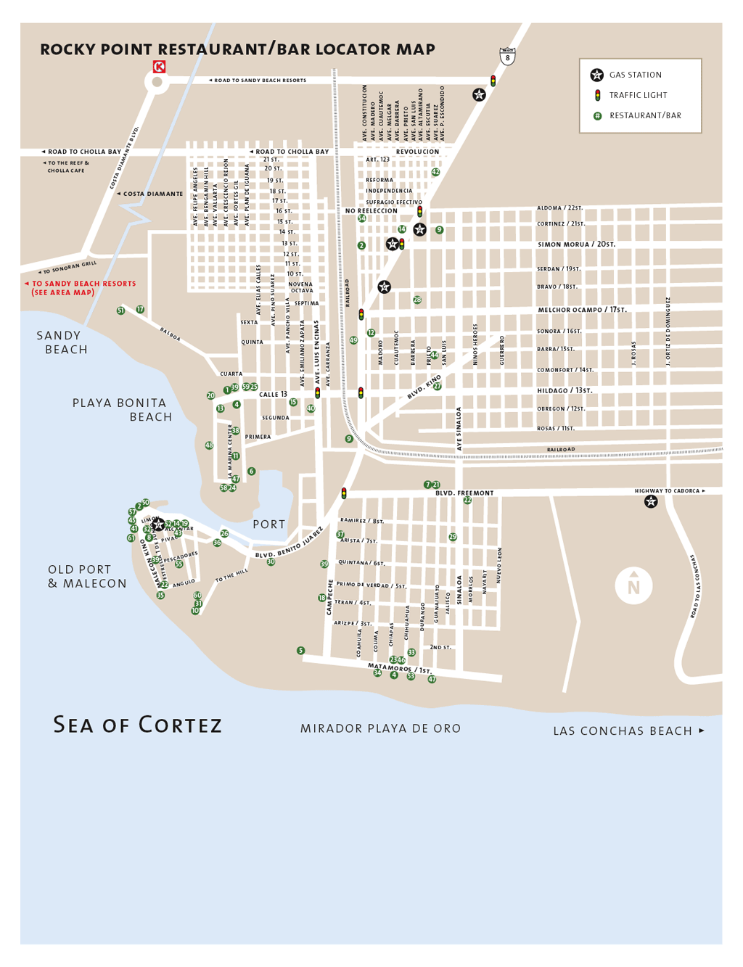
PUERTO PEÑASCO (Rocky Point), Mexico

= Las Conchas Area

Cultural Comparisons
Although the U.S. is physically close to Mexico, Mexicans have their own ways of doing and looking at things. For example, Americans are more quantitative about time and measure it precisely. Mexicans are qualitative about time; it is relative to the occasion and how one feels. To successfully interact with Mexicans, it is necessary to enter their world, and be aware of the fact that your assumptions about how things are done often are not true. The following comparison table provides a further summary of major cultural differences, and we thought you might find it fun and interesting.
Aspect | Mexico | USA
Family | Family is the first priority, interdependent.  Children are celebrated and sheltered.  Wife fulfills domestic role.  Mobility is limited. | Family is usually second to work.  Children often minimally parented; are independent.  Wife often fulfills dual roles.  Mobility is quite common.
Religion | Long Roman Catholic tradition.  Fatalistic outlook. "As God wills." | Mixed religions.  "Master of my own life" outlook.
Education | Memorization.  Emphasis on theoretical.  Rigid, broad curriculum. | Analytical approach.  Emphasis on the practical.  Narrow, in-depth specialization.
Nationalism | Very nationalistic.  Proud of long history and traditions.  Reluctant to settle outside Mexico. | Very patriotic.  Proud of "American way of life."  Assumes everyone shares his/her materialistic values.
Personal Sensitivity | Difficulty separating work and personal relationships.  Sensitive to differences of opinion.  Fears loss of face, especially publicly.  Shuns confrontation. | Separates work from emotions/personal relationships.  Sensitivity seen as weakness.  Tough business front.  Has difficulty with subtlety.
Etiquette | "Old world" formality.  Etiquette and manners seen as measure of breeding. | Formality often sacrificed for efficiency.  "Let's get to the point" approach.
Ethics | Indirect communication preferred. Truth is tempered by need for diplomacy and protecting honor. | Direct yes/no answers given and expected. Tell the truth even if creates conflict.
Status | Title and position more important than money in eyes of society. | Money is main status measure and is reward for achievement.
Spanish Phrases & Bible Verse
Our church is Community of Hope. |  | Nuestra iglesia is Community of Hope.
Thank you. You’re welcome. |  | Gracias. De nada.
Good morning. Good afternoon. Good evening. |  | Buenos días. Buenas tardes. Buenas noches.
Hello, my name is Ken. What is your name? |  | Hola, me llamo Ken. Como te llamas?
How are you? I am fine, thank you. And you? |  | Como esta? Estoy bien, gracias. Y tu?
I live in Maricopa, Arizona. Are you from Penasco? |  | Yo vivo en Maricopa, Arizona. Tu eres de Penasco?
I don’t understand. Explain to me, please. |  | No entiendo. Explicame, por favor.
Nice to meet you. |  | Mucho gusto.
Boy, girl, brother, sister, husband, wife |  | Nino, nina, hermano, hermana, esposo, esposa
Uncle, Aunt, Grandpa, Grandma, father, mother |  | Tio, Tia, Abuelo, Abuela, mama, papa
Do you have a dog? cat? |  | Tienes un perro? gato?
Do you speak English? |  | Hablas inglés?
I am happy to be here! |  | Estoy feliz de estar aqui!
Do you believe in God? Jesus? Christ? |  | Crees en Dios? Jesus? Cristo?
Good-bye. See you later. |  | Adiós. Hasta luego.
We are having nice weather. It is very hot. It is very cold. |  | Estamos teniendo un clima agradable. Hace mucho calor. Hace mucho frio.
What do you like to do? Do you like soccer? sports? music? to dance? to sing? candy? |  | Que te gusta hacer? Te gusta futbol? deportes? musica? bailar? cantar? dulce?
What are your hobbies? |  | Que son tus pasatiempos?
How much? |  | Cuanto cuesta?
We are here with a church mission. |  | Estamos aqui con una mision iglesia.
Where is your church? |  | Donde esta su iglesia?
Very delicious. Pretty. |  | Muy delicioso. Bonito.
How fun! |  | Que divertido!
Enjoy! |  | Disfruta mucho!.

1 John 3:18 - ¹⁸ Dear children, let us not love with words or speech but with actions and in truth.

1 Juan 3:18 - ¹⁸ Queridos hijos, no amemos de palabra ni de lengua, sino de hecho y en verdad.

