All Saints Anglican Church
6904 Lougheed Highway, Agassiz, B.C. V0M 1A0
Bulletin January 26th, 2026 – February 1st, 2026

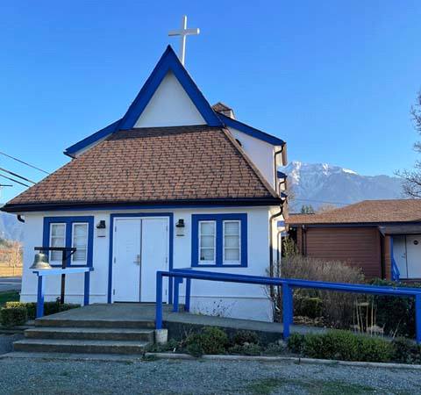

‘The ground we walk does not belong to us; for thousands of years it has been - and remains - the territory of the Stó:lō. We are grateful for their sharing.

Phone: 604-796-3553
Website: www.allsaints-agassiz.ca
https://www.facebook.com/groups/AllSaintsFamily
OUR DOOR IS OPEN AND ALL ARE WELCOME
February 1st, 2026, Fourth Sunday After Epiphany
Priest in Charge: The Reverend Philip Barker
Hosts: Graham Featherstone/Jennifer Pinlac
Intercessor: Douglas MacAdams
Lay Administrator: Dorothy Cresswell
Announcer: Virginia Jennings
Organ/Piano: Francesca Froehlich
Readers: Valerie Hamilton/David Hamilton
Vicar’s cell phone: Revd. Philip Barker. 778-867-2461

Vicar’s Warden: Ginny Jennings. 604-796-2206
People’s Warden: Lynn Laughlin. 604-799-5131
Parish email: revpb1950@gmail.com
Please contact either warden if you have an issue that needs to be brought to the attention of the Vicar - or contact the Vicar direct (see above for details).

All Saint’s Calendar/Announcements:

- Book Club has chosen the next book, "Amazing Grace, the life of John Newton", by Bruce Hindmarsh and Craig Borlase. It's $24.99 as a paperback on Amazon and is also available on Kindle and as an audio book for free if you have an audio membership.
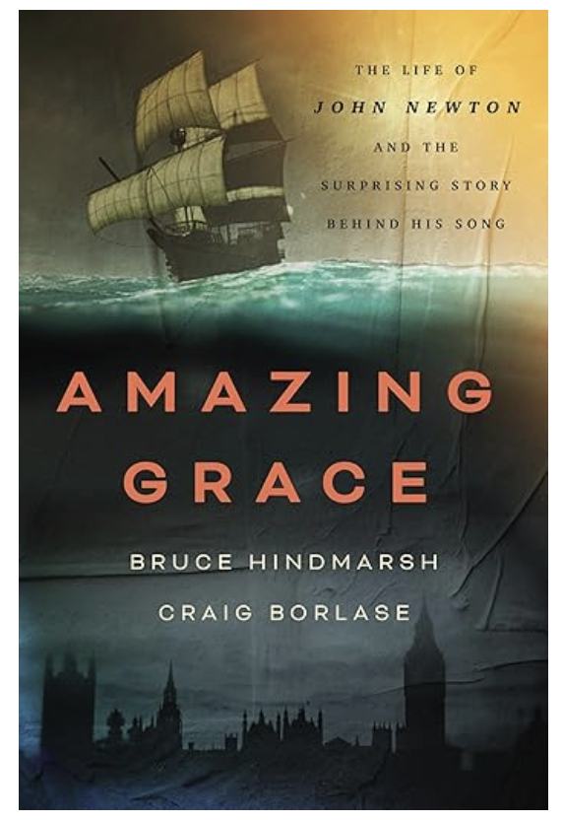

Our first meeting of the New Year will be on
Wednesday, January 14th, at 1700 (5.00pm) on Zoom.

Please let Sheila know at sjbarker0379@gmail.com
if you would like to join the group discussions or have
her order a copy of the book.

- Bible Study with Karol is every Saturday morning 0830-0900 on Zoom.

- Prayer Requests can be given on a piece of paper to either of the Wardens or the Vicar or entered in the Prayer Request Book on the lectern. Alternatively, you can contact Anthea Lewis at antheamlewis@shaw.ca for Pray First Prayer Circle, which is a confidential online prayer circle.

- Music Requests may be given to the Wardens or the Vicar.

- AA meets in the hall every Tuesday and Friday at noon.

- Every Thursday in the hall 1100-1200 we have a social time with coffee, games if you like or just talk.

- At 1000-1100 on Thursdays there is an Interactive Bible Study on the day’s Lectionary readings. All are welcome – discover the treasures in this amazing book!

- 5th Sunday of each month will be a potluck lunch after the service.

- Annual Vestry Meeting (AVM) on February 8th, 2026, after the service. Please be there if you are interested in the future of this church. Your involvement is vital to our success and survival.

Ministerial Meandering
Comfort zone?

This is, in one sense, a follow-on from last week’s MM, which presented the difficult options of choice. One obvious answer would be not to make one - and stay ‘fat, dumb, and happy’ in your comfort zone, thumb in bum and mind in neutral. Pink Floyd bassist, Roger Waters, wrote the song, ‘Comfortably Numb’ in 1977 when a doctor had to break into his hotel room to inject him with some tranquillizers so he could perform on stage that night. The song featured two amazing guitar solos by David Gilmour, who argued with Waters about the arrangement. It was the last time the two of them were able to work together constructively again.

There is a problem with being ‘comfortably numb’, in that life passes you by while you’re enjoying the buzz. Dr Hook and the Medicine Show released a song in 1975 called, ‘I got stoned and I missed it’, which had a similar message in that you don’t notice life passing you by when you are mind-numbed.
Both of these observations led me to the conclusion that my intention to ‘wander back to the asylum’ is not really an option - at least, not a constructive one.

Some people are quite willing to let life ‘happen to them’; others need to grab it, and give it a good shake. Any member of my family will tell you that if I get an idea in my head, it has to happen yesterday - tomorrow is already too late. This tendency to push boundaries and have no patience with snail-paced bureaucracy has led Sheila and me into some splendid arguments over the years. She seems to have the patience of Job - if not his serenity! I have neither. I thought I was getting a handle on my intolerance, but - honestly - I haven’t got time for it.

So, making things happen always pushes me out of my comfort zone and into challenge mode; if something is not as it should be - well then, it’s clearly my job to change it. Now some of you know from first hand experience of my tendency not to let things be, and that I fight for you as much as I fight for myself or family.
I have weighed into battle with our appalling Canadian medical system for several of you, both in hospital and with your GPs and Community Nurses. I have not always made myself popular doing so - but the end result has been that you got better service.
Years ago, Hannah had an acute slipped disc in her neck which could have paralyzed her permanently within a few days. Fortunately, I witnessed the event as we were living with her at the time. Her GP was totally useless and unable to understand the urgency of the situation, so I took her for an MRI that I paid for personally, from where she was shipped by 911 ambulance to the Royal Columbian for emergency neurosurgery. I’m not looking for accolades for this - it should have been obvious to any competent doctor what was going on and the need to act - fast.

I suppose what I’m saying is that nothing happens while you wait. Specifically, I am writing to our American brothers and sisters who are beginning to demonstrate that they are fed up with being pushed around by a malignant narcissist - although the psychiatric diagnosis suggests that such persons ‘still retain some capacity for guilt and loyalty.’ I do not think that pertains to Trump at all.
Therefore, I believe it is past time for those with any vestige of goodness and courage to coordinate and rise up - out of their comfort zones - and vehemently oppose the totalitarian regime of this evil and utterly corrupt man. That might mean taking up arms; that might mean civil war - but sitting still will get you nowhere. Except another Trump term, in which Congress will be entirely effete if it exists at all - and your wailing will be louder, but likely silenced by more bullets, incarceration, and deportation.

Philip+

Truth and Reconciliation
Thank you for the very positive response to the invitation to the current Table Talks series. I had to limit the numbers in the group because it is meant to be a series of small group conversations. Several people were disappointed, so I plan to run the series a second time, probably after Christmas.
Please let me know as soon as possible at sjbarker0379@gmail.com if you would like to join. Feel free to ask those taking part now for their feedback.
A Little Chuckle…


Birthdays this Month  February

Pat Misener – 2 Lyric George – 2
Liane Loeppky – 15 Wendy Pearson – 16
Bonnie Maitland – 26 Al Pinlac - 28

Diocesan Cycle of Prayer: We Pray for the Clergy and Congregation:

The Archdeaconry of Capilano; Church of the Epiphany, Surrey – The Revd Liz Ruder-Celiz & The Revd Alpha John; Christ Church Cathedral, Vancouver, The Very Revd Christopher Pappas, The Revd Areeta Bridgemohan, The Revd Clare Morgan

Anglican Church of Canada Cycle of Prayer – We Pray for:

The Provincial Synod of the Ecclesiastical Province of Canada

Collect

Living God, in Christ you make all things new. Transform the poverty of our nature by the riches of your grace, and in the renewal of our lives make known your glory; through Jesus Christ our Lord, who is alive and reigns with you and the Holy Spirit one God, now and for ever.

Micah 6:1-8 Valerie Hamilton

¹Listen to what the Lord says:

“Stand up, plead my case before the mountains;
let the hills hear what you have to say.
² “Hear, you mountains, the Lord’s accusation;
listen, you everlasting foundations of the earth.
For the Lord has a case against his people;
he is lodging a charge against Israel.

³ “My people, what have I done to you?
How have I burdened you? Answer me.
⁴ I brought you up out of Egypt
and redeemed you from the land of slavery.
I sent Moses to lead you,
also Aaron and Miriam.
⁵ My people, remember
what Balak king of Moab plotted
and what Balaam son of Beor answered.
Remember your journey from Shittim to Gilgal,
that you may know the righteous acts of the Lord.”

⁶ With what shall I come before the Lord
and bow down before the exalted God?
Shall I come before him with burnt offerings,
with calves a year old?
⁷ Will the Lord be pleased with thousands of rams,
with ten thousand rivers of olive oil?
Shall I offer my firstborn for my transgression,
the fruit of my body for the sin of my soul?
⁸ He has shown you, O mortal, what is good.
And what does the Lord require of you?
To act justly and to love mercy
and to walk humbly with your God.

Psalm 15

¹ Lord, who may dwell in your sacred tent?
Who may live on your holy mountain?

² The one whose walk is blameless,
who does what is righteous,
who speaks the truth from their heart;
³ whose tongue utters no slander,
who does no wrong to a neighbor,
and casts no slur on others;
⁴ who despises a vile person
but honors those who fear the Lord;
who keeps an oath even when it hurts,
and does not change their mind;
⁵ who lends money to the poor without interest;
who does not accept a bribe against the innocent.

Whoever does these things
will never be shaken.

1 Corinthians 1:18-31 David Hamilton

¹⁸ For the message of the cross is foolishness to those who are perishing, but to us who are being saved it is the power of God. ¹⁹ For it is written:

“I will destroy the wisdom of the wise;
the intelligence of the intelligent I will frustrate.”

²⁰ Where is the wise person? Where is the teacher of the law? Where is the philosopher of this age? Has not God made foolish the wisdom of the world? ²¹ For since in the wisdom of God the world through its wisdom did not know him, God was pleased through the foolishness of what was preached to save those who believe. ²² Jews demand signs and Greeks look for wisdom, ²³ but we preach Christ crucified: a stumbling block to Jews and foolishness to Gentiles, ²⁴ but to those whom God has called, both Jews and Greeks, Christ the power of God and the wisdom of God. ²⁵ For the foolishness of God is wiser than human wisdom, and the weakness of God is stronger than human strength.

²⁶ Brothers and sisters, think of what you were when you were called. Not many of you were wise by human standards; not many were influential; not many were of noble birth. ²⁷ But God chose the foolish things of the world to shame the wise; God chose the weak things of the world to shame the strong. ²⁸ God chose the lowly things of this world and the despised things—and the things that are not—to nullify the things that are, ²⁹ so that no one may boast before him. ³⁰ It is because of him that you are in Christ Jesus, who has become for us wisdom from God—that is, our righteousness, holiness and redemption. ³¹ Therefore, as it is written: “Let the one who boasts boast in the Lord.”

Matthew 5:1-12 Vicar Philip Barker

¹Now when Jesus saw the crowds, he went up on a mountainside and sat down. His disciples came to him, ² and he began to teach them.

He said:

³ “Blessed are the poor in spirit,
for theirs is the kingdom of heaven.
⁴ Blessed are those who mourn,
for they will be comforted.
⁵ Blessed are the meek,
for they will inherit the earth.
⁶ Blessed are those who hunger and thirst for righteousness,
for they will be filled.
⁷ Blessed are the merciful,
for they will be shown mercy.
⁸ Blessed are the pure in heart,
for they will see God.
⁹ Blessed are the peacemakers,
for they will be called children of God.
¹⁰ Blessed are those who are persecuted because of righteousness,
for theirs is the kingdom of heaven.

¹¹ “Blessed are you when people insult you, persecute you and falsely say all kinds of evil against you because of me. ¹² Rejoice and be glad, because great is your reward in heaven, for in the same way they persecuted the prophets who were before you.

Odds and Ends



Pancake Sunday

February 15th after the service


