St. Paul
UNITED CHURCH OF CHRIST

February 1, 2025 10:30am
Welcome! Whether you are a guest, friend or member, we are delighted that you are here. Large print bulletins are available at either door. Ask a greeter for any directions you may need.

“Please note that this service will be live-streamed on Facebook. If you do not wish to be visible on camera, please let an usher know so we can take appropriate measures to ensure
your privacy."

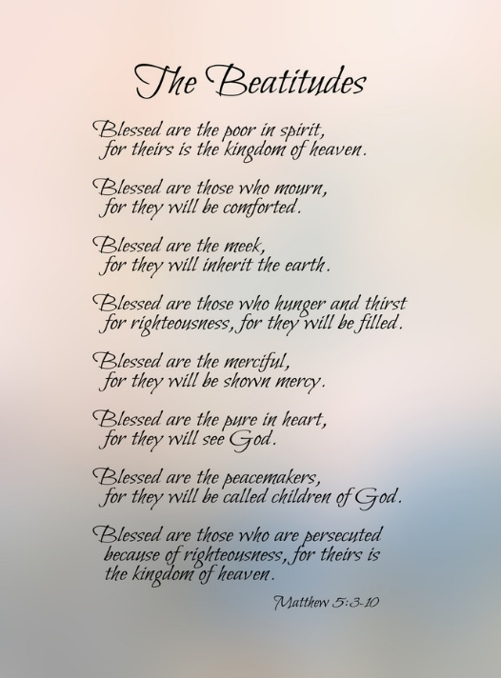

Rev. Jim Oleson, Pastor
Christopher Dickmeyer, Musician
Fourth Sunday after Epiphany
*Please rise in body or spirit
Ringing of the Bell
Welcome & Announcements
In the last days, says God, I will pour out my Spirit upon all people. Your sons and daughters shall prophesy. Your young people shall see visions, and your old people shall dream dreams. People of God, we have been baptized into one Spirit and one body through Jesus Christ. Let us worship today.
Prelude and Lighting of the Candles
*Call to Worship (from Psalm 27)
One: Jesus, our Teacher, this is what you want us to learn
Many: Not the world’s wisdom, but God’s.
One: Awaken us to our need of you in our lives
Many: And you will give us your life.
One: Move us with sorrow for the sorrow of the world
Many: And you will make us strong through our tears.
One: Give us the humility to admit our failures
Many: And you will bring treasure out of them.
One: Make us hungry for justice
Many: And you will give us food that lasts.
One: Help us to see others through your eyes
Many: And you will show us ourselves with love.
One: Show us how to practice what we preach.
Many: And we will see God in everyone.
One: Support us in standing firm for truth, even when it costs
Many: And the truth will also make us free.
*Invocation
God of the prophets, is it possible that you, who spoke to Jeremiah and Jesus, will speak to us? We may not be ready to believe it. We may not be ready to receive you. But we have gathered in your name and we pray: come, holy one. Fill us with the story of your people; fill us with your loving Word. Take us as we are, and make us wholly yours. In Jesus’ name; Amen.

*Hymn of Praise #459 New Century Come O Fount of Every Blessing
*Prayer for Transformation and New Life
One: If we say we are completely put together, the truth is not in us.
Many: But if we confess our distractions, our errors, and our anxieties, God will meet us and renew us. Before God and God’s people, I confess that I have been reluctant to speak out clearly, naming the injustice I see and declaring God’s vision. Before God and one another, we confess our reluctance to receive our calling as God’s people, made by God and chosen as witnesses to God’s dream of justice and joy. Remind me, God, that you have made me for your service and recharge me with your Word. Renew us, God. Grant us courage to live out your Way of peace and grace. We ask it in Jesus’ name; Amen.
<pause for silent reflection >
Words of Grace
One: God has promised that whenever we repent, and seek a new union with God, forgiveness is ours. That promise comes true now. Sisters and brothers, know that in Christ Jesus, we are forgiven.
People: Thanks be to God! Amen.
*Response of Praise
Glory be to the Father, and to the Son, and to the Holy Ghost; As it was in the beginning, is now, and ever shall be, World without end. Amen. Amen.
Mission Moment Janet Morris
Written Word Micah 6:1-8
1 Corinthians 1:18-31
Matthew 5:1-12
Hymn #493 New Century O Jesus, I Have Promised
Message Doing Righteousness Rev. Jim Oleson
Micah 6:1-8, 1 Corinthians 1:18-31, & Matthew 5:1-12
Church in Prayer
Pastoral Prayer
Lord’s Prayer (Debts, Debtors)
Offertory
Invitation to Generosity
*Doxology (Tune: Old Hundredth)
Praise God, from Whom all blessings flow; Praise Him, all creatures here below;
Praise Him above, ye heavenly host; Praise Father, Son, and Holy Ghost. Amen.
*Prayer of Dedication
Savior Christ, you went to the top of a mountain, and taught a sacred word about the meek and the grief stricken, about the lost and the lonely. Come to this place now, and by these gifts help us to see the world not as it is, but as it could be, that we may become good news to all. Amen.
The Lord’s Supper
INVITATION TO CHRIST’S TABLE
COMMUNION PRAYER
WORDS OF INSTITUTION
SHARING OF THE BREAD AND CUP
(Please hold each of the elements as it is distributed so that we may partake each together. The inner ring of cups in each tray holds juice rather than wine.)
* THANKSGIVING PRAYER (unison)
Bountiful God, we give you thanks that you have refreshed us at your table by granting us the presence of Christ. Strengthen our faith, increase our love for one another and send us forth into the world in courage and peace, rejoicing in the power of your Holy Spirit. Amen.
*Closing Hymn #81 New Century God Be with You
*Commission and Benediction
*Christ’s Light Leads Us into the World
*Congregational Response #182 New Century We Have Come at Christ’s Own Bidding
(Verse 1)
*Ringing of the Bell and Postlude

903 Meier Road, Old Monroe, Missouri 63369
stpauluccom@gmail.com
Website: stpauluccom.com
636-665-5329

OFFICE HOURS
Wednesday: 9:00am – 3:00pm
Friday: 9:00am - Noon

It Happens
Here St. Paul UCC
Weekly Calendar
February 1st - February 8th

February 1st Fourth Sunday after
Epiphany
9:15am Bible/Book Study
10:30am Worship
11:30am Fellowship Hour

February 8th Fifth Sunday after
Epiphany
9:15am Bible/Book Study
10:30am Worship
11:30am Fellowship Hour

Looking Ahead

February 16th
5:15pm Council Meeting

February 18th
7:00pm Ash Wednesday Service

________________________________________________________________________________________
OUR GIVING IN 2026
Needed weekly to meet our commitments $2190.29 $ 2190.29
General Fund Offering January 25th (snow) $ 0.00 January Average $ 1478.33 Stewardship Offering January 25th $ 0.00 December Average $ 1375.00
______ __________________________________________________ __ ____________________ ________

HAPPENING IN OUR COMMUNITY
Sunday, February 22: Whole Hog Pork Sausage and Sauerkraut Dinner at St. Paul’s UCC in Marthasville. Cafeteria-style dining and carry-outs. Serving from 11:00am to 5:00pm. Pork Sauage, Ribs and Bones for sale

The Cub Scouts will be meeting in the Fellowship Hall on Tuesday evenings.

Thank you to all our volunteers!

Greeters/Ushers
Jerry & Pat Giffoard

Acolyte
Marla Stewart

Liturgist

Fellowship Hour
Christian Nurture


In our prayers …

This week we added Carolyn M. to our prayers and the family and friends of Marsha, Roy and Donnie.

We continue to keep in our prayers Lauretta, Lynn and Ron D., Ernie M., Eileen T., Chuck and Marlene, Lyle R., Mike S., Jamie, Nor, Clifford P., Rick C., Bob R. and Sandy R.

We lift up in our prayers those who need prayers for their long-term circumstances: Carol Jean P.

REMINDER…Please DO NOT adjust the programmable thermostat in the Sanctuary.

The Worship Committee is looking for a volunteer to be the Communion Stewart. This is a person who prepares Communion on the first Sunday of the month and for special services. Also requires cleaning up and putting away the Communion ware. If there are any questions, please see a Worship Committee member.

