Woodbury United Methodist Church

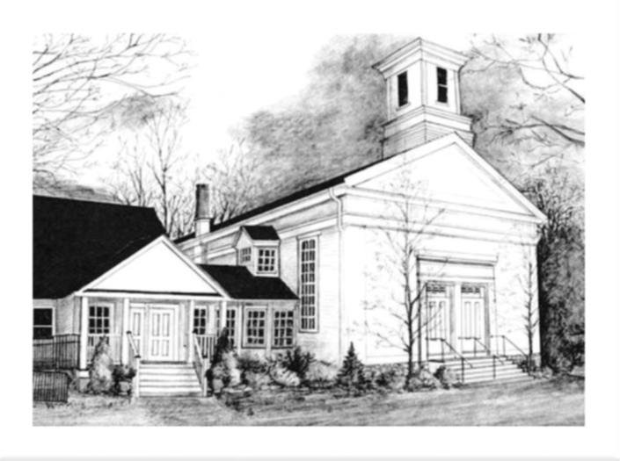
Sunday, February 1, 2026

Annual Meeting Sunday
Sacrament of the Lord’s Supper
Epiphany IV

10:30 AM Worship
Woodbury United Methodist Church
4 Church Street, Woodbury, CT 06798 203-263-4775
www.woodburyumc.net Church e-mail: wumc@woodburyumc.net

February 1, 2026
*Please stand as you are able.

WE COME TOGETHER IN PRAISE
WELCOME AND ANNOUNCEMENTS
PRELUDE “Thee We Adore O Hidden Savior" Moklebust
The Bell Choir
*CALL TO WORSHIP
L: I was glad when they said to me, “Let us go into the house of the Lord.”
P: For this is none other than the house of God,
and this is the gate of heaven.
L: Let all the earth give praise and honor to the Creator of all things.
P: And let our hearts be glad for the abundance of God’s blessings.
ALL: LET US WORSHIP GOD!
*HYMN “God Is Here” UMH #660
THE PRAYER OF THE DAY Sarah Schivera, Liturgist
Thou who art over us, Thou who art one of us, Thou who art:
Give me a pure heart, that I may see thee; a humble heart, that I may hear thee; a heart of love, that I may serve thee; a heart of faith, that I may abide in thee. Amen. Dag Hammerskjold, 20th cent. (Matthew 5:8)
INVITATION TO HOLY COMMUNION (by the pastor)
PRAYER OF CONFESSION (unison)
Lord, forgive us when we take you and each other for granted…when we take community for granted…when we take love for granted. Help us always to overcome our reluctance to give of ourselves fully and freely, as you have given yourself to us. We ask this so that we might be better disciples, day by day; through Jesus Christ our Lord. Amen.
SILENT CONFESSION AND WORDS OF PARDON

WE LISTEN FOR THE WORD OF GOD
THE PSALTER Psalm 15 UMH p. 747
(read responsively)
THE HEBREW SCRIPTURES Micah 6:1-8
*THE GOSPEL Matthew 5:1-12

*HYMN “Sanctuary” TFWS #2164
(sung three times)
“Lord, prepare me, to be a sanctuary, pure and holy, tried and true.
With thanksgiving, I’ll be a living sanctuary for you.”

THE SERMON “Sanctuary” Pastor Brian Bodt

WE RESPOND IN FAITH
SHARING JOYS AND CONCERNS THE PASTORAL PRAYER

THE LORD’S PRAYER UMH #895
Our Father, who art in heaven, hallowed be thy name. Thy kingdom come, thy will be done on earth as it is in heaven. Give us this day our daily bread. And forgive us our trespasses as we forgive those who trespass against us. And lead us not into temptation, but deliver us from evil. For thine is the kingdom, and the power, and the glory, forever. Amen.

BLACK HISTORY MONTH Mary McLeod Bethane Sam Temple

INVITATION TO THE OFFERING AND OFFERING OUR GIFTS

OFFERTORY “The Lord is My Shepherd" Pote
The Chancel Choir

*RESPONSE OF PRAISE UMH #588
“All things come of thee, O Lord; and of thine own have we given thee.”

*PRAYER OF DEDICATION

THE SACRAMENT OF THE LORD’S SUPPER
PRAYER OF CONSECRATION (by the pastor, the people seated)
(All are welcome to receive. Please follow the ushers’ direction.
You may leave a gift for the pastor’s discretionary fund if desired.)

WE GO FORTH IN JOY
*HYMN “Steal Away to Jesus” UMH #704

*PRAYER OVER THE MEAL AND A CANDLEMAS BENEDICTION
(said by all) Based on Luke 2:29-32
“Master, now you are dismissing your servant in peace, according to your word; for my eyes have seen your salvation, which you have prepared in the presence of all peoples, a light for revelation to the Gentiles and for glory to your people Israel.”

POSTLUDE “Bouree” Fandel
+ + +
THE WORSHIP IS ENDED: THE SERVICE BEGINS.
Woodbury United Methodist Church
We are a welcoming Christian fellowship who celebrate and share God’s love with everyone. We seek a closer relationship with Jesus Christ. Inspired by His example, we strive to be God’s hands in this world. Empowered by God’s word, we proclaim the Gospel and serve through worship, study, mission, and community support.

The Rev. Dr. Brian R. Bodt, Pastor Jeff and Barbara Hunt, Lay Leaders
Christopher Shay, Director of Music Matti Paparazzo, Admin. Assistant

NOTES ON TODAY’S WORSHIP
TOMORROW IS CANDLEMAS, the feast observing the Presentation of Christ in the Temple (Luke 2:22-29) forty days after his birth as the Jewish Law required (Leviticus 12:1-4).
Simeon’s words, today’s benediction, are known by their Latin name, the Nunc Dimittis, the initial words of Simeon’s blessing. They have been part of the daily prayers of the Church since the 4th century and have been given many musical settings.
FEBRUARY IS BLACK HISTORY MONTH, so identified as the birth month of both Frederick Douglass and Abraham Lincoln. Sam Temple is the first of three “Black History Moment” speakers. Some hymns will be from the African-American tradition.

TODAY AT WOODBURY UMC
WELCOME TO WOODBURY UNITED METHODIST CHURCH!
IF YOU ARE A VISITOR PLEASE COMPLETE A VISITOR’S CARD AND PLACE IT IN THE OFFERING. Our desire is that you experience the warmth of Christ’s welcome and ours in this church.

ANNUAL MEETING AND LIGHT LUNCHEON follows worship downstairs. Invite someone you don’t know to join you! Annual Reports are on the foyer document table. Informational and inspirational presentations with 1 p.m. adjournment. This is Christ’s church, yes; but it is also your church. Please be an active and engaged congregant by giving this time for information and inspiration as we move into 2026.

WE THANK TODAY’S WORSHIP LEADERS
Liturgist and Communion Assistant: Sarah Schivera
Communion Stewards: JoAnn Behlman and Karen Fimmano
A.V. Tech: Mark Davis
Ushers and Greeters: Christine Shupenis and Judy Wilhelms
VISION 2025 EMPHASIS TODAY is “Spiritual Wellness.” Emphases are Evangelism, Missions, Affirmation and Inclusion, Communications, Youth and Young Adults and Congregational Vitality and Growth (Spiritual Wellness, Financial Health, Inviting Facilities).
THE WEEK AHEAD….
PASTOR BRIAN AND CAROL will be away after today’s Annual Meeting through Sat., Feb. 7. In a pastoral emergency, please contact Co-Lay Leader Jeff Hunt at 203.558.6607 to reach the pastor on call.
THE CHURCH OFFICE WILL BE OPEN BY APPOINTMENT ONLY THIS WEEK. If you need to come to the church and do not have a key, please contact Co-Lay Leader Jeff Hunt at 203.558.6607 to make arrangements to gain access.
SUNDAY, FEBRUARY 1
FAITH AND FICTION BOOK CLUB, 8:30 a.m., Fellowship Hall
CONFIRMATION TUTORIAL, 9 a.m., Pastor’s office
WORSHIP, 10:30 a.m., Sanctuary
ANNUAL MEETING, 11:30 a.m., Fellowship Hall
WEDNESDAY, FEBRUARY 4
BELL CHOIR REHEARSAL, 6 p.m., Sanctuary
CHANCEL CHOIR REHEARSAL, 7:15 p.m., Sanctuary
FRIDAY, FEBRUARY 6
TRANSITION ACADEMY, 9:15 – 10:45 a.m., Church Grounds
WOODBURY FOOD BANK, 11 a.m. – 2 p.m., behind LaBonne’s
NEXT SUNDAY, FEBRUARY 8
“Do a Good Turn Daily” is the sermon based on Isaiah 58:1-12 and Matthew 5:13-20. We will receive new members. Our liturgist will be Keri Lavish. Our Black History Month presenter will be Connor Langdon. Free blood pressure screenings will be offered at 11:30 in the Assembly Room by Andrew Styblo, Paramedic. Communications Committee will meet at 11:45 a.m. in the Wesley Room.
FEBRUARY FOOD BANK SIGN-UPS
WUMC helps support the Food Bank overseen by the Community Services Council of Woodbury with donations of time as well as money and food. Two months a year we have two people scheduled to work at the Food Bank. February is one of those months.
The February Food Bank Sign Up Sheet is now available outside the sanctuary doors. Available dates are Fridays, February 6, 13, 20 & 27 from 11 a.m. – 2 p.m. at the Food Bank located behind LaBonne’s grocery store. You may also contact Meg Temple at 203–910-3711 or megtemple1@gmail.com to sign up. Please commit your time to help our hungry neighbors.
TIME TO START A ONE-ROOM SUNDAY SCHOOL?
WUMC has long-discussed the need to revitalize children’s ministry.
To launch, we will need a schedule of rotating team-teachers. We will pair more experienced teachers with newer ones. All will need easily arranged Safe Sanctuary certification.
If you have interest please contact any of the following:
Bob Asman; asmanct@hotmail.com; 860.567.2557
Meg Temple; megtemple1@gmail.com; 203.910.3711
Pastor Brian Bodt; pastor.woodburyumc@gmail.com; 203.747.1781
“Let the little children come to me, and do not stop them; for it is to such as these that the kingdom of heaven belongs.” Jesus, to the disciples, in Matthew 19:14
LENTEN STUDY REGISTRATION
“Why Did Jesus Have to Die?”, a Lenten study by the Rev. Adam Hamilton, begins Monday, Feb 16th, continuing each Monday through March 23rd, one week before Holy Week. I plan to offer sessions at 10 a.m. and 7 p.m. if we have 5+ registrants per session.
The doctrine of the atonement is a cornerstone of understanding Jesus’ sacrificial death, and God’s power for good in the face of the deaths we face, both physical and spiritual. Rev. Hamilton is widely regarded as a teacher and preacher, and pastor of The Church of the Resurrection in Leawood, Kansas, one of the largest United Methodist churches in the United States.
If you plan to attend, please contact me at 203.747.1781 or pastor.woodburyumc@gmail.com and let me know whether you will attend at 10 a.m. or 7 p.m. The deadline to register is Sunday, Feb. 8 so that books may be distributed. My prayer is for a robust study during Lent. Come! -- Pastor Brian Bodt
LENT IS ON THE HORIZON!
ASH WEDNESDAY WORSHIP will be February 18:
7:30 a.m. – a 30-minute service for those headed to work or who do
not wish to attend an evening service
7 p.m. – Our traditional service with music by both Bell and Chancel
Choirs. Optional imposition of ashes at both services.
For the full Lenten schedule please visit www.woodburyumc.net.
GLOBAL MISSIONS INFORMATIONAL ZOOM, Feb 5th
Join the Still-In-Mission Episode #85, via Zoom on February 5, 2026 at 12:00 PM ET, as we explore the transforming work of United Methodist missionaries serving around the world. Please see “Living Through Grace” for details. Pre-registration is required.
CELEBRATION OF ALL OUR SCOUTS, SUNDAY, FEB 8TH!
CALLING ALL SCOUTS! Sunday, Feb. 8 is the 116th anniversary of the founding of the Boy Scouts on that date in 1910. We will have a recognition of Scouting in morning worship. If anyone in your family is currently an active Scout - Webelos, Boy Scouts, Explorers, Daisys, Brownies or Girl Scouts - please let me know at pastor.woodburyumc@gmail.com or 203.747.1781. This also includes adult leaders of Scouting programs. If there are numbers of Girl Scouts, I will offer this again for them on March 9th, Girl Scout Sunday. – Pastor Brian
A PUBLIC WITNESS FOR IMMIGRANT JUSTICE, Feb 25th
A PUBLIC WITNESS FOR IMMIGRANT JUSTICE will be held in Washington, D.C. on Wednesday, February 25 from 9:30 a.m. until 5 p.m. The witness is sponsored by many United Methodist agencies, including The United Methodist Committee on Relief, the Board of Church and Society, the Board of Religion and Race, El Plan for Hispanic Latine Ministry, United Women of Faith (formerly United Methodist Women) and the Immigration Law and Justice Network.
I am currently planning to attend. If you would like to know specifics about my travel, please contact me at 203.747.1781 or pastor.woodburyumc@gmail.com
This link provides comprehensive information about the event: You can learn more and register for the gathering here. In addition, questions may be directed to advocacy@umcjustice.org
I welcome your prayers for this event and for me personally at this crucial time in our nation’s history. In the words of Dr. King, “It is always the right time to do the right thing.” – Pastor Brian Bodt
OUR PRAYER INTENTIONS
Debbie Eisemann, friend of Sandy Purdy, recovering at the Lutheran Home from a fall
For Carol Quinby, with thanksgiving for stable vision in her right eye and continued healing prayers for her left eye.
Michael Hennessey, Carol Hennessey’s brother-in-law.
For Carolyn Shay, being treated for a medical condition.
For conflicts in the Middle East and our troops stationed there; and for the conflicts in the Ukraine and the Sudan.
Bishop Bickerton; our new District Superintendent, the Rev. Heather Sinclair; and the churches and clergy of the NY Conference.
For Missionaries, especially Sarah Flores (Ecuador), Rev. Dexter Ceballos (Mongolia), and Alma and Richard Navarro (Philippines).
For those facing life’s difficulties and medical challenges, especially Carol Hennessey, Nancy Ossewaarde, Eni Mucco (friend of Jane Hutter) and Jean Lilly (Meg Temple’s mother)

ON-GOING MINISTRY
CURRENT WOODBURY FOOD BANK NEEDS coffee, instant coffee, toilet paper, paper towel, and canned mushrooms, olives and beets. Please leave them in the Foyer box.
“I was hungry and you gave me food….” Jesus, Matthew 25:35

FOR THE CHURCH COMMUNITY

Pastor Brian can be reached at pastor.woodburyumc@gmail.com or 203.747.1781 for pastoral care. Want a visit? Please let him know. He’d love to meet with you!

Are you on our “Living through Grace” weekly email? If not, please contact the Church Office at wumc@woodburyumc.net. For immediate access, please use the QR Code shown at the right.

Publication deadline for the weekly bulletin and “Living through Grace” e-newsletter is 10 a.m. THURSDAY. Thanks in advance for your cooperation.
Learn More About Our Church
If you are interested in learning more about our church, please use the QR Code in the lower lefthand corner of this page. If you would like to access our YouTube channel, including recordings of recent worship services, please use the QR Code in the lower right corner of this page.
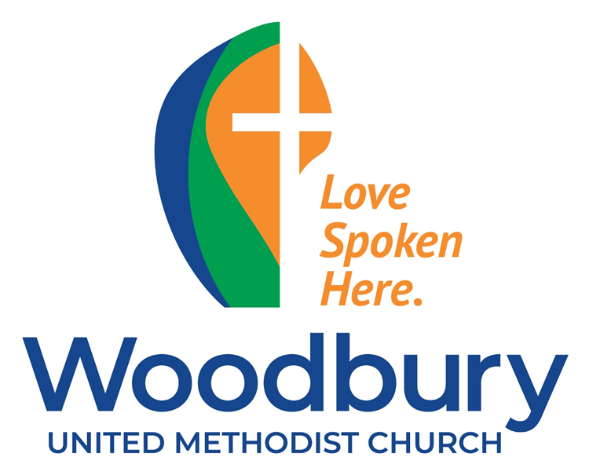


YouTube Channel
Website

