

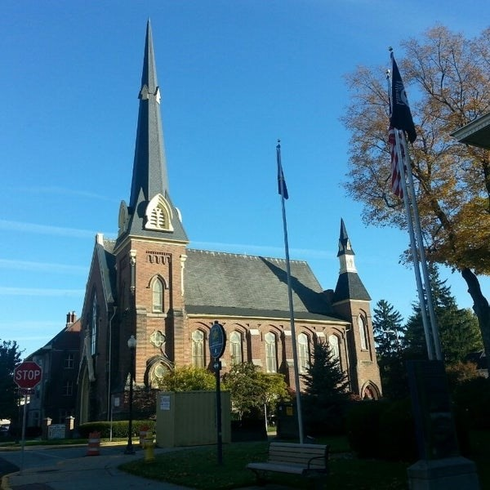
January 28, 2026

A Global Methodist Church
214 S. 5th Street
Goshen, IN 46528
Phone: 574-533-9518
Web Site: goshenfirstgmc.org

Office Hours: Monday-Friday,
8:00 a.m.-12:00 noon
Worship: 9:00 a.m.
Sunday School: 10:30 a.m.
Pastor Jeff & Lisa
Associate Pastor Rich Hull
OUR VISION: “Growing in Faith, Gathering in Community, and Giving in Love”.

The Monday morning Bible study has started up again. They meet at 9:30 a.m.
in the Parlor. They are studying the book of Acts. Everyone is welcome.

The Wednesday evening meal and classes continue. The meal is at 5:30 p.m., and classes are at 6:00 p.m. Pastor Jeff will lead a book study, “Victory Over the Darkness” by Neil Anderson. The children meet for class, and child care is provided for preschoolers. The Grief Share class will start up on March 4 and will continue until May 27. Everyone is welcome.

“Thanks so so much for the pretty carnation for my birthday! Special thanks to Donna Shirk for delivering it. I moved and she had to find me. Blessings to all.”
-Betty Kessler

“Because of the terrible cold from now through next week, Tommy and I have decided that it is best to reschedule our revival services of “Setting Hearts Free” with Tommy & Rocio Hayes to February 26 through March 1. The event schedule will be about the same with a few adjustments. Sorry, but we think it is the best.
Keep praying and hope to see you all on Sunday.” -Pastor Jeff



VOLUNTEERS – Thank you for your service! Sunday morning, February 1
Greeters: Dave & Marcia Parsons VIP: Cathy Smith
Elevator Hosts: Gary & Diane Miller
Ushers: Erv Herschberger, Sharon Hull, Ken Smith, Dan Becker, Steve Warner
Scripture Reader: Lisa Bealmear
Elementary Junior Church: Rachel Parsons Tenorio, Karen Andrews
Junior High Church:
Coffee Hour: Rich & Sharon Hull
Bus Driver: Randy Cripe
Blood Pressure Clinic: Amber Krebs
Communion Servers: Dan & Kathy Seltenright, Larry & Donna Solyom

