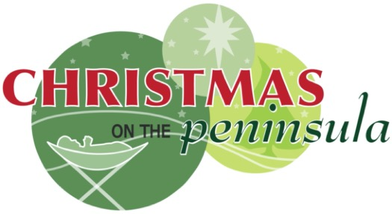
The Christmas on the Peninsula Society

is seeking a

Fundraiser

on a part-time contract for 6 weeks, with possible future contracts as an event coordinator.

Our mission is to provide a first-class Christmas Festival on the Semiahmoo Peninsula for visitors and local communities, to gather together to hear and see the Christmas Story unfold.

Scope of Services includes:
Initiate, Implement and coordinate fundraising including fundraising events. Keep financial and other documents up to date and promote fundraising events and the COTP society.

For complete contract requirements visit http://www.christmasonthepeninsula.com

