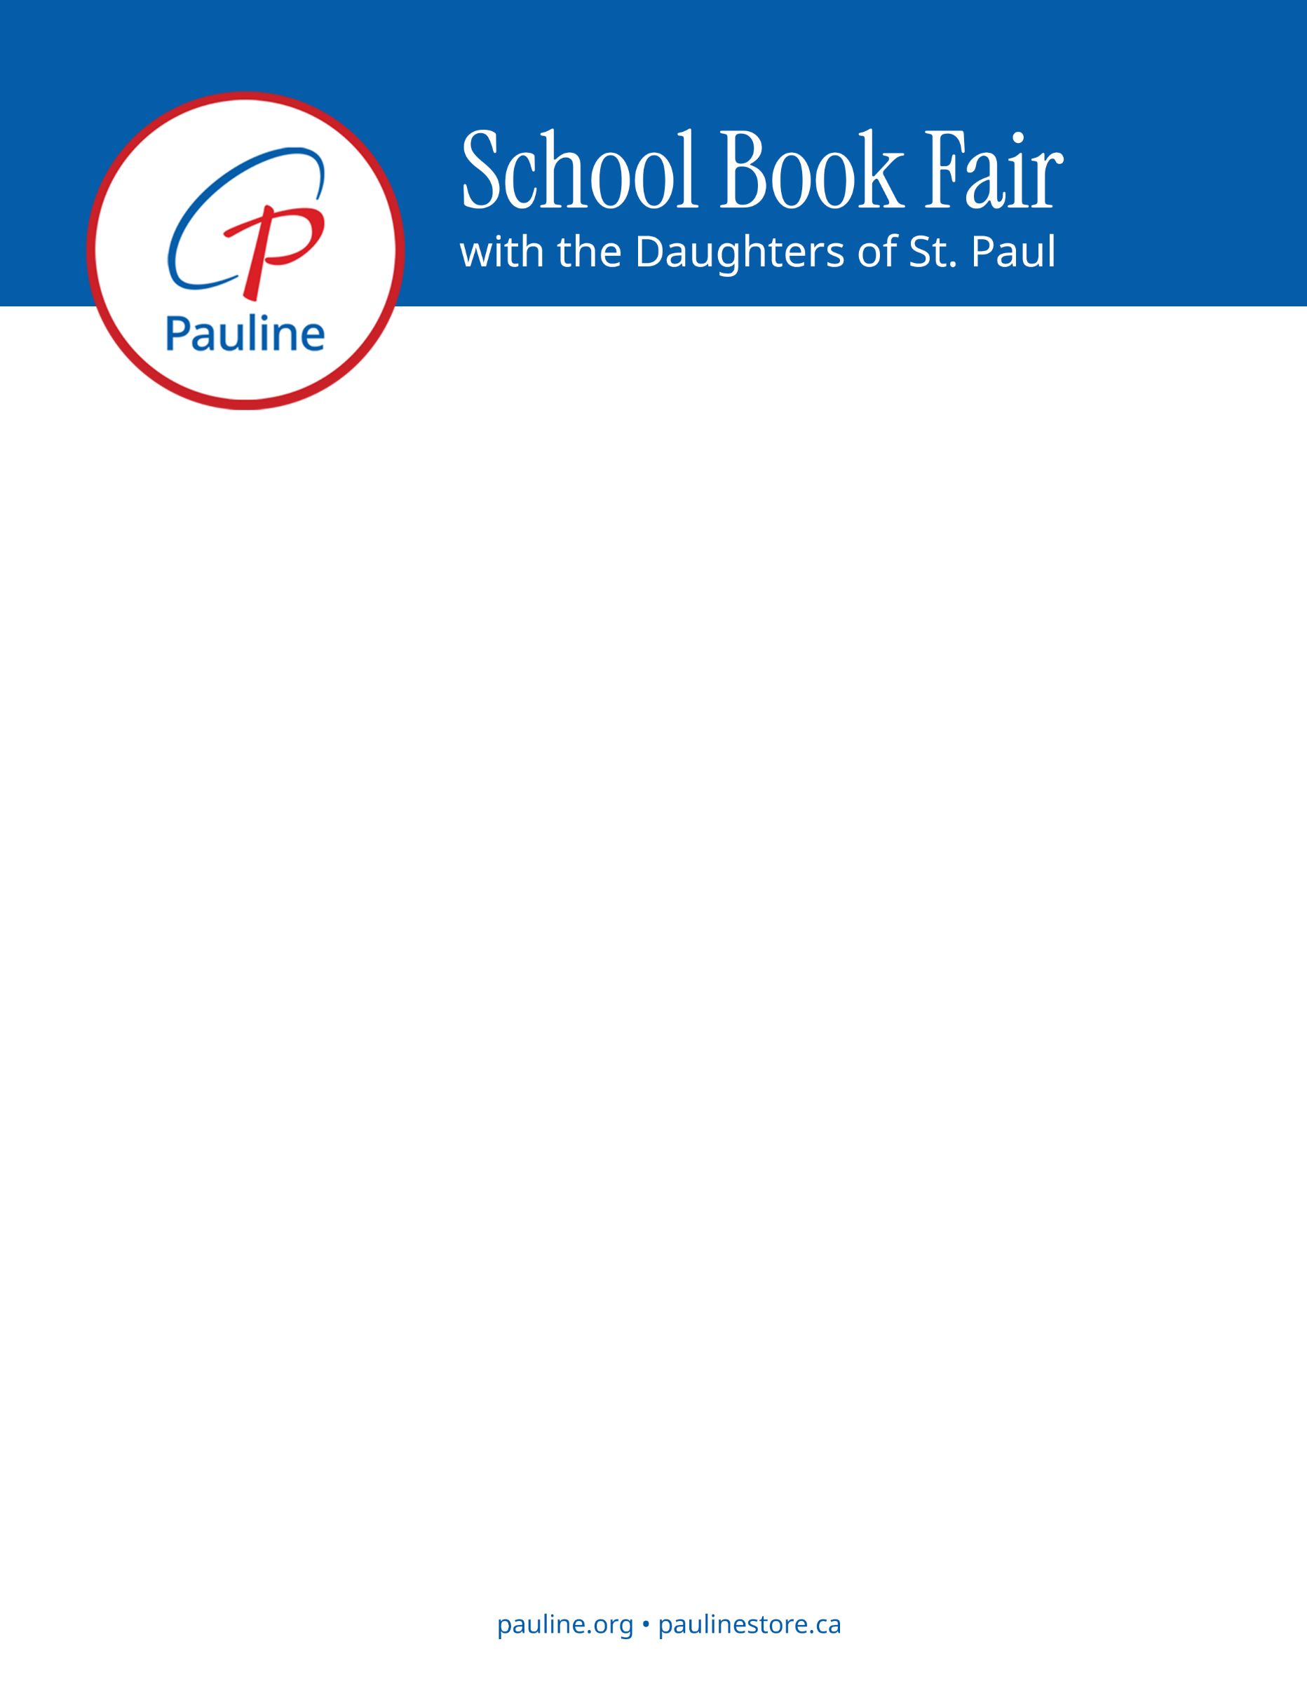

Saint Francis de Sales School
February 19, 2026
During and after school • Located in [LOCATION]

Dear parents and guardians,

The Daughters of St. Paul will be visiting SAINT FRANCIS DE SALES on FEBRUARY 19TH with a Catholic book fair. We look forward to spending time with your school community!

As Daughters of St. Paul, our mission is to proclaim the Gospel using the most effective media—including great Catholic books! Our Pauline Books & Media publishing house is just one expression of our mission to give Jesus Christ to the world in the spirit of Saint Paul. During our visit to your school, we will make available some of the award-winning books that our sisters have prayerfully written and/or published in collaboration with many talented Catholic authors and illustrators. We pray that these books will spark wonder, inspire faith, and help your family grow closer to Christ and each other.

The Pauline Book Fair will be open [all day during school hours and after school]. To preview some of the books that we will have available for children, teens, families, and teachers, please see our School Book Fair list. Note that listed prices do not include tax. (For a comprehensive list of the books we publish, as well as the books from other Catholic publishers that we carry in our Pauline Books & Media Centre in Toronto, you can also visit us online at paulinestore.ca). We can accept Visa, MasterCard, Debit Interac, and/or cash on the day of the book fair.

For more information about us and our Pauline Books & Media mission, please visit us at daughtersofstpaul.com and pauline.org.

You and your family are in our daily prayers!

In Jesus our Way, Truth, and Life,
Sr. Gioan Linh Nguyen and Sr Joane Caritas Gepitulan

