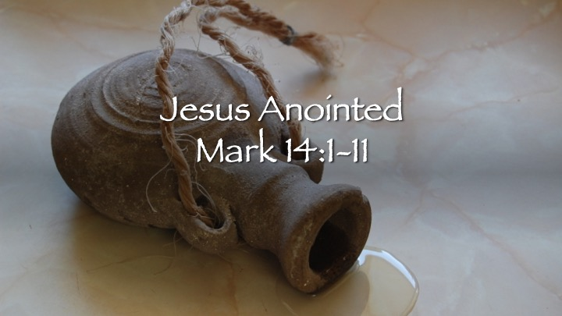

1. Love Sees What Fear Refuses to Face (Mark 14:3)
- What do you notice about the woman’s action that stands out to you this time?
- Why do you think the disciples struggled to face Jesus’ coming death, even after hearing Him talk about it?
- Where are you most tempted to avoid what Jesus has already made clear to you?

2. What We Call “Waste” Reveals What We Value (Mark 14:4–5)
- Why do you think the disciples label her act as “waste”?
- Can you think of times when obedience to Jesus might look impractical or excessive in our culture?
- Is it easier for you to give Jesus your belief or your resources (time, money, control, comfort)? Why?

3. Jesus Defends Devotion, Others Criticize (Mark 14:6–9)
- What does it mean to you that Jesus calls her act “beautiful”?
- Why do you think Jesus ties her story so closely to the gospel itself?
- How does this challenge common ideas about what “mature faith” looks like?

4. Betrayal Begins with Self-Protection (Mark 14:10–11)
- Why do you think Mark places Judas’s decision immediately after this moment of worship?
- In what subtle ways can self-protection pull us away from Jesus over time?
- What helps you stay open-hearted rather than guarded in your walk with Christ?

Spiritual Practices (Choose One or Two)

Practice 1: Open-Handed Prayer (Group or Individual)
Purpose: Cultivating surrender and trust.
Sit with palms open. Pray slowly:
“Jesus, I release my grip, form my heart to love what You love.”
Sit in silence for one minute afterward.

Practice 2: The Costly Yes (Individual, During the Week)
Purpose: Re-training our instincts toward love over calculation.
Invite each person to prayerfully choose one concrete act of obedience this week that costs something real:
- Time
- Comfort
- Attention
- Money
- Control
No announcing it.
No posting it.
Just obedience as worship.

Practice 3: Embodied Worship (Personal or Group)
Purpose: Letting the body teach the heart.
Sometime this week:
- Kneel while praying
- Sit in silence for 5 minutes
- Lift your hands in worship
- Give something away intentionally
Encourage participants to notice what resistance—or freedom—shows up.

Practice 4: Truthful Presence (Quiet Reflection)
Purpose: Naming avoidance without fixing it.
Ask Jesus:
- “Where am I avoiding what You’ve already shown me?”
Write the answer down.
No solutions yet.
Just presence.

