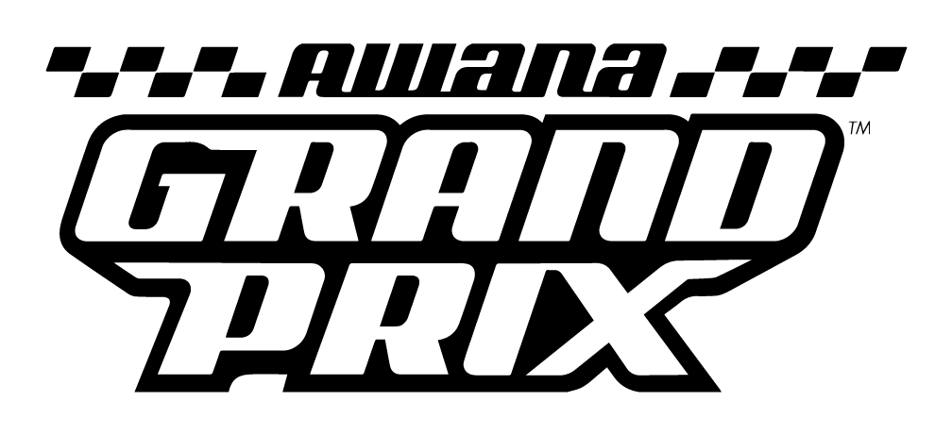
Official

2026

Splash Children’s Ministry

Bethel Baptist Church

AWANA Grand Prix

Rules & Procedures

Pit Night – February 27th, 6-8 PM
Race Night – February 28th

Registration 3:00-4:00 PM
Heat Races 4:15 PM
Chili Cook-Off to Follow Races

- Grand Prix Race Car Design Standards

  - Material:
Race cars shall be constructed for this event from the parts contained in the Official AWANA Grand Prix Kit as sold by AWANA Clubs International. Materials from the kit may not be replaced, but “add-ons” may be used.

Add-ons - Clubbers can add additional decals, steering wheels, drivers, windshields, trim or anything else as long as the car does not exceed the size and weight requirements. Starting devices are prohibited – cars must be freewheeling.

  - Weight:
The maximum allowable weight is 5 ounces as determined by the official scale during the inspection and registration periods. There is no minimum weight. Any additional weight must be securely fastened to the car.

The official scale will be available at the Children’s Welcome Center on Wednesday nights 2 weeks prior to race day, at the pit-day event, and during pre-race registration.

  - Car Size:
Cars may be no longer than 7 inches, nor wider than 2-3/4 inches, nor taller than 3 inches as determined by the official gauges.

  - Wheels and Axles:
Axles must be straight (no bent axles), and wheels must be aligned properly. Axles do not have to be mounted in the slots provided. Wheels can be cambered (angled to be closer together at the bottom than at the top) or inserted at any location or angle.

The chassis should not be lower than 3/8 of an inch from the ground to avoid scraping on the lane strips. Rough edges may be sanded off the wheels. Wheel bearings, bushings, washers, and springs are prohibited. No further modifications can be made to the wheels.

The wheels should not be inset into the block of wood.

  - Design:
The instructions are meant as a guide only. There are no limits to design or shape as long as size and weight requirements are not exceeded.

  - Chassis:
Any means can be used to shape the car including whittling, sawing, carving, or sanding.

  - Additional Rules:
- Cars raced in previous years are not eligible.
- The front of the car should not come to a point.
- The front of the car should be low and not slope so that it does not extends over the starting peg.
- The front of the car should not be notched so that any part extends past the starting peg.

- General Rules

  - Qualification
All registered AWANA clubbers may design, build, and enter cars that are eligible to participate in the annual Grand Prix.

  - Cars
All cars entered must be constructed from the “Official Awana Grand Prix Car Kit.” Kits will be available at the Children’s Welcome Center.

  - Competition Groups
There will be Four competition groups.
Division 1 - Puggles/Cubbies
Division 2 – Sparks
Division 3 - /TNT
Division 4 - Open (Any adult that wishes to join may)

  - Competition Events
There will be two competition events, “Speed” and “Design”.
- Speed Event – This will consist of a preliminary, semi-final, and final round. The top 4 from the semi-final round will race in the final round. Each Competition Group will have their own Speed Event.
- Design Event – All of the cars will be evaluated for how well the car resembles what it is meant to be, originality, creativity, and the effort that the clubber made.
- Grand Champion – This will be the final race consisting of a single speed race between each division champion to crown the years Grand Champion.

  - Attendance
Each individual MUST enter his/her own car. This means that the individual must be present at registration to enter his/her car into the competition. However, if a clubber is sick and unable to attend on race day, the car may still be entered into the competitions.

  - Single Entry per Person
Only one car may be registered per clubber participating in the Grand Prix. Open Division is allowed a max of 2 cars.

  - Pre-Race Inspection & Registration
Each car must be registered by 4:00 PM on race day and pass a technical inspection before it may compete in the Speed Event.

  - Failure to Pass Inspection
The Inspection Judges shall disqualify any car that does not meet the rules as described in the “Grand Prix Race Car Design Standards.” You have until registration closes to fix any problems.

  - Car Numbers
Clubbers will be assigned a number for their car on race day. This number will be used for race scheduling and scoring and will be written on a sticker and attached to the underside of the car during registration.

  - Impound
No car may be altered in any way after it has been registered. After a car passes inspection, the car must stay at the Pit Table until it is time to race.

