

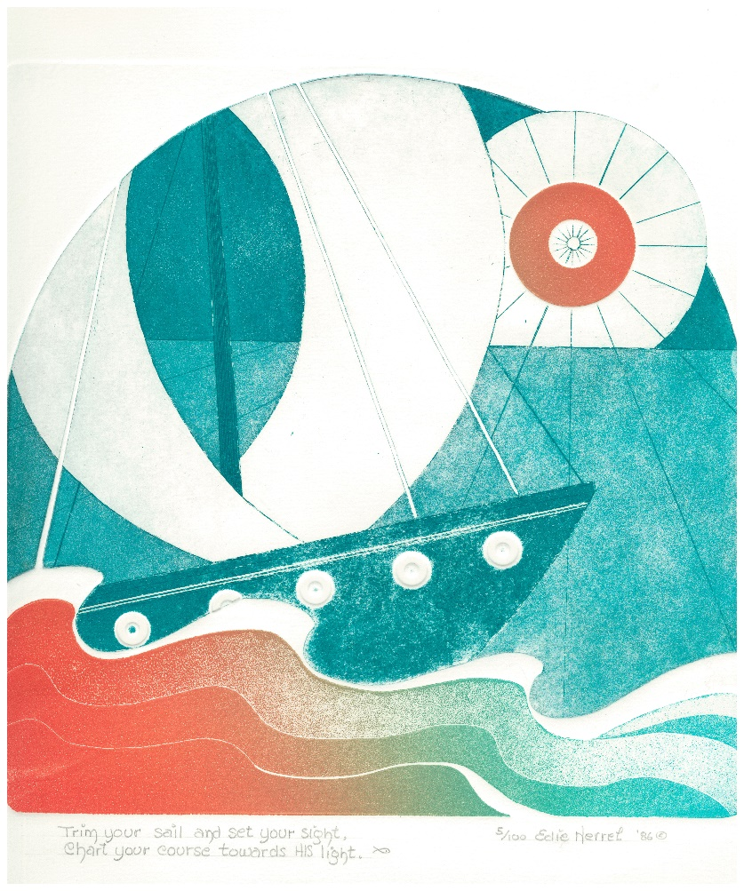

Sunday 25 January 2026, Epiphany 3
Family Eucharist
Service outline, Parish News & Events

8.00 am HOLY EUCHARIST _____________________
Celebrant and preacher: Fr. Allen Doerksen

9.30 am FAMILY EUCHARIST ___________________
Celebrant and preacher: Fr. Allen Doerksen
The Gathering of the Community
Worship Songs
Welcome
Territorial Acknowledgement
Greeting
Song of Praise Gloria tune: Pulkingham
The Story of Faith is Proclaimed
Children’s Time – Come and See the Light
First Reading: 1 Corinthians 1: 10-18
Gradual Hymn
Gospel Acclamation: Alleluia
Gospel: Matthew 4:12-23
Gospel Acclamation: Alleluia
Sermon
A short period of silent reflection follows,
signalled by the sound of a bell
Collect
Prayers of the People
Confession and Absolution
The Peace BAS 192
Offertory Hymn
Prayer over the Gifts BAS 351
The Celebration of the Eucharist
Eucharistic Prayer BAS 196
Sanctus: Holy, holy, holy Lord
The Lord’s Prayer (sung) BAS 211
Breaking of the Bread BAS 213 #6
The Communion
Music during Communion
Prayer after Communion BAS 351
Doxology (Glory to God) BAS 214
Announcements and Birthday Box
Blessing
Closing Song
Dismissal


Welcome to St Philip!
Please join us for coffee and fellowship after the service.
The abbreviation BAS in the service order refers to page numbers in the Book of Alternative Services, the green volume in the pews. CP is Common Praise, the blue hymn book.
Welcome to Communion

We want you to feel welcome at St. Philip. All are encouraged to come forward to receive the bread (communion wafer) and wine. If you prefer to receive a blessing, please keep your head and hands down. If you are more comfortable not drinking from the cup, you may keep your head down and let it pass, or return to your pew after receiving the bread. Please tell the person distributing the bread if you require a gluten-free wafer. Prayer Ministers are available during Communion at the 9:30 am service, at the side of the altar.

Offering
It is Anglican custom to receive a financial offering in our worship, as an expression of gratitude to God. Please do not feel compelled to participate in this offering. Your presence is gift enough.

Services this week
25 January 2026 – Epiphany 3
8am Holy Communion - Celebrant & preacher: Fr. Allen Doerksen
9am Community Prayers downstairs in the youth room
9.30am Holy Eucharist, in-person & streamed via Facebook Live
Celebrant and preacher: Fr. Allen Doerksen
Altar Guild: Amanda, Jenni
Usher: Bruce Fyfe
Children's ministry: Melinda Weicker
Readers: Bonnie Bailey, Mike Pipes
Prayers of the People: Florie Varga
Chalice bearer: Dana Reiter
Powerpoint slides: Clayton Savage, Mark Evans-Ehricht
Facebook Live: Karishma Iyer
Coffee: Barb Evans-Ehricht
Offerings Counters: Sharon and Leslee
27 Jan Tuesday 10:30 am Contemplative Prayer
29 Jan Thursday 10 am Holy Communion, followed by book study
From Allen’s Desk: The "Prayers of the People" is a big deal!
"The Prayers of the People” in the Book of Alternative Services is seen as an analogue to the Sermon; both sermon and prayers were seen to be concerned with "life in the world." Just as sermons were varied even as they speak to contemporary needs and hopes, so the Prayers of the People can be representative of different voices and approaches as we bring the cares of the community and the cares of the world before Christ in our midst.
At present, we are looking for a few more people to join this important ministry. Those who volunteer are often serving in this role more than is sustainable. Please let me know if you're interested in learning more about this important ministry. I can provide encouragement and training and the other people who serve in this ministry are also available for support.
Christ Church Cathedral: Ecumenical prayer service for the Week of Prayer for Christian Unity - Sunday, January 25, 2026
An ecumenical prayer service for the 2026 Week of Prayer for Christian Unity will take place on January 25, 2026 during the evensong service at Christ Church Cathedral in Victoria. The service begins at 4pm and there will be a reception to follow. All are welcome.
This service will be livestreamed. Please visit the Christ Church Cathedral website to connect with the livestream on the day of the service.
Parish Council meeting: Monday, Jan 26, 7pm in the church - All are welcome to attend.
Contemplative Prayer
Please join us on Tuesday mornings, 10:30 - 11:30, meeting in the choir area of the nave (at the front of the church), for a 20 minute contemplative sit with a time of prayer following.
Book Study: The Wednesday Zoom and Thursday in person study concludes the series on S. Mark Heim's Saved From Sacrifice: a theology of the cross: Wed Jan 28, 7 pm on Zoom— email the office for Zoom link (same as before); Thurs Jan 29, 10:30 am in person at church, following the 10am service
St Matthias Proposal – January conversations
To further facilitate listening conversations about the proposed move to St Matthias, we will host drop-in sessions at church at various times throughout January. Feel free to drop in to ask questions, seek clarification or simply share your hearts and stories with us. We will be available in the basement hall at 7:00 PM on Wednesday January 28; and in the church from 12 noon - 1pm on Thursday 29 January (ie following the regular Thursday morning book study).
- Larry and Judith
Lunch at Our Place – 28 January
St Philips Missions committee is sponsoring a luncheon at Our Place on January 28th at noon. The volunteer role is to help serve the lunch behind the food counter at lunch time.
Please see or email Evelyn Savage cedar@telus.net for details and to sign up.
Teens & Twenties Games Night - Friday, January 30, 2026
Last Fridays of the month: BOARD GAME NIGHT!
We have snacks and board games, and all we need is you! Feel free to invite your friends and bring your own snacks and games if you want to - this evening is for *everyone* between the ages of 16 and 29. We won't nitpick about the age limits :)
Date: Fridays 6:30-9:30pm, Jan 30th, Feb 27th, Mar 27th, April 24th
Where: St. Philip Anglican Church, 2928 Eastdowne - entrance to the lower level through the pathway by the garden at the side of the building - follow the signage!
Feel free to drop in or leave at any time. There are bus stops for buses 4, 9, 7, 11, and 15 within walking distance from the church.
Questions?: Contact Karishma at ms.shrutikarishma[at] gmail.com
Parish Epiphany retreat Saturday 31 January
St. Philip is on an exciting journey of discovery and we need your help! On Saturday January 31st we will have “An Epiphany Retreat” during which we will have the opportunity to pray together, learn together, and discuss aspects of our parish’s Mission and Vision.
Venue update: We will gather in the church hall at St Stephen's in Saanichton (7921 St Stephens Rd, Saanichton, BC V8M 2C3): arrival from 9.30, program 10am - 2pm. Lunch will be provided.
We are pleased that St. Stephen's is available to us for our parish retreat, as its more rural setting allows space for walks and reflection during the retreat. Please sign up to attend using the sheet on the table in the narthex, or email admin@stphilipvictoria.ca . To ensure that as many people as possible can attend, please indicate on the sign up sheet if you need a ride or can offer a ride.
- Fr. Allen, Judith and Larry
Long-term Housing Rental Request
Our family of five (2 adults, 3 children) is looking for a long-term rental property (2-3 bedroom apartment or house) in the Greater Victoria or Saanich Peninsula area with the move-in date at the beginning of January 2026. If you have a suitable place available or anticipate availability around this date, please contact Lucie at 778-533-7877 or lucie.kotesovska@seznam.cz . Thank you very much for any tips and information.
- Alecs and Lucie Kotesovsky.
Long term Housing Request
Our family of 3 (mother and 2 daughters) is looking for a clean, bright, long-term min. 2 bedroom rental with move in date 1 January 2026 or asap after that. Currently, I work as a pastry cook in one of the best restaurants in Victoria. Looking for rent of $1500 per month & offering optional help e.g. cleaning, grocery shopping, household chores, walking or caring for pets.
Julia - - 778-700-4927 or juliakroka@gmail.com
Tax receipts
Tax receipt season is fast approaching. Please contact the offerings secretary if you have moved in the past year, to confirm correct current address details: Jackie Prowse, offerings@stphilipvictoria.ca.

Oak Bay United Church: Let's Talk About Death. Death Cafe series - Wednesday lunchtimes
Oak Bay United Church invites members of local churches to attend a series of learning and discussion opportunities that aim to help us plan for our eventual death. Rev. Sarah Fanning will be hosting, with guest experts! Bring a bag lunch—we will provide coffee, tea, goodies, the space, and an expert from whom to learn!
Wednesdays, Jan. 28, Feb. 25, Mar. 25, Apr. 29 12-1:30 pm
Topics: hospice & palliative care; planning your funeral; wills, power of attorney, and legal matters; financial planning
Shrove Tuesday Pancake Supper - Tuesday, February 17, 2026
All are welcome to St Philip's Pancake Supper, held in the church hall on Shrove Tuesday, the evening before Lent begins. This year there will be two sittings, at 5.00 and 6.30pm. Organizers and volunteers wanted!
Ash Wednesday, 18 February - the season of Lent begins
Ash Wednesday services at St Philip will be at 10am and 5pm.
St Philip Parish Vestry: Annual General Meeting & Annual Reports - Tues February 24, 2026
St Philip Oak Bay will hold its Annual Vestry Meeting (AGM) at the church on Tuesday 24 February 2026 (evening, time tbc). We will receive 2025 reports, vote on a budget for 2026, and elect our Parish Council. We look forward to 2026 as we serve God by meeting the needs in the world. The 2026 agenda, 2025 annual reports, and 2026 budget will be circulated via email ahead of the meeting. Print copies will be available in the narthex.
Annual reports are due in to the office at the end of January for collation, printing and circulation ahead of the meeting: please send as plain text to admin@stphilipvictoria.ca. If you organized or led a group, team, or event at St Philip in 2025, we want to hear about it! Reports don't need to be long or formal. Even a line or two helps to create a picture of this year in our life together.

Prayers & readings for Sun 25 January & the following week:
We pray for Anna, our bishop, and Allen, our rector. In our parish cycle of prayer, we pray for the music teams.
This week our diocese prays for the people of St Saviour, Denman Island, and their lay leaders and visiting clergy.
In our ecclesiastical province's cycle of prayer, we pray for the Diocese of Kootenay and Bishop Lynne McNaughton.
This week the Anglican Church of Canada prays for The Most Rev. David Edwards, Metropolitan, and the people and clergy of the Ecclesiastical Province of Canada.
In the Anglican Communion cycle of prayer, we pray for Iglesia Anglicana de Chile.
Collect: God of all people, you sent your Son into our shadowed world. May his dawning light give hope to the broken, the persecuted, the alien and the excluded, so that we might feel the kingdom drawing near and turn to follow him; through Jesus Christ, the morning star. Amen. (Prayers for an Inclusive Church, 2009).
Anglican Communion Cycle of Prayer for the week:
- Mon 26 Jan The Diocese of Sur – Iglesia Anglicana de Chile
- Tues 27 Jan The Diocese of Del Sureste – Mexico
- Wed 28 Jan Diocese of Swansea & Brecon – Church in Wales
- Thurs 29 Jan The Diocese of Sydney – Australia
- Fri 30 Jan The Diocese of Tabora – Tanzania
- Sat 31 Jan Te Pihopatanga o Te Tai Tokerau – The Anglican Church in Aotearoa, New Zealand and Polynesia
Lectionary for Sunday 25 January: Isaiah 9:1-4; Psalm 27:1, 4-9; 1 Corinthians 1:10-18; Matthew 4:12-23
- Mon 26 Jan Psalm 27:7-14; Judges 6:11-24; Ephesians 5:6-14
- Tues 27 Jan Ps 27:7-14; Judges 7:12-22; Philippians 2:12-18
- Wed 28 Jan Ps 27:7-14; Gen 49:1-2, 8-13, 21-26; Lk 1:67-79
- Thurs 29 Jan Ps 15; Deuteronomy 16:18-20; 1 Peter 3:8-12
- Fri 30 Jan Ps 15; Deuteronomy 24:17-25:4; 1 Tim 5:17-24
- Sat 31 Jan Psalm 15; Micah 3:1-4; John 13:31-35

Cover image: Edie Mae Herrel, ‘Trim your Sail and Set your Sight; Chart your course towards his light’. Print, 1986. from Art in the Christian Tradition, a project of the Vanderbilt Divinity Library, Nashville, TN.
https://diglib.library.vanderbilt.edu/act-imagelink.pl?RC=59844
[retrieved January 21, 2026]. Original source: Image donated by Edie Mae Herrel and Dan Herrel. The artist has granted permission for the non-commercial use of this image with attribution.

Rector: Rev. Allen Doerksen (incumbent@stphilipvictoria.ca,
work cell 236-508-2928; day off: Friday)
Warden: Judith Armstrong (jarmstrong@stphilipvictoria.ca)
Warden: Larry Anthony (lanthony@stphilipvictoria.ca)
Parish Office Hours: Mon 1-4.30, Wed & Thurs 9-4.30
250-592-6823 | admin@stphilipvictoria.ca
Facebook including live streams: https://www.facebook.com/stphilipoakbay
Instagram: https://www.instagram.com/stphilipoakbay/
Thank you for avoiding scented products at church.

