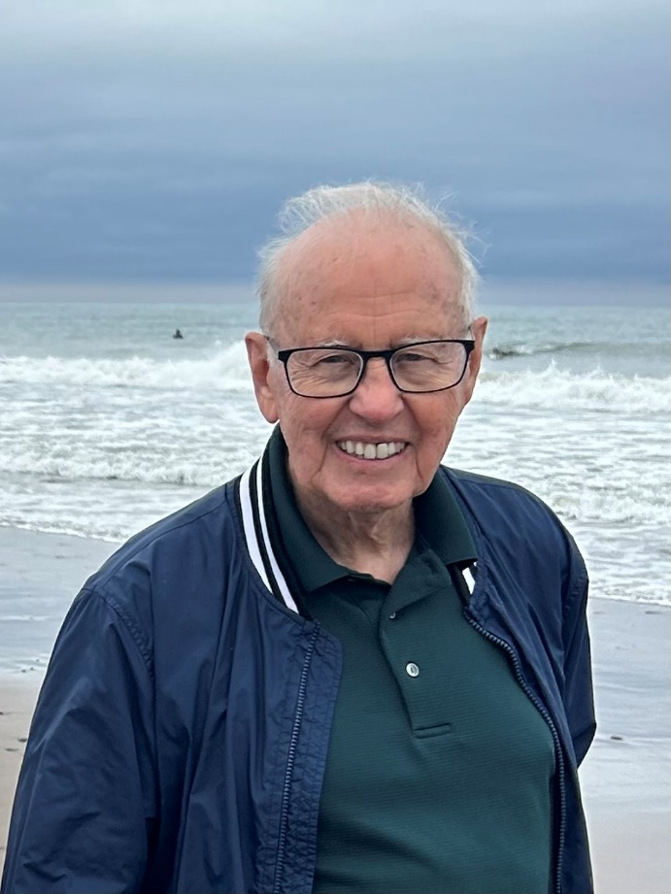
A Service in Remembrance and Celebration of
REGINALD LEONARD PERKINS
December 30, 1933 – January 8, 2026
______________________________________________

St. Timothy’s Anglican Church, Agincourt
4125 Sheppard Avenue East
Scarborough, Ontario

Saturday, January 24th, 2026

11:00 a.m.

ORDER OF SERVICE
Organ Prelude

The Sentences The Rev. Canon Andrea Christensen

Welcome

Hymn How Great Thou Art How Great Thou Art

1) O Lord my God, when I in awesome wonder consider all the worlds thy hands hath made,  I see the stars, I hear the mighty thunder, thy power throughout the universe displayed.  Refrain  3) But when I think that God, his Son not sparing, sent him to die, I scarce can take it in, that on the cross, my burden gladly bearing, he bled and died to take away my sin;  Refrain | 2) When through the woods and forest glades I wander, I hear the birds sing sweetly in the trees;  When I look down from lofty mountain grandeur and hear the brook and feel the gentle breeze;  Refrain  4) When Christ shall come, with shout of acclamation and claim his own, what joy shall fill my heart! Then I shall bow in humble adoration and there proclaim,  “My God, how great Thou art!”  Refrain

Refrain
Then sings my soul, my Saviour God, to Thee:
How great Thou art, How great Thou art!
Then sings my soul, my Saviour God, to Thee:
How great Thou art, How great Thou art!

Opening Prayer

Eulogies Deanna Perkins & Valerie Linton

First Reading Isaiah 25: 1, 4-9 Debby Maskell

Reader: The Word of the Lord
All: Thanks be to God.

Psalm 121 Jessie Linton

Hymn All Things Bright & Beautiful Royal Oak
1) Each radiant flower that opens,  each vibrant bird that sings,  God made their glowing colours,  God made their lively wings. Refrain  3) The rocky mountain splendor,  the loon’s wild, haunting call,  the great lakes and the prairies,  the forest in the fall. Refrain | 2) The cold wind in the winter,  the pleasant summer sun,  the ripe fruit in the garden,  God made them every one. Refrain  4) God gave us eyes to see them,  and lips that we might tell  how great is the Creator,  who has made all things well. Refrain

Refrain
All things bright and beautiful,
all creatures great and small,
all things wise and wonderful,
the Lord God made them all.

Gospel Reading Matthew 5: 1-12 The Rev. Canon Andrea Christensen

Leader: The Lord be with you.
All: And also with you.
Leader: The Holy Gospel of our Lord Jesus Christ according to Matthew.
All: Glory to you, Lord Jesus Christ.

The Gospel is read.

Leader: The Gospel of Christ.
All: Praise to you, Lord Jesus Christ.

Homily The Rev. Canon Andrea Christensen
Hymn Be Thou My Vision Slane

1) Be thou my vision, O Lord of my heart; naught be all else to me, save that thou art-thou my best thought, by day or by night, waking or sleeping, thy presence my light.  3) Riches I heed not, nor the world’s empty praise; thou mine inheritance, now and always. Thou and thou only, first in my heart, High King of heaven, my treasure thou art. | 2) Be thou my wisdom, be thou my true Word; I ever with thee and thou with me, Lord; thou my great Father; thine own may I be, thou in me dwelling, and I one with thee.  4) High King of heaven, when victory is won, may I reach heaven’s joys, bright heaven’s Sun! Heart of my own heart, whatever befall, still be my vision, O Ruler of all.

The Apostles’ Creed BAS pg. 592
I believe in God, the Father almighty, creator of heaven and earth. I believe in Jesus Christ, his only Son, our Lord. He was conceived by the power of the Holy Spirit, and born of the Virgin Mary. He suffered under Pontius Pilate, was crucified, died, and was buried. He descended to the dead. On the third day he rose again. He ascended into heaven, and is seated at the right hand of God the Father. He will come again to judge the living and the dead. I believe in the Holy Spirit, the holy catholic Church, the communion of saints, the forgiveness of sins, the resurrection of the body, and the life everlasting. Amen.

The Prayers of the People Sharon Bergstrom

The Lord’s Prayer (said together) BAS pg. 594
Our Father, who art in heaven, hallowed be thy name, thy kingdom come, thy will be done, on earth as it is in heaven. Give us this day our daily bread. And forgive us our trespasses, as we forgive those who trespass against us. And lead us not into temptation, but deliver us from evil. For thine is the kingdom, the power and the glory, for ever and ever. Amen.

The Commendation (said together)
Give rest, O Christ, to your servants with your saints, where sorrow and pain are no more, neither sighing, but life everlasting. “You only are immortal, the creator and maker of all; and we are mortal, formed of the earth, and to the earth shall we return. For so did you ordain when you created me, saying, you are dust, and to dust you shall return.” All of us go down to the dust; yet even at the grave we make our song: Alleluia, alleluia, alleluia. Give rest, O Christ, to your servants with your saints, where sorrow and pain are no more, neither sighing, but life everlasting.
The Blessing & Dismissal

Closing Hymn Guide Me, O Thou Great Jehovah CWM Rhondda
Guide me, O Thou great Jehovah,
Pilgrim through this barren land;
I am weak, but Thou art mighty,
Hold me with Thy powerful hand.
Bread of heaven, Bread of heaven,
Feed me till I want no more;
Feed me till I want no more.
Open now the crystal fountain,
Whence the healing stream doth flow;
Let the fire and cloudy pillar
Lead me all my journey through.
Strong deliverer, strong deliverer,
Be Thou still my Strength and Shield;
Be Thou still my Strength and Shield.
When I tread the verge of Jordan,
Bid my anxious fears subside;
Death of death and hell’s Destruction,
Land me safe on Canaan’s side.
Songs of praises, songs of praises,
I will ever give to Thee;
I will ever give to Thee.
Postlude

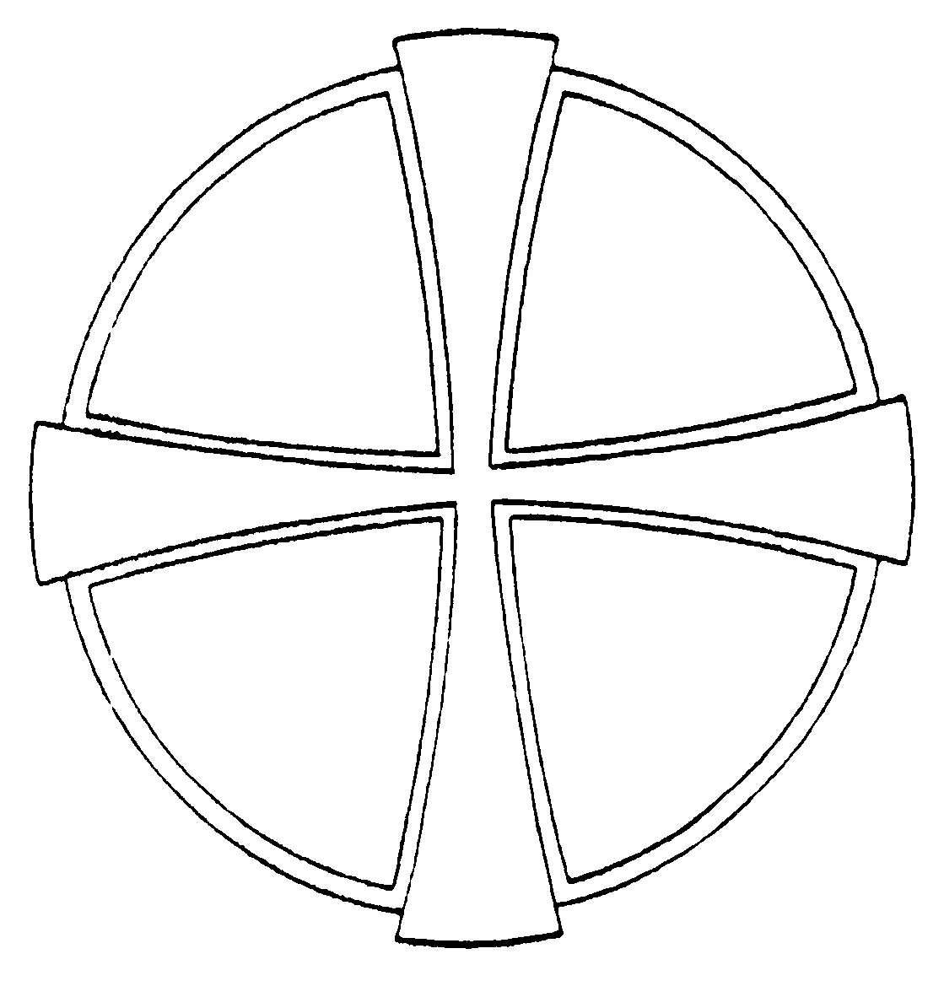

Officiant & Homilist: The Reverend Canon Andrea Christensen
Server: Janet Innes
Organist: Marianne Gast
Soloist: Taline Yeremian
Readers: Debby Maskell & Jessie Linton
Intercessor: Sharon Bergstrom
Eulogy: Deanna Perkins & Valerie Linton

DEATH IS NOTHING AT ALL

by Canon Henry Scott Holland

Death is nothing at all. It does not count. I have only slipped away into the next room.
Nothing has happened. Everything remains exactly as it was.
I am I, and you are you,
and the old life that we lived so fondly together is untouched, unchanged.
Whatever we were to each other, that we are still.
Call me by the old familiar name. Speak of me in the easy way which you always used.
Put no difference into your tone.
Wear no forced air of solemnity or sorrow.
Laugh as we always laughed at the little jokes that we enjoyed together.
Play, smile, think of me, pray for me.
Let my name be ever the household word that it always was.
Let it be spoken without an effort, without the ghost of a shadow upon it.
Life means all that it ever meant. It is the same as it ever was.
There is absolute and unbroken continuity.
What is this death but a negligible accident?
Why should I be out of mind because I am out of sight?
I am but waiting for you, for an interval, somewhere very near, just round the corner.
All is well. Nothing is hurt; nothing is lost.
One brief moment and all will be as it was before.
How we shall laugh at the trouble of parting when we meet again!
Precious in the sight of the Lord is the death of his faithful ones.
Psalm 116:15

The family invites you to a reception downstairs in Walker Hall, following the service today, where we will take nourishment for the journey of continuing our living, and share stories of caring and thankfulness for Reg's life.

In lieu of flowers, the family asks that donations
be made to the mission and ministry of
St. Timothy's Anglican Church, Agincourt.
Envelopes are available in the narthex.

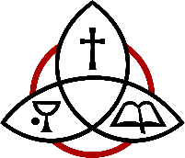

St. Timothy’s Anglican Church, Agincourt
4125 Sheppard Ave. East, Scarborough
www.sttims.ca

