Holy Trinity Lutheran Church
150 River Road Red Bank, NJ 07701
Church Office: (732) 741-9241 Fax: (732) 741-9577
email: holytrinitychurch4@verizon.net
Website: htlcredbank.org
Pastor: Rev. John Mack, Jr.
Cell: (336)-392-5839
Minister of Music: Peter Isherwood
Parish Administrator: Deanna Vergari
Council President: Cynthia Kazmac



January 18, 2026

Second Sunday after Epiphany

Introduction

Today’s gospel opens with further reflection on Jesus’ baptism. He is the Lamb of God who takes away the sin of the world and the one anointed by the Spirit. In the liturgy we come and see Christ revealed among us in word and meal. We go forth to invite others to come and worship the Holy One and to receive the gifts of grace and peace made known among us.

Welcome & Announcements (Please remember to silence your cell phone!)

Prelude (We prayerfully prepare our hearts and minds to worship!)

+ GATHERING +

Confession and Forgiveness
All may make the sign of the cross, the sign that is marked at baptism, as the presiding minister begins.
P:Blessed be the holy Trinity, ☩ one God,
the Creator of heaven and earth,
the Word who spoke life into being,
the Wind stirring the waters.
C:Amen.
P:Let us turn in confession to the one who knows us completely.
Silence is kept for reflection.
Mighty God, lover of justice,
C:you call us to life in community,
but we have served our own interests
at the expense of our neighbors.
We have sown deceit where honesty was needed.
We say the right words,
but our hearts are far from you.
Turn us to seek your face.
Knit us together and give us the mind of Christ,
that we may do justice, love mercy,
and walk humbly with you, our God.
Amen.
P:The former things have passed away,
and new things God now declares:
Like a spring of water that never fails,
God covers you in the righteousness of Christ,
and forgives your sin in ☩ Jesus’ name.
May the Spirit give you strength to live for others,
and bless you with the gift of peace.
C:Amen.

*Gathering Hymn ELW 310 Songs of Thankfulness and Praise
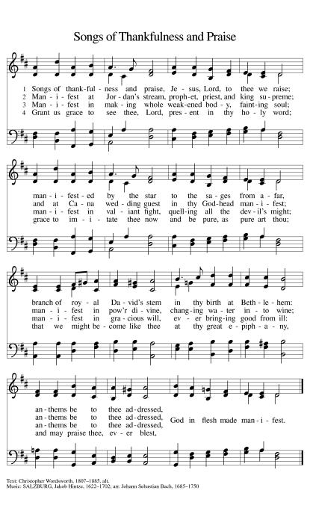

*Pastoral Greeting

P: The Grace of our Lord Jesus Christ, the love of God, and the communion of the Holy Spirit be with you all.

C: And also with you!

Hymn of Praise

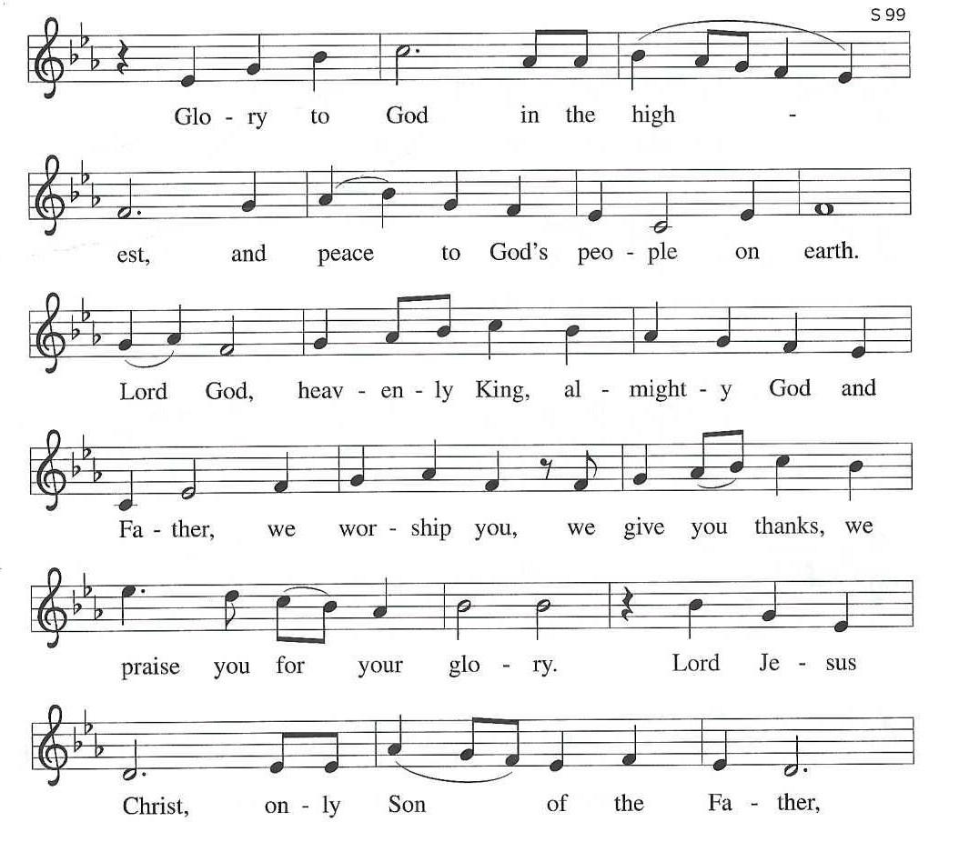

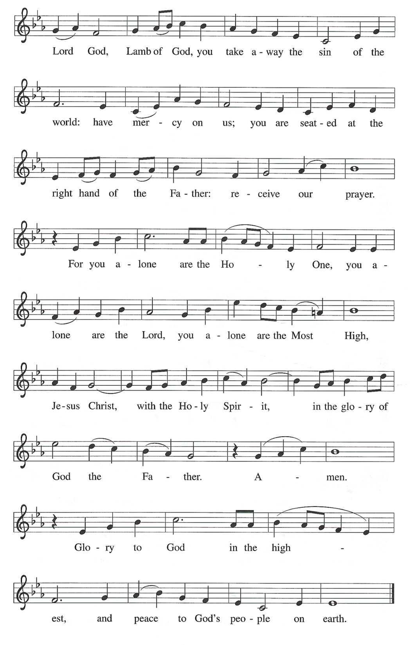

*Prayer of the Day
P: Holy God, our strength and our redeemer, by your Spirit hold us forever, that through your grace we may worship you and faithfully serve you, follow you and joyfully find you, through Jesus Christ, our Savior and Lord.
C: Amen!

+WORD+

First Reading: Isaiah 49:1-7
Here the servant, identified as Israel, speaks for herself and describes her honored mission. Called before her birth like Jeremiah and John the Baptist, the servant is not only to restore Israel. The servant’s ultimate assignment is to bring news of God’s victory to the ends of the earth. God in faithfulness has chosen Israel for this task.

¹ Listen to me, O coastlands;
pay attention, you peoples from far away!
The Lord called me before I was born;
while I was in my mother’s womb he named me.
² He made my mouth like a sharp sword;
in the shadow of his hand he hid me;
he made me a polished arrow;
in his quiver he hid me away.
³ And he said to me, “You are my servant,
Israel, in whom I will be glorified.”
⁴ But I said, “I have labored in vain;
I have spent my strength for nothing and vanity;
yet surely my cause is with the Lord
and my reward with my God.”
⁵ And now the Lord says,
who formed me in the womb to be his servant,
to bring Jacob back to him,
and that Israel might be gathered to him,
for I am honored in the sight of the Lord,
and my God has become my strength—
⁶ he says,
“It is too light a thing that you should be my servant
to raise up the tribes of Jacob
and to restore the survivors of Israel;
I will give you as a light to the nations,
that my salvation may reach to the end of the earth.”
⁷ Thus says the Lord,
the Redeemer of Israel and his Holy One,
to one deeply despised, abhorred by the nations,
the slave of rulers,
“Kings shall see and stand up;
princes, and they shall prostrate themselves,
because of the Lord, who is faithful,
the Holy One of Israel, who has chosen you.”

Psalm: Psalm 40:1-11
I love to do your will, O my God. (Ps. 40:8)
¹ I waited patiently up- | on the Lord,
who stooped to me and | heard my cry.
² The Lord lifted me out of the desolate pit, out of the | miry clay,
and set my feet upon a high cliff, making my | footing sure.
³ The Lord put a new song in my mouth, a song of praise | to our God;
many shall see, and stand in awe, and put their trust | in the Lord.
⁴ Happy are they who trust | in the Lord!
They do not turn to enemies or to those who | follow lies.
⁵ Great are the wonders you have done, O Lord my God! In your plans for us, none can be com- | pared with you!
Oh, that I could make them known and tell them! But they are more than | I can count.
⁶ Sacrifice and offering you do | not desire;
you have opened my ears: burnt-offering and sin-offering you have | not required.
⁷ And so I said, “Here I | am; I come.
In the scroll of the book it is writ- | ten of me:
⁸ ‘I love to do your will, | O my God;
your law is | deep within me.’ ”
⁹ I proclaimed righteousness in the | great assembly;
I have not restrained my lips, O | Lord, you know.
¹⁰ I have not hidden your righteousness in my heart; I have spoken of your faithfulness and | your deliverance;
I have not concealed your steadfast love and truth from the | great assembly.
¹¹ You are the Lord; do not withhold your compas- | sion from me;
may your steadfast love and your truth continually | keep me safe.

Second Reading: 1 Corinthians 1:1-9
Though God’s church in Corinth is a fractious congregation beset with many conflicts, Paul opens this letter by spotlighting the multiple ways God has enriched and sustained its life as part of the divine call into the fellowship of our Lord Jesus Christ.

¹ Paul, called to be an apostle of Christ Jesus by the will of God, and our brother Sosthenes,
² To the church of God that is in Corinth, to those who are sanctified in Christ Jesus, called to be saints, together with all those who in every place call on the name of our Lord Jesus Christ, both their Lord and ours:
³ Grace to you and peace from God our Father and the Lord Jesus Christ.
⁴ I give thanks to my God always for you because of the grace of God that has been given you in Christ Jesus, ⁵ for in every way you have been enriched in him, in speech and knowledge of every kind ⁶ just as the testimony of Christ has been strengthened among you ⁷ so that you are not lacking in any gift as you wait for the revealing of our Lord Jesus Christ. ⁸ He will also strengthen you to the end, so that you may be blameless on the day of our Lord Jesus Christ. ⁹ God is faithful, by whom you were called into the partnership of his Son, Jesus Christ our Lord.

Gospel Acclamation
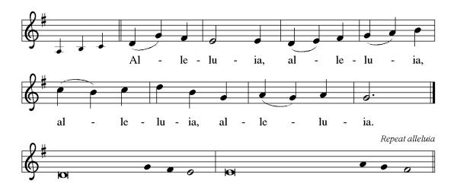

P: The Holy Gospel According to St. John 1st Chapter
C: Glory to You O Lord!

Gospel: John 1:29-42
John the Baptist’s witness to Jesus initiates a chain of testimony as his disciples begin to share with others what they have found.
²⁹ [John the Baptist] saw Jesus coming toward him and declared, “Here is the Lamb of God who takes away the sin of the world!³⁰ This is he of whom I said, ‘After me comes a man who ranks ahead of me because he was before me.’ ³¹ I myself did not know him, but I came baptizing with water for this reason, that he might be revealed to Israel.” ³² And John testified, “I saw the Spirit descending from heaven like a dove, and it remained on him. ³³ I myself did not know him, but the one who sent me to baptize with water said to me, ‘He on whom you see the Spirit descend and remain is the one who baptizes with the Holy Spirit.’ ³⁴ And I myself have seen and have testified that this is the Chosen One.”
³⁵ The next day John again was standing with two of his disciples, ³⁶ and as he watched Jesus walk by he exclaimed, “Look, here is the Lamb of God!” ³⁷ The two disciples heard him say this, and they followed Jesus. ³⁸ When Jesus turned and saw them following, he said to them, “What are you looking for?” They said to him, “Rabbi” (which translated means Teacher), “where are you staying?” ³⁹ He said to them, “Come and see.” They came and saw where he was staying, and they remained with him that day. It was about four o’clock in the afternoon. ⁴⁰ One of the two who heard John speak and followed him was Andrew, Simon Peter’s brother. ⁴¹ He first found his brother Simon and said to him, “We have found the Messiah” (which is translated Anointed). ⁴² He brought Simon to Jesus, who looked at him and said, “You are Simon son of John. You are to be called Cephas” (which is translated Peter).

P: The Gospel of the Lord
C: Praise to you, O Christ!

Sermon

*Hymn of the Day ELW 460 Now the Silence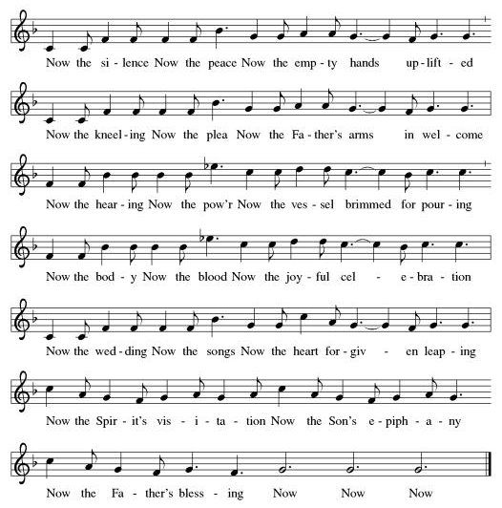

*Prayers of Intercession
As God’s beloved children united in Christ, let us pray for the church, the whole human community, and the well-being of the earth, our home.
A brief silence.
Gracious God, gather the church into one great fellowship. Equip your people to work together for justice and peace, following the example of Martin Luther King Jr., renewer of society, whose birth we remember this week. Merciful God,
C:receive our prayer.
Creating God, sustain the web of life on this planet. Protect wild places, endangered species, and vulnerable habitats. Come to the aid of those affected by natural disasters (current situations may be named). Merciful God,
C:receive our prayer.
Just God, you desire respect and equality for everyone. Raise up prophets who speak truth to the nations. Embolden leaders and those in authority to advocate for people in need. Merciful God,
C:receive our prayer.
Healing God, you lift up those who are bowed down by trouble, oppression, or illness (especially). Bring an end to social injustice and inequities of every kind, so that all people may have abundant life. Merciful God,
C:receive our prayer.
Abiding God, you are present with this congregation. Keep us mindful of our mission and guide our ministries in this community (local ministries may be named). Kindle in us a desire to help one another. Merciful God,
C:receive our prayer.
Here other intercessions may be offered.
Faithful God, you promise to be with us always. We remember with gratitude the faithful departed who now rest in you. Strengthen us to the end, that we may see you face to face. Merciful God,
C:receive our prayer.
Confident that the Holy Spirit receives our prayers and answers us, we commend all for whom we pray to God’s loving-kindness made known to us in Christ Jesus our Savior.
C: Amen.

Greeting of Peace
P: The peace of Christ be with you always!
C: And also with you!

Offering (Thank you for your support for our ministry!)

*Doxology ELW 306 Come, Beloved of the Maker (v.5)(Please stand and join in singing as we share our gifts!)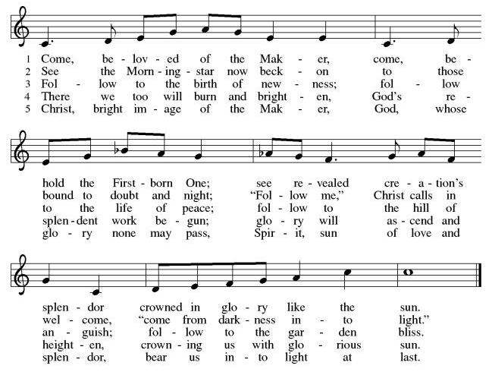

*Offering Prayer
A: God of majesty,
C: no eye has seen, no ear has heard
what you have prepared for those who love you,
yet in this meal you reveal the wideness of your mercy.
Use what we have gathered
to feed us with the reign of God come near,
Jesus Christ, our Savior and Lord.
Amen!

+MEAL+
*Great Thanksgiving
P: The Lord be with you.
C: And also with you.

P: Lift up your hearts.
C: We lift them to the Lord.

P: Let us give thanks to the Lord our God.
C: It is right to give our thanks and praise.

P: It is indeed right, our duty and our joy,
that we should at all times and in all places
give thanks and praise to you, almighty and merciful God,
through our Savior Jesus Christ.
By the leading of a star he was shown forth to all nations;
in the waters of the Jordan you proclaimed him your beloved Son;
and in the miracle of water turned to wine he revealed your glory.
And so, with all the choirs of angels,
with the church on earth and the hosts of heaven,
we praise your name and join their unending hymn:

*Sanctus
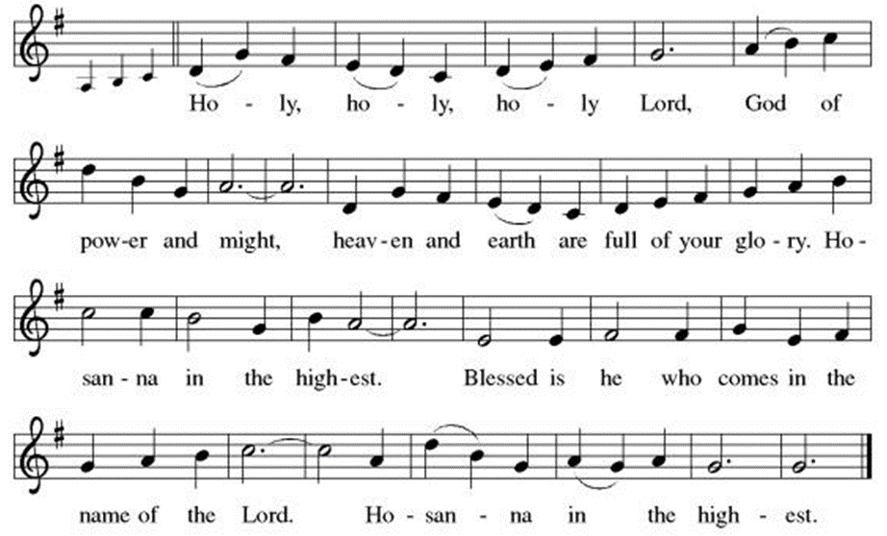
*Eucharistic Prayer
P:Holy God, mighty Lord, gracious Father:
Endless is your mercy and eternal your reign.
You have filled all creation with light and life;
heaven and earth are full of your glory.

We praise you for the grace shown to your people in every age:
the promise to Israel,
the rescue from Egypt,
the gift of the promised land,
the words of the prophets;
and, at this end of all the ages, the gift of your Son,
who proclaimed the good news in word and deed
and was obedient to your will, even to giving his life.

In the night in which he was betrayed,
our Lord Jesus took bread, and gave thanks;
broke it, and gave it to his disciples, saying:
Take and eat; this is my body, given for you.
Do this for the remembrance of me.

Again, after supper, he took the cup, gave thanks,
and gave it for all to drink, saying:
This cup is the new covenant in my blood,
shed for you and for all people for the forgiveness of sin.
Do this for the remembrance of me.

For as often as we eat of this bread and drink from this cup,
we proclaim the Lord’s death until he comes.
C: Christ has died. Christ is risen. Christ will come again.

P:Therefore, O God, with this bread and cup
we remember the life our Lord offered for us.
And, believing the witness of his resurrection,
we await his coming in power
to share with us the great and promised feast.
C:Amen. Come, Lord Jesus.

P:Send now, we pray, your Holy Spirit,
that we who share in Christ’s body and blood
may live to the praise of your glory
and receive our inheritance with all your saints in light.
C:Amen. Come, Holy Spirit.

P:Join our prayers with those of your servants
of every time and every place,
and unite them with the ceaseless petitions of our great high priest
until he comes as victorious Lord of all.
Through him, with him, in him,
in the unity of the Holy Spirit,
all glory and honor is yours, almighty Father,
now and forever.
C:Amen.

*THE LORD’S PRAYER
Our Father, who art in heaven,
hallowed be thy name,
thy kingdom come,
thy will be done,
on earth as it is in heaven.
Give us this day our daily bread;
and forgive us our trespasses,
as we forgive those
who trespass against us;
and lead us not into temptation,
but deliver us from evil.
For thine is the kingdom,
and the power, and the glory,
forever and ever. Amen.
*Lamb of God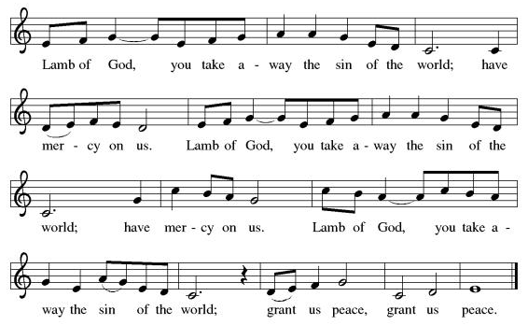

Spiritual Communion Prayer
P: Let us pray for the communion of all present here, those viewing our service virtually, those in our hearts and in our world.
C: Lord Jesus, I believe you are truly present in the Sacrament of Holy Communion. When I cannot receive Communion, I pray that you come into my heart. I know that nothing in Heaven or on earth can separate me from your love. Amen.

Invitation to Communion
P: Here is the Lamb of God who takes away the sin of the world!
Come to the table; taste and see.
C: Thanks be to God!

(All are invited to the communion rail following the guidance of the ushers. Communion will be shared through the host and individual cups. If you would like communion but are unable to join us at the rail, please alert the usher!)

Communion Hymns (Please join in singing!)

TFF 98 Open Our Eyes, Lord
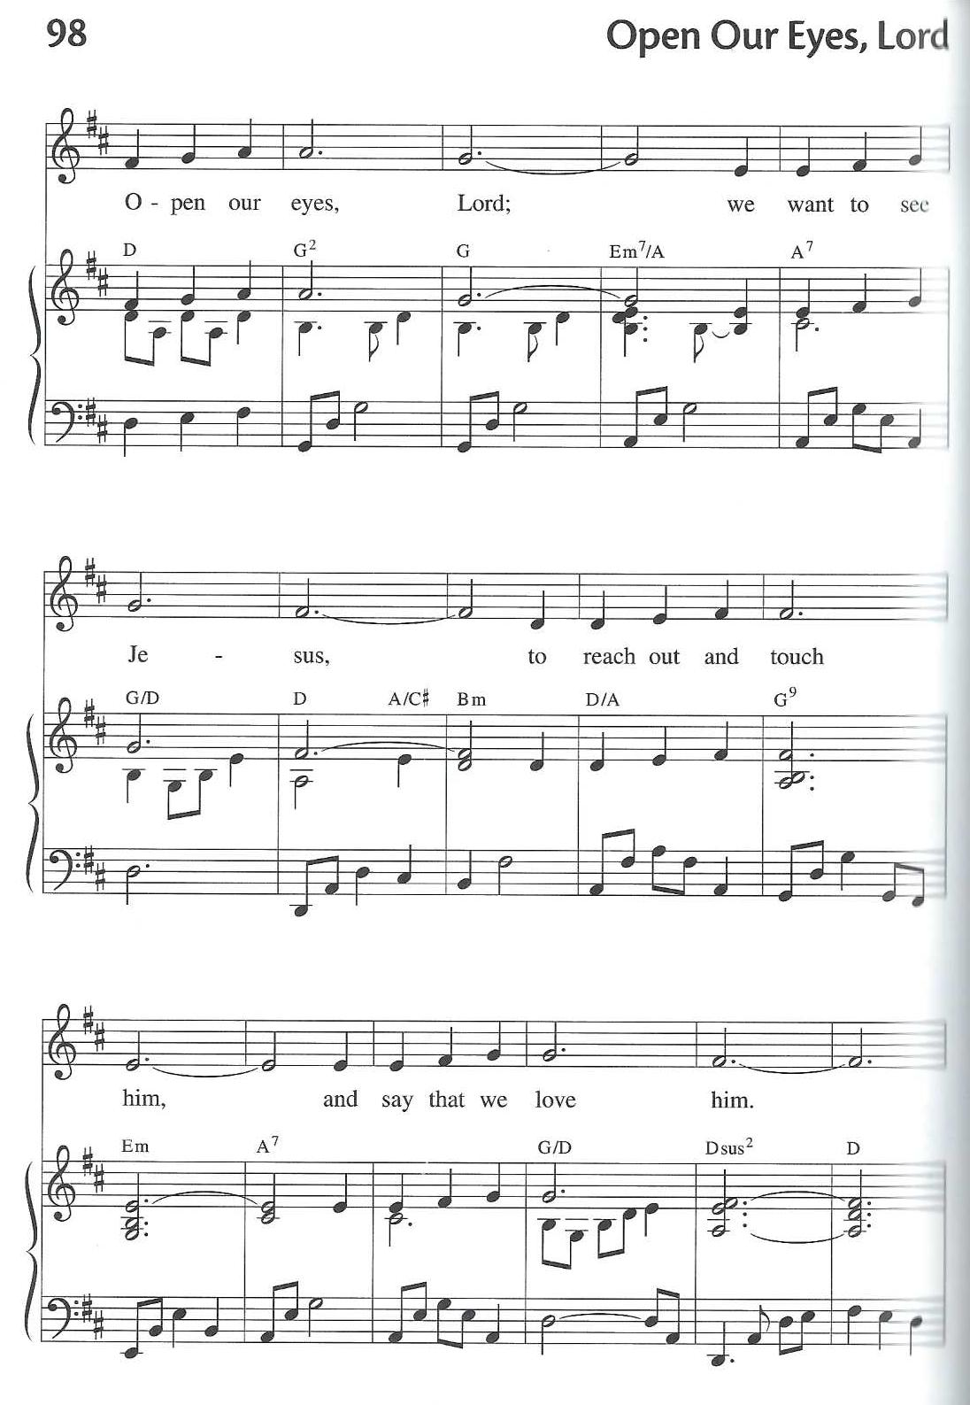
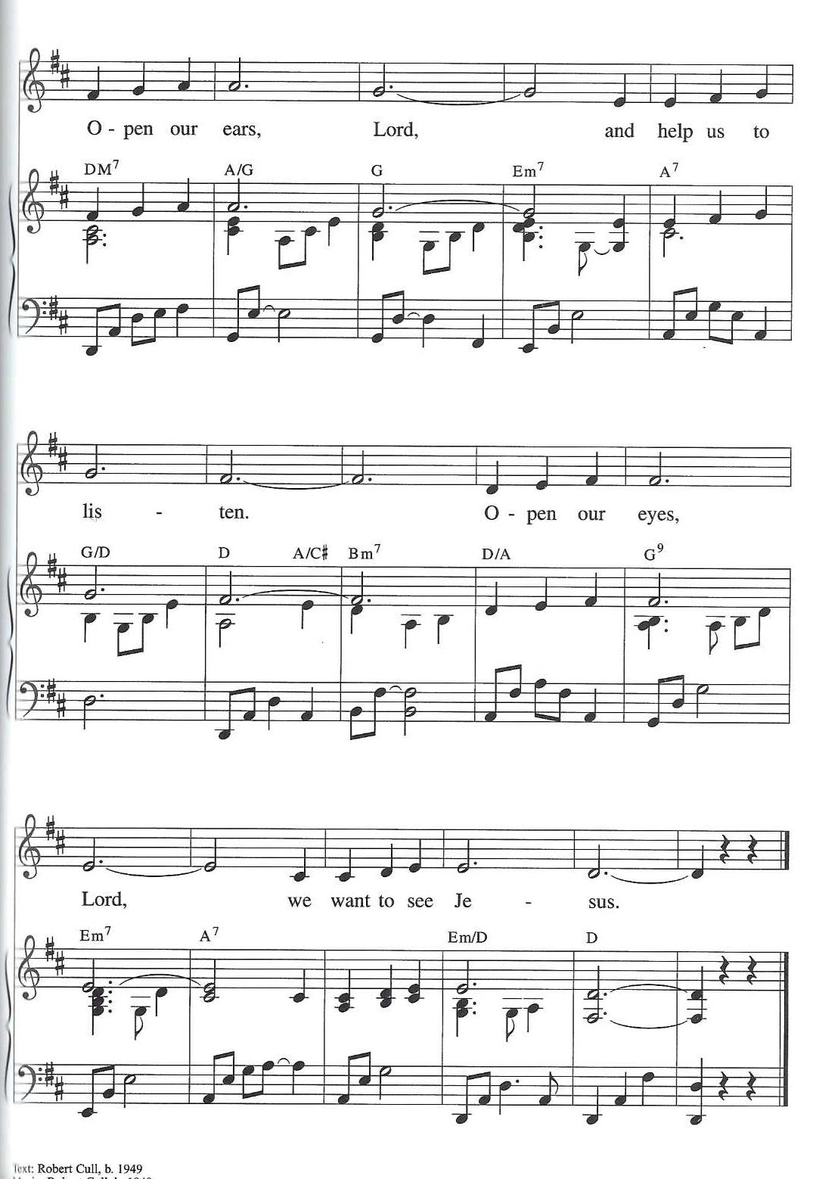

ELW 798 Will You Come and Follow Me
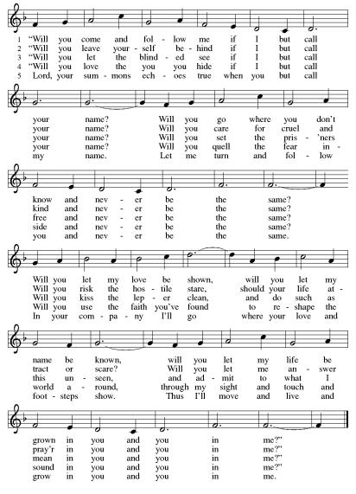

*Prayer after Communion
A: Radiant God,
we have seen your glory in the face of Jesus Christ.
In the sacrament of his body and blood
you have drawn us to your heart.
Send us from this table with delight,
that our lives may reflect the beauty of your love,
and bear witness to all we have seen and heard,
through Jesus Christ, our Savior and Lord.
C: Amen.
+Sending+

*Blessing
P: May the triune God,
who has put a new song in your mouth
and tuned your heart for praise
☩ bless you now and forever. C: Amen!

*Sending Hymn ELW 841 Lift Every Voice and Sing
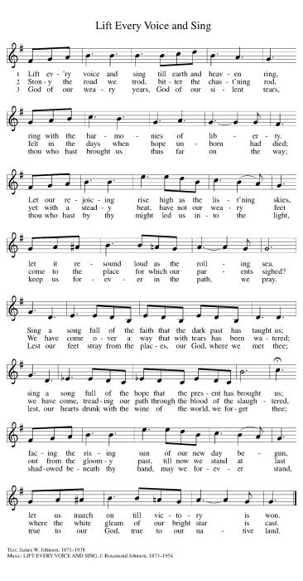

*Dismissal
A: Go in peace. Do justice. Love mercy.
C: Thanks be to God!

Postlude

Copyright © 2020 Augsburg Fortress. All rights reserved. Reprinted by permission under Augsburg Fortress Liturgies Annual License #SB106907. New Revised Standard Version Bible, Copyright © 1989, Division of Christian Education of the National Council of the Churches of Christ in the United States of America. Used by permission. All rights reserved. Revised Common Lectionary, Copyright © 1992 Consultation on Common Texts, admin Augsburg Fortress. Used by permission.

Treasurer’s Report
HTLC Financial Snapshot - December 2025
Category | Actual | Budget | +/- vs Budget | Status
December Income | $20,559 | $19,208 | $1,351 | On Track
December Expenses | $20,507 | $20,672 | -$165 | On Track
December Result | $53 | -$1,464 | $1,516 | On Track
YTD Income | $215,914 | $230,500 | -$14,586 | Attention
YTD Expense | $243,005 | $245,564 | -$2,559 | On Track
YTD Result | -$27,091 | -$15,064 | -$12,027 | Attention

While expense control was strong throughout the year,. income did not meet expectations, creating a larger deficit than planned. However, we are certain that the generosity andthe commitment of the people of Holy Trinity will make great things happen in 2026!
Thank you for supporting our ministry! Chris Foard, Treasurer

Worship Volunteer Schedule
Date | Asst. Min | Usher | Sacristan | Lector | Counter
January 18 | Elaine Bradford | Dan Grillon | Carol Rosen | Emily Kaster | Bohner/Volk
January 25 | Charlie Rugg | Gripps | Pat Pienkos | Jeff Ridberg | Bradford/Giordano
February 1 | Linda Coleman | Kathy Caputo | Sherry Lee | Cynthia Kazmac | Carleo/Csernica
February 8 | Keith Bennett | Jill Socha | Joanne Giordano | Molly Foard | McKenna/Kazmac
February 15 | Chris Foard | Dan Gillon | Helga Britton | Rosemary Lane | Foss/Coleman

Altar Flowers- They Doyle’s, Happy Birthday Theo!!
Coffee Hour- Linda Coleman

ANNOUNCEMENTS Thank you! To all who consistently support our church and ministries through your time, talent, and treasure. Please help us grow by inviting your friends and family to worship and events. You are what makes Holy Trinity a wonderful church family!

Stay in touch! Please visit our church website, www.htlcredbank.org for updates and information. You can also find us on Facebook and view services online. The office is open from 9am to 2pm, Monday to Thursday.

100 Anniversary Committee- If you are interested in being a part of the committee to help plan the 100th anniversary celebration of HTLC in 2028, please sign up in the red book. All are welcome! Also, the committee will be looking for photos and documents of HTLC throughout the years. If you have anything to share, please bring them to the church and marked envelopes or email electronic copies to the church office.

Name Tag Sundays: On the first Sunday of each month, names tags and markers will be at each entrance of the sanctuary. Please fill out a tag and wear one for worship and for coffee hour to welcome visitors and help newcomers put names to faces.

Annual Congregational Meeting January 25, 2025

Sunday School in the New Year, we will continue to study stories and lessons from the Old Testament beginning with Jacob. Kids will love the crafts, songs and games that accompany each lesson.
The following dates there will be Sunday School:
Jan- 11 and 25, Feb- 8 and 22, March- 1, 15 and 29*Easter Egg Hunt!
April- 12 and 26, May- 3, 17 and 31, June- 7 and 14
As was done in the fall, there will be opportunities to volunteer as SS lead teacher. A signup will be emailed out shortly and will also be posted in the red binder. Consider signing up! All lesson materials will be supplied and laid out and a leader guide will be emailed to volunteers approximately 1 week in advance. Blessings for a wonderful 2026!~Lauren

Trivia Night!! Mark your calendars! Plan for a fun night at Holy Trinity on Feb. 28 at 5pm for great food and trivia. We have an International theme, so we ask you to bring a pot luck dinner item showing your ethnic heritage. There is a sign up sheet for your convenience.
You don't have to be another Ken Jennings---this is just for fun. See you then!

Choir The Holy Trinity Choir welcomes our singers back for a preparation rehearsal on Sunday, September 7th at 9am in the church hall. All are welcome to join us in song as often as you are able. Choir meets each Sunday at 9am to practice and prepare our music. Join us and help us grow by spreading the word about the HTLC Choir!

Quilting- The Quilters need gently used any bed sheets of any size! Please leave any donations in the quilters closet in Fellowship Hall. Thank you!

Quilters Need Help
If anyone is traveling through Maryland on Rte. 95, and can add a few extra minutes to your trip, the warehouse for shipping quilts, school kits, etc is located directly off one of the exits.
We accumulate many quilts throughout the year and we would appreciate sending some quilts with you to deliver.
Any questions, please call Sherry Lee or Elaine Theophall.

Weekly Quilting on Wednesdays at 9:30. Bring your lunch and enjoy some fellowship at noon. All are welcome. There will be no quilting on Wednesday September 24 due to the garage sale set up.

Evening Quilting Evening Quilting –
Please share this information . This is an important ministry that helps so many. It’s very easy and you don’t need to know how to sew. We have a great time socializing too! We will meet: Jan. 21, Feb. 18, March 18 at 6:00 PM. Note: If we have to cancel I will send an email. Please let me know only if you can come. Contacts: Pat Pienkos 732-513-9615 Debbie Yetka 908-461-4084 Looking forward to seeing you all!

Social Ministry
*Year-round collections will continue for food items for Lunch Break. There is a sign-up sheet in the red book for those who can help drop these items to Lunch Break.
*We will also collect adult men's socks to periodically drop at the Red Bank Warminq Center.
*For those interested in the Heartwarminq Center — the new women's shelter is adjacent to the First Baptist Church of Red Bank at 90 Maple Ave. You can follow up on this mission through their website - https://www.thefeastnj.org- On this site, they also include wish list items that can be purchased through amazon. We will be exploring purchasing some of these through a Thrivent card. If you want to purchase on your own, you can leave items at church, and the Social Ministry will deliver them.
Pastoral Care and Prayer... We are here to care for and pray! Please contact the office to add or adjust prayer requests. If you or someone you know needs pastoral care, please contact the office and Pastor Mack!

THANK YOU for supporting and sustaining our church and ministries! All are welcome here! Please invite your family and friends to worship with us! Find us online at www.htlcredbank.org



