

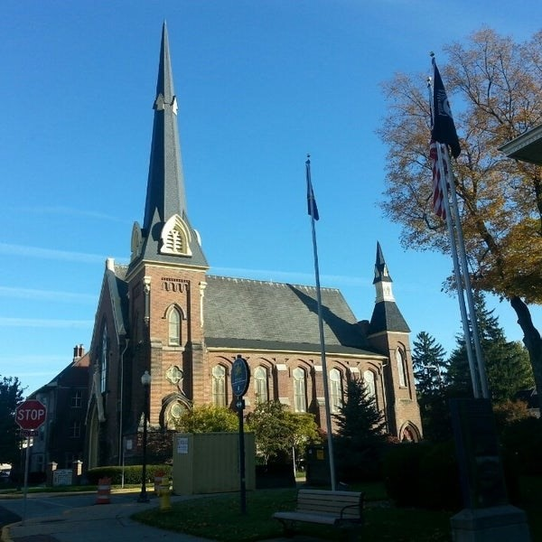
January 7, 2026

A Global Methodist Church
214 S. 5th Street
Goshen, IN 46528
Phone: 574-533-9518
Web Site: goshenfirstgmc.org

Office Hours: Monday-Friday,
8:00 a.m.-12:00 noon
Worship: 9:00 a.m.
Sunday School: 10:30 a.m.
Pastor Jeff & Lisa
Associate Pastor Rich Hull
OUR VISION: “Growing in Faith, Gathering in Community, and Giving in Love”.



Christianity 101 meets every second and third Sunday during the S.S. hour.
Anyone is welcome. Pastor Jeff leads the class in the Garden Room, and shares the basics of our Christian faith.

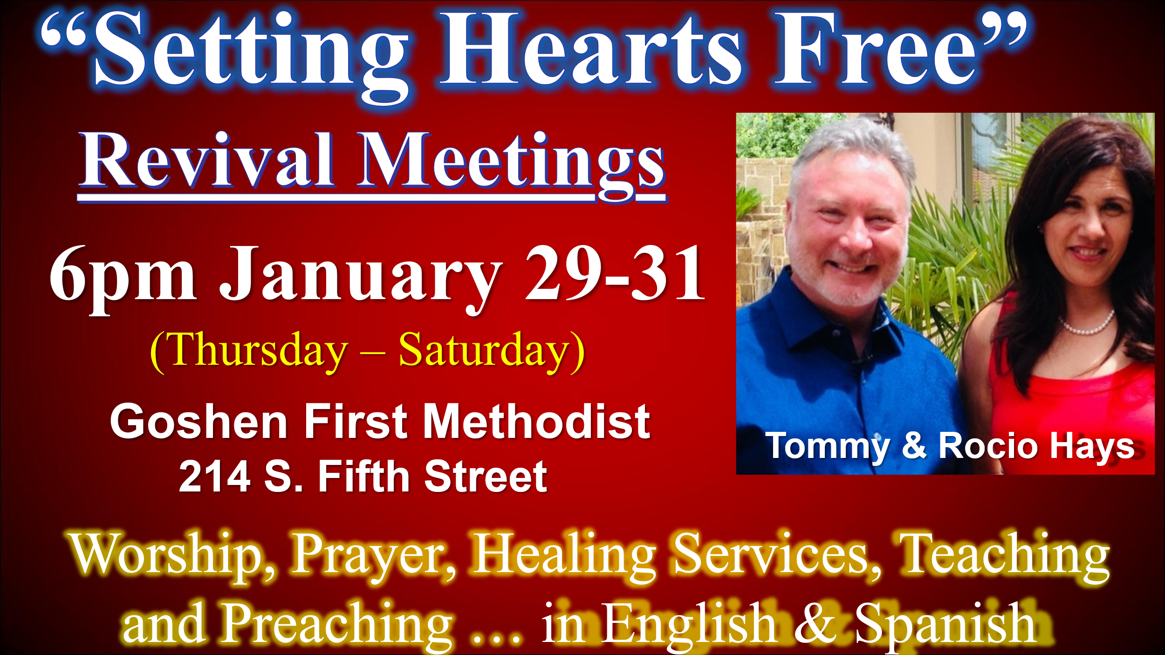

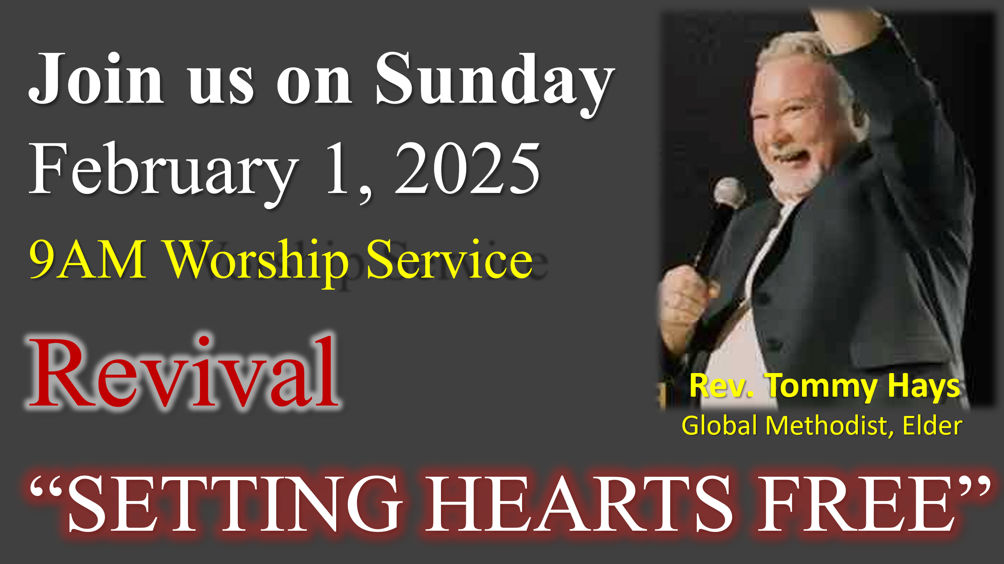


The Primetimers will meet on Thursday, January 15, at 11:30 a.m. for a ham dinner in the Garden Room. There will be a $12 charge. After lunch, the Westview High School choir, directed by Scott Carter, will sing for us. Everyone is welcome. Sign-ups will be Sunday in the gym, or call the church office or Betty Jo Morris.



The Wednesday evening meal and classes continue. The meal is at 5:30 p.m., and classes are at 6:00 p.m. Pastor Jeff leads a Bible Study, and the children meet for class. There is child care provided for preschoolers. Everyone is welcome.

VOLUNTEERS – Thank you for your service! Sunday morning, January 11
Greeters: Max Leatherman VIP: Kelly Leeper
Elevator Hosts: Ken & Cathy Smith
Ushers: Gary Miller, Patty Krebs, Jeff Showalter, Ron Troyer, Hudson Martin
Scripture Reader: J.D. Russell
Elementary Junior Church: Rachel Parsons Tenorio, Kelley Leeper
Junior High Church: Linda Russell
Coffee Hour: Max Leatherman, Betty Jo Morris, Steve & Lori Warner
Bus Driver: Randy Cripe


We are in need of a bus driver for Sunday mornings to help pick up some of our members. You would drive on a rotating basis with the other drivers. Please let Harriet at the church office know if you can help.

OUR STAFF
Pastor Jeff Bealmear – pastorjeff@goshenfirstgmc.org
Associate Pastor Rich Hull – rich@goshenfirstgmc.org
Pastor Emeritus Ben Whirledge – benwhirledge@goshenfirstgmc.org
Harriet Martin, Office Administrator – harrietmartin@goshenfirstgmc.org
Scott Carter, Director of Music Ministry – carters@westview.k12.in.us
Rachel Tenorio, Children/Youth Director – rachel@goshenfirstgmc.org
Linda Ponce, Treasurer – lcponce1@gmail.com
DeDe Russell, Caring Ministries Coordinator – russelldede@yahoo.com
Kimberly Lichty-Nyce, Social Media Editor – klichty-nyce@comcast.net
Joel Lane, Pianist – joell12068@gmail.com
John Jinright, Organist – jjinrig@troy.edu
Rodney Troyer, Custodian – troyerstc@gmail.com
Jazlyn Troyer, Sound Tech

