

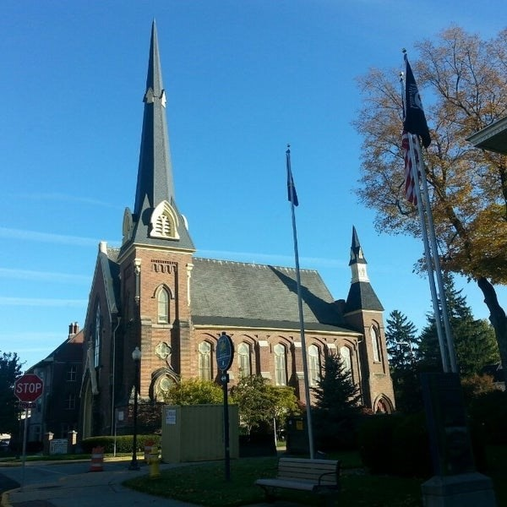
January 21, 2026

A Global Methodist Church
214 S. 5th Street
Goshen, IN 46528
Phone: 574-533-9518
Web Site: goshenfirstgmc.org

Office Hours: Monday-Friday,
8:00 a.m.-12:00 noon
Worship: 9:00 a.m.
Sunday School: 10:30 a.m.
Pastor Jeff & Lisa
Associate Pastor Rich Hull
OUR VISION: “Growing in Faith, Gathering in Community, and Giving in Love”.

The Monday morning Bible study has started up again. They meet at 9:30 a.m.
in the Parlor. They are studying the book of Acts. Everyone is welcome.

The Wednesday evening meal and classes continue. The meal is at 5:30 p.m., and classes are at 6:00 p.m. Pastor Jeff leads a Bible Study, and the children meet for class. Child care is provided for preschoolers. Everyone is welcome.

Someone donated a walker to our church, so if you are in need of a walker,
please let the church office know.



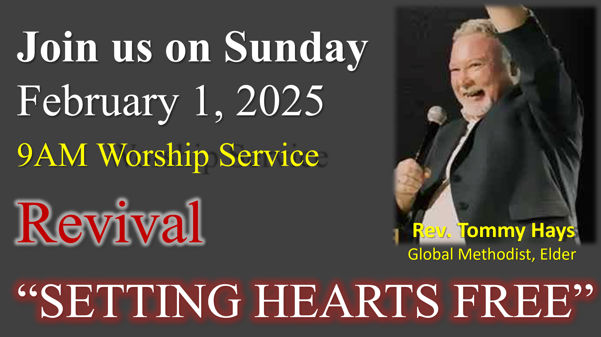

VOLUNTEERS – Thank you for your service! Sunday morning, January 25
Greeters: Erv Herschberger VIP: Kelly Leeper
Elevator Hosts: Lenette Burckhart, Jackie Lung
Ushers: Gary Miller, Patty Krebs, Jeff Showalter, Ron Troyer, Hudson Martin
Scripture Reader: Ann Stutsman
Elementary Junior Church: Pat Huber, Kelley Leeper
Junior High Church: Beth Pettit
Coffee Hour: Dave & Marcia Parsons, Ron & Loraine Troyer
Bus Driver: Al Eppert




We are in need of a bus driver for Sunday mornings to help pick up some of our members. You would drive on a rotating basis with the other drivers. Please let Harriet at the church office know if you can help.

OUR STAFF
Pastor Jeff Bealmear – pastorjeff@goshenfirstgmc.org
Associate Pastor Rich Hull – rich@goshenfirstgmc.org
Pastor Emeritus Ben Whirledge – benwhirledge@goshenfirstgmc.org
Harriet Martin, Office Administrator – harrietmartin@goshenfirstgmc.org
Scott Carter, Director of Music Ministry – carters@westview.k12.in.us
Rachel Tenorio, Children/Youth Director – rachel@goshenfirstgmc.org
Linda Ponce, Treasurer – lcponce1@gmail.com
DeDe Russell, Caring Ministries Coordinator – russelldede@yahoo.com
Kimberly Lichty-Nyce, Social Media Editor – klichty-nyce@comcast.net
Joel Lane, Pianist – joell12068@gmail.com
John Jinright, Organist – jjinrig@troy.edu
Rodney Troyer, Custodian – troyerstc@gmail.com
Jazlyn Troyer, Sound Tech

