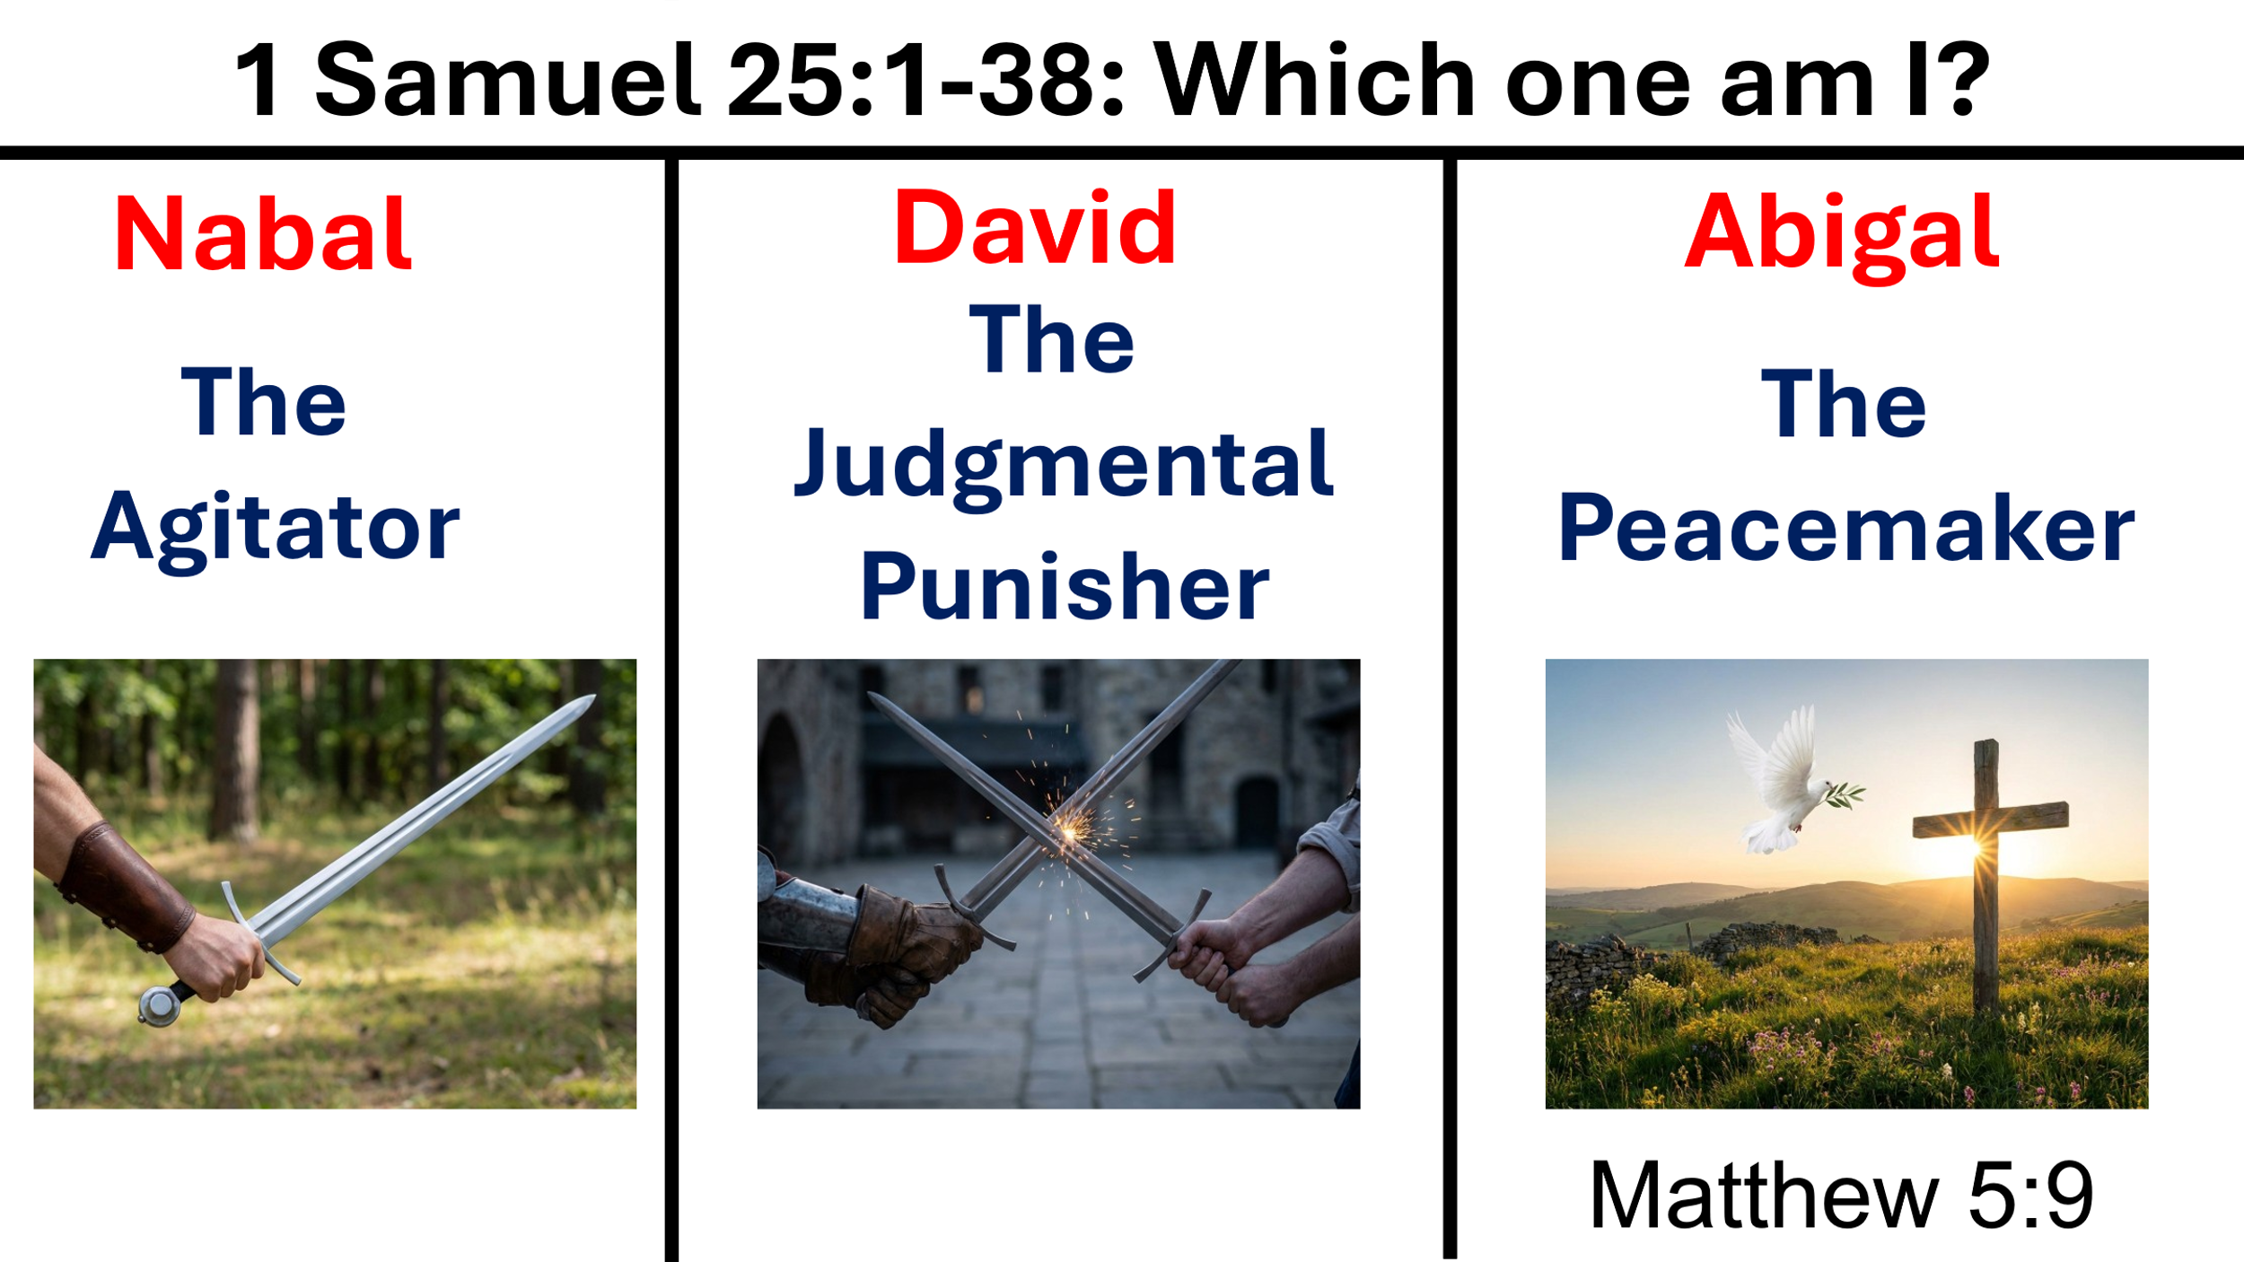

Welcome and Announcements

Passing the Peace

Prelude Instrumental

Greeting / Call to Worship (Based on Mtthew 5: 2-10)
Liturgist: Blessed are the poor in spirit, for theirs is the Kingdom of heaven
Congregation: Lord, help us to humbly know that we need your grace.
Liturgist: Blessed are those who mourn, for they will be comforted
Congregation: Lord, we mourn our sinful hearts, receive your forgiveness and that comforts us
Liturgist: Blessed are the meek, for they will inherit the earth
Congregation: Lord, we surrender to your loving will
Liturgist: Blessed are those who hunger & thirst for righteousness, for they will be filled
Congregation: Lord, change our hearts to make us holy – Christlike
Liturgist: Blessed are the merciful, for they will be shown mercy
Congregation: Lord, as we become holy, may we show unconditional love
Liturgist: Blessed are the pure in heart, for they will see God
Congregation: Lord, continue to cleanse our hearts of sin and fill them with faith, hope, and unconditional love
Liturgist: Blessed are the peacemakers, for they will be called children of God
Congregation: Lord, use us as your peacemakers
Liturgist: Blessed are those who are persecuted because they are righteous and/or they proclaim Jesus as Lord
Congregation: Lord, we trust you to give us strength and patient endurance when we are persecuted.

Opening Song* “How Majestic is Your Name” On Screens

Opening Prayer* (Prayer by Rev. Dr. Martin Luther King)
O Thou Eternal God, out of whose absolute power and infinite intelligence the whole universe has come into being, we humbly confess that we have not loved thee with our hearts, souls and minds, and we have not loved our neighbors as Christ loved us. We have all too often lived by our own selfish impulses rather than by the life of sacrificial love as revealed by Christ. We often give in order to receive. We love our friends and hate our enemies. We go the first mile but dare not travel the second. We forgive but dare not forget. And so as we look within ourselves, we are confronted with the appalling fact that the history of our lives is the history of an eternal revolt against you. But thou, O God, have mercy upon us. Forgive us for what we could have been but failed to be. Give us the intelligence to know your will. Give us the courage to do your will. Give us the devotion to love thy will. In the name and spirit of Jesus we pray. Amen.

Affirmation of Faith* Apostle’s Creed UMH # 881/On Screens

Gloria Patri* UMH #70 / On Screens

Old Testament 1 Samuel 25:1-38 page 209 in pew Bible
Liturgist: This is the word of God for the people of God.
Congregation: Thanks be to God.

Children’s Sermon….Diane Wilson

New Testament * Matthew 5:9 page 683 in Pew Bible
Liturgist: This is the word of God for the people of God.
Congregation: Thanks be to God.

Presentation of Prayers and Praises

Prayer Song “All the ways my Savior leads me” Lisa Wetszel

Prayer

Receiving God’s Tithes and Sacrifices

Offertory Song Instrumental

Doxology* UMH #95 / On Screens

Message “Am I an agitator, judgmental punisher, or peacemaker?
(Part III of “Which one am I?”) Pastor David Charlton

Closing Song* “God of Wonders” On Screens

Benediction*
Go in the name of the FATHER, SON, and HOLY SPIRIT and, with the transforming power of God’s grace, be holy because God is holy. Go in peace. Amen.

(*) Indicates to stand if able.

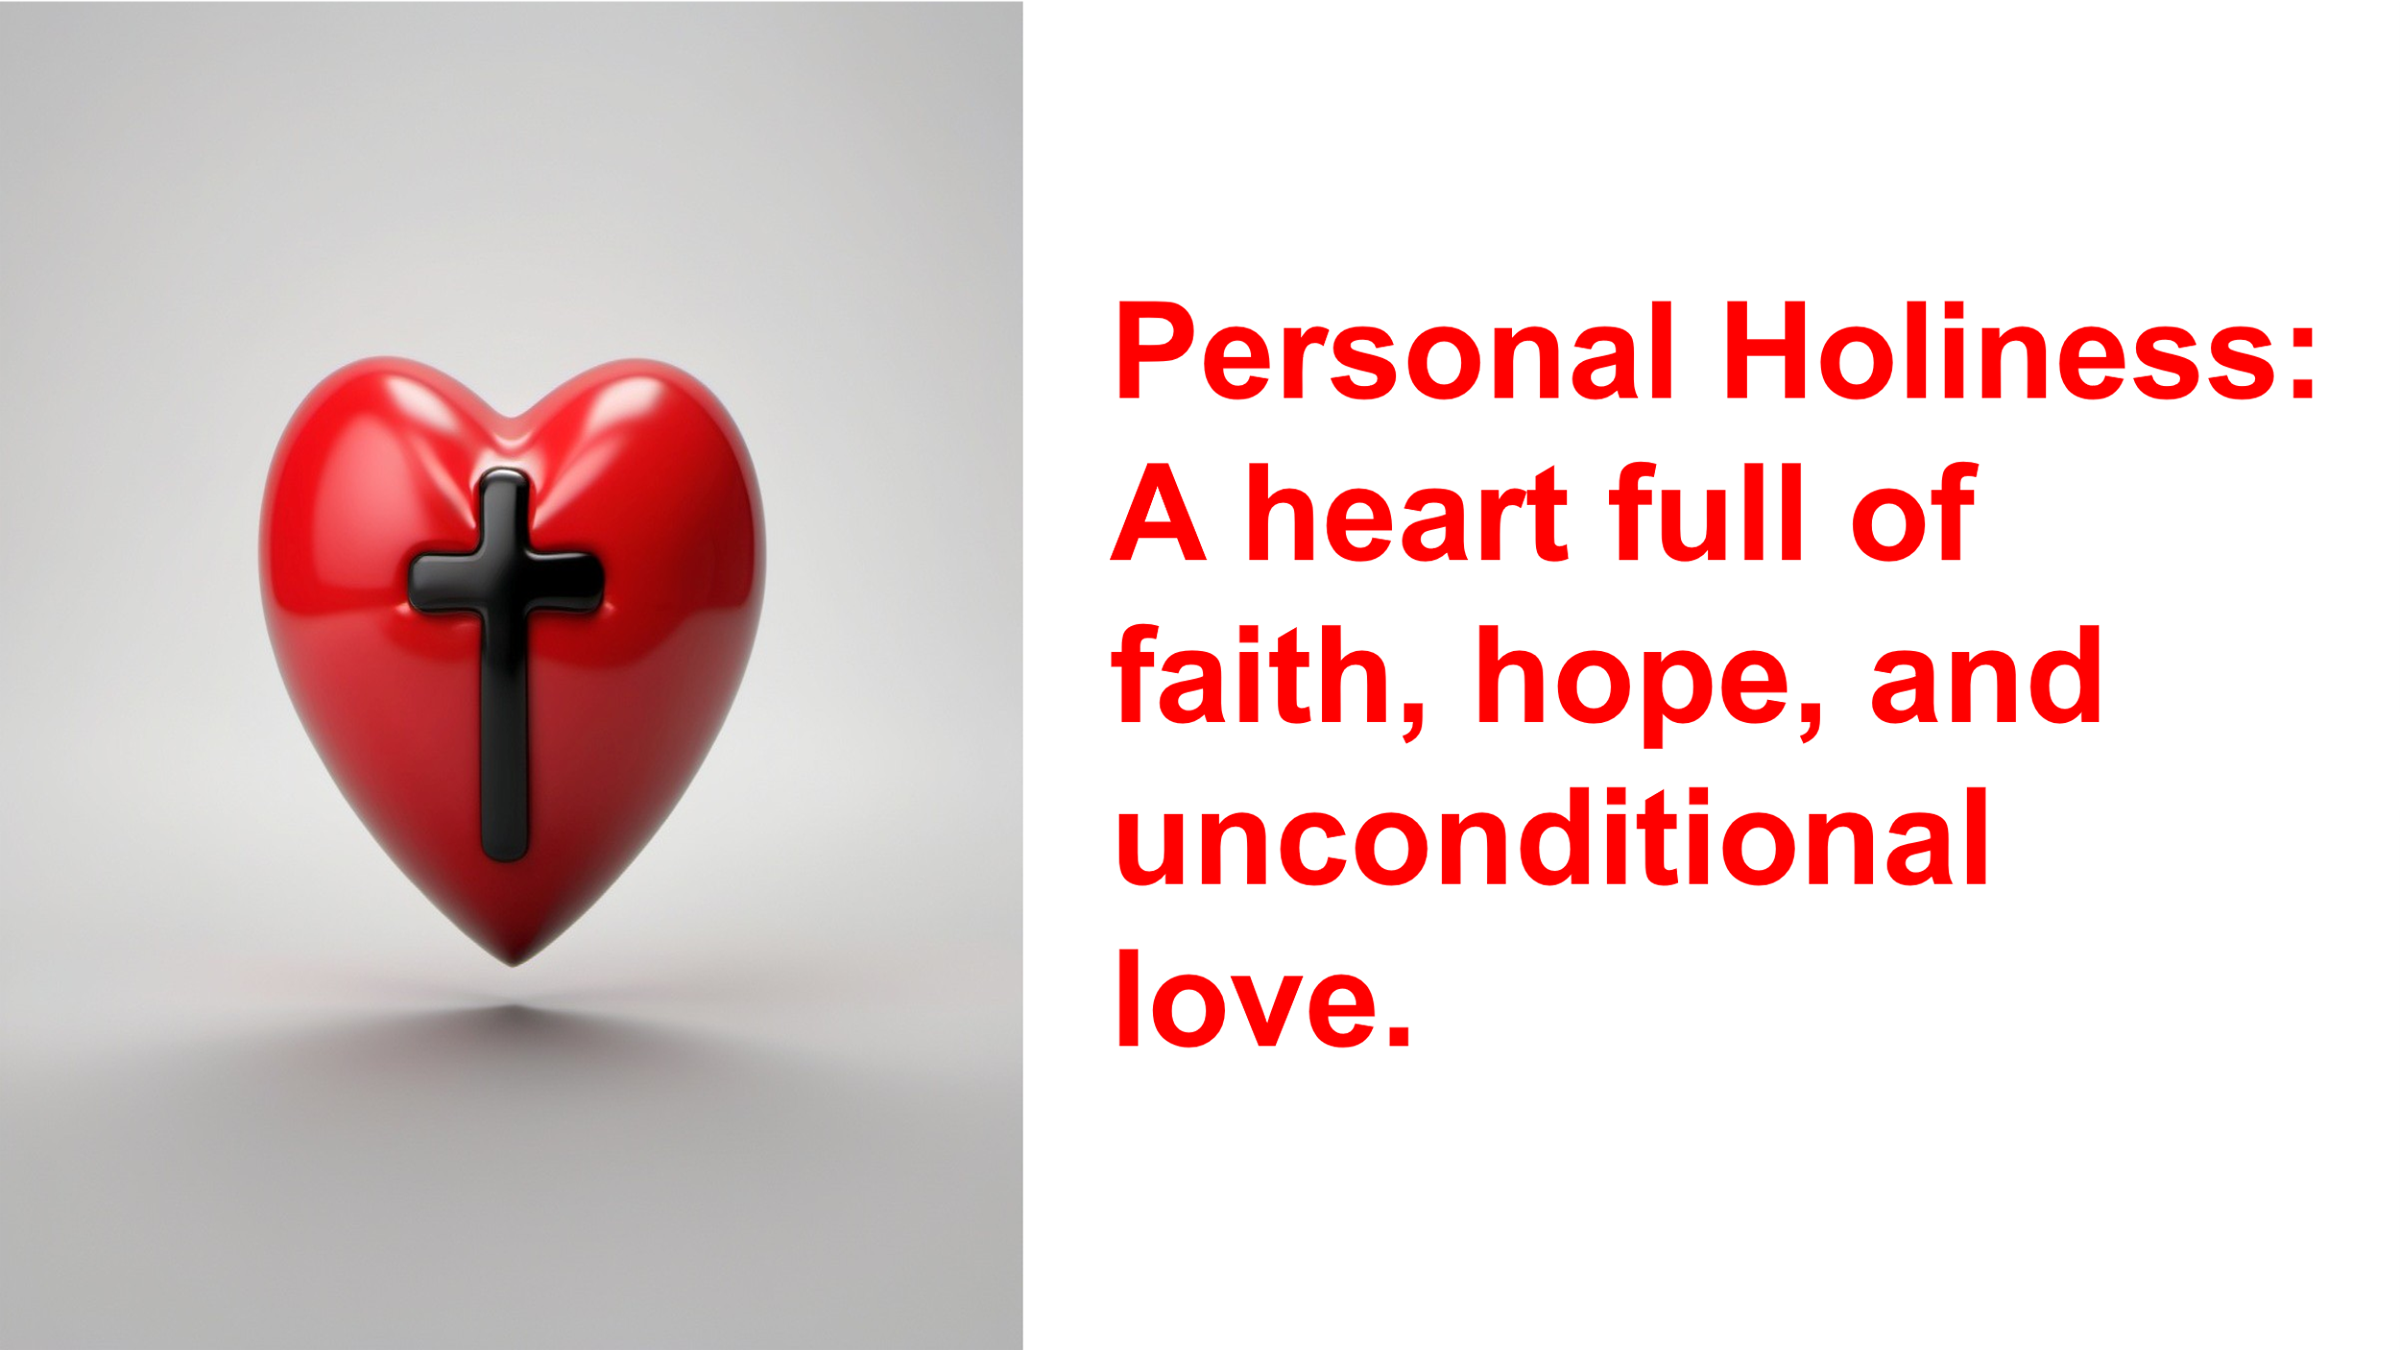
Welcome!
We are glad you are here! May you experience the transforming power of God’s love as you worship with us.

The following is our mission statement:
We are an uncommon church for common people offering a love of neighbor without boundaries. We share the gospel of love when we gather to celebrate a faith relationship with Christ. We serve both God and his children through our ongoing prayers, talents, gifts, and dedication of time until he comes again in glory.

I would love to sit down with you over coffee or a meal. If you would like that, please let me know. My contact info is:
407-687-2226, pastordavidc12@yahoo.com

David Charlton
Pastor



January 18, 2026 10 am

93001 Overseas Hwy MM 93
Tavernier, FL 33070
(305) 852-2581 / (fax) 852-4917
Office hours:
Mon. – Thurs. 9:00 am – 4:00 pm
Fri. office closed

Pastor: David Charlton

Email: pastordavidc12@yahoo.com
Web Page: www.BMUMC.net
Church Email:
bae_bmumc@att.net

We are the church on the curve.
This Week
Sunday (01/18):
10:00 am – Worship Service (Sanctuary)
Burton Memorial
Monday (01/19):
6:30 pm – Tai Chi Class (Fellowship Hall)
Office closed - observance of Rev. Dr. Martin Luther King’s day
Tuesday (01/20):
9:45 am – Tai Chi Class (Fellowship Hall)
Wednesday (01/21):
9:00 am – Food Pantry (Fellowship Hall)
Thursday (01/22):
5:00 pm – Food Pantry (Fellowship Hall)
5:00 pm – God’s Kitchen (Fellowship Hall)

6:30 pm – Prayer Shawl Meeting (Joy Classroom)
Friday (01/23): Office Closed
A United Methodist Church
Burton Memorial
A United Methodist Church
Upcoming Events
Sunday, February 1, 6:30 pm, Sanctuary – Chosen series begins
Monday, February 2, 6:30 pm, Joy Classroom – Bible Study Reflection on the Chosen begins
Wednesday, February 18, 7AM to 9AM – Ash Wed. Drive up anointing
Wednesday, February 18, 6PM - Ash Wed. Worship Service
Friday, April 3, 6 PM – Good Friday worship – starts in Fellowship Hall with soup dinner and ends in outdoor sanctuary with a contemplation on Jesus’ words while dying on the cross.

