St. Paul
UNITED CHURCH OF CHRIST

January 11, 2025 10:30am
Welcome! Whether you are a guest, friend or member, we are delighted that you are here. Large print bulletins are available at either door. Ask a greeter for any directions you may need.

“Please note that this service will be live-streamed on Facebook. If you do not wish to be visible on camera, please let an usher know so we can take appropriate measures to ensure
your privacy."

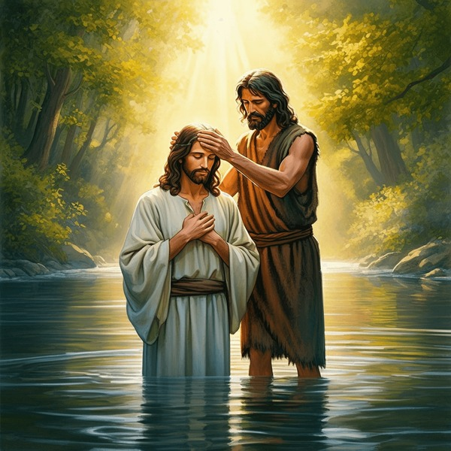

Rev. Jim Oleson, Pastor
Carolyn Meier, Musician
First Sunday after Epiphany – Baptism of Christ
*Please rise in body or spirit
Ringing of the Bell
Welcome & Announcements
In the last days, says God, I will pour out my Spirit upon all people. Your sons and daughters shall prophesy. Your young people shall see visions, and your old people shall dream dreams. People of God, we have been baptized into one Spirit and one body through Jesus Christ. Let us worship today.
Prelude and Lighting of the Candles
* Call to Worship
One: Come, all who are gathered to worship God:
Many: Let us ascribe to our God glory and strength!
One: Let us ascribe to God the glory of God’s name
Many: and let us worship God in holy splendor!
One: The voice of our God is over the waters.
Many: The God of glory thunders over mighty waters.
*Invocation
Wonderful and Gracious God, some of us come to you weary from the stress and strain of our days, seeking the rest that only you can give. Some of us come doubting or lukewarm in faith, seeking your spiritual quickening. But whatever our condition of mind, heart, or spirit, we come giving thanks that you accept and welcome us, and in your transforming love, are even now changing the old clothing of our souls for new. We open ourselves to your working within and among us, as we lift our spirits into the light of your holy presence, and our voices in praise of our goodness. As you are present to us O God, help us be present to you. Guide and lead us and help us to follow - that we might be both blessed and a blessing. Amen.
*Hymn of Praise #43 New Century Love Divine, All Loves Excelling
*Prayer for Transformation and New Life
God, your true light has come into the world, blessing all upon whom it shines. Hope, God of heaven and earth, you see all things. You know the depths of our hearts better than we can know ourselves. You know the great heights to which we aspire and the depth of our failures when we fall short of doing what we know is right. We ask for your mercy and forgiveness for our selfishness and fears.
Help us to walk as the faithful representatives you call us to be. Create in us the grace of Christ toward those with whom we disagree, just as he extended it to those who conspired against him. Amen. <pause for silent reflection >
Words of Grace
Leader: Thus says the God who created you and formed us in God’s image:
People: “Do not fear, for I have redeemed you; I have called you by name, you are mine.”
Leader: You belong to God. This is the good news!
*Response of Praise
Glory be to the Father, and to the Son, and to the Holy Ghost; As it was in the beginning, is now, and ever shall be, World without end. Amen. Amen.
Written Word Isaiah 42:1-9
Acts 10:34-43
Matthew 3:13-17
Hymn #290 New Century Spirit of God, Descend Upon My Heart
Message Why Baptism? Rev. Jim Oleson
Matthew 3:13-17
Church in Prayer
Pastoral Prayer
Lord’s Prayer (Debts, Debtors)
Offertory
Invitation to Generosity
*Doxology (Tune: Old Hundredth)
Praise God, from Whom all blessings flow; Praise Him, all creatures here below;
Praise Him above, ye heavenly host; Praise Father, Son, and Holy Ghost. Amen.
*Prayer of Dedication
Giver and Sustainer of Life, pour out your blessing upon these gifts and upon all who give from their hearts. Multiply them so they reach farther than our imaginations can carry them. In the blessed name of our Redeemer, we pray. Amen.
*Closing Hymn #312 New Century We Love Your Realm, O God

*Commission and Benediction
*Christ’s Light Leads Us into the World
*Congregational Response #182 New Century We Have Come at Christ’s Own Bidding
(Verse 1)
*Ringing of the Bell and Postlude

903 Meier Road, Old Monroe, Missouri 63369
stpauluccom@gmail.com
Website: stpauluccom.com
636-665-5329

OFFICE HOURS
Wednesday: 9:00am – 3:00pm
Friday: 9:00am - Noon

It Happens
Here St. Paul UCC
Weekly Calendar
January 11th – January 18th

January 11th First Sunday after
Epiphany – Baptism of Christ
9:15am Bible/Book Study
10:30am Worship
11:30am Fellowship Hour

January 18th Second Sunday after
Epiphany
9:15am Bible/Book Study
10:30am Worship
11:30am Carry in dinner
12:30pm Annual Meeting

Looking Ahead

January 20th
Worship Committee Meeting

________________________________________________________________________________________
OUR GIVING IN 2026
Needed weekly to meet our commitments $2190.29 $ 2190.29
General Fund Offering January 4th $ 2795.00 December Average $ 1375.00 Stewardship Offering January 4th $ 95.00 November Average $ 1521.25
______ __________________________________________________ __ ____________________ ________

HAPPENING IN OUR COMMUNITY

Saturday, January 17: Frostbite BBQ at St. John’s UCC in Weldon Springs. Dinner and sandwiches available. Dine in or carry out from 11:00am to 3:00pm or till it’s all gone.

Thank you to all our volunteers!

Greeters/Ushers
Gerald Hackman & Mary Anne Lee

Acolyte
Janet Drown

Liturgist

Fellowship Hour
PPR (Reminder…the committee
hosting fellowship needs to sweep the fellowship hall
floor.)

In our prayers …

We continue to keep in our prayers Lauretta, Lynn and Ron D., Ernie M., Eileen T., Chuck and Marlene, Lyle R., Mike S., Jamie, Nor, Clifford P., Rick C., the family of Kevin C., and the family of Dennis U.

We lift up in our prayers those who need prayers for their long-term circumstances: Carol Jean P.



REMINDER…Please DO NOT adjust the programmable thermostat in the Sanctuary.

Emergency Planning is checking into a CPR/AED refresher course. There are 2 options: refresher course without certification at no cost or a certification course at the cost of $40. Let Joyce Noble know if you are interested.

The Worship Committee is looking for a volunteer to be the Communion Stewart. This is a person who prepares Communion on the first Sunday of the month and for special services. Also requires cleaning up and putting away the Communion ware. If there are any questions, please see a Worship Committee member.

Are you interested on serving on a committee or maybe you
have served for many years in one area and are interested
in trying something new? Chairpersons of committees, does
you group need more members? Please contact Norma by January
7th or tell your committee chair if you are interested in making a
change.

The Congregational Annual Meeting is scheduled for
January 18th following a carry-in dinner.

