St. Paul
UNITED CHURCH OF CHRIST

December 24, 2025 6:00pm & 11:00pm
Welcome! Whether you are a guest, friend or member, we are delighted that you are here. Large print bulletins are available at either door. Ask a greeter for any directions you may need.

“Please note that this service will be live-streamed on Facebook. If you do not wish to be visible on camera, please let an usher know so we can take appropriate measures to ensure your privacy."

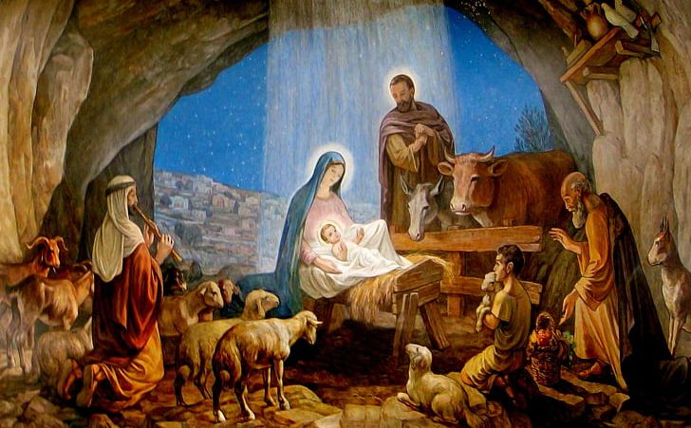

Rev. Jim Oleson, Pastor
Carolyn Meier, Musician
Christopher Dickmeyer, Musician
Christmas Eve Candlelight Service
*Please rise in body or spirit
Ringing of the Bell
Greeting
The people who walked in darkness have seen a great light; those who lived in a land of deep darkness on them light has shined. In the expectation of the birth of Christ our King, let us worship today.

Prelude and Lighting of the Candles
* Call to Worship
One: The Prophet Isaiah said: The people who walked in darkness have seen a great light; those who lived in a land of deep darkness – on them light has shined.
Many: O Come, O Come Emmanuel
One: Behold, the virgin shall be with Child, and shall bear a Son, and they shall call His name Immanuel – God with us.
Many: O Come, O Come Emmanuel
One: A shoot shall come out from the stump of Jesse, and a branch shall grow out of his roots. The Spirit of the Lord shall rest on him, the spirit of wisdom and understanding, the spirit of counsel and might, the spirit of knowledge and the fear of the Lord. His delight shall be in the fear of the Lord.
Many: O Come, O Come Emmanuel
One: The Priest Zechariah said before John’s birth: By the tender mercy of our God, the dawn from on high will break upon us, to give light to those who sit in darkness, to guide our feet into the way of peace.
Many: O Come, O Come Emmanuel
One: The Evangelist John said: What has come into being in him was life and the life is the light of all people. The light shines in the darkness, and the darkness did not overcome it.
Many: O Come, O Come Emmanuel
One: God is with us! God is coming into our lives in a new way. The birth of the Christ-child is the renewal of hope, a reminder that Christ will come again. Keep watch for the light; it is drawing near.
Many: O Come, O Come Emmanuel
*Hymn of Praise #345 New Century Let All Mortal Flesh Keep Silence
(Verses 1-3)

The Lord’s Supper
INVITATION TO CHRIST’S TABLE
COMMUNION PRAYER
WORDS OF INSTITUTION
SHARING OF THE BREAD AND CUP
(Please hold each of the elements as it is distributed so that we may partake each together. The inner ring of
cups in each tray holds juice rather than wine.)

* THANKSGIVING PRAYER (unison)
Bountiful God, we give you thanks that you have refreshed us at your table by granting us the presence of Christ. Strengthen our faith, increase our love for one another and send us forth into the world in courage and peace, rejoicing in the power of your Holy Spirit. Amen.

Written Word Isaiah 9:2-7
Meditation Darkness and Light Rev. Jim Oleson
Church in Prayer
Pastoral Prayer
Lord’s Prayer (Debts, Debtors)

Special Music Sweet Little Jesus Boy Sharon Brinkman
(6PM Service)

CHRISTMAS LESSONS AND CAROLS
The Message of the Angel
Luke 1:26-38 & Matthew 1:18-24
Carol: #126 New Century Angels from the Realms of Glory
The Lighting of the First Advent Candle
Good News for Two Women
Luke 1:39-45

Carol: #127 New Century Lo How a Rose E’er Blooming
The Lighting of the Second Advent Candle
Mary’s Hymn of Praise
Luke 1:46-55
Carol: #132 New Century Joy to the World! The Lighting of the Third Advent Candle
The Emperor’s Decree
Luke 2:1-5
Carol: #133 New Century O Little Town of Bethlehem
(Verses 1 & 4)
The Lighting of the Fourth Advent Candle
Christ Is Born
Luke 2:6-7
Carols: #124 New Century Away in a Manger
(Verse 1) #148 New Century What Child Is This?
(Verse 1)
The Lighting of the Christ Candle

The Angel Announces Christ’s Birth to the Shepherds
Luke 2:8-12
Carols: #131 New Century It Came Upon the Midnight Clear (Verses 1 & 2)
An Angelic Chorus Responds
Luke 2:13-20
Carols: #125 New Century Angels We Have Heard on High (Verses 1 & 3)
#144 New Century Hark! The Herald Angels Sing (Verses 1 & 2)

The Visitation by the Wise Men
Matthew 2:1-12
Carol: #139 New Century The First Nowell A LIGHT IN DEEP DARKNESS
CANDLELIGHT CAROL: #134 Silent Night
(We will sing verse one in German, and then verses 1-3 in English)

(NOTE: Please keep the lighted candle upright. The person receiving the light will tip his or her candle into the flame.)

BENEDICTION (Please extinguish candle after the Benediction.)

HYMN: #135 New Century O Come All You Faithful
*Ringing of the Bell and Postlude

903 Meier Road, Old Monroe, Missouri 63369
stpauluccom@gmail.com
Website: stpauluccom.com
636-665-5329
OFFICE HOURS
Wednesday: 9:00am – 3:00pm
Friday: 9:00am - 12:00pm

