St. Paul
UNITED CHURCH OF CHRIST

December 21, 2025 10:30am
Welcome! Whether you are a guest, friend or member, we are delighted that you are here. Large print bulletins are available at either door. Ask a greeter for any directions you may need.

“Please note that this service will be live-streamed on Facebook. If you do not wish to be visible on camera, please let an usher know so we can take appropriate measures to ensure
your privacy."

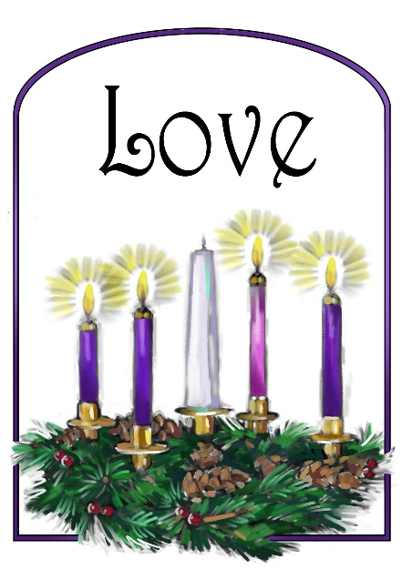

Rev. Jim Oleson, Pastor
Janet Morris, Musician
Fourth Sunday of Advent
*Please rise in body or spirit
Ringing of the Bell
Welcome & Announcements
In the last days, says God, I will pour out my Spirit upon all people. Your sons and daughters shall prophesy. Your young people shall see visions, and your old people shall dream dreams. People of God, we have been baptized into one Spirit and one body through Jesus Christ. Let us worship today.
Prelude and Lighting of the Candles
* Call to Worship
One: We look for an extraordinary sign of hope for our world but God’s sign is most ordinary of all:
Many: A young woman is with child.
One: We look to power for strength in our world but God points to the most vulnerable:
Many: She gives birth.
One: We look far and wide for a key to God’s mystery, but God points us home:
Many: She calls this child Immanuel: God-with-us!
One: Let us rejoice, and worship our God in our ordinary, vulnerable lives:
Many: God-with-us!
*Invocation
Surprising God, you make your presence known in unexpected ways, and challenge our comfortable assumptions about how you work.
Meet us here today and open our hearts to recognize you in our midst calling us to live into your new thing: a world where your love takes shape in justice and peace. In the name of the One who is coming, we pray: Amen!
*Hymn of Praise #122 New Century Come, O Long-Expected Jesus
Lighting of The Advent Candles: Love
*Prayer for Transformation and New Life
Almighty and everlasting God, always more ready to hear than we are to pray, always willing to give more than we either desire or deserve; pour upon us the abundance of your mercy; forgiving those things of which our conscience is afraid, and giving us those good things which we are not worthy to ask, except through the merits and mediation of Jesus Christ, your Begotten One, our sovereign. Amen.
<pause for silent reflection >
Words of Grace
Leader: God has done great things for us; God humbles the proud and lifts up those who are cast down.
People: Those who think themselves rich are sent away, but the hungry are filled with good things. Great mercy is on those who honor him, from generation to generation and forever.
Leader: Through Emmanuel, our sins are forgiven, and we are at peace with our God.
*Response of Praise
Glory be to the Father, and to the Son, and to the Holy Ghost; As it was in the beginning, is now, and ever shall be, World without end. Amen. Amen.
Written Word Isaiah 7:10-16
Romans 1:1-7
Matthew 1:18-25
Hymn #128 New Century In the Bleak Midwinter
Message Expecting Christmas Rev. Jim Oleson
Matthew 1:18-25
Church in Prayer
Pastoral Prayer
Lord’s Prayer (Debts, Debtors)
Offertory
Invitation to Generosity
*Doxology (Tune: Old Hundredth)
Praise God, from Whom all blessings flow; Praise Him, all creatures here below;
Praise Him above, ye heavenly host; Praise Father, Son, and Holy Ghost. Amen.
*Prayer of Dedication
Gracious God, we rejoice as we offer these gifts in response to the great things you have
done for us. We give thanks especially for the great gift of your love clothed in human
flesh. We pray that Jesus will be born anew into our hearts, and that the witness of our
lives will convince others of the wonder and the miracle of Christmas. In Jesus’ name,
we pray. Amen.

*Closing Hymn #126 New Century Angels, From the Realms of Glory
*Commission and Benediction
*Christ’s Light Leads Us into the World
*Congregational Response (Please See Insert) Come, Thou Long-Expected Jesus
(Verse 1)
*Ringing of the Bell and Postlude

903 Meier Road, Old Monroe, Missouri 63369
stpauluccom@gmail.com
Website: stpauluccom.com
636-665-5329

OFFICE HOURS
Wednesday: 9:00am – 3:00pm
Friday: 9:00am - Noon

It Happens
Here St. Paul UCC
Weekly Calendar
December 21st – December 28th

December 21st Fourth Sunday of Advent
9:15am Bible/Book Study
10:30am Worship
11:30am Fellowship Hour
6:00pm Blue Christmas Service

December 24th
6:00pm & 11:00pm Christmas Eve Services

December 28th First Sunday after
Christmas
9:15am Bible/Book Study
10:30am Worship
11:30am Fellowship Hour

Looking Ahead
December 30th
10:00am Grounds Committee Meeting
January 5th
5:15pm Council Meeting
January 18th Congregational Annual
Meeting

________________________________________________________________________________________
OUR GIVING IN 2025
Needed weekly to meet our commitments $2317.02 $ 2317.02
General Fund Offering December 14th $ 890.00 November Average $ 1521.25 Stewardship Offering December 14th $ 0.00 October Average $ 1015.00
______ __________________________________________________ __ ____________________ ________

HAPPENING IN OUR COMMUNITY

Thank you to all our volunteers!

Greeters/Ushers
Joe Walker & Marla Stewart

Acolyte
Marla Stewart

Liturgist

Fellowship Hour
Grounds Committee (Reminder…the committee
hosting fellowship needs to sweep the fellowship hall
floor.)

In our prayers …

This week we added Liza O. and all travelers, Linda, Nor, Clifford P., and the family of Kevin C.

We continue to keep in our prayers Lauretta, Lynn and Ron D., Ernie M., Eileen T., Chuck and Marlene, Lyle R., Mike S., and Jamie.

We lift up in our prayers those who need prayers for their long-term circumstances: Carol Jean P.



REMINDER…Please DO NOT adjust the programmable thermostat in the Sanctuary.

Emergency Planning is checking into a CPR/AED refresher course. There are 2 options: refresher course without certification at no cost or a certification course at the cost of $40. Let Joyce Noble know if you are interested.

The Worship Committee is looking for a volunteer to be the Communion Stewart. This is a person who prepares Communion on the first Sunday of the month and for special services. Also requires cleaning up and putting away the Communion ware. If there are any questions, please see a Worship Committee member.

HOLIDAY SCHEDULE
Joann will be in the office on Monday, December 22nd
and Tuesday, December 23rd from 9am to 3pm.

The Food Pantry will be open Tuesday, December 23rd
and Tuesday, December 30th.

Joann will be in the office on Tuesday, December 30th from
9am to 3pm and on Wednesday, December 31st until Noon.

The January 2026 Messenger will go out on Tuesday,
December 30th.

*****************************************************************

Are you interested on serving on a committee or maybe you
have served for many years in one area and are interested
in trying something new? Chairpersons of committees, does
you group need more members? Please contact Norma by January
7th or tell your committee chair if you are interested in making a
change.

2025 Committee Reports are due to Joann by January 7th.

The Congregational Annual Meeting is scheduled for
January 18th following a carry-in dinner.

