All Saints Anglican Church
6904 Lougheed Highway, Agassiz, B.C. V0M 1A0
Bulletin January 12th, 2026 – January 18th, 2026

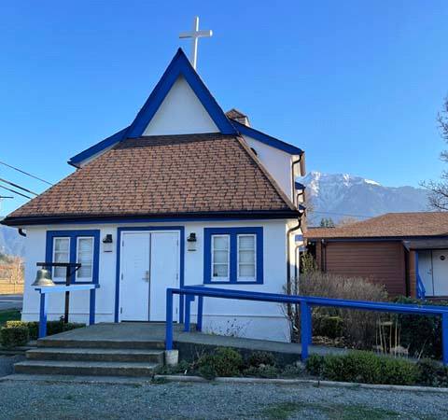

‘The ground we walk does not belong to us; for thousands of years it has been - and remains - the territory of the Stó:lō. We are grateful for their sharing.

Phone: 604-796-3553
Website: www.allsaints-agassiz.ca
https://www.facebook.com/groups/AllSaintsFamily
OUR DOOR IS OPEN AND ALL ARE WELCOME
January 18th, 2026, Second Sunday After Epiphany
Priest in Charge: The Reverend Philip Barker
Hosts: Graham Featherstone/Jennifer Pinlac
Intercessor: Douglas MacAdams
Lay Administrator: Dorothy Cresswell
Announcer: Virginia Jennings
Organ/Piano: Francesca Froehlich
Readers: Greg Veltman/Andrea Hansen
Vicar’s cell phone: Revd. Philip Barker. 778-867-2461

Vicar’s Warden: Ginny Jennings. 604-796-2206
People’s Warden: Lynn Laughlin. 604-799-5131
Parish email: revpb1950@gmail.com
Please contact either warden if you have an issue that needs to be brought to the attention of the Vicar - or contact the Vicar direct (see above for details).

All Saint’s Calendar/Announcements:

- Book Club has chosen the next book, "Amazing Grace, the life of John Newton", by Bruce Hindmarsh and Craig Borlase. It's $24.99 as a paperback on Amazon and is also available on Kindle and as an audio book for free if you have an audio membership.
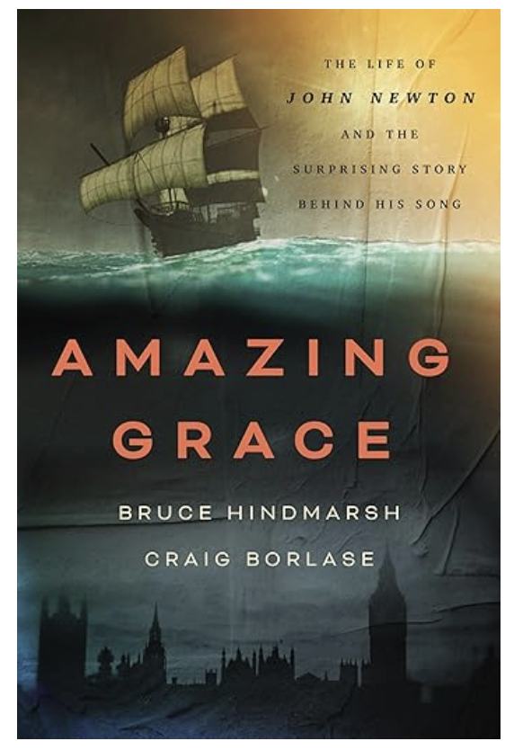

Our first meeting of the New Year will be on
Wednesday, January 14th, at 1700 (5.00pm) on Zoom.

Please let Sheila know at sjbarker0379@gmail.com
if you would like to join the group discussions or have
her order a copy of the book.

- Bible Study with Karol is every Saturday morning 0830-0900 on Zoom.

- Prayer Requests can be given on a piece of paper to either of the Wardens or the Vicar or entered in the Prayer Request Book on the lectern. Alternatively, you can contact Anthea Lewis at antheamlewis@shaw.ca for Pray First Prayer Circle, which is a confidential online prayer circle.

- Music Requests may be given to the Wardens or the Vicar.

- AA meets in the hall every Tuesday and Friday at noon.

- Every Thursday in the hall 1100-1200 we have a social time with coffee, games if you like or just talk.

- At 1000-1100 on Thursdays there is an Interactive Bible Study on the day’s Lectionary readings. All are welcome – discover the treasures in this amazing book!

- 5th Sunday of each month will be a potluck lunch after the service.

- Annual Vestry Meeting (AVM) on February 8th, 2026, after the service. Please be there if you are interested in the future of this church. Your involvement is vital to our success and survival.

Ministerial Meandering
Anger

Just the other day I was on the phone to one of those dragons who are called ‘receptionists’ at doctors’ surgeries. I am sure that these ladies go into one of two schools; one is to be a sweet and helpful person, and the other is to be a complete obnoxious and obstructive bitch. For some reason, Sheila almost always manages to obtain one of the first school on the phone, whilst I almost always encounter the hydra-headed monster, possessing poisonous breath and blood. Not being Hercules (who defeated this monster), I had to try and maintain my calm as she persistently told me that my very reasonable request for a simple blood form was impossible to provide. We should, for decency’s sake (and there might be children watching!) draw a veil over what happened next, but if a carrier pigeon had had to transport my message, he would probably have burned up during his flight.

I do not think I am an angry man, but it surprising how many of my small flock have wanted to talk to me about their concerns - most of which also involve anger at what is happening in the world around us at present.
We seem to be met with une grande insouciance for our fellow human beings, a total lack of concern for their well-being or future, of what is right or wrong in their management - or even whether they live or die. Indeed, in some parts of the world (and not far from here), it now seems to perfectly acceptable to deploy masked and armed men and women on the streets to terrorise and harass those who appear to be from another country, and fail to have the same colour skin or political outlook to them. Meeting such people in one’s neighbourhood does not promote an environment for discussion, but a reaction of fear. Such a response may then be taken as ‘resistance to questioning’ or flight - and therefore guilty as charged - and thus a legitimate target for instant execution by automatic weapons.

It is no wonder, then, that reasonable people should be afraid that they would be unable to survive if approached in such a way - particularly where there is no opportunity for any sort of dialogue - except for the stutter of repeated gunfire.
If this were confined to one area of the globe, one might hope that the international community would gather together in a united front to combat such inexplicable violence; but where such violence is already on a global scale, and the international community bodies tasked with policing such behaviour prove effete or ignored, there is left but the gleanings of hope and the lees of the cellar to cheer us.

This anger is fanned by the wind of frustration - and that is the frustration of helplessness. “What can I do?”, is the repeated cry I hear - and I find myself utterly empathetic to that rhetorical question. Except, is it rhetorical? To say so would imply that it has been made only to stress a point, rather than realistically expect an answer - as in “Is nothing sacred?”
So “No,” I don’t think for one minute it is rhetorical - because ordinary people are now truly asking what they can do to stem the flood of evil and violence that threaten to overwhelm the world as they understand it. And they are exhausted by being perpetually angry and in fear. Someone once said, ‘Fear knocked at the door - Faith answered. There was no-one there.’

My answer is therefore both practical and risky; stand up, speak out, and - for God’s sake PRAY.
Philip+

Truth and Reconciliation
Thank you for the very positive response to the invitation to the current Table Talks series. I had to limit the numbers in the group because it is meant to be a series of small group conversations. Several people were disappointed, so I plan to run the series a second time, probably after Christmas.
Please let me know as soon as possible at sjbarker0379@gmail.com if you would like to join. Feel free to ask those taking part now for their feedback.

A Little Chuckle…
What is the best way to study the Bible?
You Luke into it.

Birthdays this Month  January

Cecil Kirksey – 3rd Judy Gibb – 4th
Gord Elliot – 5th Valerie Hamilton – 29th

Diocesan Cycle of Prayer: We Pray for the Clergy and Congregation:

Archdeacon Nick Pang, (Vancouver) Executive Archdeacon; St. John the Apostle, Port Moody - The Revd Vivian Lam, The Revd Anne Anchor; St. Matthew, Abbotsford - The Revd James Hwang

Anglican Church of Canada Cycle of Prayer – We Pray for:

The Rev. Dr. Eileen Scully, Director, and the staff of Faith, Worship, and Ministry. The Week of Prayer for Christian Unity and the ecumenical work and witness of our churches

Collect

Almighty God, your Son our Saviour Jesus Christ is the light of the world. May your people, illumined by your word and sacraments, shine with the radiance of his glory, that he may be known, worshipped, and obeyed to the ends of the earth; who lives and reigns with you and the Holy Spirit, one God, now and for ever.

Isaiah 49:1-7 Greg Veltman

49 Listen to me, you islands;
hear this, you distant nations:
Before I was born the Lord called me;
from my mother’s womb he has spoken my name.
² He made my mouth like a sharpened sword,
in the shadow of his hand he hid me;
he made me into a polished arrow
and concealed me in his quiver.
³ He said to me, “You are my servant,
Israel, in whom I will display my splendor.”
⁴ But I said, “I have labored in vain;
I have spent my strength for nothing at all.
Yet what is due me is in the Lord’s hand,
and my reward is with my God.”

⁵ And now the Lord says—
he who formed me in the womb to be his servant
to bring Jacob back to him
and gather Israel to himself,
for I am honored in the eyes of the Lord
and my God has been my strength—
⁶ he says:
“It is too small a thing for you to be my servant
to restore the tribes of Jacob
and bring back those of Israel I have kept.
I will also make you a light for the Gentiles,
that my salvation may reach to the ends of the earth.”

⁷ This is what the Lord says—
the Redeemer and Holy One of Israel—
to him who was despised and abhorred by the nation,
to the servant of rulers:
“Kings will see you and stand up,
princes will see and bow down,
because of the Lord, who is faithful,
the Holy One of Israel, who has chosen you.”

Psalm 40:1-12

¹ I waited patiently for the Lord;
he turned to me and heard my cry.
² He lifted me out of the slimy pit,
out of the mud and mire;
he set my feet on a rock
and gave me a firm place to stand.
³ He put a new song in my mouth,
a hymn of praise to our God.
Many will see and fear the Lord
and put their trust in him.

⁴ Blessed is the one
who trusts in the Lord,
who does not look to the proud,
to those who turn aside to false gods.
⁵ Many, Lord my God,
are the wonders you have done,
the things you planned for us.
None can compare with you;
were I to speak and tell of your deeds,
they would be too many to declare.

⁶ Sacrifice and offering you did not desire
but my ears you have opened
burnt offerings and sin offerings you did not require.
⁷ Then I said, “Here I am, I have come
it is written about me in the scroll.
⁸ I desire to do your will, my God;
your law is within my heart.”

⁹ I proclaim your saving acts in the great assembly;
I do not seal my lips, Lord,
as you know.
¹⁰ I do not hide your righteousness in my heart;
I speak of your faithfulness and your saving help.
I do not conceal your love and your faithfulness
from the great assembly.

¹¹ Do not withhold your mercy from me, Lord;
may your love and faithfulness always protect me.
¹² For troubles without number surround me;
my sins have overtaken me, and I cannot see.
They are more than the hairs of my head,
and my heart fails within me.

1 Corinthians 1:1-9 Andrea Hansen

1 Paul, called to be an apostle of Christ Jesus by the will of God, and our brother Sosthenes,

² To the church of God in Corinth, to those sanctified in Christ Jesus and called to be his holy people, together with all those everywhere who call on the name of our Lord Jesus Christ—their Lord and ours:

³ Grace and peace to you from God our Father and the Lord Jesus Christ.

⁴ I always thank my God for you because of his grace given you in Christ Jesus. ⁵ For in him you have been enriched in every way—with all kinds of speech and with all knowledge— ⁶ God thus confirming our testimony about Christ among you. ⁷ Therefore you do not lack any spiritual gift as you eagerly wait for our Lord Jesus Christ to be revealed. ⁸ He will also keep you firm to the end, so that you will be blameless on the day of our Lord Jesus Christ. ⁹ God is faithful, who has called you into fellowship with his Son, Jesus Christ our Lord.

John 1:29-42 Vicar Philip Barker
²⁹ The next day John saw Jesus coming toward him and said, “Look, the Lamb of God, who takes away the sin of the world! ³⁰ This is the one I meant when I said, ‘A man who comes after me has surpassed me because he was before me.’ ³¹ I myself did not know him, but the reason I came baptizing with water was that he might be revealed to Israel.”

³² Then John gave this testimony: “I saw the Spirit come down from heaven as a dove and remain on him. ³³ And I myself did not know him, but the one who sent me to baptize with water told me, ‘The man on whom you see the Spirit come down and remain is the one who will baptize with the Holy Spirit.’ ³⁴ I have seen and I testify that this is God’s Chosen One.”

³⁵ The next day John was there again with two of his disciples. ³⁶ When he saw Jesus passing by, he said, “Look, the Lamb of God!”

³⁷ When the two disciples heard him say this, they followed Jesus. ³⁸ Turning around, Jesus saw them following and asked, “What do you want?”

They said, “Rabbi” (which means “Teacher”), “where are you staying?”

³⁹ “Come,” he replied, “and you will see.”

So they went and saw where he was staying, and they spent that day with him. It was about four in the afternoon.

⁴⁰ Andrew, Simon Peter’s brother, was one of the two who heard what John had said and who had followed Jesus. ⁴¹ The first thing Andrew did was to find his brother Simon and tell him, “We have found the Messiah” (that is, the Christ). ⁴² And he brought him to Jesus.

Jesus looked at him and said, “You are Simon son of John. You will be called Cephas” (which, when translated, is Peter).

Odds and Ends

Join us in celebrating the life of
Garn Misener
Saturday, January 24th, 2026
All Saints Anglican Church
1400 (2.00pm)
Followed by snacks in the hall


