The Power of a Name
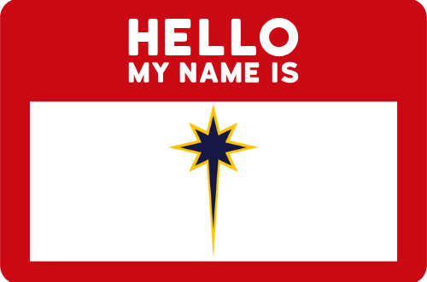
One of the most powerful things we own is our name. It’s unique to us, even if we are another generation of a name. Our name gives us identity. Our name is one of the first things determined at our birth, and many who have died have plaques, stones, or markers that display their name. Our name is a story of life experiences and events. Our name is a marker of relationships to our parents, spouses, children, and siblings. A name has great power.
We’re “early” in the church year (the season of Epiphany), and already proclaiming a name has been a huge part of the biblical story we’ve read and reflected on. John the Baptist proclaiming the name of “the one who will come after me that is greater than me,” an angel visiting a man named Joseph, saying, “you will have a child and you will name him Jesus.” On the eighth day, after Jesus was born, he was presented in the temple, for the ritual of dedicated and naming the child (and in the case of a son, circumcised according to the Jewish law). Immediately after Jesus was baptized by John, the heavens opened, and a voice spoke a name over those gathered down by the riverside, “This is my son, by beloved, in who I find happiness.”
We affirmed in worship this past week the name spoken over us in baptism, “God’s beloved: marked with the cross of Christ and sealed with the Holy Spirit, forever.” We also affirmed the calling that name draws us into, “to let our light shine, so that others may see God’s work through us and give glory to God.” And after worship, you all were called to write your name on a piece of paper under the name of one of our ministry teams. These teams, working together, empower us to “let out light shine” individually and as a congregation. For all of you who wrote your name to volunteer on a ministry team, thank you! If you weren’t here or scooted out the door before writing your name down, have no fear, the sign up sheets will be in the church this Sunday.
Remember who you are. Remember your name. Remember you are “God’s beloved: marked with the cross of Christ and sealed with the Holy Spirit, forever.” You bear a name, unique to you, and yet you bear a calling shared between you and everyone else, called to “let your light shine;” and as a part of the body of Christ at Bethlehem Lutheran Church, “Called to be a Bold, Loving, Community.”

The Peace of Christ be with y’all,
Vern Kinard
Pastor and part of the Bold, Loving, Community of Bethlehem Lutheran Church
God’s Beloved: Marked with the Cross of Christ and Sealed with the Holy Spirit Forever.
Called to “Let my light shine…” alongside you.

