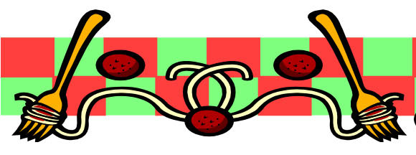
Valentine Spaghetti
Dinner
Saturday Feb. 7, 2026

Hosted by St. Dunstan’s Choir

Tickets: Adults $25 Doors open 5:30 pm
Children $5 Dinner 6 pm
Come and join us for an evening of great food, laughter and fun!


