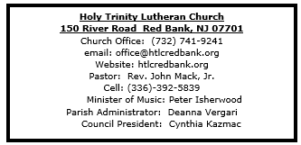

November 9, 2025

22nd Sunday after Pentecost

Introduction
We worship on the first day of the week because Jesus was raised on that day. Every Sunday is a little Easter. This Sunday feels more like Easter than many as the appointed texts celebrate the reality of the resurrection. Live it up this Lord’s day. Our God is the God of the living.

Welcome & Announcements (Please silence your cell phone!)

Prelude (We prayerfully prepare our hearts and minds to worship!)

+ GATHERING +

Confession and Forgiveness
All may make the sign of the cross, the sign that is marked at baptism, as the presiding minister begins.
P: Blessed be the holy Trinity, ☩ one God,
who forgives all our sin,
whose mercy endures forever.
C: Amen.
P: Let us confess our sin in the presence of God
and of one another.
Silence is kept for reflection.
Faithful God,
C: you have shown us the ways of your heart,
yet we stray from your paths.
We are stuck in sinful systems of oppression
and do not embrace the freedom
of your faithful promises.
We ignore our neighbors.
We exploit the earth.
We reject your abundance,
trusting our impulses instead of your steadfast love.
Repair our relationships,
restore what we have broken,
renew our hearts,
and bring us to new life.
Amen.
P: Hear the good news:
God the Faithful One loves you,
☩ in Christ Jesus your sins are forgiven,
and by the power of the Holy Spirit you are set free.
C: Amen.

*Gathering Hymn ELW 437 On Jordan’s Stormy Bank I Stand

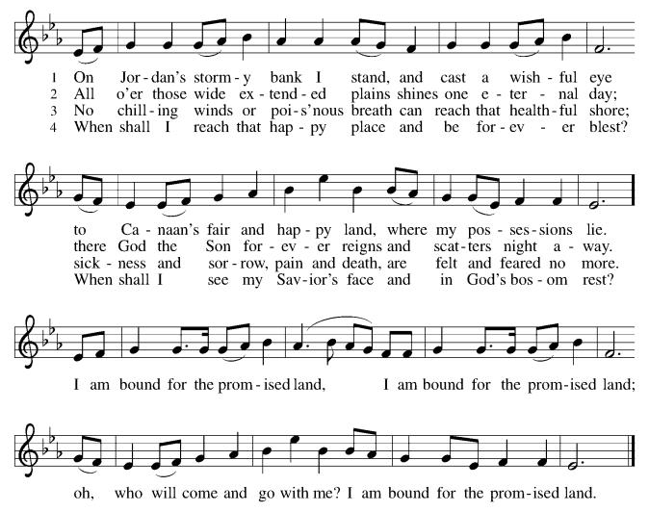

*Pastoral Greeting

P: The Grace and Peace of our Lord Jesus Christ, the love of God, and the communion of the Holy Spirit be with you all! C: And also with you!

Hymn of Praise
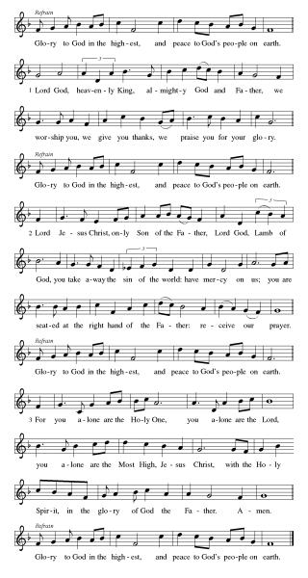

*Prayer of the Day
P: O God, our eternal redeemer, by the presence of your Spirit you renew and direct our hearts. Keep always in our mind the end of all things and the day of judgment. Inspire us for a holy life here, and bring us to the joy of the resurrection, through Jesus Christ, our Savior and Lord.C: Amen!

Children’s Message
+WORD+

First Reading: Job 19:23-27a
Job suffers the loss of children, wealth, and health. Accused by his companions of wrongdoing, he knows himself to be innocent. Here, in the midst of his suffering, Job clings to the radical hope that his vindicator, his redeemer, lives; and that one day he himself will see God.

²³ “O that my words were written down!
O that they were inscribed in a book!
²⁴ O that with an iron pen and with lead
they were engraved on a rock forever!
²⁵ For I know that my vindicator lives
and that in the end he will stand upon the earth;
²⁶ and after my skin has been destroyed,
then in my flesh I shall see God,
^{27a} whom I shall see on my side,
and my eyes shall behold, and not another.”

Psalm: Psalm 17:1-9
Keep me as the apple of your eye; hide me under the shadow of your wings. (Ps. 17:8)

¹ Hear a just cause, O Lord; give heed | to my cry;
listen to my prayer, which does not come from | lying lips.
² Let my vindication come forth | from your presence;
let your eyes be | fixed on justice.
³ Examine my heart, visit | me by night,
melt me down; you will find no impuri- | ty in me.
⁴ I have not regarded what | others do;
at the word of your lips I have avoided the ways | of the violent.
⁵ My footsteps hold fast to your | well-worn path;
and my feet | do not slip.
⁶ I call upon you, O God, for you will | answer me;
incline your ear to me and | hear my words.
⁷ Show me your marvelous | lovingkindness,
O Savior of those who take refuge at your right hand from those who | rise against them.
⁸ Keep me as the apple | of your eye;
hide me under the shadow | of your wings,
⁹ from the wicked | who assault me,
from my deadly enemies | who surround me.

Second Reading: 2 Thessalonians 2:1-5, 13-17
This portion of the letter provides encouragement for the church at Thessalonica during a time of confusion and opposition, as some allowed their concern over Jesus’ imminent return to divert them from the central teachings of the gospel.

¹ As to the coming of our Lord Jesus Christ and our being gathered together to him, we beg you, brothers and sisters, ² not to be quickly shaken in mind or alarmed, either by spirit or by word or by letter, as though from us, to the effect that the day of the Lord is already here. ³ Let no one deceive you in any way, for that day will not come unless the rebellion comes first and the lawless one is revealed, the one destined for destruction. ⁴ He opposes and exalts himself above every so-called god or object of worship, so that he takes his seat in the temple of God, declaring himself to be God. ⁵ Do you not remember that I told you these things when I was still with you?
¹³ But we must always give thanks to God for you, brothers and sisters beloved by the Lord, because God chose you as the first fruits for salvation through sanctification by the Spirit and through belief in the truth. ¹⁴ For this purpose he called you through our gospel, so that you may obtain the glory of our Lord Jesus Christ. ¹⁵ So then, brothers and sisters, stand firm and hold fast to the traditions that you were taught by us, either by word of mouth or by our letter.
¹⁶ Now may our Lord Jesus Christ himself and God our Father, who loved us and through grace gave us eternal comfort and good hope, ¹⁷ comfort your hearts and strengthen them in every good work and word.

*Gospel Acclamation
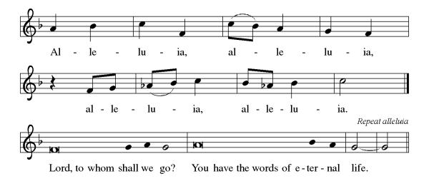
P: The Holy Gospel According to the St. Luke the 20th Chapter
C: Glory to You, O Lord!

Gospel Luke 20:27-38
Some Sadducees, who do not believe in the resurrection of the dead, try to trap Jesus. They formulate the convoluted case of a serial widow who marries a succession of seven brothers. Jesus responds by teaching about God to whom all are alive and in whom all relationships are fulfilled.

²⁷ Some Sadducees, those who say there is no resurrection, came to [Jesus] ²⁸ and asked him a question: “Teacher, Moses wrote for us that if a man’s brother dies leaving a wife but no children, the man shall marry the widow and raise up children for his brother. ²⁹ Now there were seven brothers; the first married a woman and died childless; ³⁰ then the second ³¹ and the third married her, and so in the same way all seven died childless. ³² Finally the woman also died. ³³ In the resurrection, therefore, whose wife will the woman be? For the seven had married her.”
³⁴ Jesus said to them, “Those who belong to this age marry and are given in marriage, ³⁵ but those who are considered worthy of a place in that age and in the resurrection from the dead neither marry nor are given in marriage. ³⁶ Indeed, they cannot die anymore, because they are like angels and are children of God, being children of the resurrection. ³⁷ And the fact that the dead are raised Moses himself showed, in the story about the bush, where he speaks of the Lord as the God of Abraham, the God of Isaac, and the God of Jacob. ³⁸ Now he is God not of the dead but of the living, for to him all of them are alive.”

P: The Gospel of the Lord
C: Praise to you, O Christ!

Sermon

*Hymn of the Day ELW 619 I Know That My Redeemer Lives!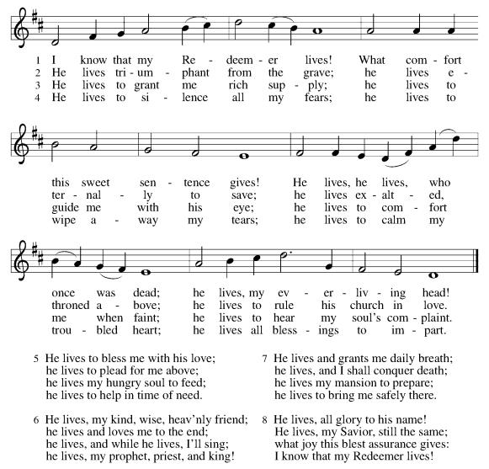

Apostles’ Creed
I believe in God, the Father almighty,
creator of heaven and earth.
I believe in Jesus Christ, God's only Son, our Lord,
who was conceived by the power of the Holy Spirit,
born of the Virgin Mary,
suffered under Pontius Pilate,
was crucified, died, and was buried;
he descended to the dead.
On the third day he rose again;
he ascended into heaven,
he is seated at the right hand of the Father,
and he will come to judge the living and the dead.
I believe in the Holy Spirit,
the holy catholic Church,
the communion of saints,
the forgiveness of sins,
the resurrection of the body,
and the life everlasting. Amen

*Prayers of Intercession
Gathered with one voice, we offer our prayers for the church, the world, and all who are in need.
A brief silence.
God our Redeemer, bless your church universal and its leaders. Set all hearts on you from generation to generation in anticipation of Christ’s return. Hear us, O God.
C:Your mercy is great.
God of life, we give thanks for the fruits and grains of harvest, for rivers and streams, for all that is made of rock and iron. Renew the earth’s natural resources and the lands from which they come. Hear us, O God.
C:Your mercy is great.
God of justice, we give thanks for the service of our veterans and pray for those needing support for wounds of any kind. Strengthen those charged with the governance and protection of vulnerable populations. Bring an end to war throughout the world. Hear us, O God.
C:Your mercy is great.
God who leads us to belief and truth, we give thanks that you are always and already here. Nurture and support those who are unsteady in mind, unsafe in spirit, or unwell in body (especially). Comfort those who suffer from trauma and exposure to traumatic events. Hear us, O God.
C:Your mercy is great.
God who gathers us together, we give thanks for our pastors and deacons, teachers and musicians, administrators, and building caretakers. May they find joy in leadership as we grow in faith together. Hear us, O God.
C:Your mercy is great.
Here other intercessions may be offered.
God of the saints, we give thanks for all who have died in faith (especially). Uplift us as we honor their memory and await your coming in glory. Hear us, O God.
C:Your mercy is great.
We offer these and all our prayers to you, O God, trusting in your grace and unyielding love; through Jesus Christ, our Lord.
C: Amen.

Greeting of Peace
P: The peace of Christ be with you and those you love!
C: And also with you! (The peace is shared with all!)

Offering (Thank you for your support for our ministry!)
*Doxology ELW 691 v. 1 (Please stand and join in singing as we share our gifts!)
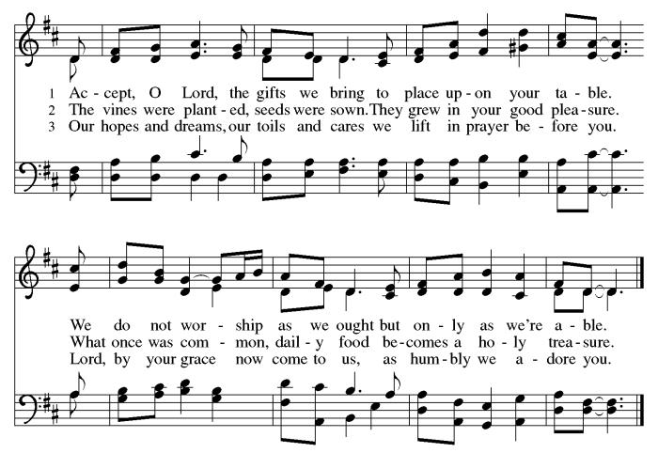

*Offering Prayer
A: God of healing and hope,
C: you bless those who are hungry,
promising to fill them with good things.
Fulfill that promise through us and these your gifts.
Nourish us with the abundance of your feast
and unite us into the blessed body of Jesus Christ our Savior,
now and forever.
Amen.
+MEAL+
(All are welcome at the table of our Lord!)
*Great Thanksgiving
P: The Lord be with you.
C: And also with you.

P: Lift up your hearts.
C: We lift them to the Lord.

P: Let us give thanks to the Lord our God.
C: It is right to give our thanks and praise.

P: It is indeed right, our duty and our joy, that we should at all times and in all places give thanks and praise to you, almighty and merciful God, through our Savior Jesus Christ; who on this day overcame death and the grave, and by his glorious resurrection opened to us the way of everlasting life. And so, with all the choirs of angels, with the church on earth and the hosts of heaven, we praise your name and join their unending hymn:

*Sanctus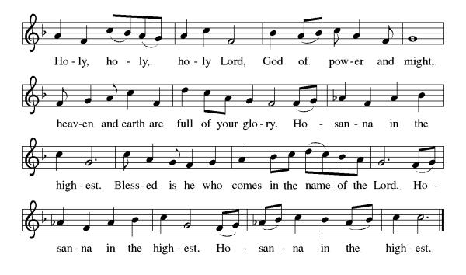

*Eucharistic Prayer
P: Blessed are you, O God,
creator of heaven and earth.
You rescued your covenant people,
led them on all their journeys,
and taught them by the prophets.
You so loved the world
that you gave your only Son,
so that everyone who believes in him
may not perish but may have eternal life.

In the night in which he was betrayed,
our Lord Jesus took bread,
and gave thanks; broke it,
and gave it to his disciples,
saying: Take and eat;
this is my body, given for you.
Do this for the remembrance of me.

Again, after supper,
he took the cup, gave thanks,
and gave it for all to drink,
saying: This cup
is the new covenant in my blood,
shed for you and for all people
for the forgiveness of sin.
Do this for the remembrance of me.

As often as we eat this bread
and drink this cup,
we proclaim the Lord’s death
until he comes.

C: Christ has died. Christ is risen. Christ will come again.

Pour out your Holy Spirit
in this meal,
and make us one
in this community of faith
and with your people
throughout the world.
Glory and praise to you, O God,
Author of life,
Word made flesh,
Power of the Most High,
now and forever.
C: Amen.

*THE LORD’S PRAYER
Our Father, who art in heaven,
hallowed be thy name,
thy kingdom come,
thy will be done,
on earth as it is in heaven.
Give us this day our daily bread;
and forgive us our trespasses,
as we forgive those
who trespass against us;
and lead us not into temptation,
but deliver us from evil.
For thine is the kingdom,
and the power, and the glory, forever and ever. Amen.
*Lamb of God
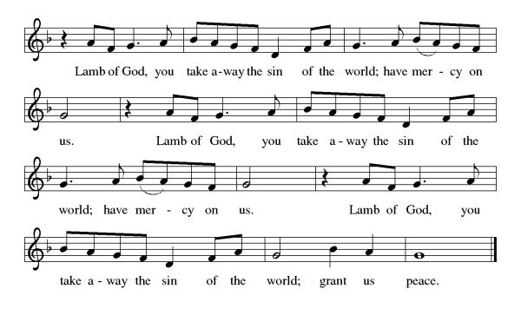

Spiritual Communion Prayer
P: Let us pray for the communion of all present here, those viewing our service virtually, those in our hearts and in our world.
C: Lord Jesus, I believe you are truly present in the Sacrament of Holy Communion. When I cannot receive Communion, I pray that you come into my heart. I know that nothing in Heaven or on earth can separate me from your love. Amen.

Invitation to Communion
P: There is a place for you at the table of God. Come, receive the food that does not perish, a taste of life eternal.
C: Thanks be to God.

(All are invited to the communion rail following the guidance of the ushers. Communion will be shared through the host and individual cups. If you would like communion but are unable to join us at the rail, please alert the usher!)
Communion Hymns (Please join in singing!)

ELW 638 Blessed Assurance
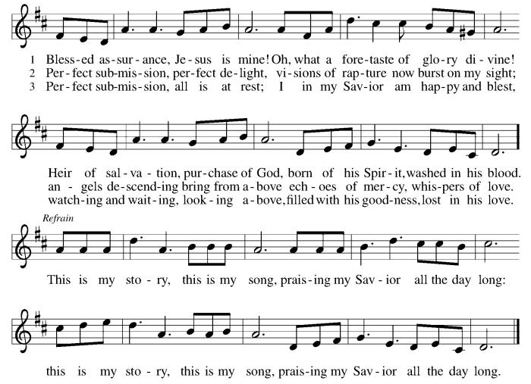
ELW 763 My Life Flows On in Endless Song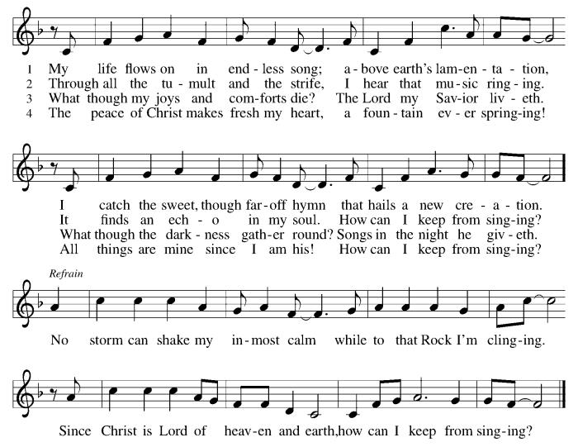

P: The body and blood of our Lord Jesus Christ strengthen you and keep you in his grace. C: Amen!

*Prayer after Communion
A: God of field and flower, wheat and grape,
you have nourished us with the bread of heaven
that gives life to the world.
Strengthened by the body and blood of your Son,
send us out to gather your good gifts for all who
hunger and thirst,
and embolden us to love and serve in Christ’s name.
C: Amen!

+Sending+

*Blessing
P: The love of God the Sovereign strengthen you,
God the Son save you,
and God the Holy Spirit anoint you for the work ahead.
The holy Trinity bless you ☩
and grant you a faithful and courageous heart
now and forever.
C: Amen!

*Sending Hymn ELW 546 To Be Your Presence
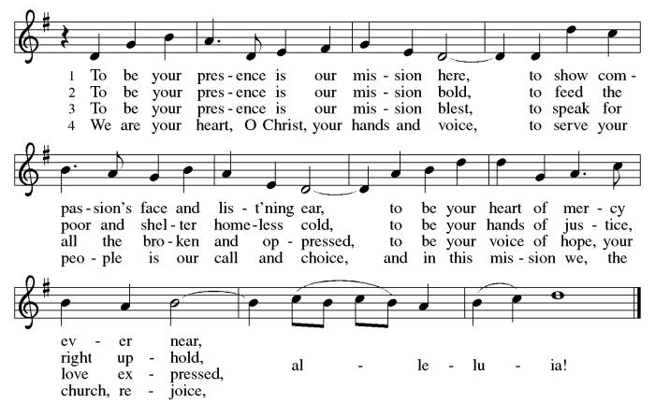
*Dismissal
A: Go in peace. Share the harvest.
C: Thanks Be to God.

Postlude

Copyright © 2020 Augsburg Fortress. All rights reserved. Reprinted by permission under Augsburg Fortress Liturgies Annual License #SB106907. New Revised Standard Version Bible, Copyright © 1989, Division of Christian Education of the National Council of the Churches of Christ in the United States of America. Used by permission. All rights reserved. Revised Common Lectionary, Copyright © 1992 Consultation on Common Texts, admin Augsburg Fortress. Used by permission.

Treasurer’s Report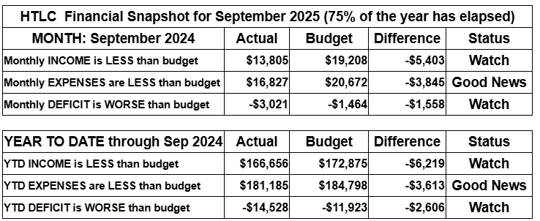
September brought renewed activity—and renewed financial pressure—as giving fell below budget while expenses stayed mostly on track. We’re watching cash flow carefully and invite everyone to help by giving a little extra, responding generously to the Stewardship Appeal, or setting up a recurring gift to support our shared ministry.

Thank you for supporting our ministry! Chris Foard, Treasurer

Worship Volunteer Schedule
Date | Asst. Min | Usher | Sacristan | Lector | Counter
November 2 | Keith Bennett | Dan Grillon | Nancy Poole | Jeff Ridberg | Bohner/Foard
November 9 | Linda Coleman | Keith Bennett | Carol Rosen | Cynthia Kazmac | Carleo/Spreen
November 16 | Elaine Bradford | Kathy Caputo | Sherry Lee | Bill Spreen | Foss/Coleman
November 23 | Keith Bennett | Gary Joblon | Nancy Poole | Molly Foard | Carleo/Csernica
November 30 | Chris Foard | Dan Grillon | Joanne Giordano | Rosemary Lane | McKenna/Kazmac

Altar Flowers
November 2ND Kathy Caputo, in memory of Bob Wolfrum
November 9th Kari Oswald in memorial of Aiden Oswald
November 16th Roger Foss In memroy of Lillian Foss
November 26th In Memory of Rober Coppotelli, Lisa Lynch
November 30th In memory of Bob Kolb and parents by Mavis Kolb

Coffee Hour
Please consider siging up of a coffee hour. Recruit some friends to help. Thank you!

ANNOUNCEMENTS Thank you! To all who consistently support our church and ministries through your time, talent, and treasure. Please help us grow by inviting your friends and family to worship and events. You are what makes Holy Trinity a wonderful church family!

Stay in touch! Please visit our church website, www.htlcredbank.org for updates and information. You can also find us on Facebook and view services online. The office is open from 9am to 2pm, Monday to Thursday.

100 Anniversary Committee- If you are interested in being a part of the committee to help plan the 100th anniversary celebration of HTLC in 2028, please sign up in the red book. All are welcome! Also, the committee will be looking for photos and documents of HTLC throughout the years. If you have anything to share, please bring them to the church and marked envelopes or email electronic copies to the church office.

Photo Directory- The time has come for an updated Holy Trinity photo directory.
Please join in... it will be easy and informal. For the next five or six Sundays (starting 11/9) after worship we will snap photos that show your best smile. Please step up -- singles, couples and families! Casey H. and her boyfriend Bart (professional photographer!) will have an area set up downstairs to get consistent distancing. If the weather is nice, photo's outside can be an option. Questions can be addressed to Casey or Elaine B.

Name Tag Sundays: On the first Sunday of each month, names tags and markers will be at each entrance of the sanctuary. Please fill out a tag and wear one for worship and for coffee hour to welcome visitors and help newcomers put names to faces.

Choir The Holy Trinity Choir welcomes our singers back for a preparation rehearsal on Sunday, September 7th at 9am in the church hall. All are welcome to join us in song as often as you are able. Choir meets each Sunday at 9am to practice and prepare our music. Join us and help us grow by spreading the word about the HTLC Choir!

Quilting- The Quilters need gently used any bed sheets of any size! Please leave any donations in the quilters closet in Fellowship Hall. Thank you!

Weekly Quilting on Wednesdays at 9:30. Bring your lunch and enjoy some fellowship at noon. All are welcome. There will be no quilting on Wednesday September 24 due to the garage sale set up.

Save the Date- Trivia Night will be on February 28th, 2026

WELCA Update:The garage sale was another success. The net profit after the bank deposit was $3,408.24. It should be noted that other money is still coming in. There was a meeting on 10/12 with congregation members, and it was decided that the giving amount would be rounded up to $3,500. The donations would be made to:

Lutheran Disaster Response - $1,000. It will be noted that this donation should cover both national & international needs.
180 Turning Lives Around - $500
HABCore - $1,000
Monmouth Day Care - $1,000
*It should be noted that a regional donation will be made later in the year to Crossroads for the Tee sign.

Evening Quilting Evening Quilting –
Please share this information . This is an important ministry that helps so many. It’s very easy and you don’t need to know how to sew. We have a great time socializing too! We will meet:
Oct. 15, Nov 19, Dec 17 At 6:00 PM. Note: If we have to cancel I will send an email. Please let me know only if you can come. Contacts: Pat Pienkos 732-513-9615 Debbie Yetka 908-461-4084 Looking forward to seeing you all!

Bagels and Bible- Bagels and Bible will be meeting on the second and fourth Saturdays of the month at 8:30. The group will meet in the Parish House.

Social Ministry
*Year-round collections will continue for food items for Lunch Break. There is a sign-up sheet in the red book for those who can help drop these items to Lunch Break.
*We will also collect adult men's socks to periodically drop at the Red Bank Warminq Center.
*For those interested in the Heartwarminq Center — the new women's shelter is adjacent to the First Baptist Church of Red Bank at 90 Maple Ave. You can follow up on this mission through their website - https://www.thefeastnj.org- On this site, they also include wish list items that can be purchased through amazon. We will be exploring purchasing some of these through a Thrivent card. If you want to purchase on your own, you can leave items at church, and the Social Ministry will deliver them.

Pastoral Care and Prayer... We are here to care for and pray! Please contact the office to add or adjust prayer requests. If you or someone you know needs pastoral care, please contact the office and Pastor Mack!

THANK YOU for supporting and sustaining our church and ministries! All are welcome here! Please invite your family and friends to worship with us! Find us online at www.htlcredbank.org

