This Week at PPBC
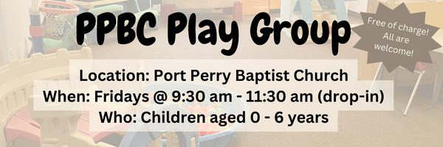





February 14th, 2026

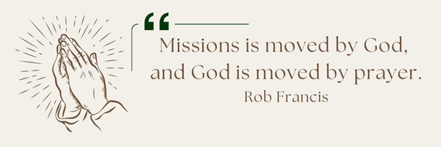
A Prayer Request from AOJ: Mission Teams
Praise God! In 2025 10 mission teams joined us to serve in powerful ways — building homes, distributing food, and sharing the gospel. Each team brought encouragement and hope to countless families. Looking ahead, we are preparing to receive 8 mission teams in 2026. Please pray for their safety, health, and unity, and that God would use each one in mighty ways to advance His Kingdom through both their work and their witness.

Notes

Sunday Ministry Schedules
Below are ministry schedules for Nursery, Jr. Church, Greeters, Ushers, and Sound & Video:
Nursery
Jan 18: Brenda Clemens, Audrianna Angrove
Jan 25: Jen Werner, Brantley Colwell
Infant Nursery
Jan 18: Stephanie Anderson, Karis Henkelman
Jan 25: Laura Saunders, Amber Saunders
Jr. Church; ages 3 to grade 1
Jan 18: Ellianne McLaren, Hailey Ferguson
Jan 25: Christine McLaren, Grace Brown
Jr. Church; Grades 2 to 6
Jan 18: Kate Anderson, Jen Owens
Jan 25: Miriam Bolsonello, Graeme Anderson
Greeters
Jan 18: Graeme & Barb Foster
Jan 25: Steve & Wendy Angrove
Ushers
Jan 18: Mark McLaren, Paul Sammut
Jan 25: Nick Woytowich, Joe Colwell
Sound & Video
Jan 18: Sound: Jordan Anderson | Video: William Conley
Jan 25: Sound: Wyatt Werner | Video: Josh Myers

Morning Service
Song – O Worship The King
Welcome
Song – Behold Our God
Scripture – Matthew 25:1-30
Prayer
Song – When We All Get to Heaven
Song – Welcome Home
Message – Pastor Jim
Song – Welcome Home
Song – We Will Glorify

PPBC Membership Class
Membership class will be held Sunday, January 25th, 2026 @ 4pm in the fellowship room (beside the kitchen)
Please let the office know if you plan to attend and if you will be needing childcare.

Praise & Prayer Highlights
PRAY for Joan Mabley who has been placed in isolation in Bowmanville Hospital due to covid. PRAY for her comfort and care and for her family as they care for Joan.
PRAY for John & Joan Mank and their ongoing health concerns.
PRAY for Martin & Tina McCurley and their ongoing health concerns. PRAISE that they are now both home from Hospital.
PRAY for Bert Faber and the family as the mourn Ada's passing. PRAY that God will give them great comfort in Christ and that the truth of the Gospel will shine through this loss.
PRAY for Sam and Susan Millington. Susan is dealing with ongoing chronic pain. PRAY for her comfort and peace.
PRAY for Caleb Bolsonello and his fiancée Stephanie as they prepare for their wedding and marriage January 17th, 2026.
PRAY for New Song Church & Port Perry Baptist as they plan to co-host a Christianity Explored outreach at That Place on Queen in the new year. Please PRAY for God to prepare the hearts of those who will attend from the community to receive the gospel.

Giving
Just as a reminder, there are several ways you can give:
In Person using the offering box located on the back wall of the sanctuary. Donation envelopes are available at the Welcome Centre. Please contact the church office if you would like a box of donation envelopes (office@portperrybaptist.ca)
Through your online banking, you may send electronic transfers to ppbcdonations@gmail.com.
You can also give through Canada Helps. Donation receipts will be provided by Canada Helps, and transaction fees apply.
***********************************************************************
Weekly Newsletter
The PPBC Newsletter is emailed to the church family every Friday. If you would like to be added to the weekly email list, please contact the office by phone: 905-985-8681 or by email: office@portperrybaptist.ca.
*****************************************************************
Church Information:
Location:
2210 Hwy 7A
Port Perry, ON
L9L 1B4
Office Hours:
Monday: 8:30am – 4:00pm
Tuesday: 8:30am – 4:00pm
Wednesday: Closed
Thursday: 8:30am – 4:00pm
Friday: 8:30 am - 3:00 pm
Contact:
Phone: 905.985.8681
Email: office@portperrybaptist.ca
Website: www.portperrybaptist.ca
Staff:
Sr. Pastor – Rev. Jim Clemens
Administrative Assistant – Madeline Werner
Family Ministries Director – Josh Anderson
Pastoral Intern – Scott McKenzie

PPBC Newsletter
Sunday, January 18, 2026


Sunday Starting Point
Sunday, January 18, 2026 - 9:30 am
“Beginning the day with the Word and prayer”
Adults:
Adults will meet in the sanctuary for a time of study and prayer.
Youth:
Jr High (Grades 7-8) will meet in room 18 with Kate Anderson to study Ecclesiastes.
Children:
Children ages 3 - grade 6 will meet in room 26.
(Please note nursery is unavailable during Starting Point)
Sunday Morning Worship
Sunday, January 18, 2026 - 10:30 am
We are meeting in the sanctuary and will continue to live-stream for those who are unable to attend.
Message: Home
Scripture: Revelation 20-22
Pastor Jim Clemens

