THE ANGLICAN PARISH OF ST. MARK
“Drawing People to the Light”
Part of the Diocese of British Columbia
www.stmarkqualicum.ca https://bc.anglican.ca

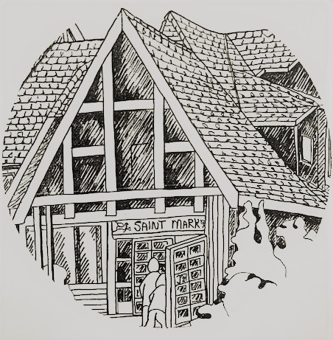

2nd Sunday after Epiphany
JANUARY 18, 2026
10:00 am Holy Communion
Book of Alternative service (BAS)

We acknowledge with thanksgiving that we gather to worship on the territories of
the Kwakwaka’Wakw, Nuu-Chah-Nulth and Coast Salish Peoples.
We are grateful for our growing relationship with the Qualicum First Nation.
As part of the Anglican Church of Canada, a church of Settlers and First Nations,
we commit ourselves to a journey of truth and reconciliation between the indigenous peoples of this land and the non-native peoples of Canada.

A Service of HOLY COMMUNION

Before the service, please observe silence so that we can be in quiet prayer.

Opening Sentence: Jesus preached the gospel of the kingdom and healed every infirmity among the people.

Processional Hymn: 430 Will You Come and Follow Me

The Gathering of the Community

Celebrant: The grace of our Lord Jesus Christ, and the love of God, and the fellowship of the Holy Spirit, be with you all.
People and also with you.

Celebrant Almighty God,
People to you all hearts are open, all desires known, and from you no secrets are hidden. Cleanse the thoughts of our hearts by the inspiration of your Holy Spirit, that we may perfectly love you, and worthily magnify your holy name; through Christ our Lord. Amen.

Glory to God: CP 702
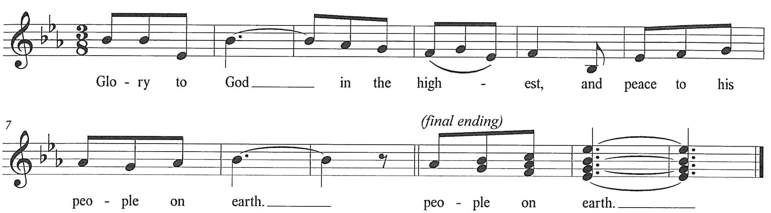

The Collect of the Day
All Almighty God, by grace alone you call us and accept us in your service. Strengthen us by your Spirit, and make us worthy of your call; through Jesus Christ our Lord, who lives and reigns with you and the Holy Spirit, one God, now and for ever.

First Reading: Isaiah 49: 1-7

Psalm 40: 1-11
Please read responsively by the full verse
40:1 I waited patiently for the LORD; he inclined to me and heard my cry.
40:2 He drew me up from the desolate pit, out of the miry bog, and set my feet upon a rock, making my steps secure.
40:3 He put a new song in my mouth, a song of praise to our God. Many will see and fear and put their trust in the LORD.
40:4 Happy are those who make the LORD their trust, who do not turn to the proud, to those who go astray after false gods.
40:5 You have multiplied, O LORD my God, your wondrous deeds and your thoughts toward us; none can compare with you. Were I to proclaim and tell of them, they would be more than can be counted.
40:6 Sacrifice and offering you do not desire, but you have given me an open ear. Burnt offering and sin offering you have not required.
40:7 Then I said, "Here I am; in the scroll of the book it is written of me.
40:8 I delight to do your will, O my God; your law is within my heart."
40:9 I have told the glad news of deliverance in the great congregation; see, I have not restrained my lips, as you know, O LORD.
40:10 I have not hidden your saving help within my heart; I have spoken of your faithfulness and your salvation; I have not concealed your steadfast love and your faithfulness from the great congregation.
40:11 Do not, O LORD, withhold your mercy from me; let your steadfast love and your faithfulness keep me safe forever.

Second Reading: 1 Corinthians 1: 1-9

Gradual Hymn – Just as I am CP 615 vs 1-2/3

The Gospel: John 1: 29-42 (Please stand as you are able)

Reader The Lord be with you
People And also with you.

Reader The Holy Gospel of our Lord Jesus Christ according to Matthew.
People Glory to you, Lord Jesus Christ.

Now when Jesus heard that John had been arrested, he withdrew to Galilee. He left Nazareth and made his home in Capernaum by the sea, in the territory of Zebulun and Naphtali, so that what had been spoken through the prophet Isaiah might be fulfilled:
“Land of Zebulun, land of Naphtali, on the road by the sea, across the Jordan, Galilee of the gentiles— the people who sat in darkness have seen a great light,
and for those who sat in the region and shadow of death light has dawned.”
From that time Jesus began to proclaim, “Repent, for the kingdom of heaven has come near.”
As he walked by the Sea of Galilee, he saw two brothers, Simon, who is called Peter, and Andrew his brother, casting a net into the sea—for they were fishers. And he said to them, “Follow me, and I will make you fishers of people.” Immediately they left their nets and followed him. As he went from there, he saw two other brothers, James son of Zebedee and his brother John, in the boat with their father Zebedee, mending their nets, and he called them. Immediately they left the boat and their father and followed him.
Jesus went throughout all Galilee, teaching in their synagogues and proclaiming the good news of the kingdom and curing every disease and every sickness among the people.

Reader The Gospel of Christ
People Praise to you, Lord Jesus Christ.

Sermon The Rev. Deborah Rivet

Hymn : Amazing Grace CP 352

- Amazing grace! How sweet the sound
That saved a wretch like me.
I once was lost, but now am found;
Was blind, but now I see.
- 'Twas grace that taught my heart to fear,
And grace my fears relieved;
How precious did that grace appear
The hour I first believed.
- Through many dangers, toils, and snares,
I have already come;
'Tis grace hath brought me safe thus far,
And grace will lead me home.
- The Lord has promised good to me,
His Word my hope secures;
He will my shield and portion be
As long as life endures.
- When we've been there ten thousand years,
Bright shining as the sun,
We've no less days to sing God's praise
Than when we first begun.

The Apostles’ Creed

I believe in God, The Father almighty, Creator of heaven and earth.
I believe in Jesus Christ, his only Son, our Lord.
He was conceived by the power of the Holy Spirit And born of the Virgin Mary.
He suffered under Pontius Pilate, Was crucified, died, and was buried.
He descended to the dead.
On the third day he rose again. He ascended into heaven,
And is seated at the right hand of the Father. He will come again
To judge the living and the dead. I believe in the Holy Spirit,
The holy catholic Church, The communion of saints,
The forgiveness of sins, The resurrection of the body, And the life everlasting. Amen.

Prayers of the People
All: AMEN

Celebrant: Dear friends in Christ, God is steadfast in love and infinite in mercy; God welcomes sinners and invites us to this table. Let us confess our sins, confident in God’s forgiveness.
Silence is kept

Celebrant: Most merciful God,
All We confess that we have sinned against you in thought, word, and deed, by what we have done, and by what we have left undone. We have not loved you with our whole heart; we have not loved our neighbours as ourselves. We are truly sorry and we humbly repent. For the sake of your Son Jesus Christ, have mercy on us and forgive us, that we may delight in your will, and walk in your ways, to the glory of your name. Amen.

Celebrant: Almighty God have mercy upon you, pardon and deliver you from all your sins, confirm and strengthen you in all goodness, and keep you in eternal life; through Jesus Christ our Lord.
People Amen.

Celebrant The peace of the Lord be always with you.
People And also with you.

Offertory Hymn: CP341 God of Mercy

Prayer over the Gifts
Loving God, before the world began you called us. Make holy all we offer you this day, and strengthen us in that calling. We ask this in the name of Jesus Christ the Lord. Amen.

Presider: God is here
People: The Spirit is with us.

Presider: Lift up your hearts and minds.
People: We lift them to God.

Presider: Let us give thanks to God the Creator.
People: It is right to give our thanks and praise.

Presider: God of love, our source and our fulfillment,
for you create all things and in you we live and move and have our being.
Your wonder is manifest in land and sea and sky.
You made us in your image.
And even though we turn from you,
again and again you call us to yourself,
and in every age, promise liberation.
As a mother gathers her children,
you embraced a people as your own,
to nurture them in the way of compassionate love.
You sent Jesus among us,
incarnate of the Holy Spirit and born of Mary.
Jesus revealed your love for all Creation,
and showed us the way of reconciliation.

Presider: To you be glory, almighty God, because on the night before he died, Jesus took bread, when he had given thanks, he broke it, gave it to his disciples, and said: Take, eat, this is my body
which is given for you; do this to remember me.
After supper he took the cup; when he had given thanks,
he gave it to them and said: Drink this all of you.
This is my blood of the new covenant, Poured out for you and for many; do this to remember me.
Great is the mystery of faith.

All: Christ has died, Christ is risen, Christ will come again.

Presider: Recalling Christ’s death and resurrection, we ask you to accept this, our sacrifice of praise.
Pour out your Holy Spirit on us gathered here, and on these gifts of bread and wine that we may be fed with the body and blood of your Son. When all of creation groans, unite us in Christ and give us your hope that we might be strengthened to do your work, as your body in the world. Through Christ our Redeemer, in the power of the Spirit, all praise and glory be yours, Almighty God, now and forever.
All: Amen.

The Lord’s Prayer – (sung) David Haas

Celebrant We break the bread of life,
And that life is the light of the world.

All God here among us,
Light in the midst of us,
Bring us to light and life.

Prayer Ministry
Our healing prayer team invites you to join them to pray or give thanks to God in the narthex (entrance) during or after communion, or in the alcove under the Exit sign after the service. Confidentiality is assured.

Post Communion Hymn: CP439 Blest are the Pure in Heart

Prayers after Communion

All Loving God, you have fed us heavenly food in the sacrament of the body and blood of Christ. Grant that we, sharing in this mystery, may turn always to that name which is above all other, Jesus Christ our Lord. Amen.
Celebrant Glory to God,
All whose power, working in us, can do infinitely more than we can ask or imagine.
Glory to God from generation to generation, in the Church and in Christ Jesus, for ever and ever. Amen.

Blessing
Go forth into the world in peace;
be of good courage;
hold fast which is good;
render to no one evil for evil;
strengthen the fainthearted;
support the weak;
help the afflicted;
honour everyone;
love and serve the Lord,
rejoicing in the power of the Holy Spirit;
and the blessing of God almighty,
the Father, the Son, and the Holy Spirit,
be among you and remain with you always. 1Thess 5:14-18

Recessional Hymn: Sent Forth by God’s Blessing SGP#96
1 Sent forth by God’s blessing,
our true faith confessing,
the people of God from this dwelling take leave.
The supper is ended.
Oh, now be extended
the fruits of this service in all who believe.
The seed of Christ’s teaching,
receptive souls reaching,
shall blossom in action for God and for all.
Your grace shall incite us,
your love shall unite us
to work for your kingdom and answer your call.
2 With praise and thanksgiving
to God ever-living,
the tasks of our ev’ryday life we will face—
our faith ever sharing,
in love ever caring,
embracing God’s children, the whole human race.
With your feast you feed us,
with your light now lead us;
unite us as one in this life that we share.
Then may all the living
with praise and thanksgiving
give honor to Christ and his name that we bear.

Dismissal

Celebrant Alleluia! Go in peace to love and serve the Lord.
All Thanks be to God. Alleluia

Announcements

- Bishop Anna Greenwood-Lee will be officiating on February 8th. Please join us in welcoming our Bishop to St Mark.

- The hall is being given a fresh coat of paint the week of February 9-13 and will be closed to all groups. If you have a meeting that week, please make alternative arrangements.

- Thank you for returning your Intention forms. They are a great help as we prepare the Budget for 2026.

- Men’s Bible Study meets every Tuesday in the Church at 9:15AM.

- Some time ago a few parishioners asked if there was a way to have access to other parishioners’ contact info. Unfortunately, due to policies regarding privacy, there is not a way to release this information, en masse. However, after discussion and approval of Parish Council, we have a solution.
There will be an additional column to the sign-in sheet for the next Annual Vestry Meeting (Sunday, Feb 22nd). If you agree (consent) to having your contact information (phone number) made available to other parishioners, please sign this added column. A list will then be compiled of those who have signed this added column and released to all those who are on the list. Questions may be directed to Sandy Morter.

- The Repair Café is back for the New Year on Saturday, Jan 24th, at St. Stephen’s Church Hall in Qualicum, 10a.m. to 1p.m. Let you friends and contacts know! Bring in those dull knifes, clothing that needs mending, broken kettles, computers and tech items, and our skilled volunteers will help fix them for free! We also do clocks and children’s toys. Free coffee, tea and baked goods available (let us know if you’re willing to help bake!). Contact Lally Grauer, lallygrauer@gmail.com

- On Sunday, February 1st, our 10:00 service will be from the Lutheran liturgy, led by the Rev. Bob Goos and the Rev. Faith Brace.

- Parish Council meets on Tuesday, January 27 at 1:00pm. Please note the change of date. We will meet in the Sunday School room in the basement. Please enter through the door from the lower parking lot.

- Annual Reports from all Ministry leaders are due by Tues, February 10
Please submit your report by email to the parish office, admin@stmarkqualicum.ca

Feel free to call Reverend Deborah at 250-709-4017 or email: revdeb@shaw.ca

Intergenerational Service –
January 18th,2026 10:00 a.m.
Thank you to those who assisted in the service today.
Presider: | Rev. Deborah Rivet | Greeters: | Maggie & Neil
Crucifer & Liturgical Assistant: | Wendy | Reader: | Simon
Chalice: | Wendy & Ryan | Musical Director: Guitarist: | Pippa  Richard
Intercessor: | Lally | Altar Guild: | Christine & Perry
Announcements: People’s Warden Wendy and Bishop’s Warden Sue

St Mark’s Calendar
Jan 19 - Jan 25

Monday 19th

Tuesday 20th
9:15am - Men’s Bible Study
9:00am – 3:00pm - Seaside Quilters
3:30pm - Handbells

Wednesday 21st
10:00am – Sermon Circle (Library)
11:30am – Holy Communion
5:30pm - 7:30pm - Narcotics Anonymous (downstairs)
7:00pm -9:00 pm - Mick’s Ukulele Group Practice (Library)

Thursday 22nd
9:15am – Men’s Club
11:15 am – Choir (Church)
3:30pm - 52 Ways

Friday 23rd

Saturday 24th

Sunday 25th Third Sunday Day after the Epiphany
8:30am - Holy Communion - BCP
10:00am - Holy Communion – BAS
3:00pm – Quarantones Men’s Choir Concert
- - - - - - - - - - - - - - - - - - - - - - - - - - - - - - - - - - - - - - - - - - - - - - - -- - - - - - - - - - - - - - - - -
Welcome to St Mark’s!
It is a pleasure to have you visit with us today. If you would like to learn more about our church and how we can serve you or become a member of our parish family please fill in your name/phone number and our priest will be happy to contact you.
Name ____________________________ Phone No.__________________________
Cell No. _______________________ email________________________________
(Please detach and hand to one of the Greeters or Place on the Offering Table)

