Holy Trinity Lutheran Church
150 River Road Red Bank, NJ 07701
Church Office: (732) 741-9241 Fax: (732) 741-9577
email: holytrinitychurch4@verizon.net
Website: htlcredbank.org
Pastor: Rev. John Mack, Jr.
Cell: (336)-392-5839
Minister of Music: Peter Isherwood
Parish Administrator: Deanna Vergari
Council President: Cynthia Kazmac



January 11, 2026

Epiphany/Baptism of our Lord

Introduction

In the waters of the Jordan, Jesus is revealed as the beloved Son of God. Through this great epiphany, Jesus fulfills all righteousness and becomes the servant of God who will bring forth justice and be a light to the nations. In the waters of baptism we too are washed by the Word, anointed by the Spirit, and named God’s beloved children. Our baptismal mission is to proclaim good news to all who are oppressed or in need of God’s healing.

Welcome & Announcements (Please remember to silence your cell phone!)

Prelude (We prayerfully prepare our hearts and minds to worship!)

+ GATHERING +

Thanksgiving for Baptism
P: In the name of the Father,
and of the ☩ Son,
and of the Holy Spirit.
C: Amen.
P:Joined to Christ in the waters of baptism,
we are clothed with God's mercy and forgiveness.
Let us give thanks for the gift of baptism.
Water may be poured into the font as the presiding minister gives thanks.
We give you thanks, O God,
for in the beginning your Spirit moved over the waters
and by your Word you created the world,
calling forth life in which you took delight.

Through the waters of the flood you delivered Noah and his family.
Through the sea you led your people Israel from slavery into freedom.
At the river your Son was baptized by John and anointed with the Holy Spirit.
By water and your Word you claim us as daughters and sons,
making us heirs of your promise and servants of all.

We praise you for the gift of water that sustains life,
and above all we praise you for the gift of new life in Jesus Christ.
Shower us with your Spirit,
and renew our lives with your forgiveness, grace, and love.

To you be given honor and praise
through Jesus Christ our Lord
in the unity of the Holy Spirit, now and forever.
C:Amen.

*Gathering Hymn ELW 303 Brightest and Best of the Stars
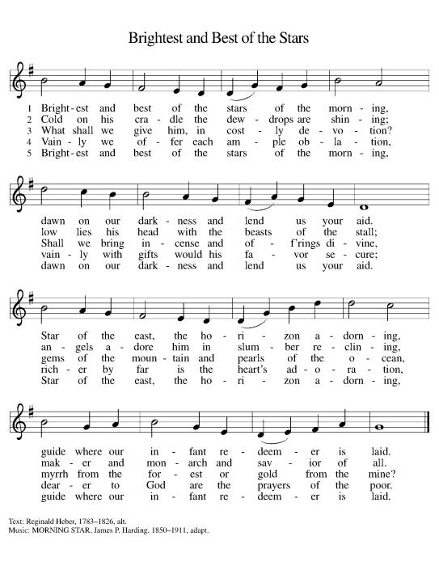

*Pastoral Greeting

P: The Grace of our Lord Jesus Christ, the love of God, and the communion of the Holy Spirit be with you all.

C: And also with you!

Hymn of Praise ELW #289 Angels We Have Heard on High (v.1)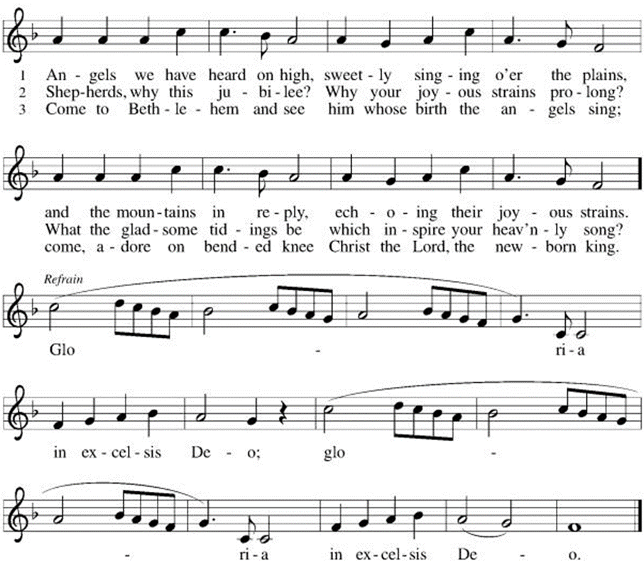

*Prayer of the Day
P: O God our Father, at the baptism of Jesus you proclaimed him your beloved Son and anointed him with the Holy Spirit. Make all who are baptized into Christ faithful to their calling to be your daughters and sons, and empower us all with your Spirit, through Jesus Christ, our Savior and Lord, who lives and reigns with you and the Holy Spirit, one God, now and forever.
C: Amen!

Children’s Message

+WORD+

First Reading: Isaiah 42:1-9
God’s servant is endowed with God’s spirit in order to bring justice to the nations. The servant will not exercise authority boisterously or with violence, nor will weariness ever prevent the fulfilling of the servant’s task. God’s old promises have been fulfilled; the servant’s new assignment is to bring light to the nations.

¹ Here is my servant, whom I uphold,
my chosen, in whom my soul delights;
I have put my spirit upon him;
he will bring forth justice to the nations.
² He will not cry out or lift up his voice
or make it heard in the street;
³ a bruised reed he will not break,
and a dimly burning wick he will not quench;
he will faithfully bring forth justice.
⁴ He will not grow faint or be crushed
until he has established justice in the earth,
and the coastlands wait for his teaching.
⁵ Thus says God, the Lord,
who created the heavens and stretched them out,
who spread out the earth and what comes from it,
who gives breath to the people upon it
and spirit to those who walk in it:
⁶ I am the Lord; I have called you in righteousness;
I have taken you by the hand and kept you;
I have given you as a covenant to the people,
a light to the nations,
⁷ to open the eyes that are blind,
to bring out the prisoners from the dungeon,
from the prison those who sit in darkness.
⁸ I am the Lord; that is my name;
my glory I give to no other,
nor my praise to idols.
⁹ See, the former things have come to pass,
and new things I now declare;
before they spring forth,
I tell you of them.

Psalm: Psalm 29
The voice of the Lord is upon the waters. (Ps. 29:3)

¹ Ascribe to the | Lord, you gods,
ascribe to the Lord glo- | ry and strength.
² Ascribe to the Lord the glory | due God’s name;
worship the Lord in the beau- | ty of holiness.
³ The voice of the Lord is upon the waters; the God of | glory thunders;
the Lord is upon the | mighty waters.
⁴ The voice of the Lord is a pow- | erful voice;
the voice of the Lord is a | voice of splendor.
⁵ The voice of the Lord breaks the | cedar trees;
the Lord breaks the ce- | dars of Lebanon;
⁶ the Lord makes Lebanon skip | like a calf,
and Mount Hermon like a | young wild ox.
⁷ The voice | of the Lord
bursts forth in | lightning flashes.
⁸ The voice of the Lord | shakes the wilderness;
the Lord shakes the wilder- | ness of Kadesh.
⁹ The voice of the Lord makes the oak trees writhe and strips the | forests bare.
And in the temple of the Lord all are | crying, “Glory!”
¹⁰ The Lord sits enthroned a- | bove the flood;
the Lord sits enthroned as king for- | evermore.
¹¹ O Lord, give strength | to your people;
give them, O Lord, the bless- | ings of peace.

Second Reading: Acts 10:34-43
Peter crosses the sharp religious boundary separating Jews from Gentiles and proclaims the good news of God’s inclusive forgiveness in Jesus’ name to Cornelius, a Roman centurion. As a result of Peter’s preaching, Cornelius and his family become the first Gentiles to be baptized in the name of Jesus Christ.

³⁴ Peter began to speak to [Cornelius and his household]: “I truly understand that God shows no partiality, ³⁵ but in every people anyone who fears him and practices righteousness is acceptable to him. ³⁶ You know the message he sent to the people of Israel, preaching peace by Jesus Christ—he is Lord of all. ³⁷ That message spread throughout Judea, beginning in Galilee after the baptism that John announced: ³⁸ how God anointed Jesus of Nazareth with the Holy Spirit and with power; how he went about doing good and healing all who were oppressed by the devil, for God was with him. ³⁹ We are witnesses to all that he did both in Judea and in Jerusalem. They put him to death by hanging him on a tree, ⁴⁰ but God raised him on the third day and allowed him to appear, ⁴¹ not to all the people but to us who were chosen by God as witnesses and who ate and drank with him after he rose from the dead. ⁴² He commanded us to preach to the people and to testify that he is the one ordained by God as judge of the living and the dead. ⁴³ All the prophets testify about him that everyone who believes in him receives forgiveness of sins through his name.”

Gospel Acclamation
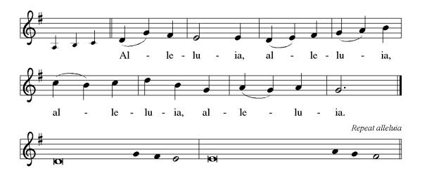

P: The Holy Gospel According to St. Matthew 3rd Chapter
C: Glory to You O Lord!

Gospel: Matthew 3:13-17
Before Jesus begins his ministry, he is baptized by John, touched by the Spirit, and identified publicly as God’s child.

¹³ Jesus came from Galilee to John at the Jordan, to be baptized by him. ¹⁴ John would have prevented him, saying, “I need to be baptized by you, and do you come to me?” ¹⁵ But Jesus answered him, “Let it be so now, for it is proper for us in this way to fulfill all righteousness.” Then he consented. ¹⁶ And when Jesus had been baptized, just as he came up from the water, suddenly the heavens were opened to him and he saw God’s Spirit descending like a dove and alighting on him. ¹⁷ And a voice from the heavens said, “This is my Son, the Beloved, with whom I am well pleased.”

P: The Gospel of the Lord
C: Praise to you, O Christ!

Sermon

*Hymn of the Day ELW 305 When Jesus Came to Jordan
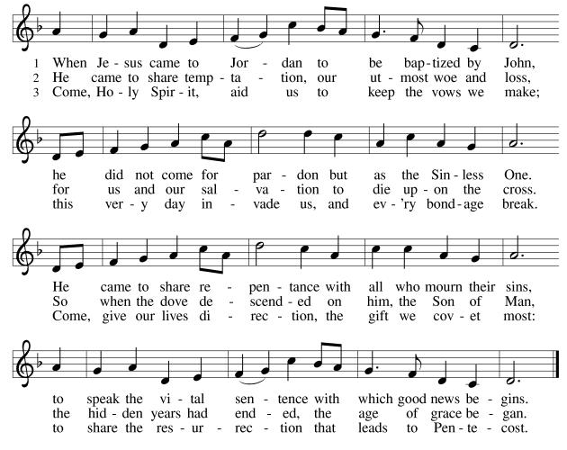

*Prayers of Intercession
As God’s beloved children united in Christ, let us pray for the church, the whole human community, and the well-being of the earth, our home.
A brief silence.
Steadfast God, give courage to your servant church. Heal our divisions and unite us in mission. Uphold our lay leaders, missionaries, pastors, and bishops, and all who proclaim hope in a broken world. Merciful God,
C:receive our prayer.
Restoring God, cleanse the life-giving waters of rivers, seas, and springs (local water sources may be named). Create in us an urgent desire to preserve the beauty and bounty of your good creation. Merciful God,
C:receive our prayer.
Righteous God, you guide the nations. Reconcile warring enemies and end cycles of violent retribution. Defend the rights of prisoners, detainees, and all who flee from persecution. Sustain international aid workers and peacemakers. Merciful God,
C:receive our prayer.
Compassionate God, you care for all in distress. Provide safety and support for those seeking asylum or in need of shelter. Be near to the dying, and comfort all who are grieving or ill (especially). Merciful God,
C:receive our prayer.
Loving God, awaken the gifts of the Spirit in this congregation, that we may serve Christ by loving one another, our neighbors, and our enemies. We pray for travelers and those who are homebound. Merciful God,
C:receive our prayer.
Here other intercessions may be offered.
Promising God, in baptism we die and rise with Christ. We give thanks for those who have gone before us, and we trust that we will join them in your everlasting peace. Merciful God,
C:receive our prayer.
Confident that the Holy Spirit receives our prayers and answers us, we commend all for whom we pray to God’s loving-kindness made known to us in Christ Jesus our Savior.
C: Amen.

Greeting of Peace
P: The peace of Christ be with you always!
C: And also with you!

Offering (Thank you for your support for our ministry!)

*Doxology ELW 275 Angels, From the Realms of Glory (v.4)
(Please stand and join in singing as we share our gifts!)
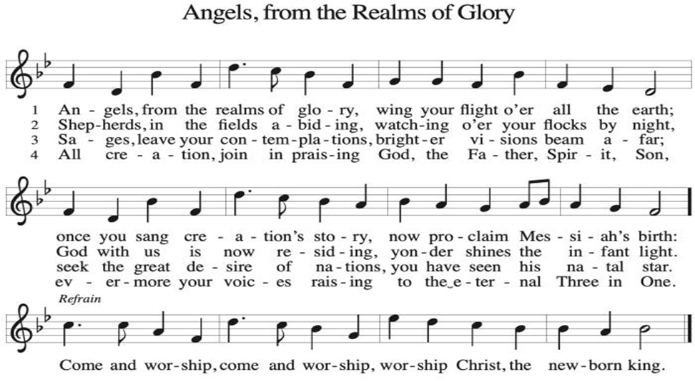

*Offering Prayer
A: God of majesty,
C: no eye has seen, no ear has heard
what you have prepared for those who love you,
yet in this meal you reveal the wideness of your mercy.
Use what we have gathered
to feed us with the reign of God come near,
Jesus Christ, our Savior and Lord.
Amen!
+MEAL+
*Great Thanksgiving
P: The Lord be with you.
C: And also with you.

P: Lift up your hearts.
C: We lift them to the Lord.

P: Let us give thanks to the Lord our God.
C: It is right to give our thanks and praise.

P: It is indeed right, our duty and our joy,
that we should at all times and in all places
give thanks and praise to you, almighty and merciful God,
through our Savior Jesus Christ.
By the leading of a star he was shown forth to all nations;
in the waters of the Jordan you proclaimed him your beloved Son;
and in the miracle of water turned to wine he revealed your glory.
And so, with all the choirs of angels,
with the church on earth and the hosts of heaven,
we praise your name and join their unending hymn:

*Sanctus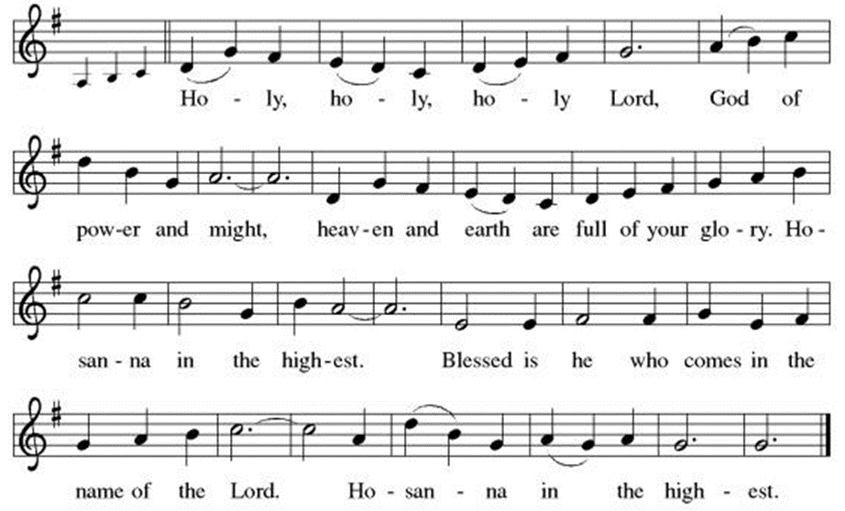

*Eucharistic Prayer
P: Holy One,
the beginning and the end, the giver of life:
Blessed are you for the birth of creation.
Blessed are you in the darkness and in the light.
Blessed are you for your promise to your people.
Blessed are you in the prophets’ hopes and dreams.
Blessed are you for Mary’s openness to your will.
Blessed are you for your Son Jesus,
the Word made flesh.

In the night in which he was betrayed,
our Lord Jesus took bread, and gave thanks;
broke it, and gave it to his disciples, saying:
Take and eat; this is my body, given for you.
Do this for the remembrance of me.

Again, after supper, he took the cup, gave thanks,
and gave it for all to drink, saying:
This cup is the new covenant in my blood,
shed for you and for all people for the forgiveness of sin.
Do this for the remembrance of me.

Let us proclaim the mystery of faith:
C: Christ has died. Christ is risen. Christ will come again.

P: With this bread and cup
we remember your Word dwelling among us,
full of grace and truth.
We remember our new birth in his death and resurrection.
We look with hope for his coming.
C: Come, Lord Jesus.

P: Holy God, we long for your Spirit.
Come among us.
Bless this meal.
May your Word take flesh in us.
Awaken your people.
Fill us with your light.
Bring the gift of peace on earth.
C: Come, Holy Spirit.

P:All praise and glory are yours,
Holy One of Israel,
Word of God incarnate,
Power of the Most High,
one God, now and forever.
C: Amen.

*THE LORD’S PRAYER
Our Father, who art in heaven,
hallowed be thy name,
thy kingdom come,
thy will be done,
on earth as it is in heaven.
Give us this day our daily bread;
and forgive us our trespasses,
as we forgive those
who trespass against us;
and lead us not into temptation,
but deliver us from evil.
For thine is the kingdom,
and the power, and the glory,
forever and ever. Amen.
*Lamb of God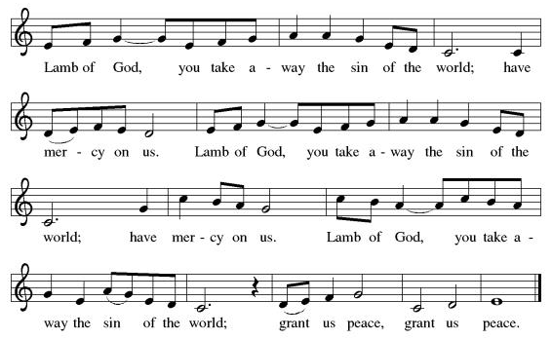

Spiritual Communion Prayer
P: Let us pray for the communion of all present here, those viewing our service virtually, those in our hearts and in our world.
C: Lord Jesus, I believe you are truly present in the Sacrament of Holy Communion. When I cannot receive Communion, I pray that you come into my heart. I know that nothing in Heaven or on earth can separate me from your love. Amen.

Invitation to Communion
P: Here is the Lamb of God who takes away the sin of the world!
Come to the table; taste and see.
C: Thanks be to God!

(All are invited to the communion rail following the guidance of the ushers. Communion will be shared through the host and individual cups. If you would like communion but are unable to join us at the rail, please alert the usher!)

Communion Hymns (Please join in singing!)

ELW 296 What Child is This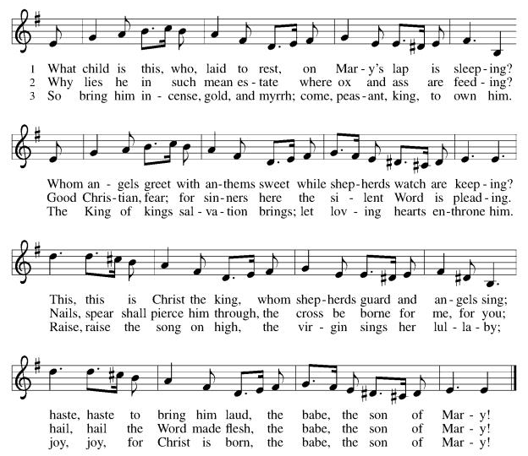

ELW 302 As with Gladness Men of Old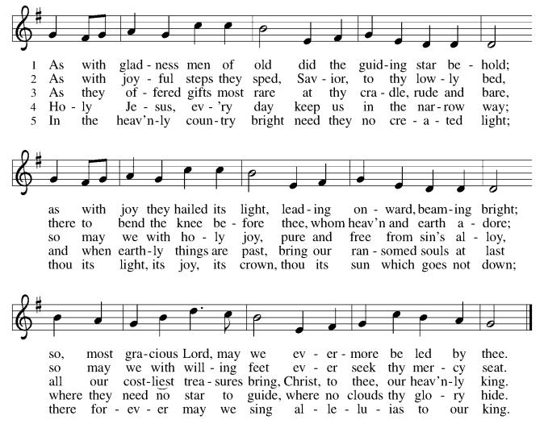

*Prayer after Communion
A: Radiant God,
we have seen your glory in the face of Jesus Christ.
In the sacrament of his body and blood
you have drawn us to your heart.
Send us from this table with delight,
that our lives may reflect the beauty of your love,
and bear witness to all we have seen and heard,
through Jesus Christ, our Savior and Lord.
C: Amen.
+Sending+

*Blessing
P: May the triune God,
who has put a new song in your mouth
and tuned your heart for praise
☩ bless you now and forever. C: Amen!
*Sending Hymn 304 Christ, When for Us You Were Baptized
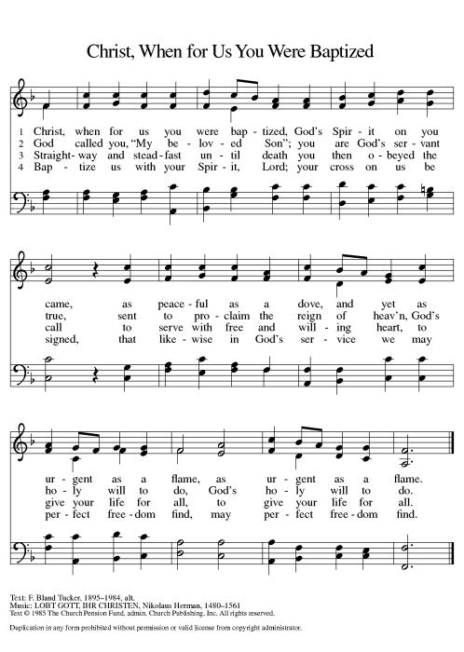

*Dismissal
A: Go in peace. Do justice. Love mercy.
C: Thanks be to God!

Postlude

Copyright © 2020 Augsburg Fortress. All rights reserved. Reprinted by permission under Augsburg Fortress Liturgies Annual License #SB106907. New Revised Standard Version Bible, Copyright © 1989, Division of Christian Education of the National Council of the Churches of Christ in the United States of America. Used by permission. All rights reserved. Revised Common Lectionary, Copyright © 1992 Consultation on Common Texts, admin Augsburg Fortress. Used by permission.

Treasurer’s Report
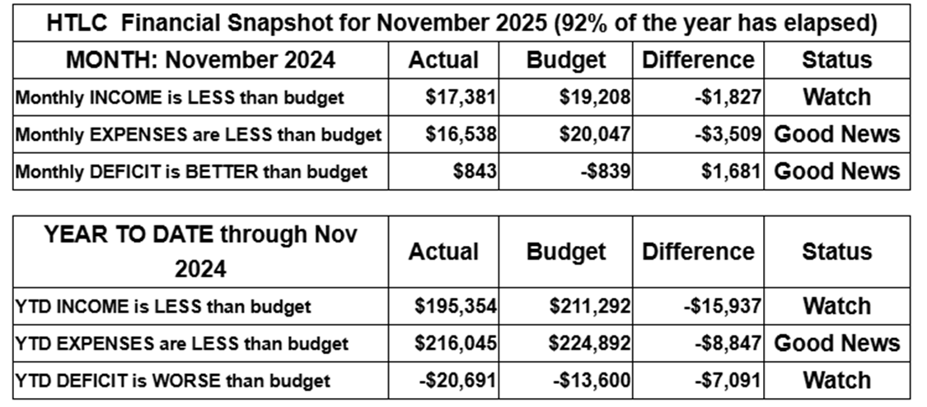
November giving improved over that of October, but still is short for the year to date. Expenses remain under control, but we rely on strong giving in December to maintain stability and support our ministries. Gifts above and beyond regular giving will help us build a growing, healthy church. Thank you for your generosity.
Thank you for supporting our ministry! Chris Foard, Treasurer

Worship Volunteer Schedule
Date | Asst. Min | Usher | Sacristan | Lector | Counter
January 11 | Chris Foard | Kathy Caputo | Sherry Lee | Rosemary Lane | Socha/Foard
January 18 | Elaine Bradford | Dan Grillon | Carol Rosen | Emily Kaster | Bohner/Volk
January 25 | Charlie Rugg | Gripps | Pat Pienkos | Jeff Ridberg | Bradford/Giordano
February 1 | Linda Coleman | Jill Socha | Sherry Lee | Cynthia Kazmac | Carleo/Csernica

Coffee Hour- Roger Foss

ANNOUNCEMENTS Thank you! To all who consistently support our church and ministries through your time, talent, and treasure. Please help us grow by inviting your friends and family to worship and events. You are what makes Holy Trinity a wonderful church family!

Stay in touch! Please visit our church website, www.htlcredbank.org for updates and information. You can also find us on Facebook and view services online. The office is open from 9am to 2pm, Monday to Thursday.

100 Anniversary Committee- If you are interested in being a part of the committee to help plan the 100th anniversary celebration of HTLC in 2028, please sign up in the red book. All are welcome! Also, the committee will be looking for photos and documents of HTLC throughout the years. If you have anything to share, please bring them to the church and marked envelopes or email electronic copies to the church office.

Name Tag Sundays: On the first Sunday of each month, names tags and markers will be at each entrance of the sanctuary. Please fill out a tag and wear one for worship and for coffee hour to welcome visitors and help newcomers put names to faces.

Sunday School in the New Year, we will continue to study stories and lessons from the Old Testament beginning with Jacob. Kids will love the crafts, songs and games that accompany each lesson.
The following dates there will be Sunday School:
Jan- 11 and 25, Feb- 8 and 22, March- 1, 15 and 29*Easter Egg Hunt!
April- 12 and 26, May- 3, 17 and 31, June- 7 and 14
As was done in the fall, there will be opportunities to volunteer as SS lead teacher. A signup will be emailed out shortly and will also be posted in the red binder. Consider signing up! All lesson materials will be supplied and laid out and a leader guide will be emailed to volunteers approximately 1 week in advance. Blessings for a wonderful 2026!~Lauren

Trivia Night!! Mark your calendars! Plan for a fun night at Holy Trinity on Feb. 28 at 5pm for great food and trivia. We have an International theme, so we ask you to bring a pot luck dinner item showing your ethnic heritage. There is a sign up sheet for your convenience.
You don't have to be another Ken Jennings---this is just for fun. See you then!

Choir The Holy Trinity Choir welcomes our singers back for a preparation rehearsal on Sunday, September 7th at 9am in the church hall. All are welcome to join us in song as often as you are able. Choir meets each Sunday at 9am to practice and prepare our music. Join us and help us grow by spreading the word about the HTLC Choir!

Quilting- The Quilters need gently used any bed sheets of any size! Please leave any donations in the quilters closet in Fellowship Hall. Thank you!

Quilters Need Help
If anyone is traveling through Maryland on Rte. 95, and can add a few extra minutes to your trip, the warehouse for shipping quilts, school kits, etc is located directly off one of the exits.
We accumulate many quilts throughout the year and we would appreciate sending some quilts with you to deliver.
Any questions, please call Sherry Lee or Elaine Theophall.

Weekly Quilting on Wednesdays at 9:30. Bring your lunch and enjoy some fellowship at noon. All are welcome. There will be no quilting on Wednesday September 24 due to the garage sale set up.

Evening Quilting Evening Quilting –
Please share this information . This is an important ministry that helps so many. It’s very easy and you don’t need to know how to sew. We have a great time socializing too! We will meet: Jan. 21, Feb. 18, March 18 at 6:00 PM. Note: If we have to cancel I will send an email. Please let me know only if you can come. Contacts: Pat Pienkos 732-513-9615 Debbie Yetka 908-461-4084 Looking forward to seeing you all!

Social Ministry
*Year-round collections will continue for food items for Lunch Break. There is a sign-up sheet in the red book for those who can help drop these items to Lunch Break.
*We will also collect adult men's socks to periodically drop at the Red Bank Warminq Center.
*For those interested in the Heartwarminq Center — the new women's shelter is adjacent to the First Baptist Church of Red Bank at 90 Maple Ave. You can follow up on this mission through their website - https://www.thefeastnj.org- On this site, they also include wish list items that can be purchased through amazon. We will be exploring purchasing some of these through a Thrivent card. If you want to purchase on your own, you can leave items at church, and the Social Ministry will deliver them.
Pastoral Care and Prayer... We are here to care for and pray! Please contact the office to add or adjust prayer requests. If you or someone you know needs pastoral care, please contact the office and Pastor Mack!

THANK YOU for supporting and sustaining our church and ministries! All are welcome here! Please invite your family and friends to worship with us! Find us online at www.htlcredbank.org

