Diocese of Ottawa • Anglican Church of Canada



The Baptism
of the Lord

Jan 11th, 2026
Sung Eucharist ~ 10 a.m.
Book of Alternative Services, p. 185

Welcome to the Church of
St. John the Evangelist

We acknowledge that we gather at St. John’s on the traditional and unceded territory of the Algonquin Nation. May we dwell on this land with respect and peace.

This service is video recorded, streamed, and broadcast. By attending this service, you are agreeing to appear on video in our on-line worship offering through St. John’s website and Facebook pages.
Hymns are from the blue Common Praise hymnbook unless otherwise indicated.
Today’s service can be found on page 185 of the green Book of Alternative Services (BAS) located in the pew-back in front of you.

THE GATHERING OF THE COMMUNITY
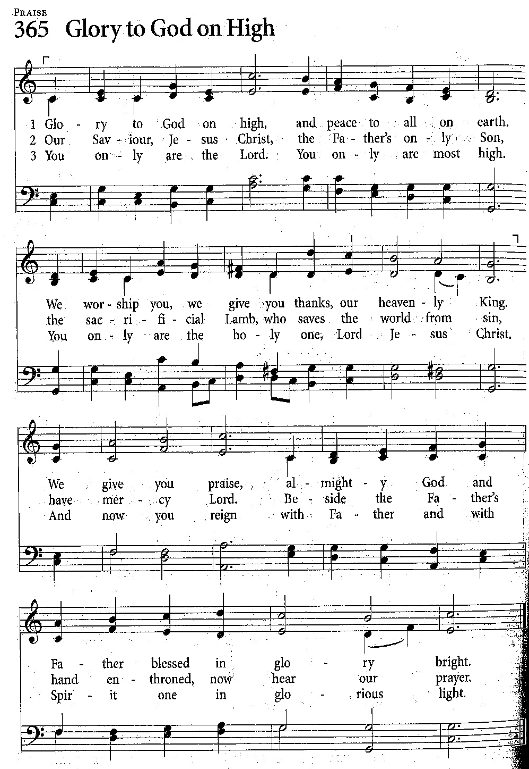

Prelude – “The Little Drummer Boy”

Announcements

Processional (Opening) Hymn

139 – “The First Nowell”

Greeting, p.185

Children’s Talk

Collect for Purity, p.185

The Gloria
Sung as printed here.

Collect of the Day
Eternal Father,
who at the baptism of Jesus
revealed him to be your Son,
anointing him with the Holy Spirit,
keep your children, born of water and the Spirit,
faithful to their calling;
through Jesus Christ our Lord,
who lives and reigns with you and the Holy Spirit,
one God, now and for ever.
Amen.

THE PROCLAMATION OF THE WORD

First Reading Isaiah 42:1-9
Here is my servant, whom I uphold, my chosen, in whom my soul delights; I have put my spirit upon him; he will bring forth justice to the nations. He will not cry or lift up his voice, or make it heard in the street; a bruised reed he will not break, and a dimly burning wick he will not quench; he will faithfully bring forth justice. He will not grow faint or be crushed until he has established justice in the earth; and the coastlands wait for his teaching. Thus says God, the Lord, who created the heavens and stretched them out, who spread out the earth and what comes from it, who gives breath to the people upon it and spirit to those who walk in it: I am the Lord, I have called you in righteousness, I have taken you by the hand and kept you; I have given you as a covenant to the people, a light to the nations, to open the eyes that are blind, to bring out the prisoners from the dungeon, from the prison those who sit in darkness. I am the Lord, that is my name; my glory I give to no other, nor my praise to idols. See, the former things have come to pass, and new things I now declare; before they spring forth, I tell you of them.

Reader: The Word of the Lord
People: Thanks be to God

Psalm 29 Tune 350

Ascribe to God, you gods,
Ascribe glory and might;
Ascribe the glory due his Name,
Worship in holy light.

God’s voice is on the deep,
His thunder rolls on high;
The Lord is on the water-flood,
God’s voice a mighty cry.

God’s voice breaks mighty trees,
Tall cedars of great worth;
The writhe and leap like mountain sheep,
God’s voice shakes all the earth.

God’s voice splits flames of fire,
God’s voice shakes desert sands;
God’s voice makes oak trees shake and strips
The leaves from forest stands.

Within God’s templ all
Cry “Glory!” and adore;
The Lord sits throned above the flood
As King for evermore.

The Lord will give his strength
To all his own, nor cease
To give his people evermore
The blessing of his peace

Second Reading Acts 10:34-43
Peter began to speak to the Gentiles: "I truly understand that God shows no partiality, but in every nation anyone who fears him and does what is right is acceptable to him. You know the message he sent to the people of Israel, preaching peace by Jesus Christ - he is Lord of all. That message spread throughout Judea, beginning in Galilee after the baptism that John announced: how God anointed Jesus of Nazareth with the Holy Spirit and with power; how he went about doing good and healing all who were oppressed by the devil, for God was with him. We are witnesses to all that he did both in Judea and in Jerusalem. They put him to death by hanging him on a tree; but God raised him on the third day and allowed him to appear, not to all the people but to us who were chosen by God as witnesses, and who ate and drank with him after he rose from the dead. He commanded us to preach to the people and to testify that he is the one ordained by God as judge of the living and the dead. All the prophets testify about him that everyone who believes in him receives forgiveness of sins through his name."

Reader: The Word of the Lord
People: Thanks be to God

Gospel Acclamation
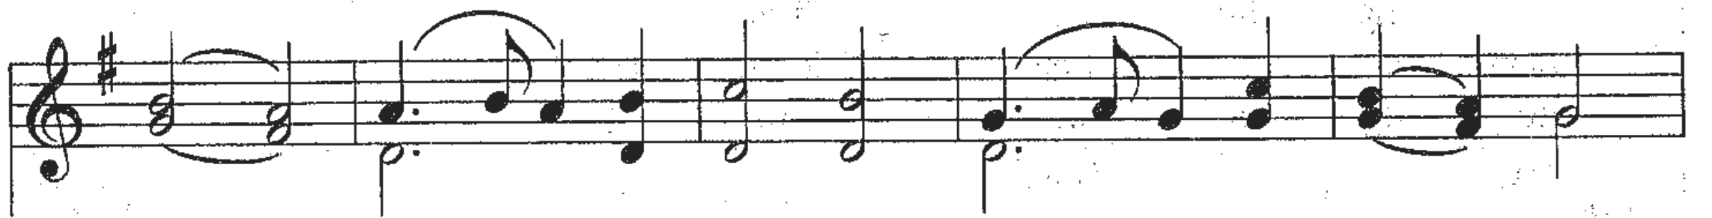
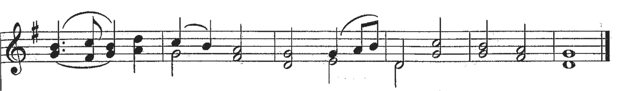

Holy Gospel Matthew 3:13-17

Gospeller: The Lord be with you
All: And also with you
Gospeller: The Holy Gospel of our Lord Jesus Christ according to Matthew
All: Glory to you, Lord Jesus Christ
Then Jesus came from Galilee to John at the Jordan, to be baptized by him.
John would have prevented him, saying, "I need to be baptized by you, and do you come to me?" But Jesus answered him, "Let it be so now; for it is proper for us in this way to fulfil all righteousness." Then he consented. And when Jesus had been baptized, just as he came up from the water, suddenly the heavens were opened to him and he saw the Spirit of God descending like a dove and alighting on him. And a voice from heaven said, "This is my Son, the Beloved, with whom I am well pleased."

Gospeller: The Gospel of Christ
People: Praise to you, Lord Jesus Christ

Sermon

Nicene Creed p. 188

Prayers of the People

All: Gracious God, by whose spirit the whole body of your faithful people is governed and sanctified, send your guidance upon us as we prepare to elect a bishop for our diocese. Grant wisdom to those discerning a call, to those who are candidates, to Members of Synod, and to our diocesan administrator, Bishop Michael Bird; through Jesus Christ our Lord.

Anthem “The Wexford Carol”

Confession and Absolution p. 191

The Peace p. 192

People may greet one another with the peace of Christ.

Offertory Hymn

103 – “On Jordan’s Bank, the Baptist’s Cry”
THE CELEBRATION OF THE EUCHARIST

Prayer over the Gifts
God of life and freedom,
we celebrate the revelation of Jesus
as the Christ who makes all creation new.
Accept all we offer you this day
and make us new in him,
who is Lord for ever and ever.
Amen.

Eucharistic Prayer 3 p. 198

Sanctus (sung)

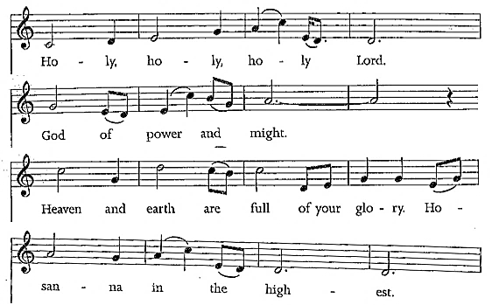
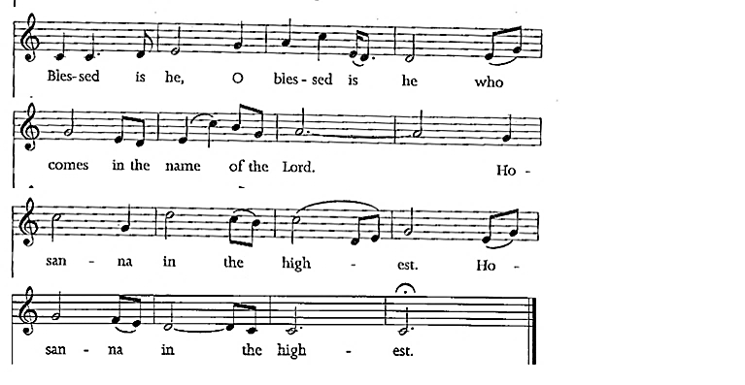

The Lord’s Prayer (sung)
Our Father in heaven, hallowed be your name;
Your kingdom come;
Your will be done
On earth, as in heav’n.
Give us today our daily bread.
Forgive us our sins
as we forgive those who sin against us.
Save us from the time of trial,
and deliver us from evil.
For the kingdom, and the power, and the glory are yours;
Now and forever.
Amen.

Breaking of the Bread 6 p. 213
Celebrant: We break the bread of life,
And that life is the light of the world.
All: God here among us,
light in the midst of us,
bring us to light and life.

Agnus Dei (Lamb of God) Sung as printed here.

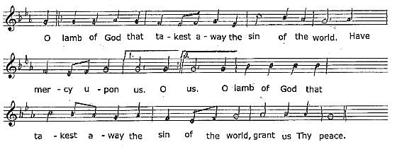

Communion
All who are baptized are welcome to receive the bread and/or the wine of Holy Communion. At the Greeter’s direction, please make your way to receive the elements if you wish to. All are welcome to come forward for a blessing.

Hymns during Communion
647 – “Spirit of the Living God”
158 – “Earth Has Many a Noble City
163 – “When Christ’s Appearing” Tune 431

Prayer after Communion
Gracious God, lover of all,
by this sacrament
you make us one family in Christ your Son,
one in the sharing of his body and blood,
one in the communion of his Spirit.
Help us to grow in love for one another
and come to the full maturity of the Body of Christ.
We ask this in his name.
Amen.

Doxology p. 214

The Blessing

Recessional Hymn – 619 – “Fairest Lord Jesus”

Dismissal

Postlude – “Linus and Lucy” (Wilson)

ANNOUNCEMENTS

Gluten free Wafers Available – We have gluten free wafers available for anyone who is looking for this option. Please advise the priest at communion.

2026 Offering Envelopes – The 2026 weekly giving envelopes are now at the back of church, sorted alphabetically. If you do not see your name or I have missed someone, please let me know. As well, there are extra boxes of envelopes if you or someone you know would like a set. – Tammy Mulrooney, Envelope Secretary.

Coffee Hour! Wednesdays at 11:00am – Everyone is welcome to join our additional coffee hour where we can enjoy great coffee and fellowship. All are welcome! If you love coffee, if you like coffee, if you don't like coffee, please come out!
We are excited to see how the Holy Spirit works in this new fellowship time. We hope new friendships are formed and positive connections are made.
If you have any questions, please contact Laura Porter or Thomas.

Choir - For those of you that love music, take the opportunity to join the Choir. Practices are held Friday and Saturday mornings at 10am. For further information or to sign up, please contact Wendy at: w.wearl@hotmail.com.

Canadian Church Calendars for Sale – Please pick up your copy of the Canadian Church Calendar for $7.00. The last few copies can be found at the back of the church in the Canterbury room and there is an envelope for your purchase (cash or cheque only).

Presiding Celebrant: Rev. Dr. Thomas Brauer
Preacher: Rev. Dr. Thomas Brauer
Communion Assistant: Kevin Lewis*
Reader/Intercessor: Karen Bryan
Greeters: Gail Brennan & Linda Coleman
Altar Guild: Debbie Lewis & Ila Bennett
Organist: Wendy Stokes-Earl
Readings for next Sunday, Jan 18, 2026 ~
IS 49:1-7; PS 40:1-12; 1 COR 1:1-9; JN 1:29-42

ST. JOHN THE EVANGELIST ANGLICAN CHURCH
2 George Street South, Smiths Falls, Ontario K7A 1X4
613.283.1261 | stjohns.smithsfalls@gmail.com
www.stjohn-smithsfalls.com

Follow us on Facebook at:
St-John-the-Evangelist-Anglican-Church-Smiths-Falls

Laura Savage – Parish Administrator
Office Hours: Monday – Wednesday 9 a.m. – 12 noon
Thursday 1 – 4 p.m.
Friday 9 a.m. – 12 noon

Weekly Liturgies
Holy Eucharist – Sundays 8 a.m. & 10 a.m.* – Wednesdays 10 a.m.
*Sunday School offered at 10 a.m. from September – June

The Reverend Dr. Thomas Brauer, Presiding Celebrant & Preacher
The Reverend Canon Brian Burrows – Honorary Assistant
The Reverend Canon Jim Roberts – Honorary Assistant

Wendy Stokes-Earl – Organist
Dan Willis – Rector’s Warden 613.884.5095
Lois Arkell – People’s Warden 613.485.9181
Tammy Mulrooney – Deputy Warden 613.485.3128
Pat Lee – Deputy Warden 613.485.3368
Tammy Mulrooney – Envelope Secretary
sjsfenvelopesecretary@gmail.com

