THE ANGLICAN PARISH OF ST. MARK
“Drawing People to the Light”
Part of the Diocese of British Columbia
www.stmarkqualicum.ca https://bc.anglican.ca
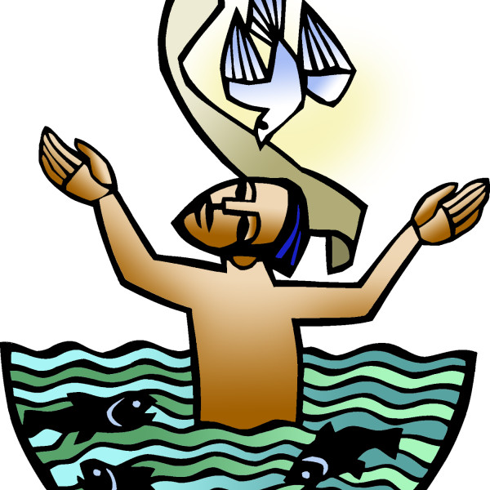

BAPTISM OF THE LORD
JANUARY 11, 2026
10:00 am Holy Communion
Book of Alternative Services (BAS)

We acknowledge with thanksgiving that we gather to worship on the territories of the Kwakwaka’Wakw, Nuu-Chah-Nulth and Coast Salish Peoples.
We are grateful for our growing relationship with the Qualicum First Nation.
As part of the Anglican Church of Canada, a church of Settlers and First Nations,
we commit ourselves to a journey of truth and reconciliation between the indigenous peoples of this land and the non-native peoples of Canada.

HOLY COMMUNION
Before the service, please observe silence so that we can be in quiet prayer.

Processional Hymn: CP 628 O Love How Deep vs 1,2,3,7

The Gathering of the Community

Celebrant: The grace of our Lord Jesus Christ, and the love of God, and the fellowship of the Holy Spirit, be with you all.
People and also with you.

Celebrant Almighty God,
People to you all hearts are open, all desires known, and from you no secrets are hidden. Cleanse the thoughts of our hearts by the inspiration of your Holy Spirit, that we may perfectly love you, and worthily magnify your holy name; through Christ our Lord. Amen.

Gloria
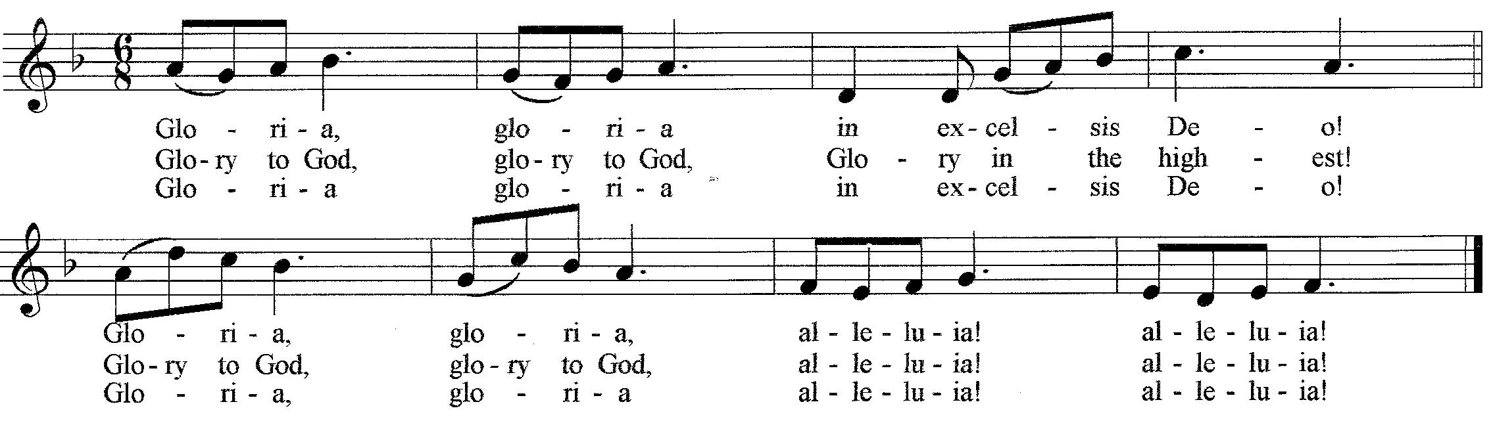
© 1998 Ateliers et Presses de Taizé (France). All rights reserved

The Collect of the Day
All O God, our Father, at the baptism of Jesus you proclaimed him your beloved Son and anointed him with the Holy Spirit. Make all who are baptized into Christ faithful to their calling to be your daughters and sons, and empower us all with your Spirit, through Jesus Christ, our Saviour and Lord, who lives and reigns with you and the Holy Spirit, one God, now and forever. Amen

First Reading: Isaiah 42:1-9

Psalm 29
Ascribe to the Lord, O heavenly beings,
ascribe to the Lord glory and strength.

Ascribe to the Lord the glory of his name;
worship the Lord in holy splendor.

The voice of the Lord is over the waters;
the God of glory thunders,
the Lord, over mighty waters.

The voice of the Lord is powerful;
the voice of the Lord is full of majesty.

The voice of the Lord breaks the cedars;
the Lord breaks the cedars of Lebanon.

He makes Lebanon skip like a calf
and Sirion like a young wild ox.

The voice of the Lord flashes forth flames of fire.
The voice of the Lord shakes the wilderness;
the Lord shakes the wilderness of Kadesh.

The voice of the Lord causes the oaks to whirl
and strips the forest bare,
and in his temple all say, “Glory!”

The Lord sits enthroned over the flood;
the Lord sits enthroned as king forever.

May the Lord give strength to his people!
May the Lord bless his people with peace!

Second Reading: Acts 10:34-43

Gradual Hymn: CP 38 This Child of Ours

The Gospel: Matthew 3:13-17(Please stand as you are able)

Reader The Lord be with you
People And also with you.

Reader The Holy Gospel of our Lord Jesus Christ according to Matthew.
People Glory to you, Lord Jesus Christ.

Then Jesus came from Galilee to John at the Jordan, to be baptized by him. John would have prevented him, saying, “I need to be baptized by you, and do you come to me?” But Jesus answered him, “Let it be so now, for it is proper for us in this way to fulfill all righteousness.” Then he consented. And when Jesus had been baptized, just as he came up from the water, suddenly the heavens were opened to him and he saw God’s Spirit descending like a dove and alighting on him. And a voice from the heavens said, “This is my Son, the Beloved, with whom I am well pleased.”

Reader The Gospel of Christ
People Praise to you, Lord Jesus Christ.

Sermon The Rev Deborah Rivet

Anthem – Come to the Water By John Foley

The Apostles’ Creed

I believe in God, The Father almighty,
Creator of heaven and earth. I believe in Jesus Christ, his only Son, our Lord.
He was conceived by the power of the Holy Spirit
And born of the Virgin Mary. He suffered under Pontius Pilate,
Was crucified, died, and was buried. He descended to the dead.
On the third day he rose again. He ascended into heaven,
And is seated at the right hand of the Father.
He will come again To judge the living and the dead.
I believe in the Holy Spirit, The holy catholic Church,
The communion of saints, The forgiveness of sins,
The resurrection of the body, And the life everlasting. Amen.

Prayers of the People – Cynthia Preyser

Celebrant Dear friends in Christ, God is steadfast in love and infinite in mercy; God welcomes sinners and invites us to this table. Let us confess our sins, confident in God’s forgiveness.

Silence is kept

Celebrant: Most merciful God,
All We confess that we have sinned against you in thought, word, and deed, by what we have done, and by what we have left undone. We have not loved you with our whole heart; we have not loved our neighbours as ourselves. We are truly sorry and we humbly repent. For the sake of your Son Jesus Christ, have mercy on us and forgive us, that we may delight in your will, and walk in your ways, to the glory of your name. Amen.
Celebrant: Almighty God have mercy upon you, pardon and deliver you from all your sins, confirm and strengthen you in all goodness, and keep you in eternal life; through Jesus Christ our Lord.
People Amen.

Celebrant The peace of the Lord be always with you.
People And also with you.

Offertory Hymn: CP 165 Mark How the Lamb

Prayer over the Gifts
Source of love and life, receive all we offer you this day, and through the coming of your Son, help us to see in others him who is alive and reigns with you and the Holy Spirit, one God, now and for ever. Amen.

Celebrant The Lord be with you.
All: And also with you

Celebrant Lift up your hearts.
All: We lift them up to the Lord.

Celebrant Let us give thanks to the Lord our God.
All: It is right to give our thanks and praise

Celebrant: Blessed are you, gracious God, creator of heaven and earth; we give you thanks and praise through Jesus Christ our Lord, who on this first day of the week overcame death and the grave, and by his glorious resurrection opened to us the way of everlasting life. In our unending joy we echo on earth the song of the angels in heaven as we raise our voices to proclaim the glory of your name.

All Holy, holy, holy Lord, God of power and might,
Holy, holy, holy Lord, God of power and might,
heaven and earth are full of your glory. Hosanna in the highest.
Blessed is he who comes in the name of the Lord.
Hosanna in the highest.

Celebrant We give thanks to you, Lord our God, for the goodness and love you have made known to us in creation; in calling Israel to be your people; in your Word made flesh, Jesus your Son.
For in these last days you sent him to be incarnate from the Virgin Mary, to be the Saviour and Redeemer of the world. In him, you have
delivered us from evil, and made us worthy to stand before you. In him, you have brought us out of error into truth, out of sin into righteousness, out of death into life.
On the night he was handed over to suffering and death, a death he freely accepted, our Lord Jesus Christ took bread; and when he had given thanks to you, he broke it, and gave it to his disciples, and said, “Take, eat; this is my body which is given for you. Do this for the remembrance of me.”
After supper he took the cup of wine; and when he had given thanks, he gave it to them, and said, “Drink this, all of you: this is my blood of the new covenant, which is shed for you and for many for the forgiveness of sins. Whenever you drink it, do this
for the remembrance of me.”
Therefore, Loving God, according to his command,

All We remember his death,
we proclaim his resurrection,
we await his coming in glory;
Celebrant and we offer our sacrifice of praise and thanksgiving to you, Lord of all; presenting to you, from your creation, this bread and this wine.
We pray you, gracious God, to send your Holy Spirit upon these gifts, that they may be the sacrament of the body of Christ and his blood of the new covenant. Unite us to your Son in his sacrifice, that we, made acceptable in him, may be sanctified by the Holy Spirit.
In the fullness of time, reconcile all things in Christ, and make them new, and bring us to that city of light where you dwell with all your
sons and daughters; through Jesus Christ our Lord, the firstborn of all creation, the head of the Church, and the author of our salvation;
By whom, and with whom, and in whom, in the unity of the Holy Spirit, all honor and glory are yours, almighty Father, now and forever. Amen.

The Lord’s Prayer – (sung) David Haas

Celebrant We break the bread of life,
And that life is the light of the world.

All God here among us,
Light in the midst of us,
Bring us to light and life.

Celebrant The gifts of God for the People of God
All Thanks be to God
Healing Prayer team Ministry will come forward to receive Communion first

Prayer Ministry
Our healing prayer team invites you to join them to pray or give thanks to God
in the narthex (entrance) during or after communion,
or in the alcove under the Exit sign after the service. Confidentiality is assured.
Hymn after Communion CP 360 Bless the Lord my Soul ( sung 3 times)

Prayers after Communion

All Loving God, you have fed us heavenly food in the sacrament of the body and blood of Christ. Grant that we, sharing in this mystery, may turn always to that name which is above all other, Jesus Christ our Lord. Amen.
Celebrant Glory to God,
All whose power, working in us, can do infinitely more than we can ask or imagine. Glory to God from generation to generation, in the Church and in Christ Jesus, for ever and ever. Amen.

Blessing

Recessional Hymn: CP 40 O Spirit of the Living God

Dismissal

Crucifer Alleluia! Go in peace to love and serve the Lord.
All Thanks be to God. Alleluia!

The Flowers on the altar are given to the Glory of God, and with much love, in remembrance of our son,
Julian Forsyth, from Joe and Kay Forsyth

ANNOUNCEMENTS

A warm welcome to all who are worshipping with us today. Please join us in the hall following the service for coffee and conversation.
+++

Our Interim Priest, The Reverend Deborah Rivet, is with us on Sundays, and also in her office on Tuesdays and Wednesday mornings prior to mid-week Eucharist. You are welcome to make an appointment or simply drop in to see her. She is also available by phone (Mondays - Wednesdays @ (250) 709-4017).
For pastoral care needs, please contact the church office 250-752-5414 (Tuesday-Thursday mornings)

Please return your Intention (Pledge) form by Sunday, January 18. This will assist your Treasurer with preparing the Budget for 2026. Please place in the box in the Narthex. If you’ve misplaced the form, there are some on the table in the Narthex.
+++
There are just 10 Holy Roller Apple pies available for purchase. You can pick one up in the Hall following the service today for $20. Tuck it away in the freezer –
you’ll be glad you did. The pie ladies are also accepting frozen fruit for the next batch of pies. If you have any in your freezer, speak to Kate Knappett. Thank you.
+++
"52 Ways to Reconcile" discussion group continues every Thursday in the Church Hall at 3:30pm. All are welcome.
+++
The Altar Flower Calendar for 2026 is now posted on the bulletin board in the hall next to the kitchen hatch. Please choose your special date to honour loved ones or mark a special occasion and sign up on the calendar. We respectfully request a minimum donation of $70 to purchase flowers. Envelopes are available for your dedication and donation.
Coming Up
It is that time of year when we prepare for our annual Vestry Meeting.
We are asking that all Ministry Leaders send their annual report by email to Marianne in the office by Tuesday February 10th.
Email: admin@stmarkqualicum.com

The next Repair Cafe will take place at St. Stephen’s United Church on Saturday, January 24 from 9:30am-1:00pm. This is a wonderful opportunity to get those items that need repair handled by willing volunteers. Items include small electronics, tools, clothing, china, etc. For more information, speak to Lally Grauer.

The Quarantones Male Chorus, a small, auditioned, male voice choir from the Comox Valley, will perform in concert at St. Mark’s on Sunday afternoon, January 25 at 3:00pm. This concert, Songs in the key of “Eh”, will feature Canadian music, musicians and composers. Tickets are $25 and will be available at the door.

Dear Friends,

Thank you for the kind and warm welcome I received after my first service with you last Sunday. What a wonderful way for me to start the new year and I am very grateful to all of you.

I asked you a few questions during my sermon, “Is it obvious to the community here in Qualicum that God lives in the midst of our congregation? Are we reaching out with the Light of Christ into our community? Are we an open and caring community that invites people into faith?”

From my experience Sunday, Tuesday and Wednesday of this past week as I spent time with the wardens, Marianne in the office, with Ryan as he showed me around and introduced me to the school, and as I learned about the Manna Program and the support given by St. Mark. I learned about the many outreach projects that are currently underway, educational programs, prayer ministries, pastoral care, the amazing and dedicated volunteers, and just so much more.

I must also say a special note of thanks the Wardens: Sue and Wendy and their spouses for their kind and warm welcome, and to Paul for helping me navigate my first services, setting up my computer, and looking for ways to lighten my work load in so many ways.

So the answer to my questions? Yes! most definitely! You are a light shining in the community and beyond. What a wonderful parish is St. Mark. I am very excited about my time with you.

Your new incumbent will be truly blessed to be among you, when he or she arrives. Meanwhile, may we have a blessed time together.
Wishing you all a wonderful 2026 and may St. Mark continue to be a beacon of light to the community of Qualicum and the surrounding communities.

Blessings,
Rev. Deborah Rivet

St Mark’s Calendar

Jan 12 - Jan 18

Monday 12th

Tuesday 13th
9:00am – 3:00pm - OK Quilters
3:30pm - Handbells

Wednesday 14th
10:00am – Sermon Circle (Library)
11:30am – Holy Communion
5:30pm - 7:30pm - Narcotics Anonymous (downstairs)

Thursday 15th
11:15 am – Choir (Church)
3:30pm - 52 Ways

Friday 16th
1:30pm - Outreach Team (Library)

Saturday 17th
9:30am - Discernment Team (Library)

Sunday 18th Second Sunday Day after the Epiphany

8:30a - Holy Communion - BCP
10:00am - Holy Communion – BAS

