Nicaragua Mission Trip – Day 6 update, (Jan 8, 2026)
Greetings again from Nicaragua.
To God be the glory. What an amazing week He had planned and allowed us to be a part of it.
Beds were delivered to multiple houses today. 3 young boys and 2 adults are sleeping on beds tonight.
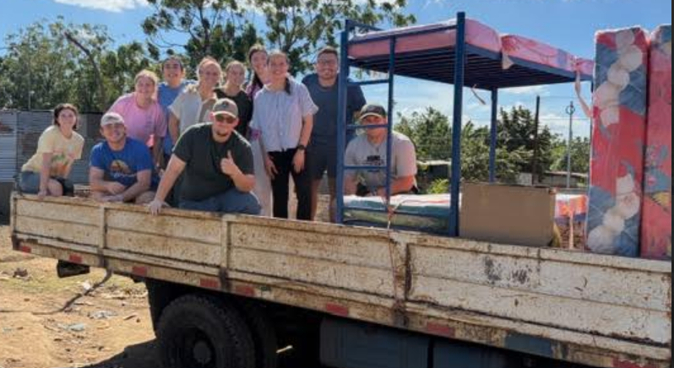
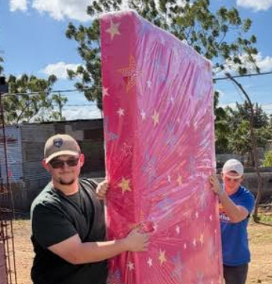 | 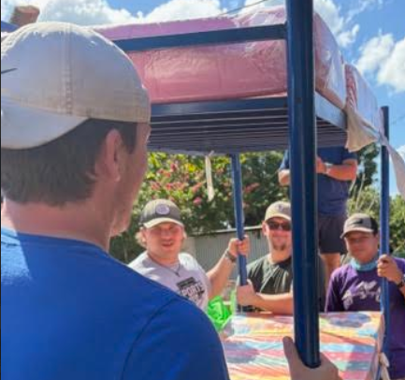 | 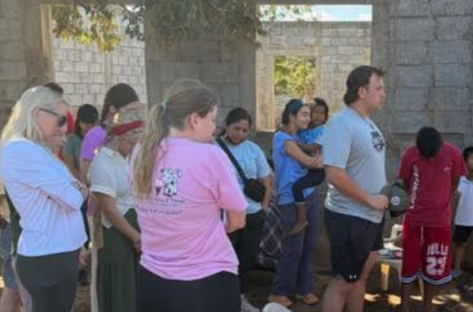

The house was completed and dedicated with prayer. Blanca shed many tears. We have a tradition where we form a circle and pass the key along saying an individual prayer then the last person presents the family the key to their new home. It’s always emotional. It rained tonight but she was dry, along with a new bed with bedding, table and 4 chairs, a propane grill, and a door that locks.

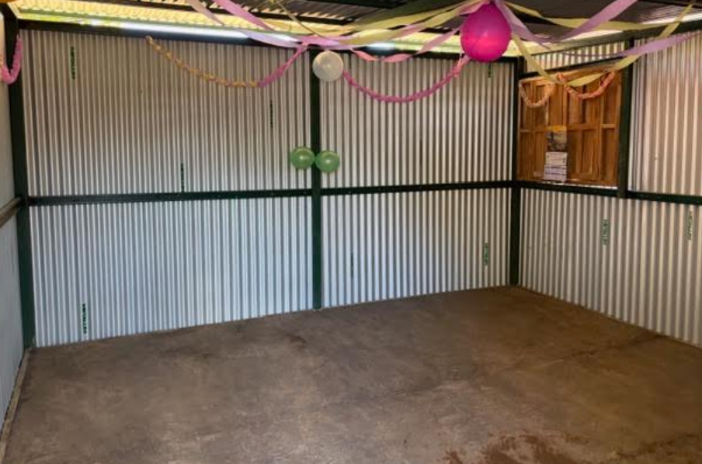 | 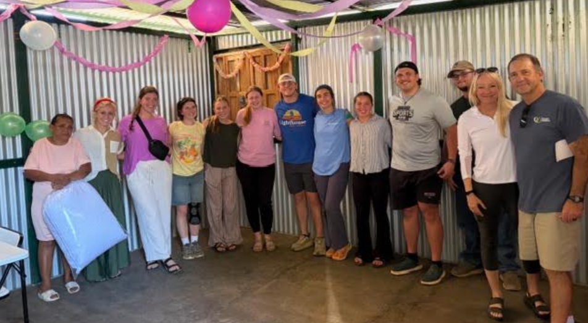 | 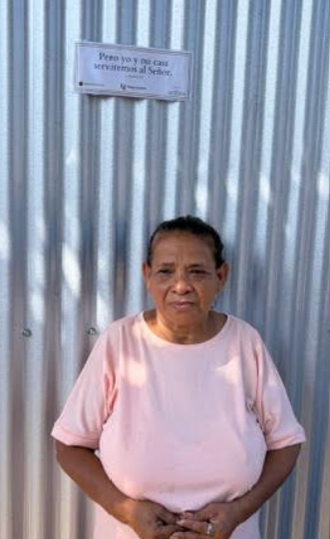

Just before the community feeding we had a service, and it was packed. I spoke on Matt 11:28-29, about coming to Jesus when you are tired, and He will give you rest. We had 4 adults trust Christ. Praise God!
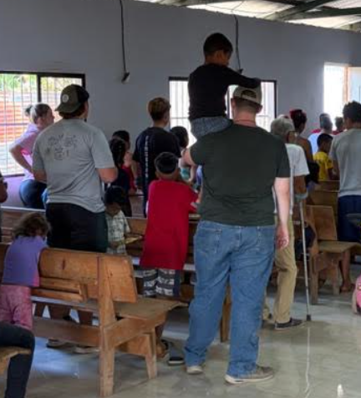 | 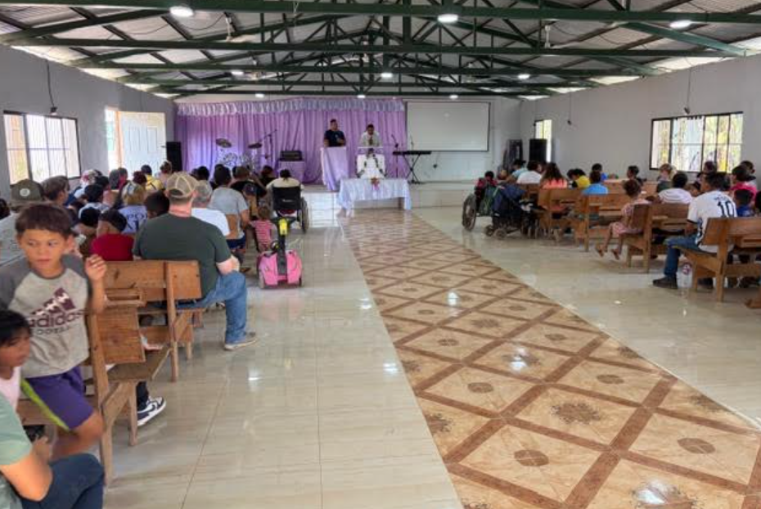

We then did a community feeding, offering rice and drinks to over 300 people. Many were grateful.
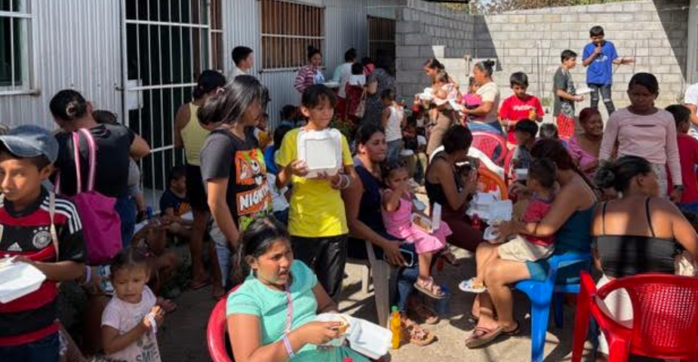 | 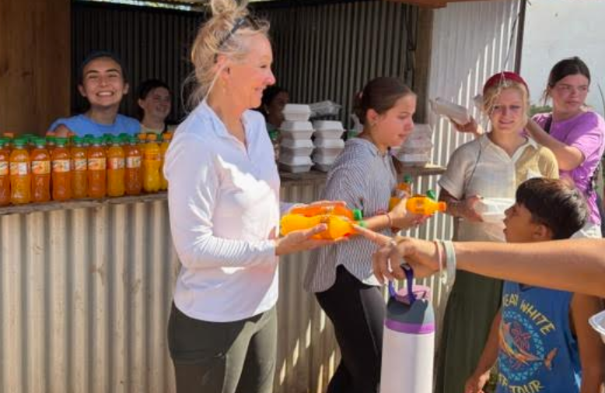

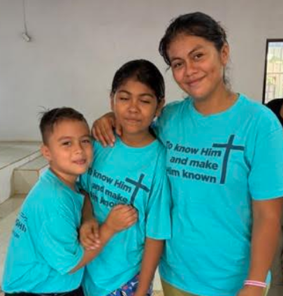 | 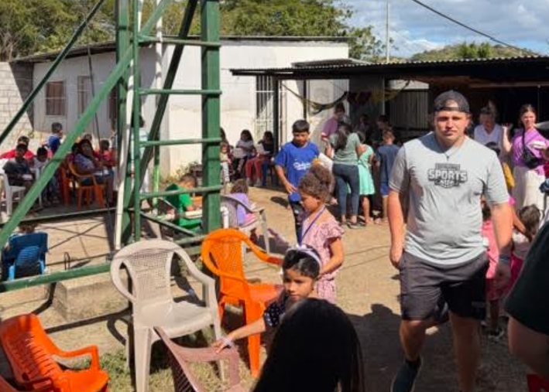

The tough part of the last day is the many “good byes” that are said.
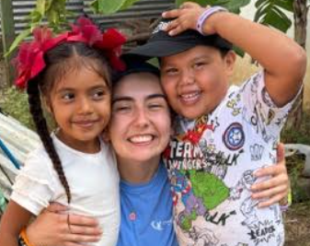 | 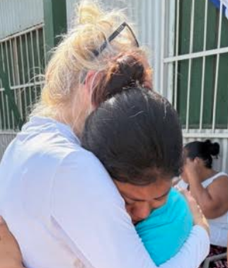 | 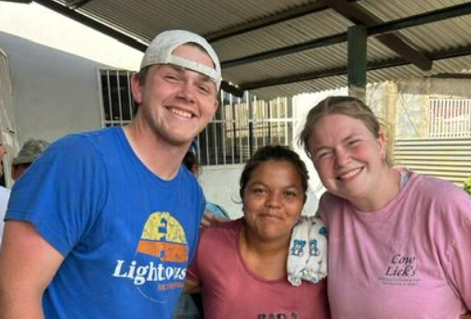

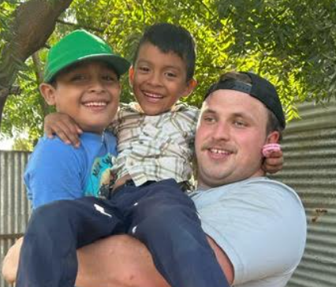 | 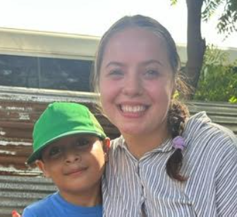 | 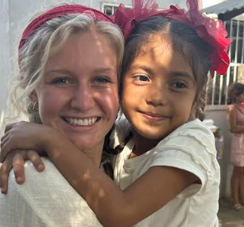

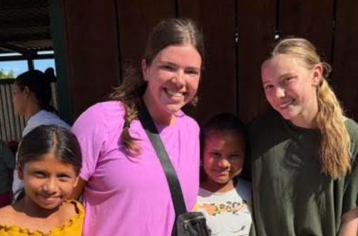 | 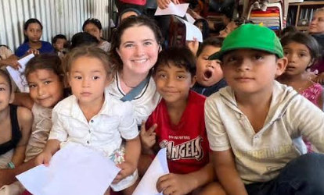

God knows the true and eternal impact from what He has allowed us to do. But we got to witness:
- 16 salvations – Praise God!
- Many asking for prayer relative to health, marriages, or their walk with God
- Multiple people who walked away from the church now returned after prayer and encouragement
- The Gospel being shared with hundreds over the course of 5 days
- 90+ door signs placed on homes referencing Joshua 24:15
- Feeding of over 300 in a community where many struggle to get food daily
- Support and encouragement for a pastor and his staff to keep going strong
- And the formation of many friendships in the body of Christ

It’s amazing what God can do through such a small team (12 people). But it was not just the team, but your prayers and support helped sustain, protect, encourage, and guide us, as we believe in the power of prayer. As you consider your prayer list for 2026, please remember the people of Carlos Fonseca. Also, for the walk of those who trusted Christ, the pastor and his staff, the people of the community with their physical challenges, but also their spiritual growth.
We are grateful for your prayers all week. We are grateful for His provision and protection. We are grateful for the spiritual growth with the team as God worked in all of us. And we are grateful that God allowed us to witness His grace and goodness in dramatic ways, serving as a reminder of His work around the world to bring the lost unto Himself.
Buenas Noches from Nicaragua…..
May you get to experience His grace and goodness in a dramatic way in 2026
Pastor Chris

