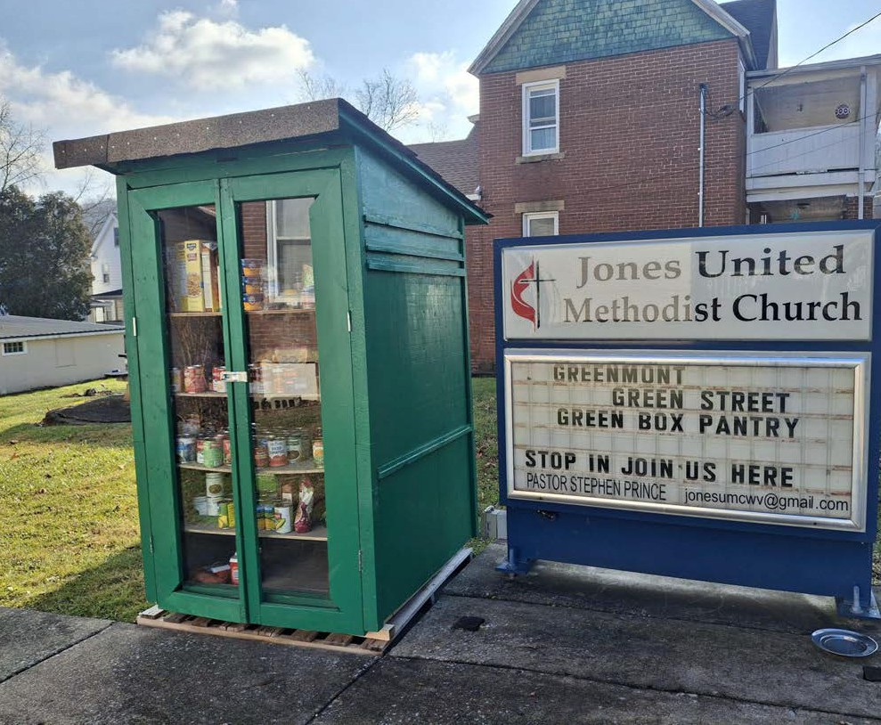
Submitted photo
Prayers take many forms, and Pastor Stephen Prince is hoping yours take the form of canned goods,
boxes of pasta, and other non-perishable food items for your neighbors in need. Right before Christmas, he and congregants installed a blessing box at Jones United Church in Greenmont to serve the community.

'We're all here for each other'

Blessing box goes up in Greenmont

BY JIM BISSETT
JBissett@DominionPost.com

Call it the ministry of Campbell’s Soup.
Or the parable of the pasta box.
Pastor Stephen Prince will take it with appreci-ation either way.
“I like it that the shelves haven’t been empty since we put it up,” said the clergyman, who preaches at the Morgantown Methodist churches of Sabra, Highland Park and Jones United.
The latter is key outreach real estate in the story.
Shortly before Christ-mas, Prince and a group of congregants built and
installed a good-sized blessing box at Jones United, for those in need in Greenmont.
The shelves filled up immediately, he said, and the blessing box was well-used through the remainder of the holiday, he said.
For him, the true blessing comes in the fact that the shelves have yet to be empty. Items are replaced as quickly as someone in need partakes of the offering.
“I’m really glad to see that,” he said.
“We’re all here for each other. I call it community ministry.”
The West Virginia community, and the prayerful sense of place that is Appalachia, is something he well knows.
He can thank his par-ents for that, he said.
They left West Virginia for other opportunities.
Both hailed from Clarksburg, where their son, the once-and-future clergyman, was born.
After time in the Midwest, they settled on Maryland’s Eastern Shore. In 1970, his parents answered an almost pri-mordial call from West Virginia’s ancient moun-tains.
“West Virginia had a pretty robust back-to-the-land movement then,” Prince said. “So we came back home.
Gilmer County, in this case. The family’s new West Virginia home, where his parents would remain and their son grew up.
Having a sense of the land and its people is what drives his ministry, he said. In recent years, he’s opened the churches he serves as warming shelters and community meeting places. He’s presided over

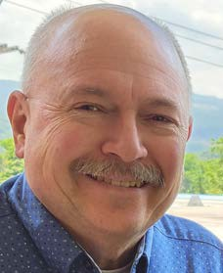
Stephen Prince

funerals where the smat-tering of friends who gathered only knew the person who passed by his nickname, and not his given one.
If you make an offering to the Jones United blessing box, he said, you’ll be helping people you may not know at all.
“We’re all here for each other,” Prince said. “And you have something in your house that someone can use and someone needs.”

