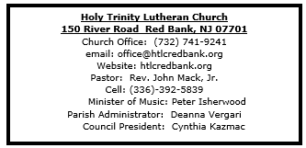

- Greetings and welcome! Angels and Archangels are rejoicing before the throne of God that you have found your way here this day!
- As we gather in this sanctuary and joyfully greet one another, may we also be sensitive to those preparing for worship through silent meditation or by listening to the choir.
- All are invited to share in the Lord's Supper receiving Christ's presence through the ministration of bread and wine. As you come forward, you may receive wine from the pouring chalice (take a small glass from the tray as you approach the communion rail) or common cup. Grape juice is distributed at the communion rail if you prefer it instead. Gluten free communion is available upon request.
- Should you need communion brought to your seat, let the usher know.
- Children are encouraged to participate in the lively movement of worship as they are able.If instead, or at any point in the service your child desires to go to the nursery, it is located across the hall through the double doors of the church in the East transept (the shorter wing of the church). The nursery is for children through age 4.
- Bathrooms are located on the ground floor of the East transept (the shorter wing of the church).
- If this is your first time to worship at Holy Trinity Lutheran Church, please sign our guest book, including your name, address and phone number. Guest books are located at both entrances.
- After worship, please come downstairs for coffee (or tea) and informal fellowship.



December 24, 2025

Nativity of Our Lord I: Christmas Eve

Introduction
In winter’s deepest night, we welcome the light of the Christ child. Isaiah declares that the light of the long-promised king will illumine the world and bring endless peace and justice. Paul reminds us that the grace of God through Jesus Christ brings salvation to all people. The angels declare that Jesus’ birth is good and joyful news for everyone, including lowly shepherds. Filled with the light that shines in our lives, we go forth to share the light of Christ with the whole world.
Welcome & Announcements (Please silence your cell phone!)

Prelude (We prayerfully prepare our hearts and minds to worship!)

+ GATHERING +
P: In the name of the Father, and of the +Son, and of the Holy Spirit.
C: Amen

Christmas Eve Dialogue
P: On this night, Christ is born!
C: Now the Savior has appeared!
P: On this night, the heavenly chorus resounds!
C: All creation rejoices.
P: On this night, the church throughout the world joins their cry!
C: Glory to God in the highest! Alleluia!

*Gathering Hymn ELW 283 O Come, All Ye Faithful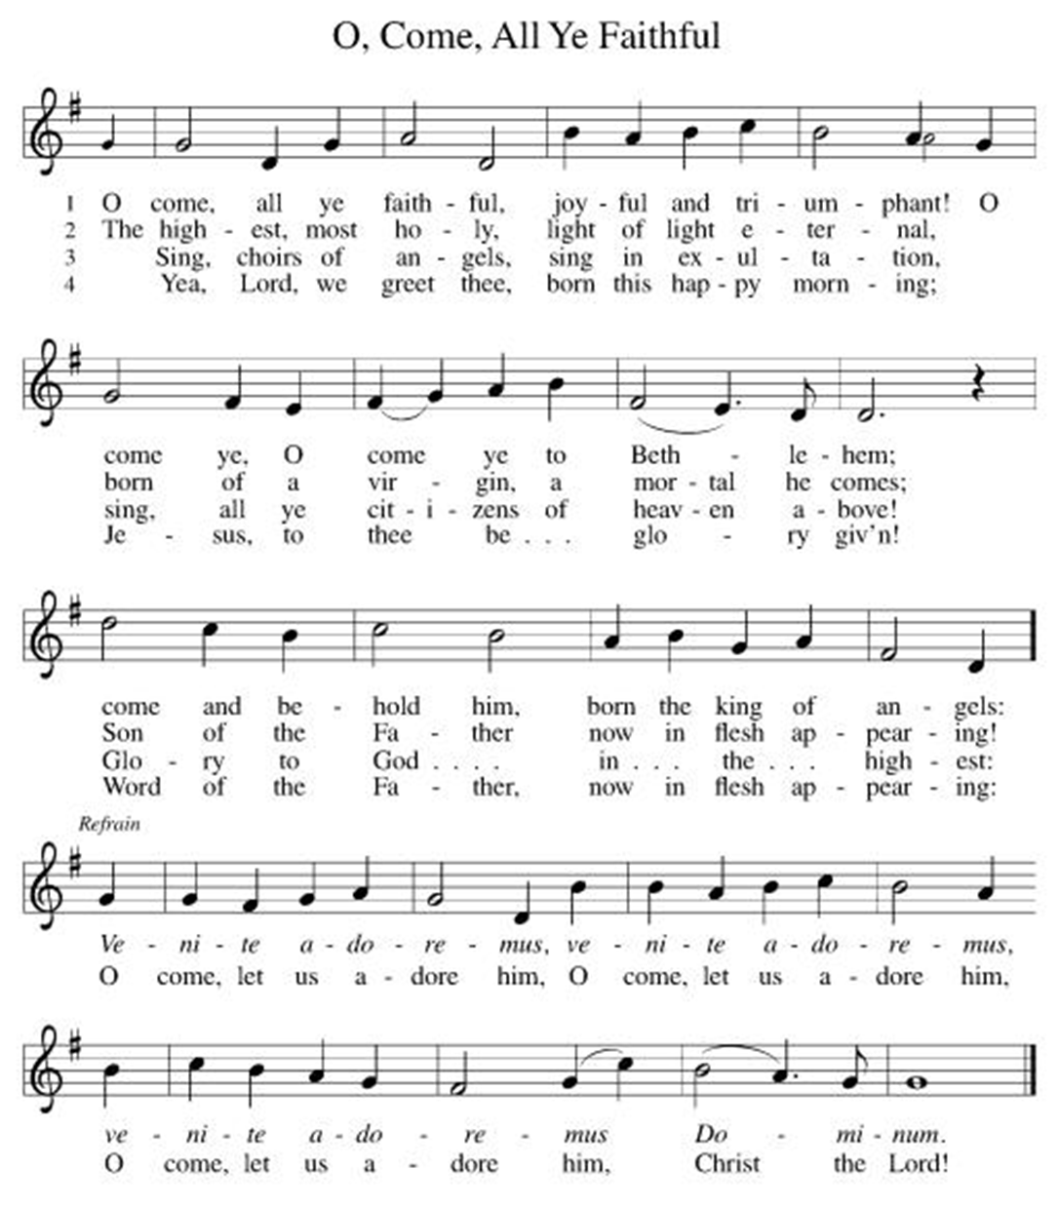
*Pastoral Greeting

P: The Grace and Peace of our Lord Jesus Christ, the love of God, and the communion of the Holy Spirit be with you all!

C: And also with you!

Hymn of Praise ELW 289 (v1)
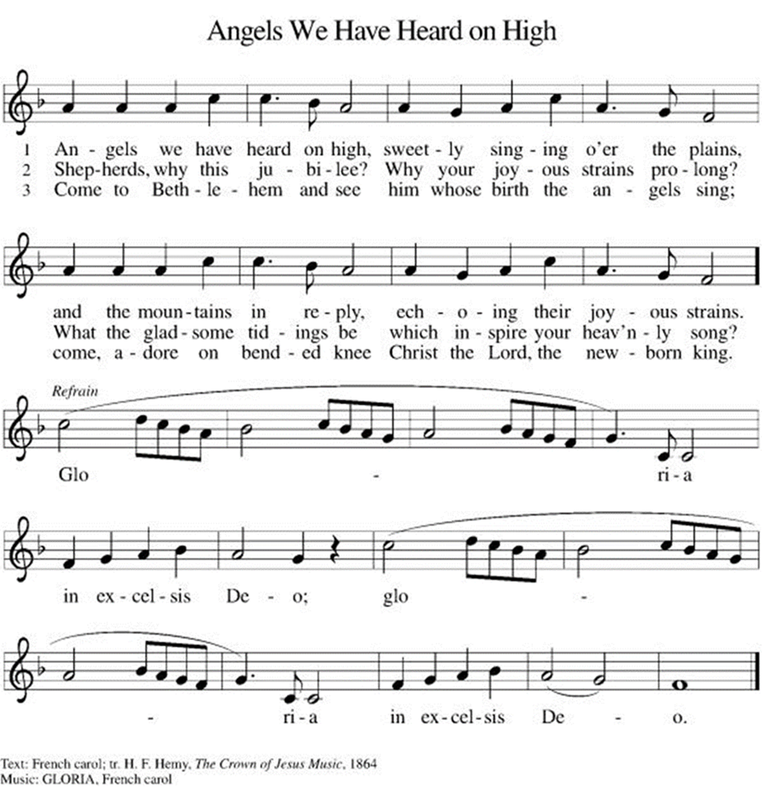

*Prayer of the Day
P: Almighty God, you made this holy night shine with the brightness of the true Light. Grant that here on earth we may walk in the light of Jesus’ presence and in the last day wake to the brightness of his glory; through your Son, Jesus Christ our Lord, who lives and reigns with you and the Holy Spirit, one God, now and forever. C: Amen!

+WORD+

First Reading: Isaiah 9:2-7
This poem promises deliverance from Assyrian oppression, a hope based on the birth of a royal child with a name full of promise. While Judah’s king will practice justice and righteousness, the real basis for faith lies in God’s passion for the people: The zeal of the Lord of hosts will do this!
² The people who walked in darkness
have seen a great light;
those who lived in a land of deep darkness—
on them light has shined.
³ You have multiplied the nation,
you have increased its joy;
they rejoice before you
as with joy at the harvest,
as people exult when dividing plunder.
⁴ For the yoke of their burden,
and the bar across their shoulders,
the rod of their oppressor,
you have broken as on the day of Midian.
⁵ For all the boots of the tramping warriors
and all the garments rolled in blood
shall be burned as fuel for the fire.
⁶ For a child has been born for us,
a son given to us;
authority rests upon his shoulders;
and he is named
Wonderful Counselor, Mighty God,
Everlasting Father, Prince of Peace.
⁷ His authority shall grow continually,
and there shall be endless peace
for the throne of David and his kingdom.
He will establish and uphold it
with justice and with righteousness
from this time onward and forevermore.
The zeal of the Lord of hosts will do this.

Psalm: Psalm 96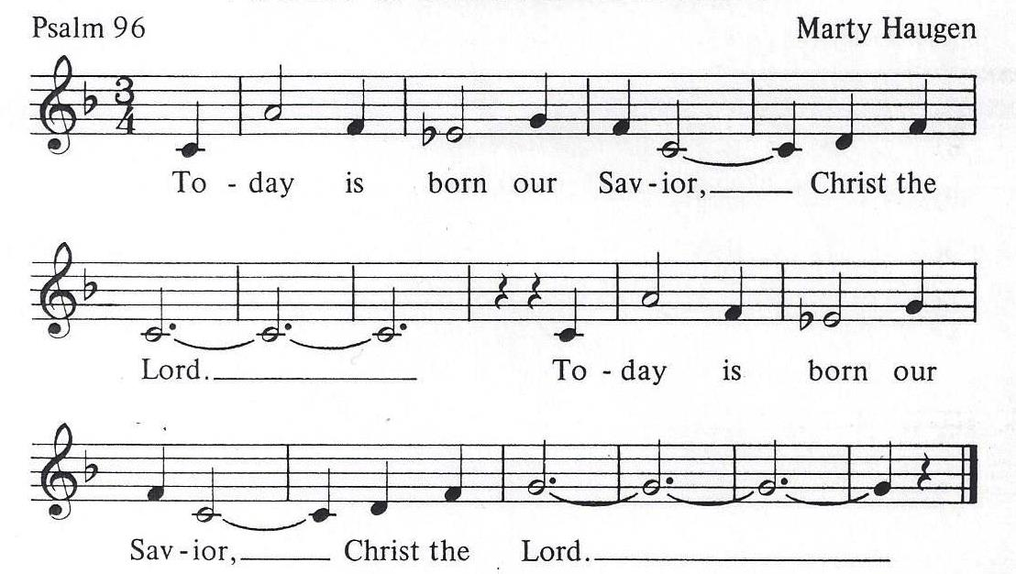
1. Sing to our God a joyful song!
Everyone bless God's name.
Tell of God's wondrous deeds
sing to all the world

2. Heaven be glad and earth rejoice,
let every ocean roar!
Every forest, every tree
joins the song of joy exclamationpoint point

3. Cry out with joy for God has come,
come, to rule the earth.
God will rule the world with love,
righteousness and truth

Second Reading: Titus 2:11-14
The appearance of God’s grace in Jesus Christ brings salvation for all humanity. Consequently, in the present we live wisely and justly while also anticipating the hope of our Savior’s final appearance.
¹¹ The grace of God has appeared, bringing salvation to all, ¹² training us to renounce impiety and worldly passions, and in the present age to live lives that are self-controlled, upright, and godly, ¹³ while we wait for the blessed hope and the manifestation of the glory of our great God and Savior, Jesus Christ. ¹⁴ He it is who gave himself for us that he might redeem us from all iniquity and purify for himself a people of his own who are zealous for good deeds.

*Gospel Acclamation (v.1&2)
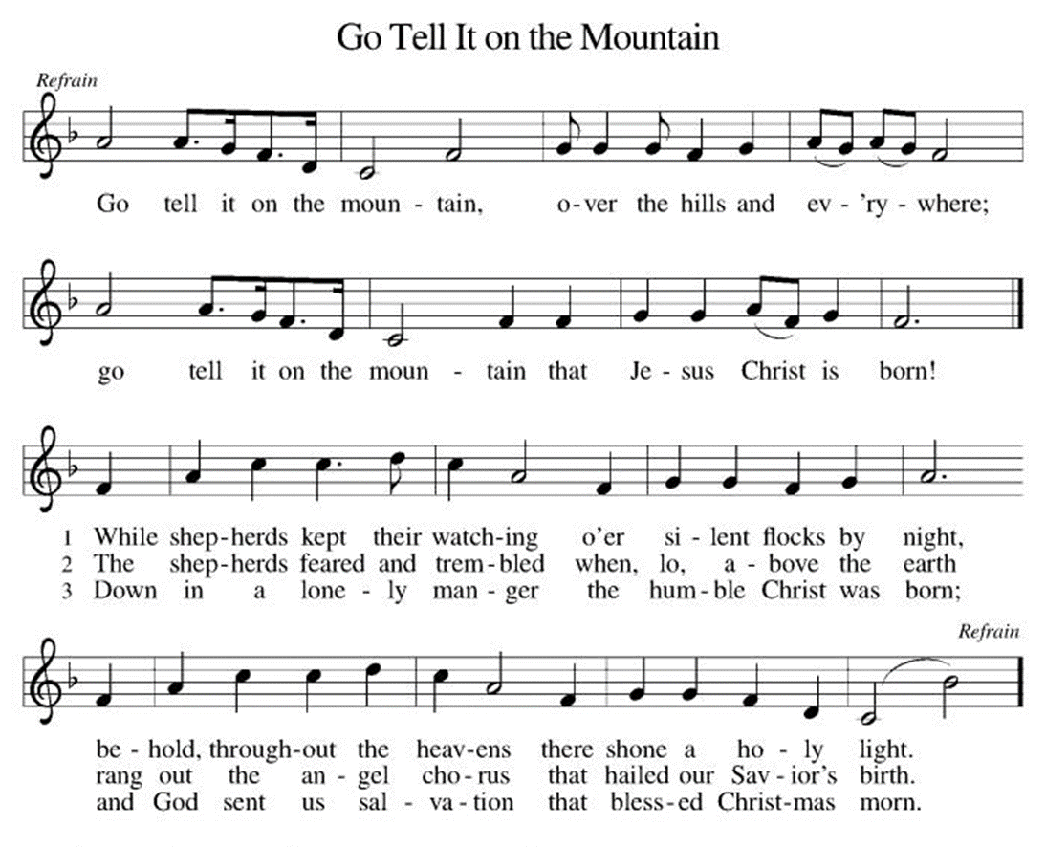
P: The Holy Gospel According to the St. Luke the 2nd Chapter
C: Glory to You, O Lord!

Gospel: Luke 2:1-14 [15-20]
God’s greatest gift comes as a baby in a manger. Angels announce the “good news of great joy” and proclaim God’s blessing of peace.
¹ In those days a decree went out from Emperor Augustus that all the world should be registered. ² This was the first registration and was taken while Quirinius was governor of Syria. ³ All went to their own towns to be registered. ⁴ Joseph also went from the town of Nazareth in Galilee to Judea, to the city of David called Bethlehem, because he was descended from the house and family of David. ⁵ He went to be registered with Mary, to whom he was engaged and who was expecting a child. ⁶ While they were there, the time came for her to deliver her child. ⁷ And she gave birth to her firstborn son and wrapped him in bands of cloth, and laid him in a manger, because there was no place for them in the inn.
⁸ In that region there were shepherds living in the fields, keeping watch over their flock by night. ⁹ Then an angel of the Lord stood before them, and the glory of the Lord shone around them, and they were terrified. ¹⁰ But the angel said to them, “Do not be afraid; for see—I am bringing you good news of great joy for all the people: ¹¹ to you is born this day in the city of David a Savior, who is the Messiah, the Lord. ¹² This will be a sign for you: you will find a child wrapped in bands of cloth and lying in a manger.” ¹³ And suddenly there was with the angel a multitude of the heavenly host, praising God and saying,
¹⁴ “Glory to God in the highest heaven,
and on earth peace among those whom he favors!”
[
¹⁵ When the angels had left them and gone into heaven, the shepherds said to one another, “Let us go now to Bethlehem and see this thing that has taken place, which the Lord has made known to us.” ¹⁶ So they went with haste and found Mary and Joseph, and the child lying in the manger. ¹⁷ When they saw this, they made known what had been told them about this child; ¹⁸ and all who heard it were amazed at what the shepherds told them. ¹⁹ But Mary treasured all these words and pondered them in her heart. ²⁰ The shepherds returned, glorifying and praising God for all they had heard and seen, as it had been told them.]

P: The Gospel of the Lord
C: Praise to you, O Christ!

Gospel Acclamation (v. 3)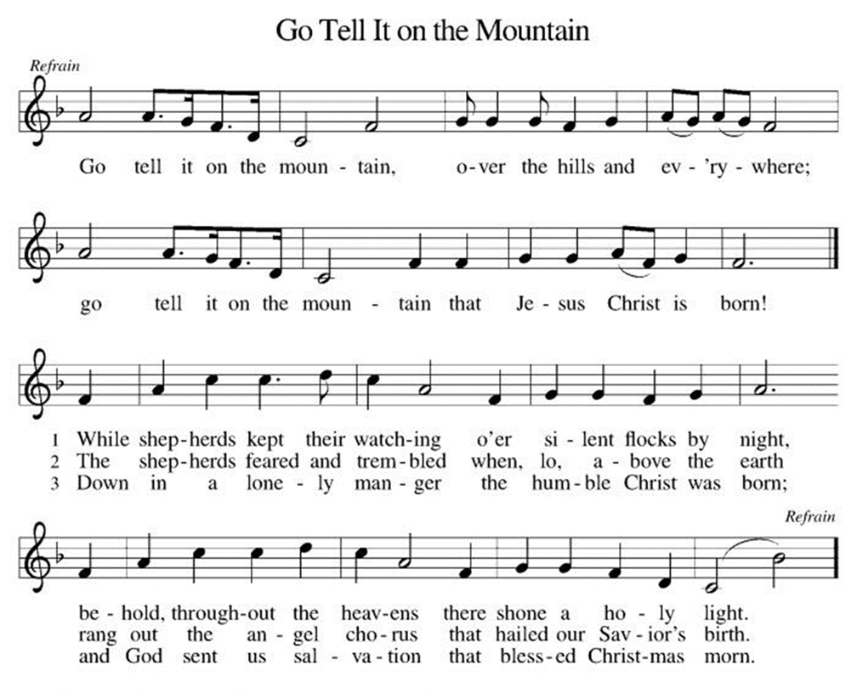

Sermon

*Hymn of the Day ELW 288 Good Christian Friends, Rejoice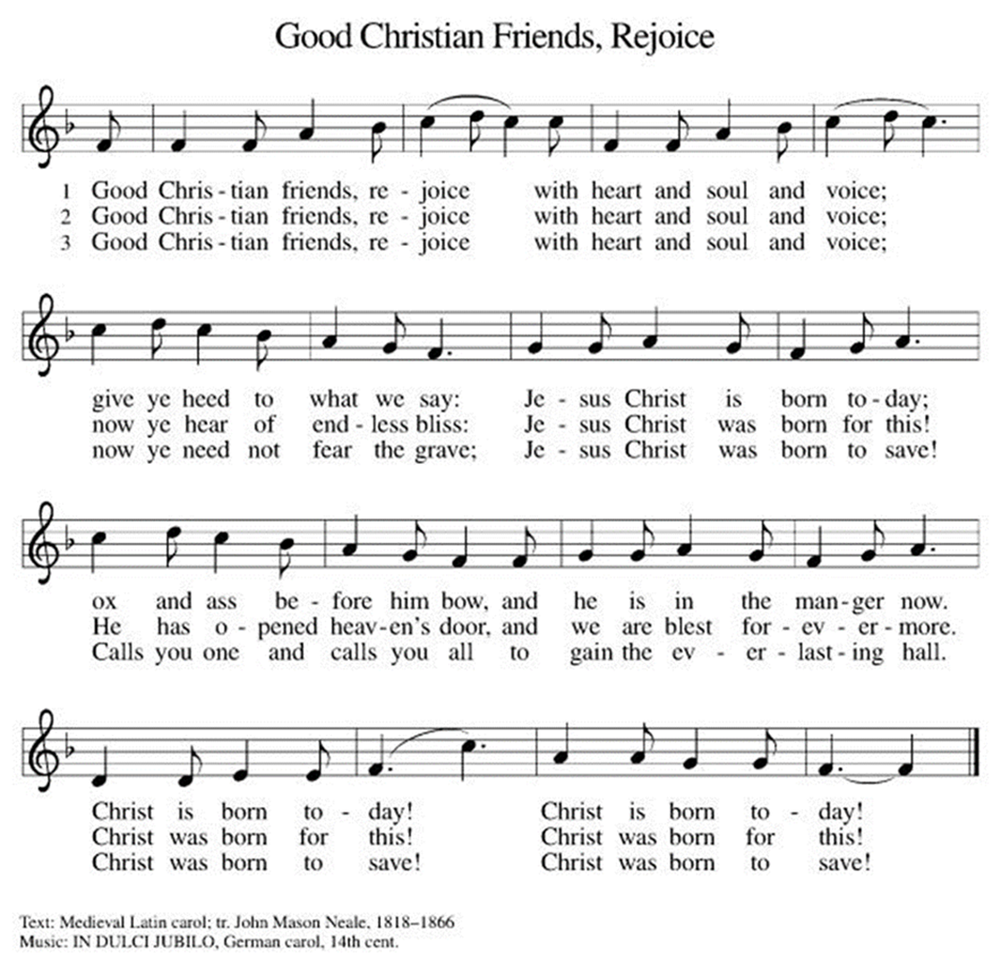

* Nicene Creed
We believe in one God,
the Father, the Almighty,
maker of heaven and earth,
of all that is, seen and unseen.
We believe in one Lord, Jesus Christ,
the only Son of God,
eternally begotten of the Father,
God from God, Light from Light,
true God from true God,
begotten, not made,
of one Being with the Father;
through him all things were made.
For us and for our salvation
he came down from heaven,
was incarnate of the Holy Spirit and the Virgin Mary
and became truly human.
For our sake he was crucified under Pontius Pilate;
he suffered death and was buried.
On the third day he rose again
in accordance with the Scriptures;
he ascended into heaven
and is seated at the right hand of the Father.
He will come again in glory to judge the living and the dead,
and his kingdom will have no end.
We believe in the Holy Spirit, the Lord, the giver of life,
who proceeds from the Father and the Son,
who with the Father and the Son is worshiped and glorified,
who has spoken through the prophets.
We believe in one holy catholic and apostolic church.
We acknowledge one baptism for the forgiveness of sins.
We look for the resurrection of the dead,
and the life of the world to come. Amen.

*Prayers of Intercession
Empowered by the news of Christ’s birth, let us pray boldly for the church, creation, and all who are in need.
A brief silence.
Gathering God, you bring your people from every corner of the earth together before the manger that you have made a throne. Unite the church in love as we rejoice in the news of your coming. Hear us, O God.
C:Your mercy is great.
Creating God, you brought forth the earth and all that is in it. Join our voices with the roaring seas, the exulting fields, and the trees of the forest singing for joy on this holy night. Hear us, O God.
C:Your mercy is great.
Transforming God, the world trembles amid violence and war. Empower our hands, feet, and hearts with your Spirit to shatter the rod of the oppressor and turn swords into plowshares (especially in . . . specific instances of conflict may be named). Hear us, O God.
C:Your mercy is great.
Shepherding God, you lead us to your love in the face of our neighbor. Send us into the world to find your Word made flesh in one another, especially those who are sick or struggling (especially). Hear us, O God.
C:Your mercy is great.
Nurturing God, you dwell with us in humble places. Sustain housing and clothing ministries in this community, that all find shelter and warmth. We pray especially for youth seeking safety and care. Hear us, O God.
C:Your mercy is great.
Here other intercessions may be offered.
Abiding God, you remain at the side of all the departed. Grant all who mourn hope in the resurrection and peace in Christ Jesus. Hear us, O God.
C:Your mercy is great.
With the joy of Christ’s birth in our hearts, we commend our prayers to you, O God, trusting in your boundless mercy and eternal love; through Jesus Christ our Savior.
C: Amen.

Greeting of Peace
P: The peace of Christ be with you and those you love!
C: And also with you! (The peace is shared with all!)

Offering (Thank you for your support for our ministry!)

Offering Hymn ELW 270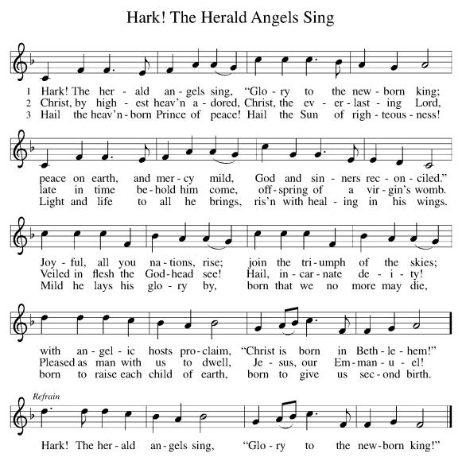

*Doxology ELW 275 Angels, From the Realms of Glory (v.4)
(Please stand and join in singing as we share our gifts!)
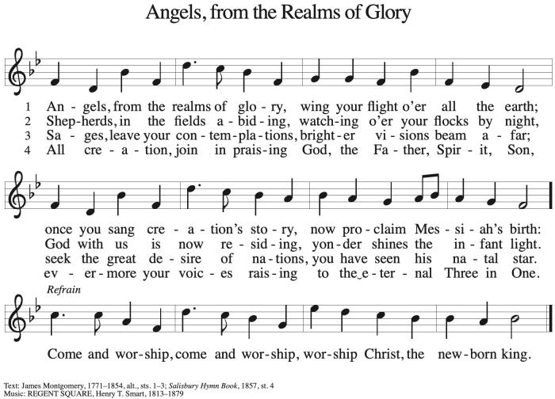

*Offering Prayer
A: God of heaven and earth,
C: from the beginning, you have called forth life,
in which you take delight.
The trees, the fields, and the seas sing for joy.
Bless now these gifts, received from your bounty,
that we may join the chorus of creation
to tell of your salvation from day to day.
Amen.

+MEAL+
(All are welcome at the table of our Lord!)
*Great Thanksgiving
P: The Lord be with you.
C: And also with you.

P: Lift up your hearts.
C: We lift them to the Lord.

P: Let us give thanks to the Lord our God.
C: It is right to give our thanks and praise.

P: It is indeed right, our duty and our joy,
that we should at all times and in all places
give thanks and praise to you, almighty and merciful God,
through our Savior Jesus Christ.
In the wonder and mystery of the Word made flesh
you have opened the eyes of faith
to a new and radiant vision of your glory,
that, beholding the God made visible,
we may be drawn to love the God whom we cannot see.
And so, with all the choirs of angels,
with the church on earth and the hosts of heaven,
we praise your name and join their unending hymn:
*Sanctus
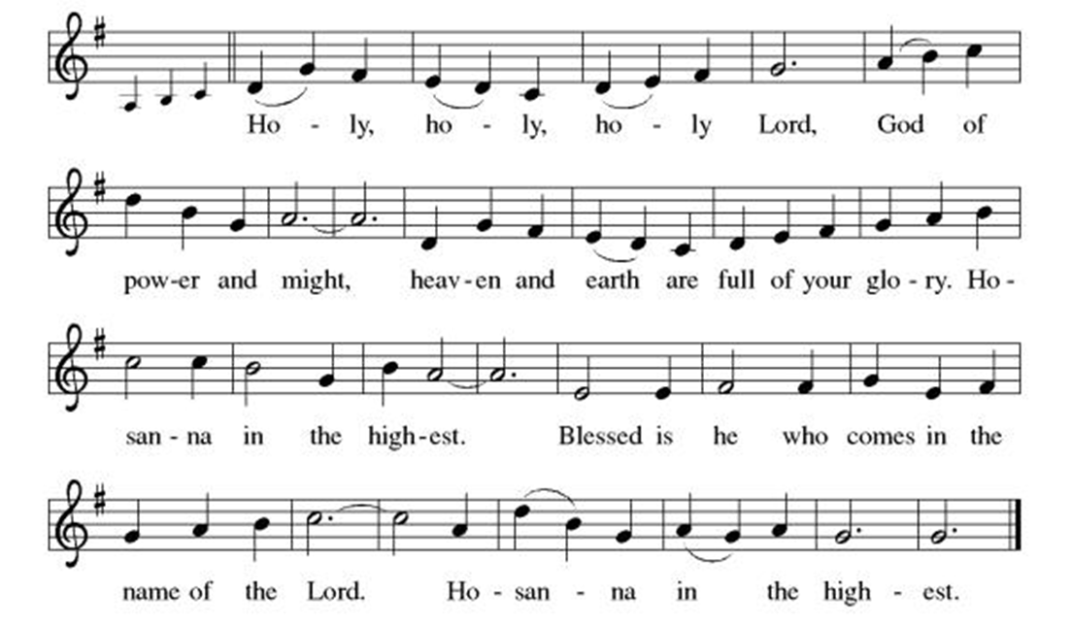
P: In the night in which he was betrayed,
our Lord Jesus took bread, and gave thanks;
broke it, and gave it to his disciples, saying:
Take and eat; this is my body, given for you.
Do this for the remembrance of me.

Again, after supper, he took the cup, gave thanks,
and gave it for all to drink, saying:
This cup is the new covenant in my blood,
shed for you and for all people for the forgiveness of sin.
Do this for the remembrance of me.

Through him, with him, in him, in the unity of the Holy Spirit,
all glory and honor is yours, almighty Father, now and forever.
C: Amen!

*THE LORD’S PRAYER
Our Father, who art in heaven,
hallowed be thy name,
thy kingdom come,
thy will be done,
on earth as it is in heaven.
Give us this day our daily bread;
and forgive us our trespasses,
as we forgive those
who trespass against us;
and lead us not into temptation,
but deliver us from evil.
For thine is the kingdom,
and the power, and the glory,
forever and ever. Amen.

*Lamb of God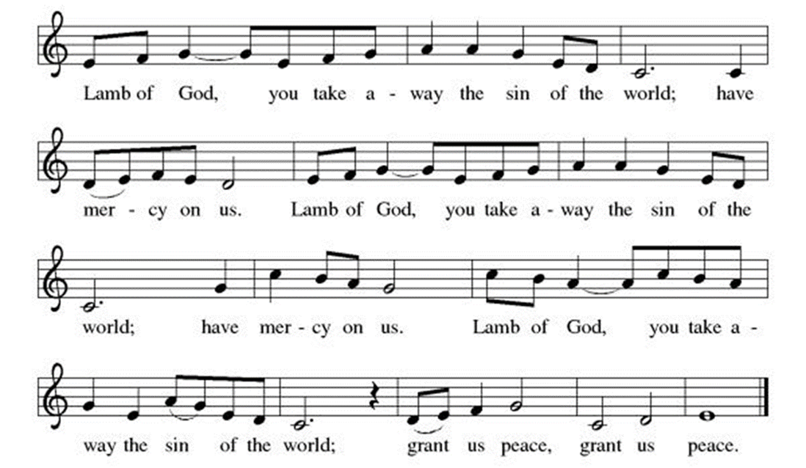
Spiritual Communion Prayer
P: Let us pray for the communion of all present here, those viewing our service virtually, those in our hearts and in our world.
C: Lord Jesus, I believe you are truly present in the Sacrament of Holy Communion. When I cannot receive Communion, I pray that you come into my heart. I know that nothing in Heaven or on earth can separate me from your love. Amen.

Invitation to Communion
P: God is now in flesh appearing.
Come to the feast of joy!
C: Thanks be to God.
(All are invited to the communion rail following the guidance of the ushers. Communion will be shared through the host and individual cups. If you would like communion but are unable to join us at the rail, please alert the usher!)

Communion Hymns (Please join in singing!)
ELW 277 Away in a Manger 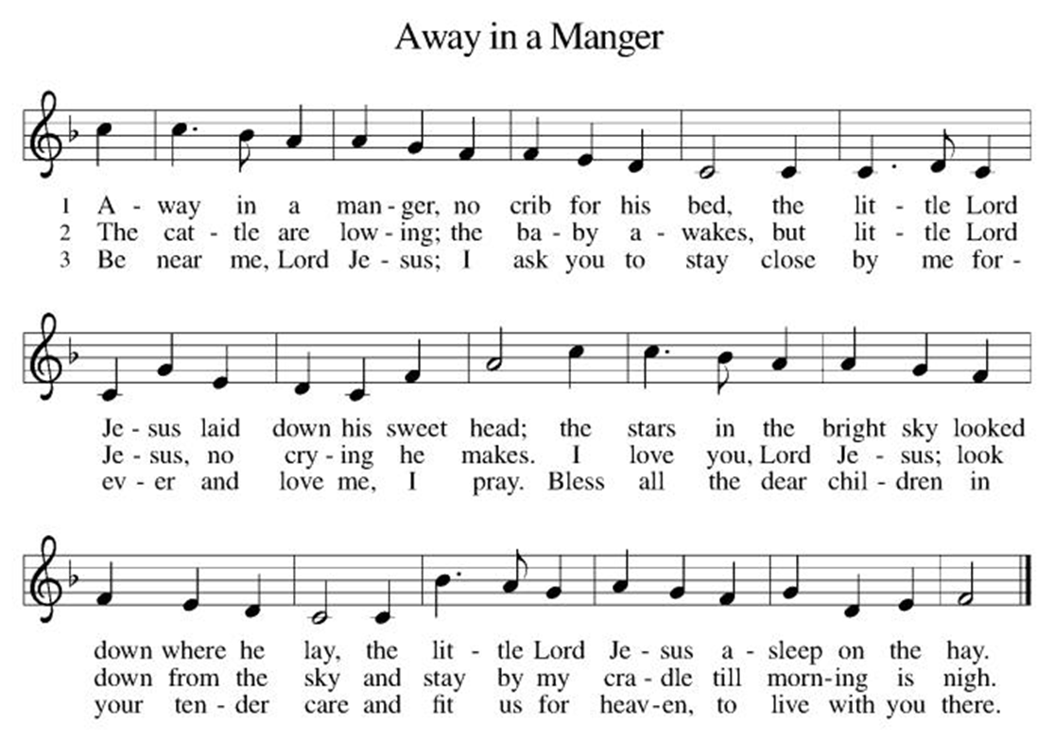

ELW 282 It Came upon the Midnight Clear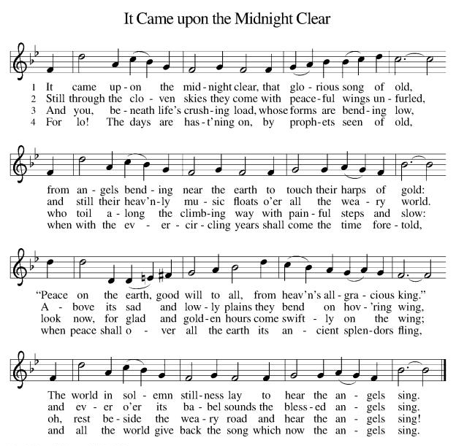
ELW 279 O Little Town of Bethlehem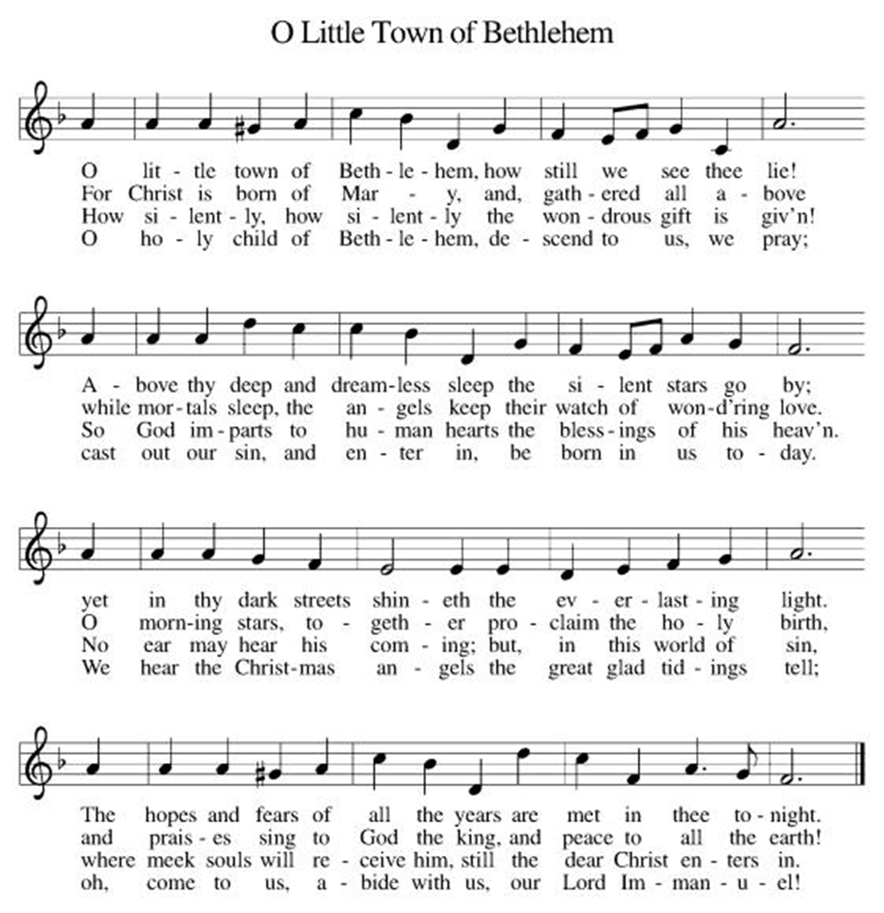
P: The body and blood of our Lord Jesus Christ strengthen you and keep you in his grace. C: Amen!

*Prayer after Communion
A: Incarnate God, you are among us at this table.
May we treasure this gift and ponder in our hearts
the mystery of your presence.
Move us to discover the wonders of your love
in the everyday moments of our lives,
through Christ born in us.
C: Amen!

Candle Lighting ELW 281 Silent Night, Holy Night (English)
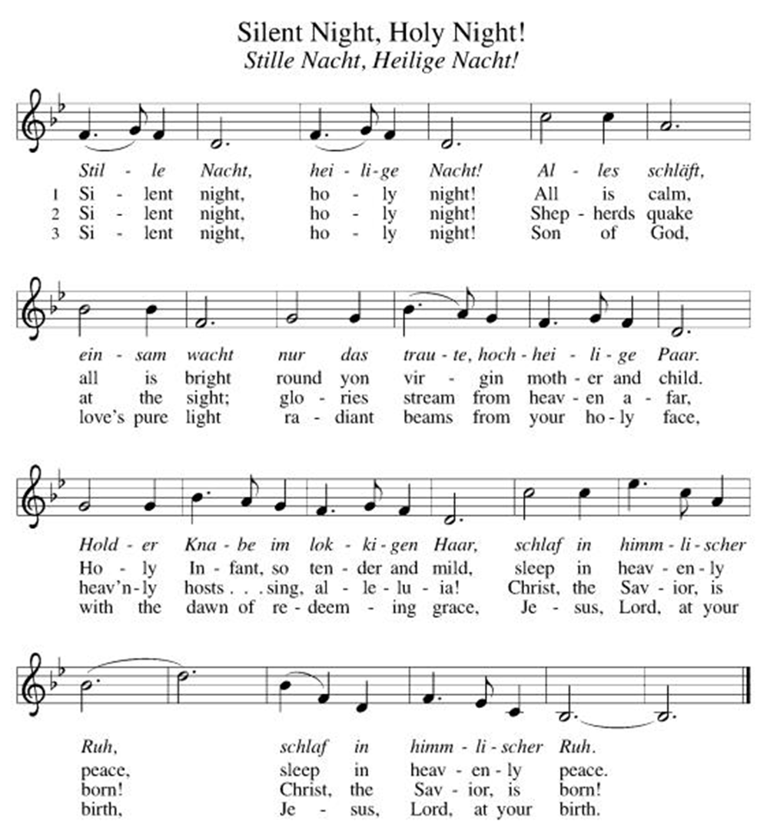

+Sending+

*Blessing
P: The triune God,
glorious Mystery,
holy Incarnate One,
abiding Comforter,
☩ bless you with endless grace, peace, and joy.
C: Amen!
*Sending Hymn ELW 267 Joy to the World
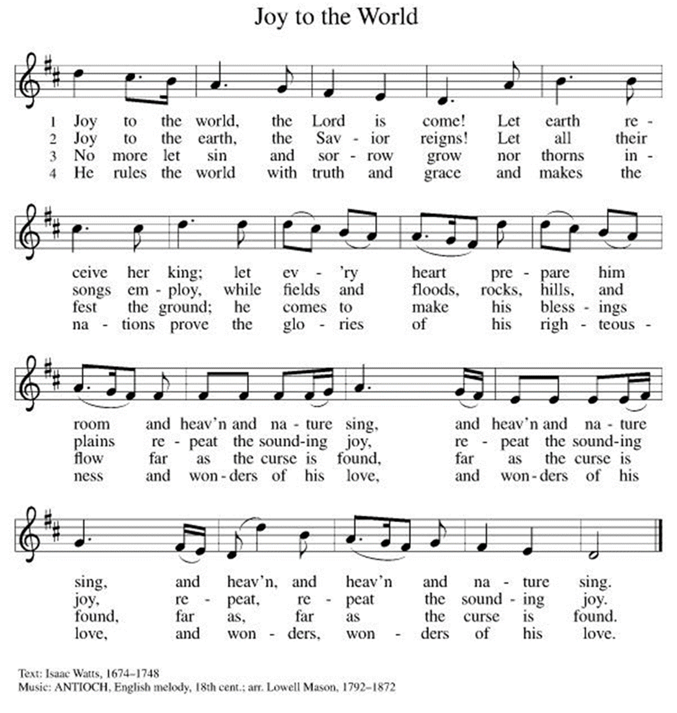
*Dismissal
A: Glory to God in the highest!
C: And peace to God’s people on earth!
A:Go in joy. Embody God’s redeeming grace.
C: Thanks be to God!
Postlude
(Thank you for listening to our musicians & your support!)

Copyright © 2020 Augsburg Fortress. All rights reserved. Reprinted by permission under Augsburg Fortress Liturgies Annual License #SB106907. New Revised Standard Version Bible, Copyright © 1989, Division of Christian Education of the National Council of the Churches of Christ in the United States of America. Used by permission. All rights reserved. Revised Common Lectionary, Copyright © 1992 Consultation on Common Texts, admin Augsburg Fortress. Used by permission.
Treasurer’s Report
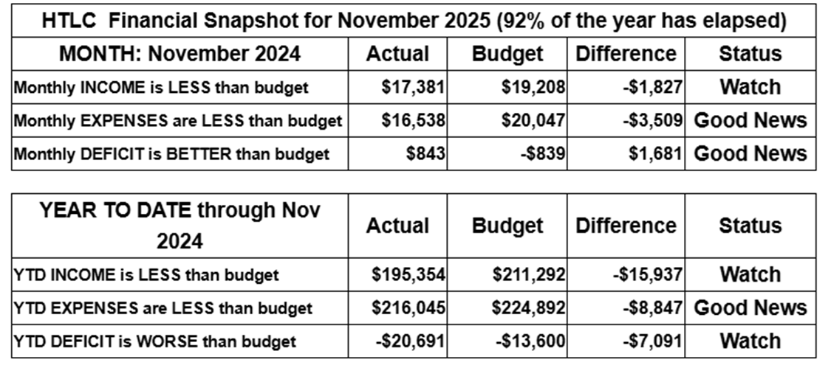
November giving improved over that of October, but still is short for the year to date. Expenses remain under control, but we rely on strong giving in December to maintain stability and support our ministries. Gifts above and beyond regular giving will help us build a growing, healthy church. Thank you for your generosity.
Thank you for supporting our ministry! Chris Foard, Treasurer
Worship Volunteer Schedule
Date | Asst. Min | Usher | Sacristan | Lector | Counter
December 28 | Linda Coleman | Dan Grillon | Helga Britton | Cynthia Kazmac | McKenna/Kazmac
January 4 | Keith Bennett | Gary Joblon | Joanne Giordano | Jeff Ridberg | Foss/Coleman
January 11 | Chris Foard | Kathy Caputo | Sherry Lee | Rosemary Lane | Socha/Foard
January 18 | Elaine Bradford | Dan Grillon | Carol Rosen | Emily Kaster | Bohner/Volk

ANNOUNCEMENTS Thank you! To all who consistently support our church and ministries through your time, talent, and treasure. Please help us grow by inviting your friends and family to worship and events. You are what makes Holy Trinity a wonderful church family!

Stay in touch! Please visit our church website, www.htlcredbank.org for updates and information. You can also find us on Facebook and view services online. The office is open from 9am to 2pm, Monday to Thursday.

100 Anniversary Committee- If you are interested in being a part of the committee to help plan the 100th anniversary celebration of HTLC in 2028, please sign up in the red book. All are welcome! Also, the committee will be looking for photos and documents of HTLC throughout the years. If you have anything to share, please bring them to the church and marked envelopes or email electronic copies to the church office.

Name Tag Sundays: On the first Sunday of each month, names tags and markers will be at each entrance of the sanctuary. Please fill out a tag and wear one for worship and for coffee hour to welcome visitors and help newcomers put names to faces.

Choir The Holy Trinity Choir welcomes our singers back for a preparation rehearsal on Sunday, September 7th at 9am in the church hall. All are welcome to join us in song as often as you are able. Choir meets each Sunday at 9am to practice and prepare our music. Join us and help us grow by spreading the word about the HTLC Choir!

Blood drive Tuesday January 6, 2026, noon to 6 pm
On Tuesday, January 6, 2026 we will be hosting a blood drive here at Holy Trinity from Noon to 6pm. Donors, mark your calendars! If you cannot donate, please recruit from among your friends and family. This day marks Epiphany, ending the Christmas season, so let's give a final gift -- of life!

Quilting- The Quilters need gently used any bed sheets of any size! Please leave any donations in the quilters closet in Fellowship Hall. Thank you!

Weekly Quilting on Wednesdays at 9:30. Bring your lunch and enjoy some fellowship at noon. All are welcome. There will be no quilting on Wednesday September 24 due to the garage sale set up.

Evening Quilting Evening Quilting –
Please share this information . This is an important ministry that helps so many. It’s very easy and you don’t need to know how to sew. We have a great time socializing too! We will meet:
Jan. 21, Feb. 18, March 18 at 6:00 PM. Note: If we have to cancel I will send an email. Please let me know only if you can come. Contacts: Pat Pienkos 732-513-9615 Debbie Yetka 908-461-4084 Looking forward to seeing you all!

Bagels and Bible- In January 2026 we will be starting the video lecture series The Great Courses: Confucius, Buddha, Jesus, and Muhammad. We will meet in the Parish House and watch a 30 minute video that will be followed by a group discussion. In an attempt to find a time that works best for most we are soliciting your preference for one of the following days/times:
Saturday mornings at 8:30am Or Sunday mornings at 9:00am. Please make your preference known by signing up in the Red Book. If you have any questions please email Rosemary Lane, rrlane13@gmail.com

Social Ministry
CPC Thanksgiving Dinner
We celebrated another joyful Thanksgiving dinner with 45 CPC clients and staff the Wednesday before Thanksgiving! Thank you to all the volunteers that helped make this happen and run smoothly including shopping, decorating, setting up, cooking, serving, and clean up! With the help of Thrivent in Action grant money, we were able to provide this dinner which means so much to the gracious CPC clients. HTLC has been hosting this dinner since 1983 and we hope to keep the tradition going!

*Year-round collections will continue for food items for Lunch Break. There is a sign-up sheet in the red book for those who can help drop these items to Lunch Break.
*We will also collect adult men's socks to periodically drop at the Red Bank Warminq Center.
*For those interested in the Heartwarminq Center — the new women's shelter is adjacent to the First Baptist Church of Red Bank at 90 Maple Ave. You can follow up on this mission through their website - https://www.thefeastnj.org- On this site, they also include wish list items that can be purchased through amazon. We will be exploring purchasing some of these through a Thrivent card. If you want to purchase on your own, you can leave items at church, and the Social Ministry will deliver them.

Pastoral Care and Prayer... We are here to care for and pray! Please contact the office to add or adjust prayer requests. If you or someone you know needs pastoral care, please contact the office and Pastor Mack!

THANK YOU for supporting and sustaining our church and ministries! All are welcome here! Please invite your family and friends to worship with us! Find us online at www.htlcredbank.org

Poinsettia Donations
The Busch Family | Johanna, Herman and Barbara Pluschau  Margaret, August, and Herbert Busch
Linda Coleman | Merry Christmas!
Linda and Mark Csernica | In honor of our children and grandchildren
The Doyles | Greg, Carly, Theo and Clara
The Foards | In memory of loved ones.
The Grillon Family | In celebration of the Christmas season.
Bruce and Rosemary Lane | In memory of our parents.
Lisa Lynch | In memory of Robert Coppotelli.
Pat and Jeff Pienkos | In celebration of our granddaughter Matilda born 10/21/2025
Carol Rosen | Glory of God.
Peter and Elaine Theophall | In celebration of Christ’s birth and our family.
Linda Vacca D’Amico | In memory of parents Joyce & Erwin Taper



