Nicaragua Mission Trip – Day 5 update, (Jan 7, 2026)
Greetings again from Nicaragua.
Thank you for your prayers, we could see a lot of things coming together by God’s divine grace.
The exterior of the home was completed today. The house has windows, a door that can be locked, and a cement floor that is above the current grade so the house stays dry during the heavy rains.
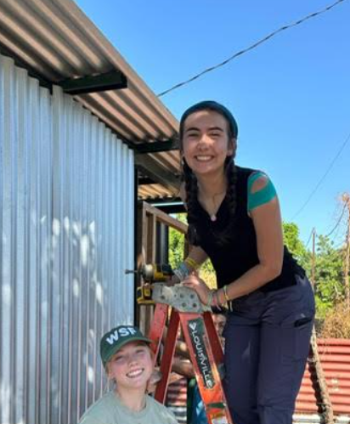 | 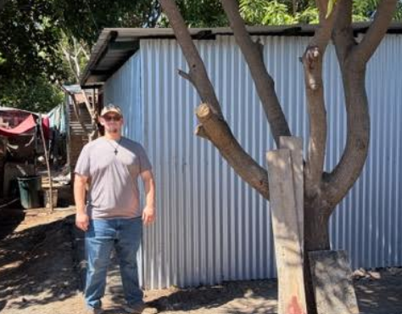
What’s hard to envision is the step function improvement in living conditions this family will experience in one day. Tomorrow they will have a roof that does not leak and metal sides and poles replacing their current rotting structure. Their bed that is broken and the mattress that is rotted from moisture will be replaced. A cement pad will replace their dirt floor which remains wet for 6 months out of the year. They will have a table with chairs, which they don’t have today, and a 2 burner stove (via propane) replacing their metal tin for cooking. Below is their current home and the coals where they cook.
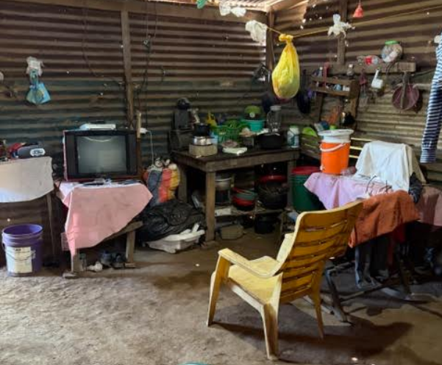 | 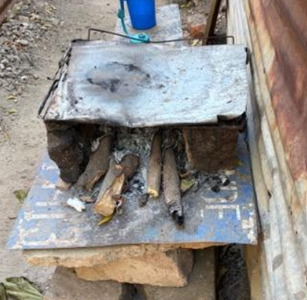
Tomorrow we will give them the keys to their new house. It’s always an exciting and sobering time.
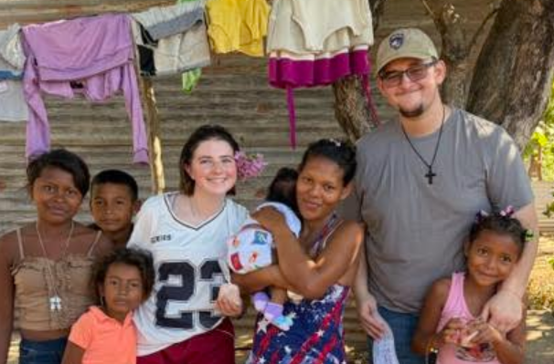 | Door to door was amazing as always.  There were many prayers offered to various homes for health and family. Signs on homes were put up. We had a young girl, 15 years old with a set of twins, hear the Gospel but did not want to accept today.  We also had one lady (holding her baby) trust Christ today (picture here between Autumn and Evan).

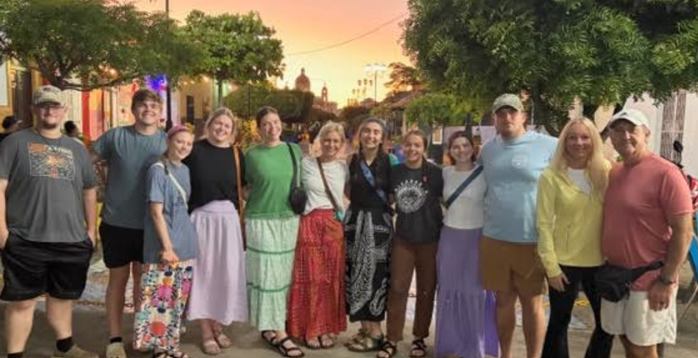 | The team is doing great and very bold in sharing their faith and getting their hands dirty to help anyone in need.  Last night we went into Granada for some awesome brick oven pizza.  It’s an amazing old Spanish town that is rich in history.

Friendships and connections are growing each day.
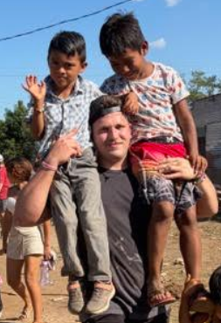 | 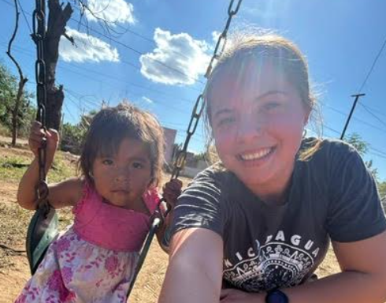 | 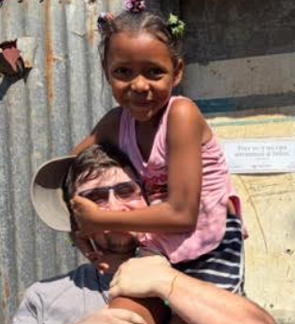

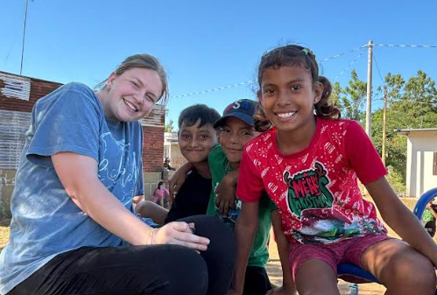 | 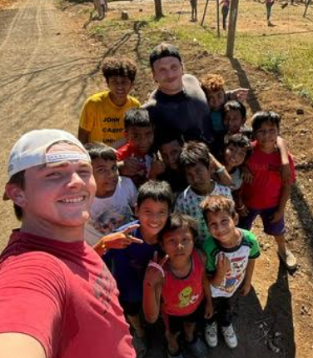 | 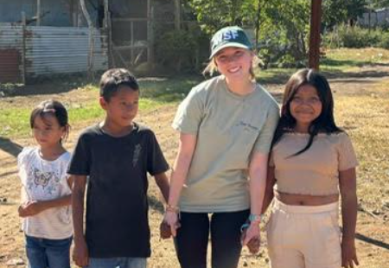

VBS got kicked out again this afternoon to the outside Sunday School room given the size of the adult discipleship (100+). But, VBS was packed…and a little warm
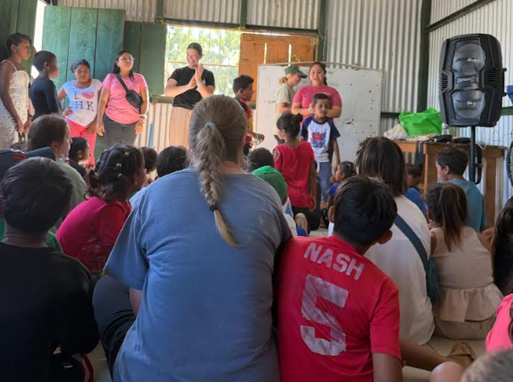 | 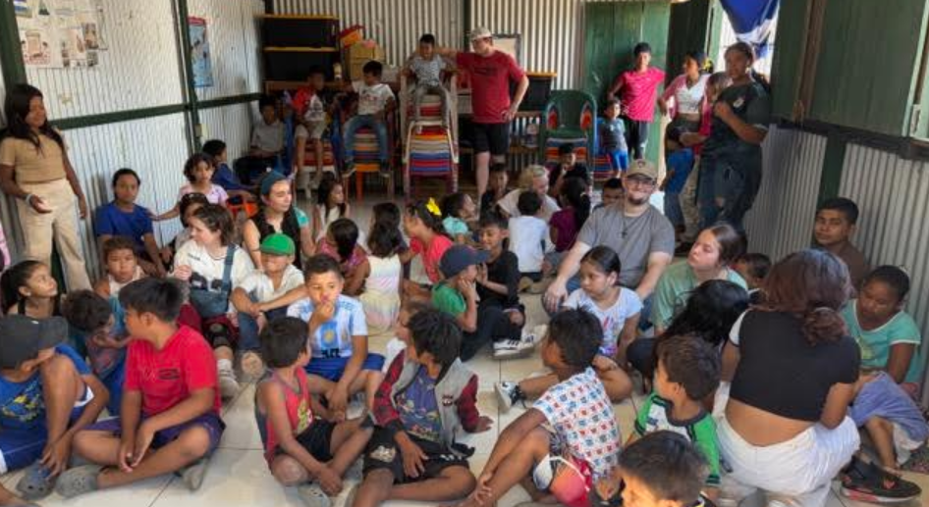

With adult discipleship, I taught on the “blessedness of God” (Matt 5, Psalm 1, Psalm 23). How blessedness is available now (a state of being), it follows obedience, and God’s blessings follow us. We don’t chase God’s blessings, they chase us, when you live for Him. We had one man trust Christ today during this teaching, Praise God! We also have had many more return to church who were not coming, partly due to us going door to door to pray, encourage, and share the Gospel.
When we leave each day, the scene is the same. A community coming together to hear the Word of God. Experiencing true fellowship in the name of Christ. Being encouraged and challenged to live for Him. And with laughter, enjoying each other’s company and friendship.
They may only be a street apart but without the church coming together, some may never see each other. The fellowship is great to see and is a healthy reminder to all of us.
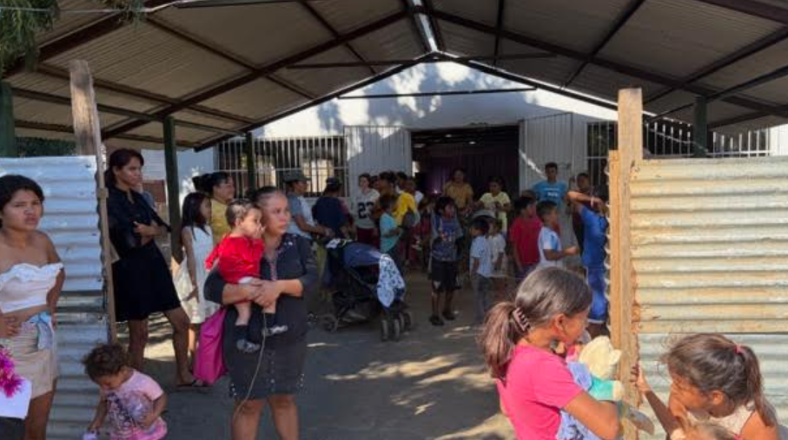

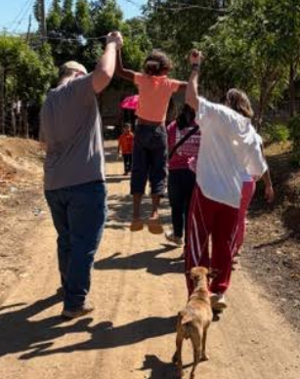 | We’ve been to this community for about 5 years. Many in the church recognize us immediately. Today I had a young man wave to me and ask, do you remember me? I said, yes. Then he asked, what is my name? I told him his name, and that he still needs to get baptized (He trusted Christ 2 years ago). He smiled and was grateful. Whenever we greet them by name, know where they live, or just give a hug, they know you care. And in this environment, just like in the days of Christ, a little compassion goes a long way.  This picture is a reminder that when we are His hands and feet, having compassion on the least of these, it lifts them up in many ways.

Tomorrow is our last day of ministry. We will be BUSY, BUSY, BUSY….furnishing then dedicating the house. There will be some quick “door to doors” to invite people to the church; I will give a short message; we will then do a community feeding and have some painful goodbyes to many brothers and sisters in Christ.
Please pray that all the logistics go well tomorrow, that more lives are saved, needs are met, and our Lord is honored. We are grateful for your prayers. And please remember the people of Carlos Fonseca.
May His face shine upon you and be gracious to you
Pastor Chris

