Nicaragua Mission Trip – Day 2 update, (Jan 4, 2026)

Greetings from Nicaragua,
We worshipped today at the church in Carlos Fonseca. When the church first started, they met under a tree. Over time, a wood frame church was made. Then a metal structure was built (pictured below). But the church kept growing.
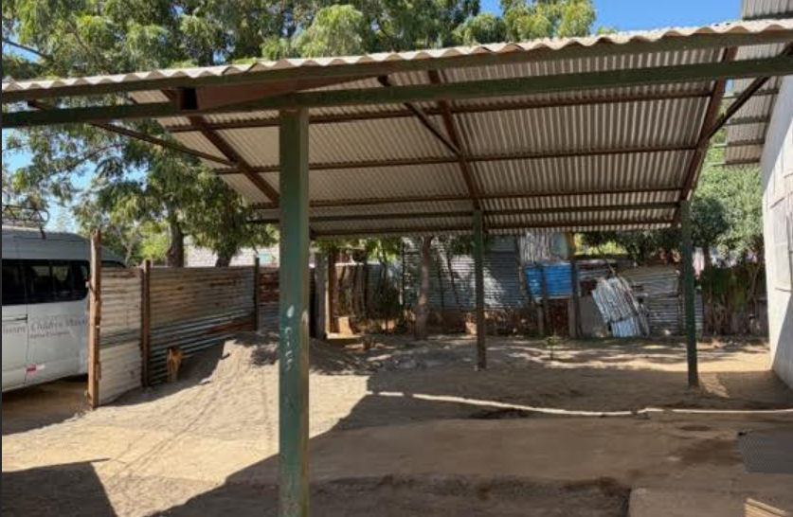
Now the old metal church is the entrance to the current church.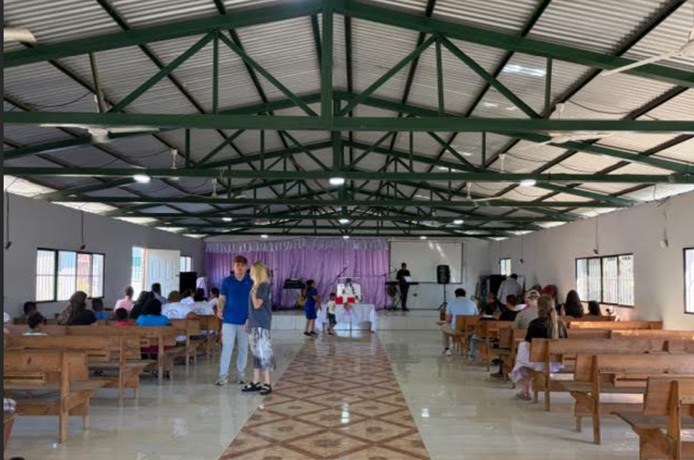
There was just over 100 today at church with 30+ kids. All heard Michael’s testimony, then the kids went to kids’ church.
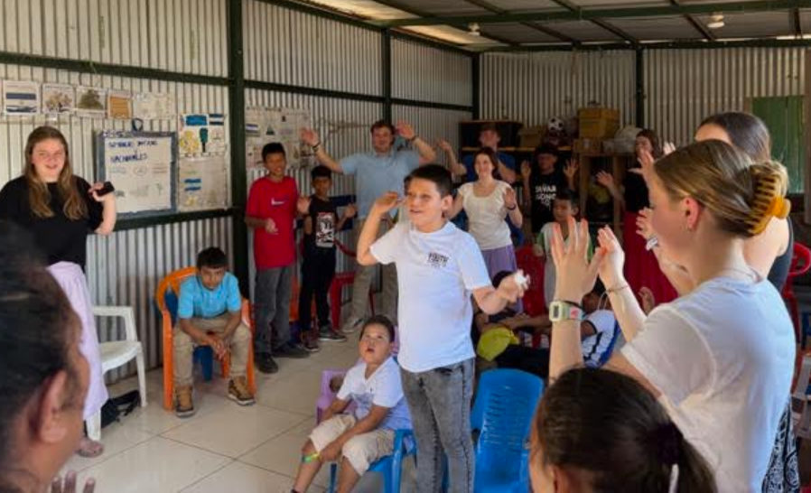
The adults heard the message on Finishing Strong from Hebrews 12. There were 2 who trusted Christ and many asked for strength from God in finishing their race strong for Him.
As always, many relationships were instantly formed.
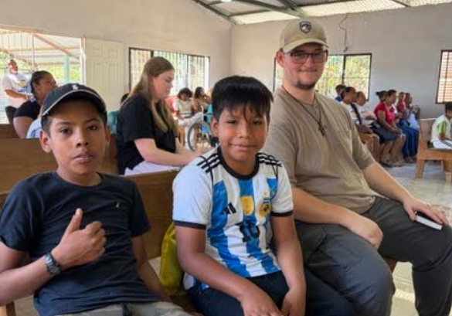 | 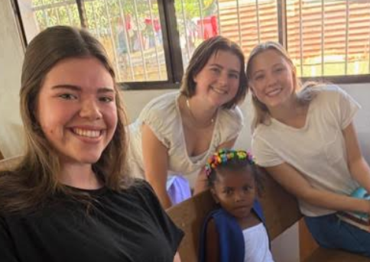
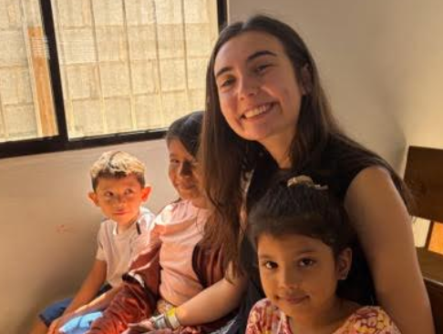 | 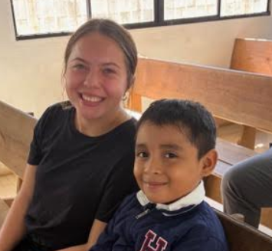

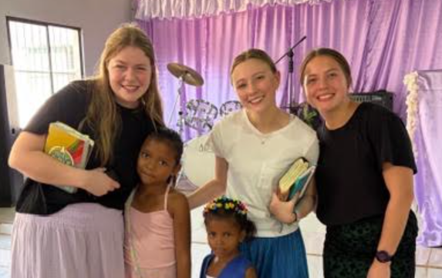
We also got the lay of the land relative to where we will be building the house for someone in the congregation and activities for the week. Each day will start early with home construction and 2 teams doing door to door evangelism. We will be inviting people to VBS and adult discipleship at 1pm, which will go to about 3pm each day. On Thursday, we will be doing a community feeding which will be a real blessing to many.
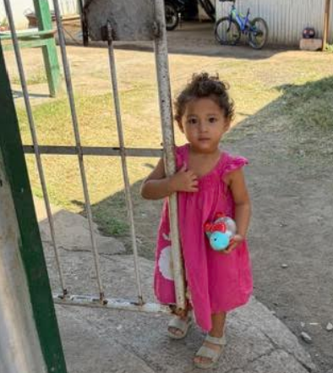 | The picture of this little girl helps paint some of the picture here.  In the Carlos Fonseca barrio there is extreme poverty, unemployment, mainly women with children, some churched, but many are not.  Children who are sponsored by someone through Chosen Children receive food for each month, supplies for school, and bible instruction as long as they attend classes every Saturday at the church.  Discipleship is instrumental, especially when they’re young, so children sponsorship is stressed in the communities.
In today’s sermon we learned about the race we are in (Hebrews 12). Not everyone who starts the race finishes it. Many want to quit because the race is hard. Hebrews 12 is written for those who are tired and worn out.
There are two sure signs of a tired runner in a race; their hands drop and their knees wobble. His Word tells us to “strengthen” our hands that hang down and our feeble knees (Heb 12:12). Runners need to keep their hands up (near the heart) for blood flow and pick up their feet so they don’t trip. Spiritually, when our hands drop, this means God is no longer the center of our lives. We need to bring Him to the center and do things in service for Him like we used to. When our knees wobble, it means we tend to drag our feet, which implies tripping. We need to pick up our feet so we don’t trip in sin. Moreover, in this race, we are to “Pursue peace with all people, and holiness, without which no one will see the Lord” (v14). In this race, we should not have unresolved anger or sin, but living pure, holy, devoted lives. Finishing is important, but how we finish is more important, and that implies living holy lives.
As you consider your own race, please keep in mind those here in Nicaragua who are tired. There are some great faithful saints down here that are under some tough circumstances. Please pray for them that they would continue to seek God’s strength, as many acknowledged that today. Also pray for the ministry down here (Chosen Children) as they have planted 28 churches through the years in barrios where the forgotten and marginalized are hearing and walking in the truth. But at the same time, we have witnessed those who have started the race but are no longer in it. Please pray for them to come back to church, to finish strong, for our Savior.
We covet your prayers. We know our Lord hears. The effort picks up greatly tomorrow as we spend full days in Carlos Fonseca. Please pray for His strength for us, guidance, favor, and anointing as we play with kids, build a house, go into homes with dirt floors to share the Gospel, teach adults, and conduct VBS for so many. Pray for our team that we hear from God, grow, and leave changed, being even more aligned to His will for our lives and where He has us planted. We are grateful for the opportunity and your prayers as He guides and uses us.
Until tomorrow….Finish Strong and Finish Faithful
Pastor Chris

