Nicaragua Mission Trip – Day 1 update, (Jan 3, 2026)

Blessings to all from Nicaragua,
We made it! Praise God! Our team of 12 met up in Miami from 3 different locations (Virgina, Atlanta, and Daytona Beach), arriving safely today in Nicaragua. (Picture taken from Miami Airport)
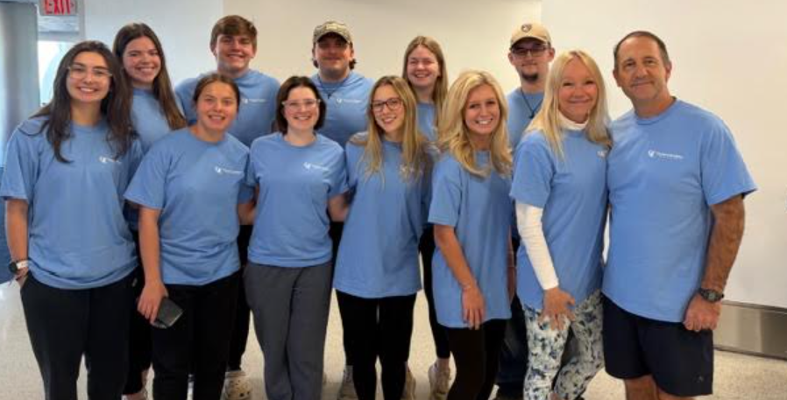
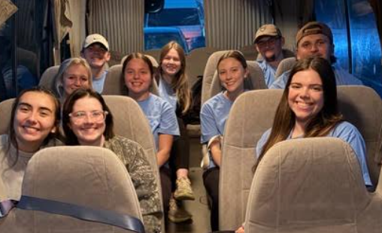 | The flight was great and all customs processing went smooth, no issues.  After a 45 minute bus ride to the Mission house, we got some lunch.
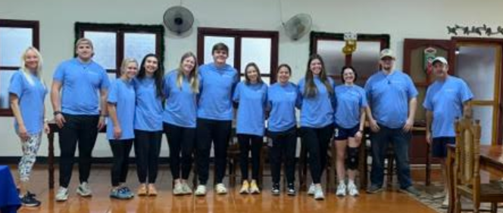 |  | (Picture taken inside the meal hall of Chosen Children’s Ministry)

Some enjoyed a quick break while they got the chance
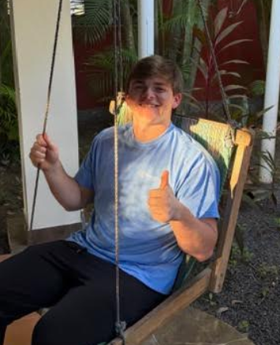 |  | 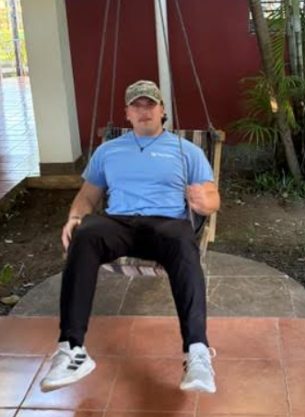
We then took a look at Masaya Volcano, which is active but has been smoldering for years | 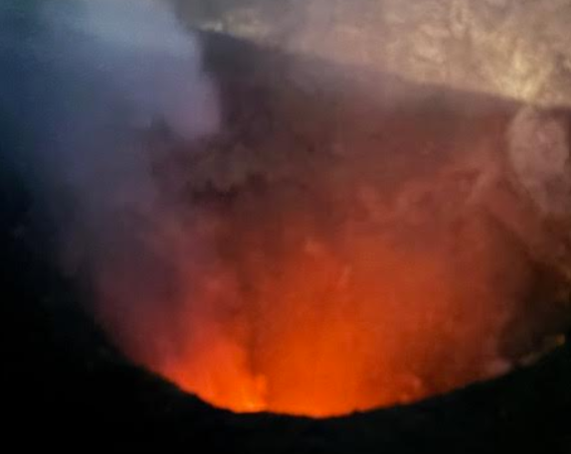

This is by far the lightest day in just trying to get here and get settled. Tomorrow we leave for church at 9am and will worship at Carlos Fonseca, a community we have been working in for multiple years now. We’ve seen this church grow from an open air experience to a building where 120 adults and 30 kids should meet us tomorrow. The message tomorrow will be from Hebrews 12 on finishing the race strong.
Thank you for your prayers. We could feel them as we got here safely and with peace. Please pray for the community that lives will be changed this week. Please pray for the team for their walk, growth, and use where He sends us. Please pray for our mission partners, Chosen Children, in leading and guiding us. But most importantly, please pray that God’s Name is lifted High this week, that His will be accomplished, and that light would penetrate darkness while encouraging the faithful here to finish strong.
Thank you and God bless
Pastor Chris Maiocco

